
Auto Controller 2 Manual
by brianuuuSonic

Pokemon Fire Red/Leaf Green: Gift Reset
Soft reset gift Pokemon until a shiny is found, this includes Magikarp, Eevee, Larpas etc.
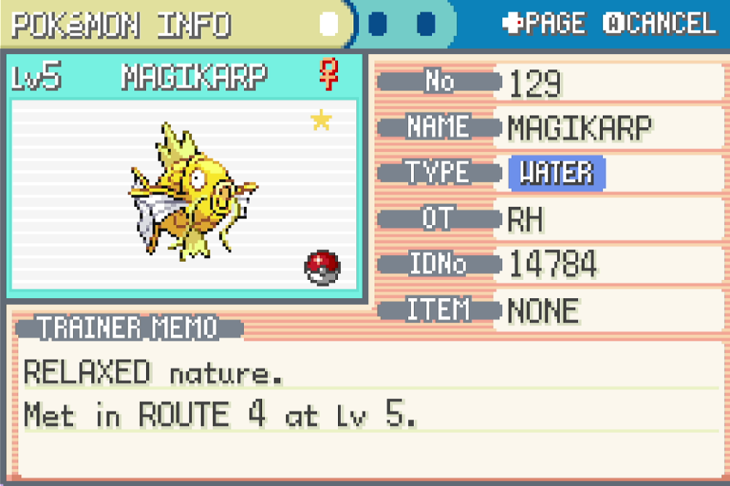

Requirements
- Serial Port: Yes
- Camera Device: Yes
- Audio Input: No

Program Settings
- Seed Frame:
Wait this many frames (not accurate) before pressing A at the title screen. This setting is changed by the program while running
- Advance Frame:
Wait this many frames (not accurate) before finishing dialogue after picking starter. This setting is changed by the program while running

- Accept Gift:
Check this if gift Pokemon requires you to press Yes, Eevee does not need this.

Setup Instructions
- Switch 2 user must disable all HDR settings, Console Screen’s HDR Output and HDR Output below
- Set Text Speed to Fast
- Save in front of gift NPC or Pokeball

Expected Results
The programs starts by soft resetting with ABXY, delay by Seed Frame at title screen, delay by Advance Frame and accepts the gift. Then it checks last Pokemon’s summary for the yellow shiny star, if not shiny the program increments Seed Frame or Advance Frame to check a different RNG permutation.

