
Auto Controller 2 Manual
by brianuuuSonic

Pokemon Fire Red/Leaf Green: Pickup Farmer
Indefinitely farm items using Pickup ability

Requirements
- Serial Port: Yes
- Camera Device: Yes
- Audio Input: No

Program Settings
- Max PP:
Max PP for the first move of the first Pokemon, must be divisible by 5
- Stop For Shiny:
Stop the program if a shiny is detected, it will still detect and send discord message even if unchecked but the program will continue

Setup Instructions
- Switch 2 user must disable all HDR settings, Console Screen’s HDR Output and HDR Output below
- Set Text Speed to Fast, Battle Scene to OFF
- Have 5 Pokemon with Pickup ability in your team
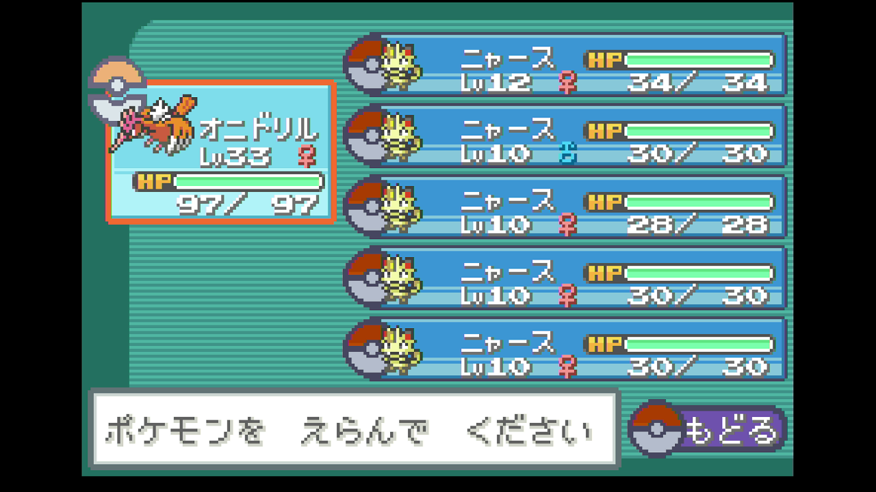
- Your first Pokemon must be able to OHKO Gastly, Cubone and Lv.20 Haunter with the first move
- Stand at this exact spot and save the game
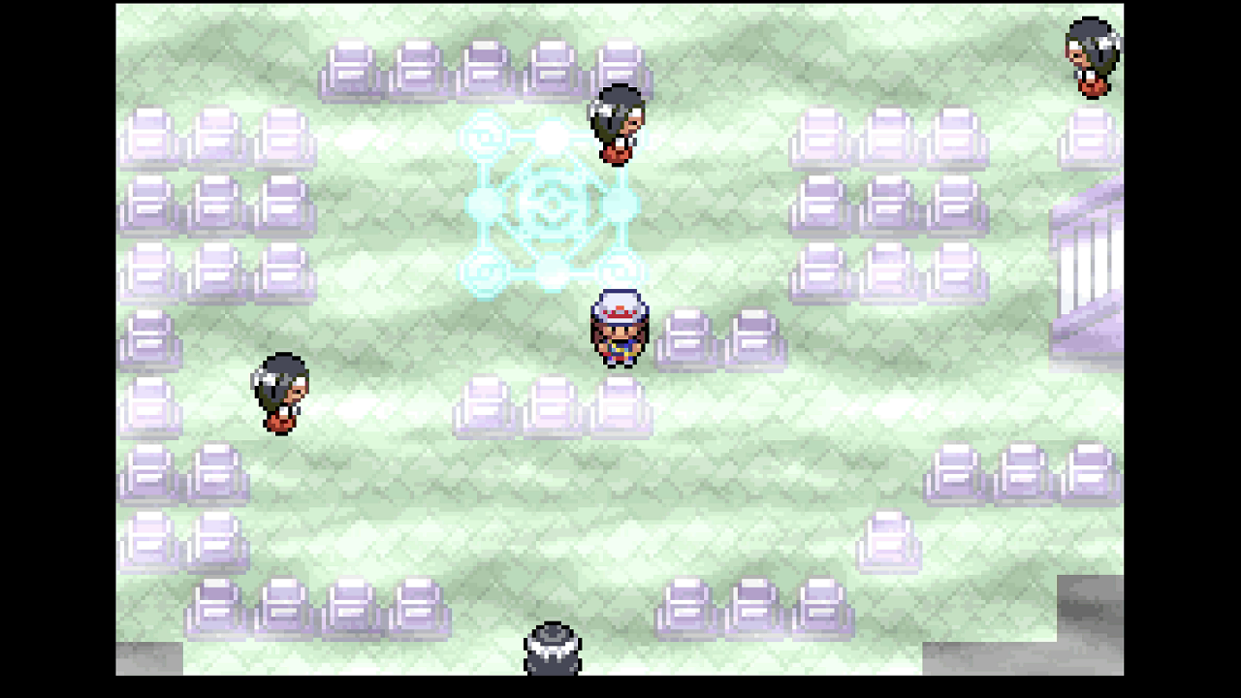
- The menu cursor MUST BE on Pokemon, close the menu and start the program
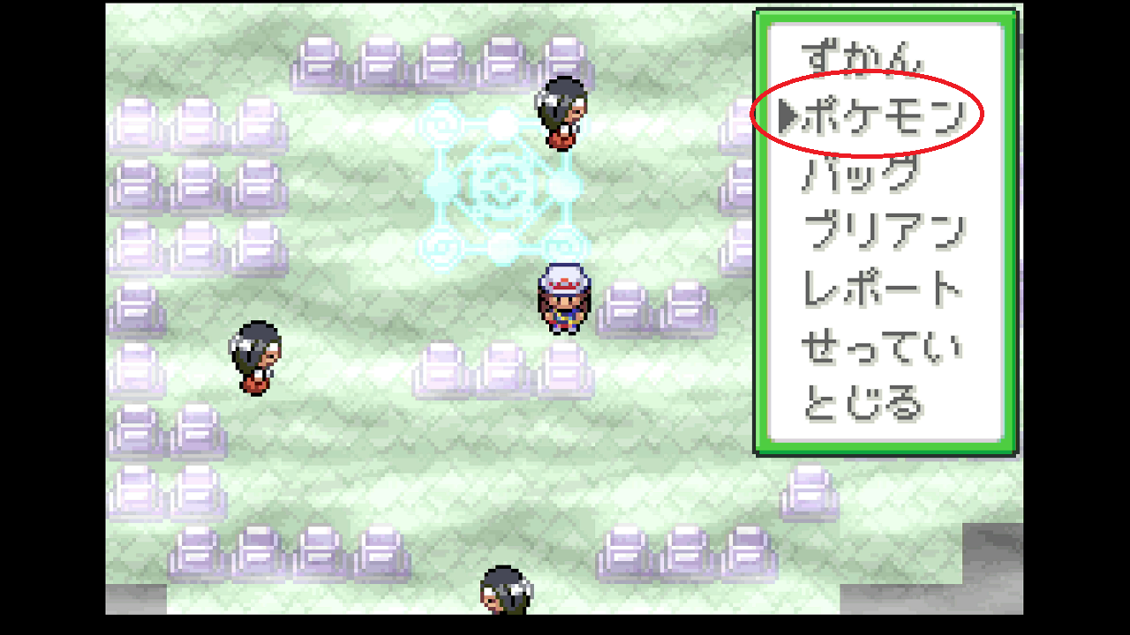

Expected Results
The program starts by fetching items from your Pickup Pokemon, if not you likely did not have cursor on Pokemon before starting the program. Next it heals on the heal pad to restore PP. Then it will start spinning in place for encounters and OHKO wild Pokemon with the first move. Every 5 battles it will fetch items again. Once PP runs out it will heal and the process repeats.

