
Auto Controller 2 Manual
by brianuuuSonic

Splatoon Raiders: Auto Temprah Den
Auto completes Temprah Den raid for EXP, weapons and materials.

Requirements
- Serial Port: Yes
- Camera Device: Yes
- Audio Input: No

Program Settings
- Raid Count:
How many raids to do, set 0 for infinity

- Mash Fire:
Mash ZR to fire weapon instead of hold

Setup Instructions
- Switch 2 user must disable all HDR settings, Console Screen’s HDR Output and HDR Output below
- The following Gadgets setup is recommended:
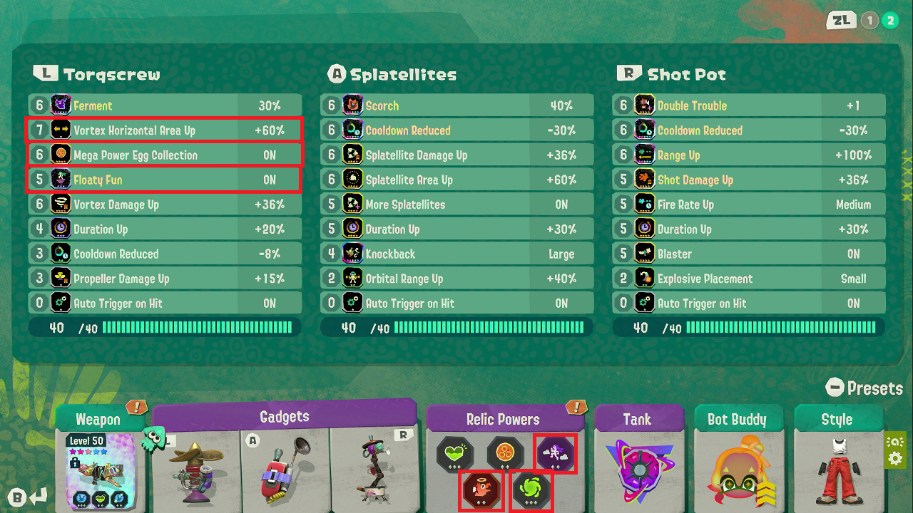
You do not have to follow the exact setup but the red highlighted upgrades and Relic Powers are essential.
- Oil Blaster is the recommended weapon
- You MUST turn off motion control for TV mode
- Enter Temprah Den Super Spicy raid, complete it or exit. You MUST do this so next time it automatically selects this level

Expected Results
The program will start by entering Temprah Den, then it auto fires weapon and all gadgets until raid is completed. If raid is not completed in time or player fails to retrieve treasure at the end of the raid, it will quit the level but all the loots will still be collected. After results screen it repeats all over again.
