**DATA PERTAMA**

26 26 27 29 29 30 30 30 31

32 32 32 32 33 33 33 33 33

33 35 35 35 35 36 36 37 38

39 39 39 39 40 41 41

*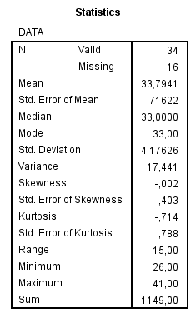***MENGGUNAKAN EXCEL MENGGUNAKAN SPSS**

|  |  |  |
| --- | --- | --- |
|  | *HASIL* | |
|  |  |  |
|  | Mean | 33,79412 |
|  | Standard Error | 0,716223 |
|  | Median | 33 |
|  | Mode | 33 |
|  | Standard Deviation | 4,176263 |
|  | Sample Variance | 17,44118 |
|  | Kurtosis | -0,71425 |
|  | Skewness | -0,0023 |
|  | Range | 15 |
|  | Minimum | 26 |
|  | Maximum | 41 |
|  | Sum | 1149 |
|  | Count | 34 |
|  | Largest(1) | 41 |
|  | Smallest(1) | 26 |
|  | ConfidenceLevel(95,0%) | 1,457167 |

**MENGGUNAKAN SPSS**

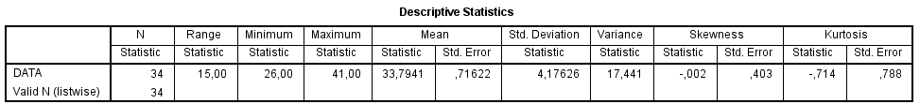

**DATA KEDUA**

48 48 53 55 57 57 62 64 64 64

65 68 68 68 68 68 68 68 69 70

70 71 71 71 71 71 74 75 75 75

75 75 75 75 75 79 79 80 80 80

81 81 81 82 82 82 88 88 88 90

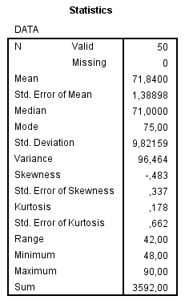**MENGGUNAKAN EXCEL MENGGUNAKAN SPSS**

|  |  |  |
| --- | --- | --- |
|  | *HASIL* | |
|  |  |  |
|  | Mean | 71,84 |
|  | Standard Error | 1,388983 |
|  | Median | 71 |
|  | Mode | 75 |
|  | Standard Deviation | 9,821592 |
|  | Sample Variance | 96,46367 |
|  | Kurtosis | 0,178041 |
|  | Skewness | -0,48294 |
|  | Range | 42 |
|  | Minimum | 48 |
|  | Maximum | 90 |
|  | Sum | 3592 |
|  | Count | 50 |
|  | Largest(1) | 90 |
|  | Smallest(1) | 48 |
|  | Confidence Level(95,0%) | 2,791266 |

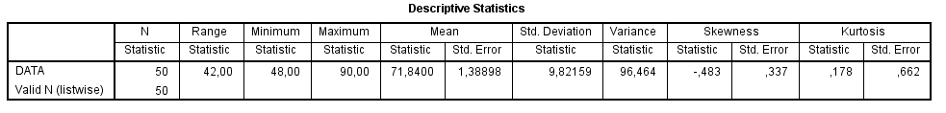 **MENGGUNAKAN SPSS**