As you probably know, you can't print extensions using the standard way offered by QlikView because they're dynamic javascript.

The other day I came across a JS library called [html2canvas](http://html2canvas.hertzen.com/) which scans the DOM of the page and recreates (as best it can) the HTML of that page on a <canvas> element.  So I played with it a bit and made it so it would also convert that canvas element to a PNG image that you can download and do whatever you want with (print,etc.).  It works with extensions, BUT in no way is this library perfect.

Since html2canvas uses the <canvas> element, you'll need to be running IE9 or above.  The library does what it can to convert the HTML to a canvas but it's a pretty new library and there's some things that are too complex for it.  For example, none of my Raphael extensions were showing up in the screen captures I created from this extension, and I guess a few people were having problems with the background image of the QVW showing up.  Like I said, this is what it is, and it's far from perfect, but hopefully it helps.

Anyway, it's pretty easy to use.  Once you install the doc extension, there will be an icon in the upper right of the QVW (in webview) next to the "+" sign:

Click that and a window will pop up underneath it showing you a preview thumbnail of the screen capture and giving you instructions on how to download the image:

[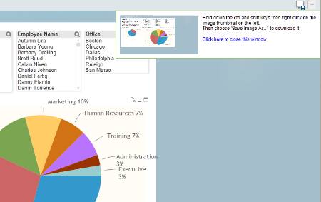](http://community.qlikview.com/servlet/JiveServlet/showImage/2-264467-22688/window.png)

Obviously telling people to hold down ctrl and shift then right clicking the thumbnail isn't ideal, but it was really the only way to do it.  It's pretty easy, just hit Save Picture As...

[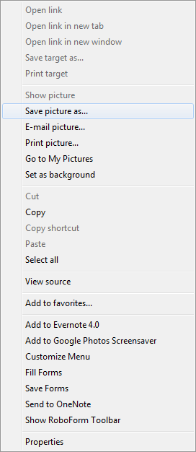](http://community.qlikview.com/servlet/JiveServlet/showImage/2-264467-22689/saveAs.png)

When you open the image you downloaded, it will be a screen capture of what you were just seeing in the QVW similar to this:

[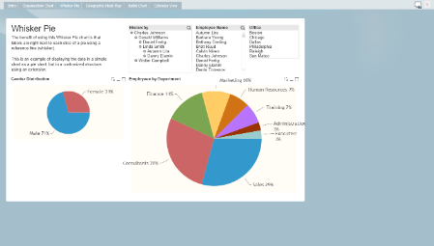](http://community.qlikview.com/servlet/JiveServlet/showImage/2-264467-22690/shot.png)

That's it.  Like I said, it's not perfect, but hopefully it helps out.