CPE301D – SPRING 2021

PCB Final Project

Student Name: Brian Wolak

Student #: 2000509437

Student Email: wolak@unlv.nevada.edu

Primary Github address: <https://github.com/brianwolak/submission_da.git>

Directory: <https://github.com/brianwolak/submission_da/tree/main/CpE301D>

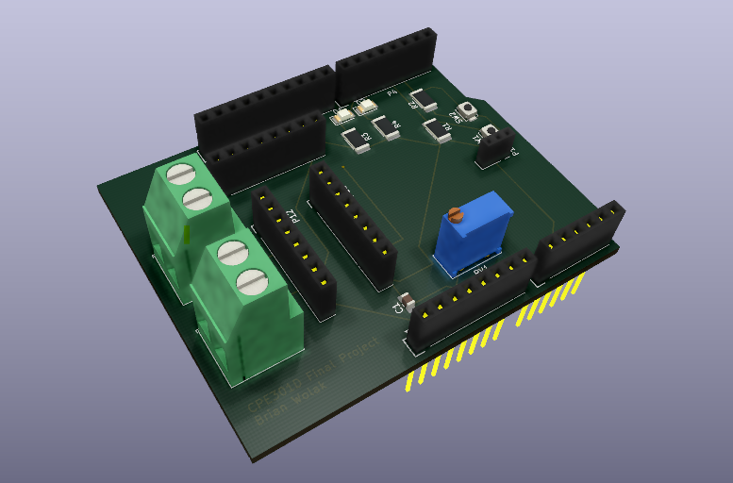

*3-D View of PCB Final Project*

**Task 1:**

Create a PCB multi-function shield capable of use with the ATmega328pb Xplained Mini that will allow interfacing all components used during the previous design assignments for the semester.

1. Two LEDs appropriate resistors connected to PORTD pins 5&6 in reverse logic
2. Two push buttons working in internal pull-up mode connected to PORTD pins 2&3
3. A 10K Potentiometer with a filter connected to PORTC pin 0
4. Female header pins to interface to LM34/35 to PORTC pin 1
5. Female header pins for SPI0 interface with VCC and GND to accommodate the ICM20948 sensor
6. Female header pin for I2C interface with VCC and GND to accommodate the ICM20948 sensor
7. Interface to DRV8833 DUAL MTR DRIVER CARRIER board and terminal block connectors to the side of the shield

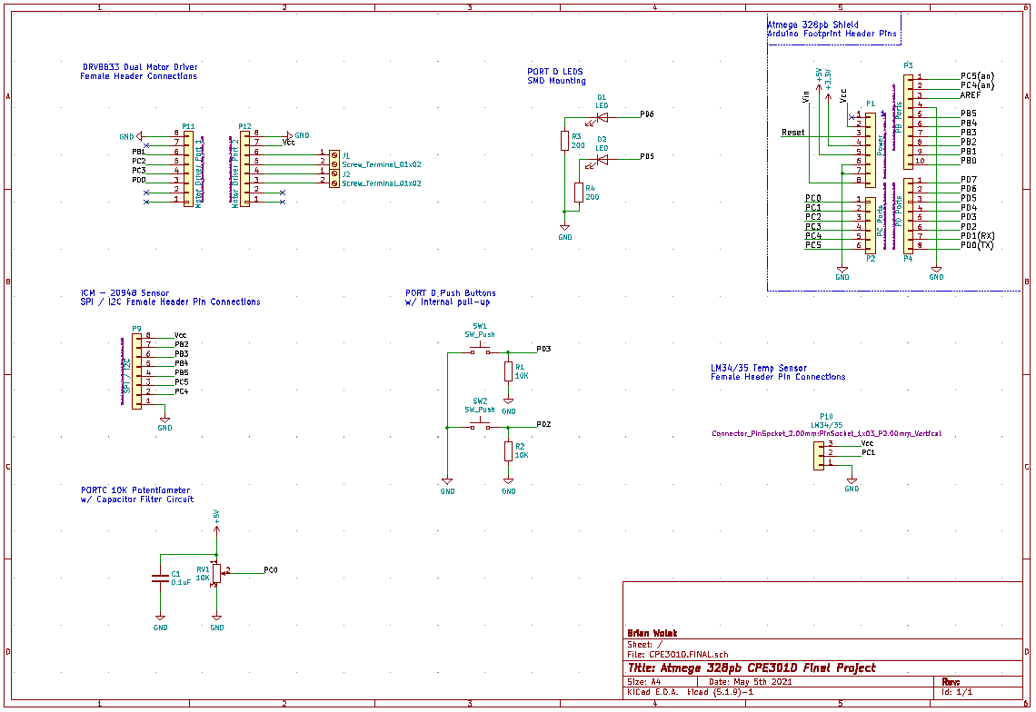

*Final Project - PCB Schematic*

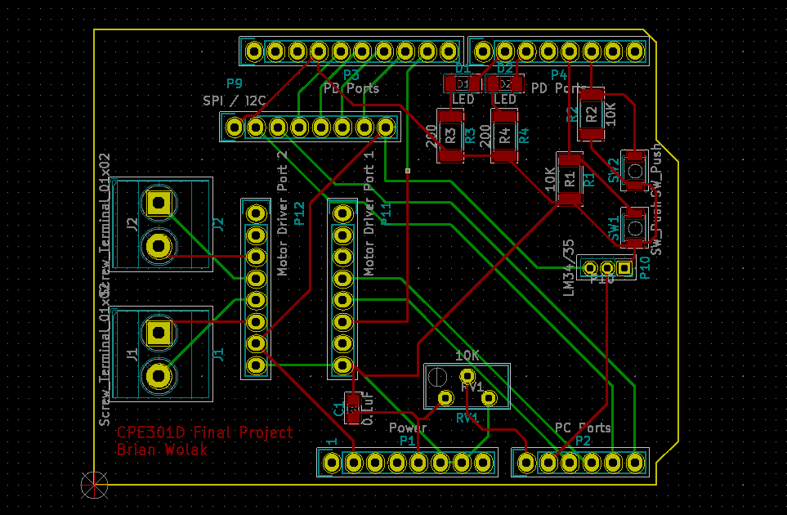

*PCB Layout – Note: you can see the Motor Driver sockets allow the DRV8833 driver to be plugged directly into the board eliminating the need for jumper wire connections*

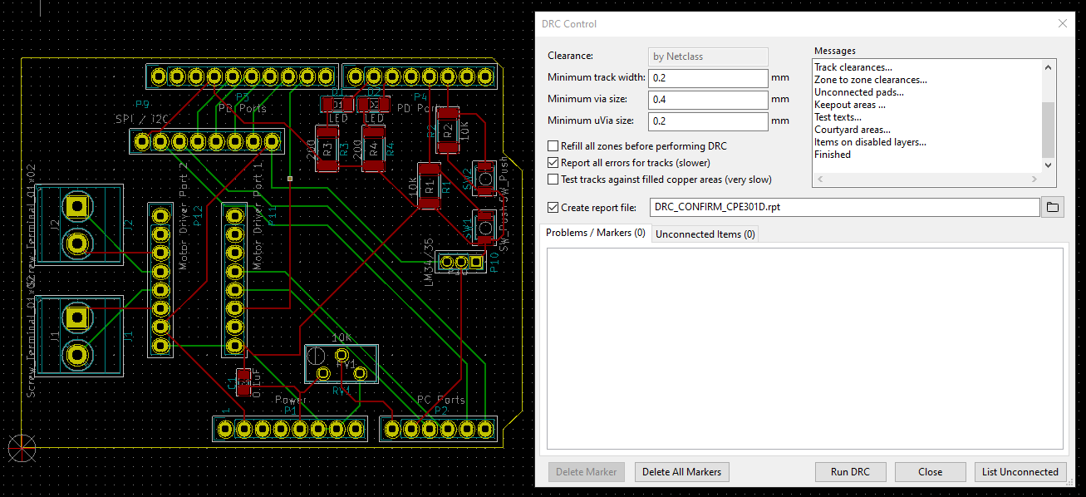

*DRC Confirmation – Note: I have generated a DRC confirmation file to be included in my GitHub submission*

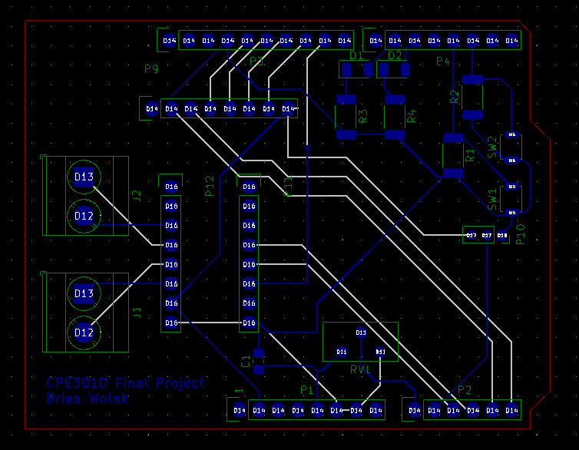

*Gerber .gbrjob file Preview*

**GitHub Link:**

[**https://github.com/brianwolak/submission_da/tree/main/CpE301D**](https://github.com/brianwolak/submission_da/tree/main/CpE301D)