CPE301 – SPRING 2021

Design Assignment 5

Student Name: Brian Wolak

Student #: 2000509437

Student Email: wolak@unlv.nevada.edu

Primary Github address: <https://github.com/brianwolak/submission_da.git>

Directory: <https://github.com/brianwolak/submission_da/tree/main/DA_5>

**Task 1:**

In this design assignment a C code is written to interface a 9-DOF ICM-20948 sensor with the ATmega328pb using SPI. The goal was to gather information from the accelerometer and gyro for each axis (x,y,z). Below you can see the code, demonstration video link, and outputs verifying the proper operation.

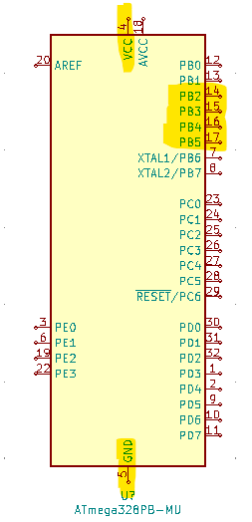

*Design Assignment 5 Ports Used*

**Video Link:**

<https://youtu.be/sRIJNMjxx3k>

**C Code:**

#define *F_CPU* 16000000UL //CPU clock speed

#define BAUD 9600 //9600 baud rate

#ifndef __SMALL_SPI_H__

#define __SMALL_SPI_H__

#include <avr/common.h>

void spi_master_init(void);

void spi_bulk_send(*uint8_t* *send_buffer, *uint8_t* count);

void spi_send(*uint8_t* send_data);

void spi_bulk_exchange(*uint8_t* *send_buffer, *uint8_t* *receive_buffer, *uint8_t* count);

*uint8_t* spi_exchange(*uint8_t* send_data);

#endif

#include <avr/common.h>

#include <avr/io.h>

#include <avr/interrupt.h>

#include <util/setbaud.h>

#include <stdio.h>

#include <util/delay.h>

#define DDR_SPI DDRB //define SPI port

#define DD_MOSI DDB3 //MOSI pin3

#define DD_MISO DDB4 //MISO pin4

#define DD_SCK DDB5 //SCK pin5

char display[20]; //uart string display

char X = 'X';

char Y = 'Y';

char Z = 'Z';

*uint8_t* who_am_i = 0; //whoami value

//retrived data storage variables

*uint16_t* Xacc, Yacc, Zacc, Xgyr, Ygyr, Zgyr;

//SPI initialize

void spi_master_init(void)

{

SPCR0 = (0 << SPIE) | (1 << SPE) | (0 << DORD) | (1 << MSTR) |

(0 << CPOL) | (0 << CPHA) | (0 << SPR1) | (1 << SPR0);

}

//bulk send function

void spi_bulk_send(*uint8_t* *send_buffer, *uint8_t* count)

{

while(count--)

{

SPDR0 = *send_buffer++;

loop_until_bit_is_set(SPSR0, SPIF);

}

}

//spi command function

void spi_send(*uint8_t* send_data)

{

SPDR0 = send_data;

while(!(SPSR0 & (1<<SPIF)));

}

//bulk send/receive function

void spi_bulk_exchange(*uint8_t* *send_buffer, *uint8_t* *receive_buffer, *uint8_t* count)

{

while(count--)

{

SPDR0 = *send_buffer++;

loop_until_bit_is_set(SPSR0, SPIF);

*receive_buffer++ = SPDR0;

}

}

//8-bit exchange function

*uint8_t* spi_exchange(*uint8_t* send_data)

{

SPDR0 = send_data;

while(!(SPSR0 & (1<<SPIF)));

return SPDR0;

}

//UART initialize

void USART_init(void)

{

UBRR0H = *UBRRH_VALUE*;

UBRR0L = *UBRRL_VALUE*;

UCSR0C = _BV(UCSZ01) | _BV(UCSZ00);

UCSR0B = _BV(RXEN0) | _BV(TXEN0);

}

//terminal print function

void USART_tx_string(char *data)

{

while((*data != '\0')) //loop while string not empty

{

while(!(UCSR0A & (1 << UDRE0))); //loop while data register not empty

UDR0 = *data; //save data to UDR0

data++; //increment data

}

}

//who_am_i function

*uint16_t* who_am_i_func(void){

*uint16_t* data;

PORTB &= ~(1 << 2); //spi enable

spi_send(0x80); //send who_am_i address

data = spi_exchange(0x00); //get who_am_i value

PORTB |= (1 << 2); //spi disable

return data;

}

//get 16-bit data function

int get_data(*uint16_t* addressH, *uint16_t* addressL){

int data;

PORTB &= ~(1 << 2); //spi enable

spi_send(addressH); //send address high

data = spi_exchange(0x00); //get data

PORTB |= (1 << 2); //spi disable

PORTB &= ~(1 << 2); //spi enable

spi_send(addressL); //send address low

data = ((*uint16_t*)(8<<data)) | (*uint16_t*)(spi_exchange(0x00)); //combining L and H

PORTB |= (1 << 2); //spi disable

return data;

}

int main(void)

{

DDRB |= (1 << 2)|(1<<3)|(1<<5); //set output ports

DDRB &= ~(1<<4); //set input

USART_init(); //initialize UART

USART_tx_string("Connection Established\r\n"); //confirm UART connection

spi_master_init(); //spi master initialize

PORTB &= ~(1 << 2); //spi enable

spi_send(0x06); //address sensor clock

spi_send(0x05); //send sensor clock speed

PORTB |= (1 << 2); //toggle SPI enable

//who_am_i

who_am_i = who_am_i_func();

//print who_am_i info

*sprintf*(display, "%d", who_am_i);

USART_tx_string("Slave address is: ");

USART_tx_string(display);

USART_tx_string("\r\n");

while (1)

{

who_am_i = who_am_i_func(); //who_am_i check

if (who_am_i == 234) //if true, device connected

USART_tx_string("ICM-20948 is still Connected\r\n");

else //if false, device not connected

USART_tx_string("ICM-20948 is NOT Connected\r\n");

//gyro X

Xgyr = get_data(0xB3, 0xB4);

//print gyro X info

*sprintf*(display, "%d", Xgyr);

USART_tx_string("Gyro X Value: ");

USART_tx_string(display);

USART_tx_string("\r\n");

//gyro Y

Ygyr = get_data(0xB5, 0xB6);

//print gyro Y info

*sprintf*(display, "%d", Ygyr);

USART_tx_string("Gyro Y Value: ");

USART_tx_string(display);

USART_tx_string("\r\n");

//gyro Z

Zgyr = get_data(0xB7, 0xB8);

//print gyro Z info

*sprintf*(display, "%d", Zgyr);

USART_tx_string("Gyro Z Value: ");

USART_tx_string(display);

USART_tx_string("\r\n");

//accelerometer X

Xacc = get_data(0xAD, 0xAE);

//print accel X info

*sprintf*(display, "%d", Xacc);

USART_tx_string("Accelerometer X Value: ");

USART_tx_string(display);

USART_tx_string("\r\n");

//accelerometer Y

Yacc = get_data(0xAF, 0xB0);

//print accel Y info

*sprintf*(display, "%d", Yacc);

USART_tx_string("Accelerometer Y Value: ");

USART_tx_string(display);

USART_tx_string("\r\n");

//Accelerometer Z

Zacc = get_data(0xB1, 0xB2);

//print accel Z info

*sprintf*(display, "%d", Zacc);

USART_tx_string("Accelerometer Z Value: ");

USART_tx_string(display);

USART_tx_string("\r\n");

USART_tx_string("\r\n");

*_delay_ms*(500); //terminal delay

}

}

*Design Assignment 5 Board Setup*

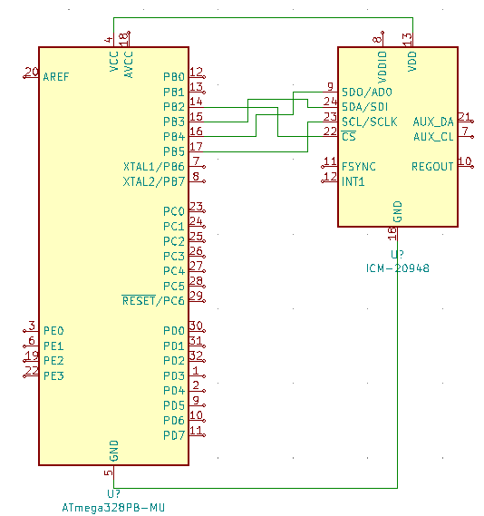

*Design Assignment 5 Circuit*

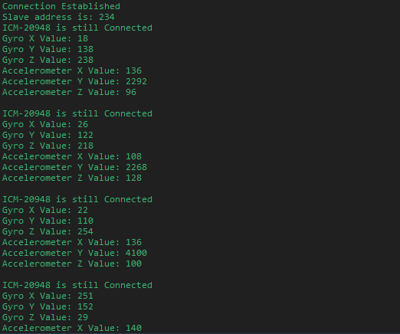

*Terminal Output Showing Initial Connection and Confirmation of Connection*

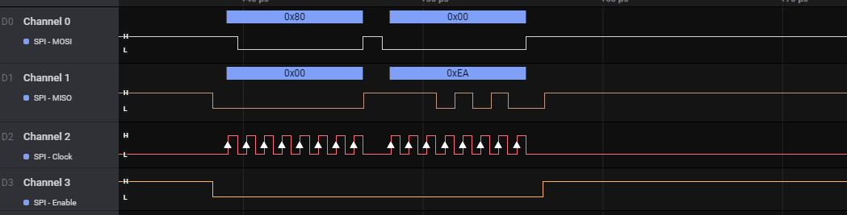

*Logic Output Showing who_am_i Reading*

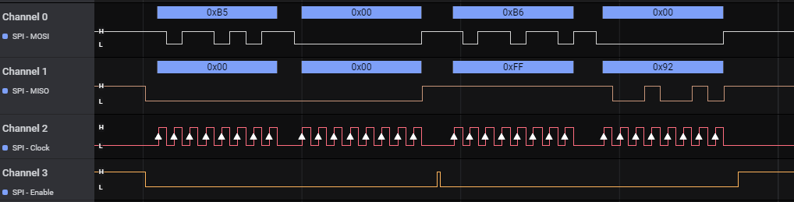

*Logic Output Showing Y Gyro Scope H/L Read*

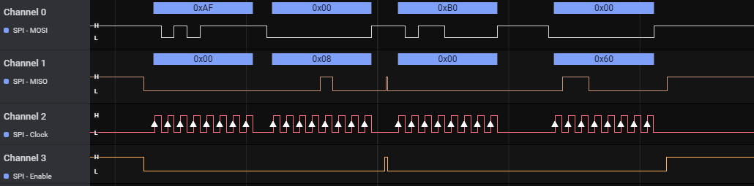

*Logic Output Showing Y Accelerometer H/L Read*

**GitHub Link:**

<https://github.com/brianwolak/submission_da/tree/main/DA_5>

**Video Link:**

<https://youtu.be/sRIJNMjxx3k>