CPE301 – SPRING 2021

Design Assignment 6

Student Name: Brian Wolak

Student #: 2000509437

Student Email: wolak@unlv.nevada.edu

Primary Github address: <https://github.com/brianwolak/submission_da.git>

Directory: [submission_da/DA_6 at main · brianwolak/submission_da (github.com)](https://github.com/brianwolak/submission_da/tree/main/DA_6)

**Task 1:**

In this design assignment a C code is written to interface a 9-DOF ICM-20948 sensor with the ATmega328pb using i2C. The goal was to gather information from the accelerometer and gyro for each axis (x,y,z). Below you can see the code, demonstration video link, and outputs verifying the proper operation.

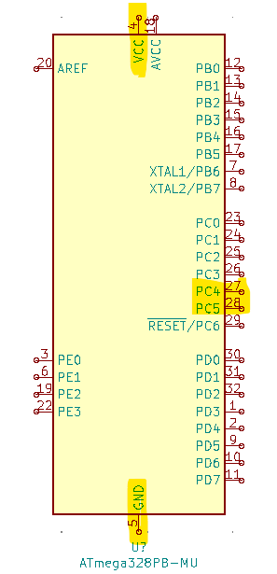

*Design Assignment 6 Ports Used*

**Video Link:**

<https://youtu.be/EF3NKGJFo8Q>

**C Code:**

#define *F_CPU* 16000000UL //CPU clock speed

#define BAUD 9600 //Baud rate is 9600

#include <avr/common.h>

#include <avr/io.h>

#include <avr/interrupt.h>

#include <util/setbaud.h>

#include <stdio.h>

#include <util/delay.h>

#include <inttypes.h>

#include <util/twi.h>

#define SCL_CLOCK 100000L

#define TW_STATUS_PB (TWSR0 & 0xF8)

char display[20], display2[20];

*uint8_t* who_am_i; //device address

*uint16_t* Xacc, Yacc, Zacc, Xgyr, Ygyr, Zgyr;

float Xaccf, Yaccf, Zaccf, Xgyrf, Ygyrf, Zgyrf;

//UART initialize

void USART_init(void)

{

UBRR0H = *UBRRH_VALUE*;

UBRR0L = *UBRRL_VALUE*;

UCSR0C = _BV(UCSZ01) | _BV(UCSZ00);

UCSR0B = _BV(RXEN0) | _BV(TXEN0);

}

//UART print function

void USART_tx_string(char *data){

while((*data != '\0')){ //while the data string is not empty

while(!(UCSR0A & (1 << UDRE0))); //while the data regsiter is not empty

UDR0 = *data; //UDR0 register receives data

data++; //next data value

}

}

void i2c_init(void)

{/* initialize TWI clock: 100 kHz clock, TWPS = 0 => prescaler = 1 */

TWSR0 = 0; /* no prescaler */

TWBR0 = ((*F_CPU*/SCL_CLOCK)-16)/2; /* must be > 10 for stable operation 12*/

}/* i2c_init */

unsigned char i2c_start(unsigned char address)

{

*uint8_t* twst;

// send START condition

TWCR0 = (1<<TWINT) | (1<<TWSTA) | (1<<TWEN);

// wait until transmission completed

while(!(TWCR0 & (1<<TWINT)));

// check value of TWI Status Register. Mask prescaler bits.

twst = TW_STATUS_PB & 0xF8;

if ( (twst != *TW_START*) && (twst != *TW_REP_START*)) return 1;

// send device address

TWDR0 = address;

TWCR0 = (1<<TWINT) | (1<<TWEN);

// wail until transmission completed and ACK/NACK has been received

while(!(TWCR0 & (1<<TWINT)));

// check value of TWI Status Register. Mask prescaler bits.

twst = TW_STATUS_PB & 0xF8;

if ( (twst != *TW_MT_SLA_ACK*) && (twst != *TW_MR_SLA_ACK*) ) return 1;

return 0;

}/* i2c_start */

unsigned char i2c_rep_start(unsigned char address)

{

return i2c_start( address );

}/* i2c_rep_start */

void i2c_stop(void)

{

/* send stop condition */

TWCR0 = (1<<TWINT) | (1<<TWEN) | (1<<TWSTO);

// wait until stop condition is executed and bus released

while(TWCR0 & (1<<TWSTO));

}/* i2c_stop */

unsigned char i2c_write( unsigned char data )

{

*uint8_t* twst;

// send data to the previously addressed device

TWDR0 = data;

TWCR0 = (1<<TWINT) | (1<<TWEN);

// wait until transmission completed

while(!(TWCR0 & (1<<TWINT)));

// check value of TWI Status Register. Mask prescaler bits

twst = TW_STATUS_PB & 0xF8;

if( twst != *TW_MT_DATA_ACK*) return 1;

return 0;

}//* i2c_write *

unsigned char i2c_readAck(void)

{

TWCR0 = (1<<TWINT) | (1<<TWEN) | (1<<TWEA);

while(!(TWCR0 & (1<<TWINT)));

return TWDR0;

}/* i2c_readAck */

unsigned char i2c_readNak(void)

{

TWCR0 = (1<<TWINT) | (1<<TWEN);

while(!(TWCR0 & (1<<TWINT)));

return TWDR0;

}/* i2c_readNak */

void i2c_start_wait(unsigned char address)

{

*uint8_t* twst;

while ( 1 )

{

// send START condition

TWCR0 = (1<<TWINT) | (1<<TWSTA) | (1<<TWEN);

// wait until transmission completed

while(!(TWCR0 & (1<<TWINT)));

// check value of TWI Status Register. Mask prescaler bits.

twst = TW_STATUS_PB & 0xF8;

if ( (twst != *TW_START*) && (twst != *TW_REP_START*)) continue;

// send device address

TWDR0 = address;

TWCR0 = (1<<TWINT) | (1<<TWEN);

// wail until transmission completed

while(!(TWCR0 & (1<<TWINT)));

// check value of TWI Status Register. Mask prescaler bits.

twst = TW_STATUS_PB & 0xF8;

if ( (twst == *TW_MT_SLA_NACK* )||(twst ==*TW_MR_DATA_NACK*) )

{/* device busy, send stop condition to terminate write operation */

TWCR0 = (1<<TWINT) | (1<<TWEN) | (1<<TWSTO);

// wait until stop condition is executed and bus released

while(TWCR0 & (1<<TWSTO));

continue;

}

//if( twst != TW_MT_SLA_ACK) return 1;

break;

}

}/* i2c_start_wait */

//who_am_i function

*uint16_t* who_am_i_func(void){

*uint16_t* data;

i2c_start_wait(0xD0); //open write communication with 20948

i2c_write(0x00); //select register address

i2c_start_wait(0xD1); //open communication again

data = i2c_readNak(); //read data value

i2c_stop(); //stop transmission

return data;

}

//get 16-bit data function

int get_data(*uint16_t* addressL, *uint16_t* addressH){

*uint16_t* data;

i2c_start_wait(0xD0); //start communication with sensor

i2c_write(addressH); //send high register address

i2c_start_wait(0xD1); //open communication

data = i2c_readNak(); //read high register

i2c_stop(); //stop transmission

i2c_start_wait(0xD0); //open write

i2c_write(addressL); //send low address

i2c_start_wait(0xD1); //open communication

data = (8 << data) | i2c_readNak(); //read values

i2c_stop(); //stop transmission

return data;

}

int main(void)

{

int device; //device read address

USART_init(); //function call

i2c_init(); //initialize i2c

USART_tx_string("Connection Established!\r\n"); //UART connection confirm

i2c_start_wait(0xD0); //open communication with sensor

i2c_write(0x06); //select register 6

i2c_write(0x00); //write value to the register location

i2c_stop(); //stop i2c

//who_am_i

who_am_i = who_am_i_func();

//print who_am_i info

*sprintf*(display, "%d", who_am_i);

USART_tx_string("i2c device address is: ");

USART_tx_string(display);

USART_tx_string("\r\n");

device = who_am_i;

while (1){

who_am_i = who_am_i_func(); //who_am_i check

if (who_am_i == device) //if true, device connected

USART_tx_string("ICM-20948 is still Connected\r\n");

else //if false, device not connected

USART_tx_string("ICM-20948 is NOT Connected\r\n");

//gyro X

Xgyr = get_data(0x33, 0x34);

Xgyrf = Xgyr / 131.0; //scale with sensitivity factor

//print gyro X info

*sprintf*(display, "%.2f", Xgyrf);

USART_tx_string("Gyro X Value: ");

USART_tx_string(display);

USART_tx_string("\r\n");

//gyro Y

Ygyr = get_data(0x35, 0x36);

Ygyrf = Ygyr / 131.0; //scale with sensitivity factor

//print gyro Y info

*sprintf*(display, "%.2f", Ygyrf);

USART_tx_string("Gyro Y Value: ");

USART_tx_string(display);

USART_tx_string("\r\n");

//gyro Z

Zgyr = get_data(0x37, 0x38);

Zgyrf = Zgyr / 131.0; //scale with sensitivity factor

//print gyro Z info

*sprintf*(display, "%.2f", Zgyrf);

USART_tx_string("Gyro Z Value: ");

USART_tx_string(display);

USART_tx_string("\r\n");

//accelerometer X

Xacc = get_data(0x2D, 0x2E);

Xaccf = Xacc / 16384.0; //scale with sensitivity factor

//print accel X info

*sprintf*(display, "%.2f", Xaccf);

USART_tx_string("Accelerometer X Value: ");

USART_tx_string(display);

USART_tx_string("\r\n");

//accelerometer Y

Yacc = get_data(0x2F, 0x30);

Yaccf = Yacc / 16384.0; //scale with sensitivity factor

//print accel Y info

*sprintf*(display, "%.2f", Yaccf);

USART_tx_string("Accelerometer Y Value: ");

USART_tx_string(display);

USART_tx_string("\r\n");

//Accelerometer Z

Zacc = get_data(0x31, 0x32);

Zaccf = Zacc / 16384.0; //scale with sensitivity factor

//print accel Z info

*sprintf*(display, "%.2f", Zaccf);

USART_tx_string("Accelerometer Z Value: ");

USART_tx_string(display);

USART_tx_string("\r\n");

USART_tx_string("\r\n");

*_delay_ms*(500); //terminal delay

}

}

*Design Assignment 6 Board Setup*

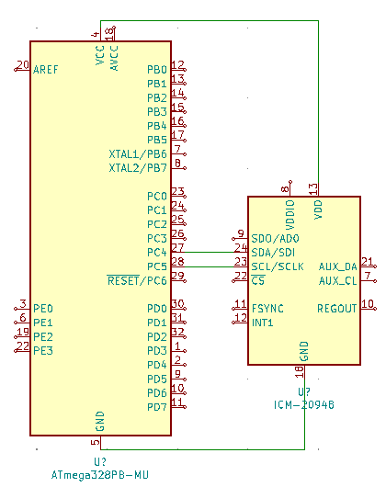

*Design Assignment 6 Circuit*

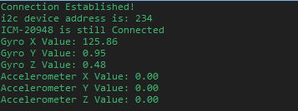

*Terminal Output Showing Initial Connection and Confirmation of Connection*

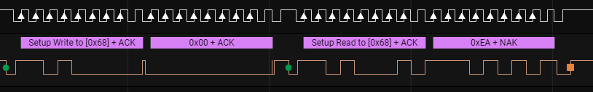

*Logic Output Showing who_am_i Reading*

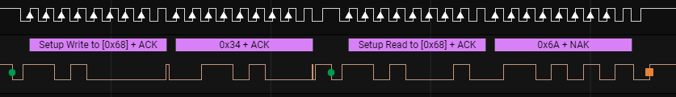

*Logic Output Showing X Gyro Scope L Read*

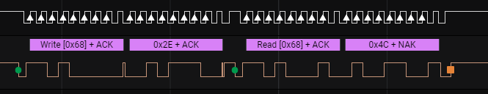

*Logic Output Showing X Accelerometer L Read*

**GitHub Link:**

[submission_da/DA_6 at main · brianwolak/submission_da (github.com)](https://github.com/brianwolak/submission_da/tree/main/DA_6)

**Video Link:**

<https://youtu.be/EF3NKGJFo8Q>