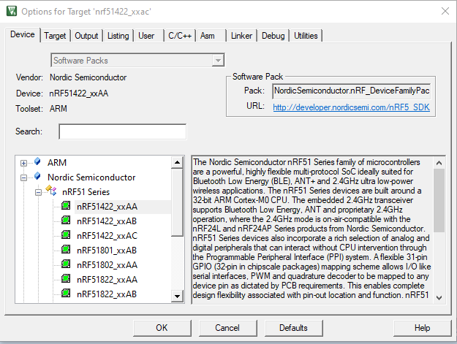

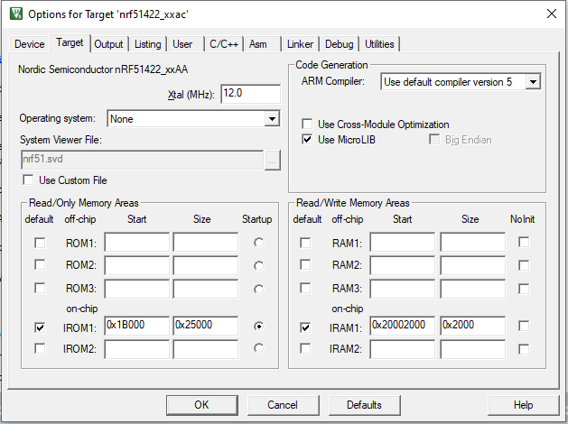

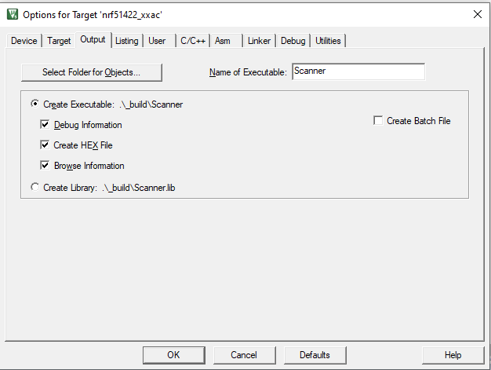

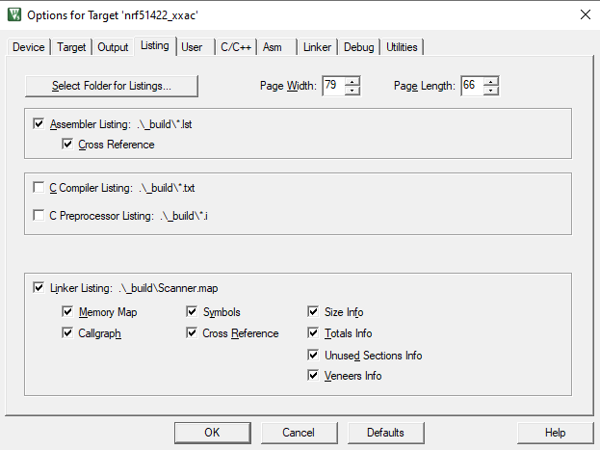

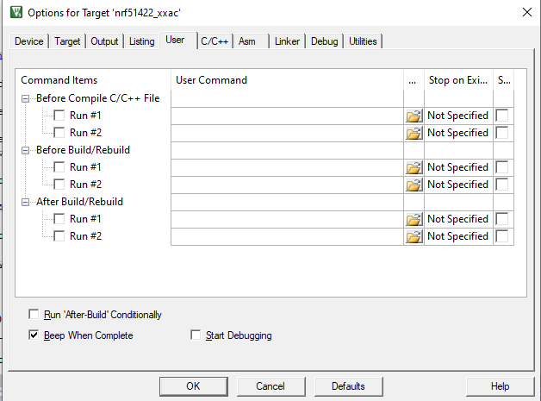

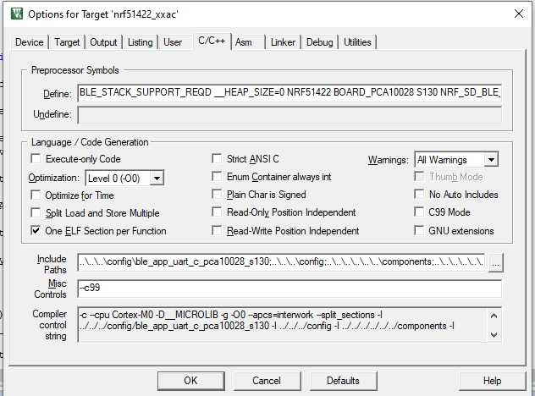

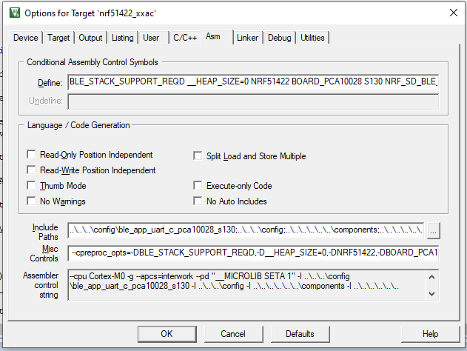

**C Preprocessor symbols define :**

|  |
| --- |
| BLE_STACK_SUPPORT_REQD __HEAP_SIZE=0 NRF51422 BOARD_PCA10028 S130 NRF_SD_BLE_API_VERSION=2 BSP_UART_SUPPORT NRF51 SOFTDEVICE_PRESENT SWI_DISABLE0 |

**Compiler control string :**

|  |
| --- |
| -c --cpu Cortex-M0 -D__MICROLIB -g -O0 --apcs=interwork --split_sections -I ../../../config/ble_app_uart_c_pca10028_s130 -I ../../../config -I ../../../../../../components -I ../../../../../../components/ble/ble_advertising -I ../../../../../../components/ble/ble_db_discovery -I ../../../../../../components/ble/ble_dtm -I ../../../../../../components/ble/ble_racp -I ../../../../../../components/ble/ble_services/ble_ancs_c -I ../../../../../../components/ble/ble_services/ble_ans_c -I ../../../../../../components/ble/ble_services/ble_bas -I ../../../../../../components/ble/ble_services/ble_bas_c -I ../../../../../../components/ble/ble_services/ble_cscs -I ../../../../../../components/ble/ble_services/ble_cts_c -I ../../../../../../components/ble/ble_services/ble_dfu -I ../../../../../../components/ble/ble_services/ble_dis -I ../../../../../../components/ble/ble_services/ble_gls -I ../../../../../../components/ble/ble_services/ble_hids -I ../../../../../../components/ble/ble_services/ble_hrs -I ../../../../../../components/ble/ble_services/ble_hrs_c -I ../../../../../../components/ble/ble_services/ble_hts -I ../../../../../../components/ble/ble_services/ble_ias -I ../../../../../../components/ble/ble_services/ble_ias_c -I ../../../../../../components/ble/ble_services/ble_lbs -I ../../../../../../components/ble/ble_services/ble_lbs_c -I ../../../../../../components/ble/ble_services/ble_lls -I ../../../../../../components/ble/ble_services/ble_nus -I ../../../../../../components/ble/ble_services/ble_nus_c -I ../../../../../../components/ble/ble_services/ble_rscs -I ../../../../../../components/ble/ble_services/ble_rscs_c -I ../../../../../../components/ble/ble_services/ble_tps -I ../../../../../../components/ble/common -I ../../../../../../components/ble/nrf_ble_qwr -I ../../../../../../components/ble/peer_manager -I ../../../../../../components/boards -I ../../../../../../components/device -I ../../../../../../components/drivers_nrf/adc -I ../../../../../../components/drivers_nrf/clock -I ../../../../../../components/drivers_nrf/common -I ../../../../../../components/drivers_nrf/comp -I ../../../../../../components/drivers_nrf/delay -I ../../../../../../components/drivers_nrf/gpiote -I ../../../../../../components/drivers_nrf/hal -I ../../../../../../components/drivers_nrf/i2s -I ../../../../../../components/drivers_nrf/lpcomp -I ../../../../../../components/drivers_nrf/pdm -I ../../../../../../components/drivers_nrf/power -I ../../../../../../components/drivers_nrf/ppi -I ../../../../../../components/drivers_nrf/pwm -I ../../../../../../components/drivers_nrf/qdec -I ../../../../../../components/drivers_nrf/rng -I ../../../../../../components/drivers_nrf/rtc -I ../../../../../../components/drivers_nrf/saadc -I ../../../../../../components/drivers_nrf/spi_master -I ../../../../../../components/drivers_nrf/spi_slave -I ../../../../../../components/drivers_nrf/swi -I ../../../../../../components/drivers_nrf/timer -I ../../../../../../components/drivers_nrf/twi_master -I ../../../../../../components/drivers_nrf/twis_slave -I ../../../../../../components/drivers_nrf/uart -I ../../../../../../components/drivers_nrf/usbd -I ../../../../../../components/drivers_nrf/wdt -I ../../../../../../components/libraries/bsp -I ../../../../../../components/libraries/button -I ../../../../../../components/libraries/crc16 -I ../../../../../../components/libraries/crc32 -I ../../../../../../components/libraries/csense -I ../../../../../../components/libraries/csense_drv -I ../../../../../../components/libraries/experimental_section_vars -I ../../../../../../components/libraries/fds -I ../../../../../../components/libraries/fifo -I ../../../../../../components/libraries/fstorage -I ../../../../../../components/libraries/gpiote -I ../../../../../../components/libraries/hardfault -I ../../../../../../components/libraries/hci -I ../../../../../../components/libraries/led_softblink -I ../../../../../../components/libraries/log -I ../../../../../../components/libraries/log/src -I ../../../../../../components/libraries/low_power_pwm -I ../../../../../../components/libraries/mem_manager -I ../../../../../../components/libraries/pwm -I ../../../../../../components/libraries/queue -I ../../../../../../components/libraries/scheduler -I ../../../../../../components/libraries/slip -I ../../../../../../components/libraries/timer -I ../../../../../../components/libraries/twi -I ../../../../../../components/libraries/uart -I ../../../../../../components/libraries/usbd -I ../../../../../../components/libraries/usbd/class/audio -I ../../../../../../components/libraries/usbd/class/cdc -I ../../../../../../components/libraries/usbd/class/cdc/acm -I ../../../../../../components/libraries/usbd/class/hid -I ../../../../../../components/libraries/usbd/class/hid/generic -I ../../../../../../components/libraries/usbd/class/hid/kbd -I ../../../../../../components/libraries/usbd/class/hid/mouse -I ../../../../../../components/libraries/usbd/class/msc -I ../../../../../../components/libraries/usbd/config -I ../../../../../../components/libraries/util -I ../../../../../../components/softdevice/common/softdevice_handler -I ../../../../../../components/softdevice/s130/headers -I ../../../../../../components/softdevice/s130/headers/nrf51 -I ../../../../../../components/toolchain -I ../../../../../../external/segger_rtt -I ../config -I ../../../../../../components/boards -I C:/Keil_v5/ARM/PACK/ARM/CMSIS/5.1.0/CMSIS/Include -I ../../../../ibeaconscanner -I ../../../../../../components/ble/ble_services/ble_nus -I ../../../../../../components/libraries/fstorage --c99  -I./RTE/_nrf51422_xxac  -I"C:/Users/Marc Landes/AppData/Local/Arm/Packs/ARM/CMSIS/5.5.1/CMSIS/Core/Include"  -I"C:/Users/Marc Landes/AppData/Local/Arm/Packs/NordicSemiconductor/nRF_DeviceFamilyPack/8.24.1/Device/Include"  -D__UVISION_VERSION="527" -D_RTE_ -DNRF51 -DBLE_STACK_SUPPORT_REQD -D__HEAP_SIZE="0" -DNRF51422 -DBOARD_PCA10028 -DS130 -DNRF_SD_BLE_API_VERSION="2" -DBSP_UART_SUPPORT -DNRF51 -DSOFTDEVICE_PRESENT -DSWI_DISABLE0  -o .\_build\*.o --omf_browse .\_build\*.crf --depend .\_build\*.d |

**Asm misc controls :**

|  |
| --- |
| --cpreproc_opts=-DBLE_STACK_SUPPORT_REQD,-D__HEAP_SIZE=0,-DNRF51422,-DBOARD_PCA10028,-DS130,-DNRF_SD_BLE_API_VERSION=2,-DBSP_UART_SUPPORT,-DNRF51,-DSOFTDEVICE_PRESENT,-DSWI_DISABLE0 |

**Assembler control string :**

|  |
| --- |
| --cpu Cortex-M0 -g --apcs=interwork --pd "__MICROLIB SETA 1" -I ..\..\..\config\ble_app_uart_c_pca10028_s130 -I ..\..\..\config -I ..\..\..\..\..\..\components -I ..\..\..\..\..\..\components\ble\ble_advertising -I ..\..\..\..\..\..\components\ble\ble_db_discovery -I ..\..\..\..\..\..\components\ble\ble_dtm -I ..\..\..\..\..\..\components\ble\ble_racp -I ..\..\..\..\..\..\components\ble\ble_services\ble_ancs_c -I ..\..\..\..\..\..\components\ble\ble_services\ble_ans_c -I ..\..\..\..\..\..\components\ble\ble_services\ble_bas -I ..\..\..\..\..\..\components\ble\ble_services\ble_bas_c -I ..\..\..\..\..\..\components\ble\ble_services\ble_cscs -I ..\..\..\..\..\..\components\ble\ble_services\ble_cts_c -I ..\..\..\..\..\..\components\ble\ble_services\ble_dfu -I ..\..\..\..\..\..\components\ble\ble_services\ble_dis -I ..\..\..\..\..\..\components\ble\ble_services\ble_gls -I ..\..\..\..\..\..\components\ble\ble_services\ble_hids -I ..\..\..\..\..\..\components\ble\ble_services\ble_hrs -I ..\..\..\..\..\..\components\ble\ble_services\ble_hrs_c -I ..\..\..\..\..\..\components\ble\ble_services\ble_hts -I ..\..\..\..\..\..\components\ble\ble_services\ble_ias -I ..\..\..\..\..\..\components\ble\ble_services\ble_ias_c -I ..\..\..\..\..\..\components\ble\ble_services\ble_lbs -I ..\..\..\..\..\..\components\ble\ble_services\ble_lbs_c -I ..\..\..\..\..\..\components\ble\ble_services\ble_lls -I ..\..\..\..\..\..\components\ble\ble_services\ble_nus -I ..\..\..\..\..\..\components\ble\ble_services\ble_nus_c -I ..\..\..\..\..\..\components\ble\ble_services\ble_rscs -I ..\..\..\..\..\..\components\ble\ble_services\ble_rscs_c -I ..\..\..\..\..\..\components\ble\ble_services\ble_tps -I ..\..\..\..\..\..\components\ble\common -I ..\..\..\..\..\..\components\ble\nrf_ble_qwr -I ..\..\..\..\..\..\components\ble\peer_manager -I ..\..\..\..\..\..\components\boards -I ..\..\..\..\..\..\components\device -I ..\..\..\..\..\..\components\drivers_nrf\adc -I ..\..\..\..\..\..\components\drivers_nrf\clock -I ..\..\..\..\..\..\components\drivers_nrf\common -I ..\..\..\..\..\..\components\drivers_nrf\comp -I ..\..\..\..\..\..\components\drivers_nrf\delay -I ..\..\..\..\..\..\components\drivers_nrf\gpiote -I ..\..\..\..\..\..\components\drivers_nrf\hal -I ..\..\..\..\..\..\components\drivers_nrf\i2s -I ..\..\..\..\..\..\components\drivers_nrf\lpcomp -I ..\..\..\..\..\..\components\drivers_nrf\pdm -I ..\..\..\..\..\..\components\drivers_nrf\power -I ..\..\..\..\..\..\components\drivers_nrf\ppi -I ..\..\..\..\..\..\components\drivers_nrf\pwm -I ..\..\..\..\..\..\components\drivers_nrf\qdec -I ..\..\..\..\..\..\components\drivers_nrf\rng -I ..\..\..\..\..\..\components\drivers_nrf\rtc -I ..\..\..\..\..\..\components\drivers_nrf\saadc -I ..\..\..\..\..\..\components\drivers_nrf\spi_master -I ..\..\..\..\..\..\components\drivers_nrf\spi_slave -I ..\..\..\..\..\..\components\drivers_nrf\swi -I ..\..\..\..\..\..\components\drivers_nrf\timer -I ..\..\..\..\..\..\components\drivers_nrf\twi_master -I ..\..\..\..\..\..\components\drivers_nrf\twis_slave -I ..\..\..\..\..\..\components\drivers_nrf\uart -I ..\..\..\..\..\..\components\drivers_nrf\usbd -I ..\..\..\..\..\..\components\drivers_nrf\wdt -I ..\..\..\..\..\..\components\libraries\bsp -I ..\..\..\..\..\..\components\libraries\button -I ..\..\..\..\..\..\components\libraries\crc16 -I ..\..\..\..\..\..\components\libraries\crc32 -I ..\..\..\..\..\..\components\libraries\csense -I ..\..\..\..\..\..\components\libraries\csense_drv -I ..\..\..\..\..\..\components\libraries\experimental_section_vars -I ..\..\..\..\..\..\components\libraries\fds -I ..\..\..\..\..\..\components\libraries\fifo -I ..\..\..\..\..\..\components\libraries\fstorage -I ..\..\..\..\..\..\components\libraries\gpiote -I ..\..\..\..\..\..\components\libraries\hardfault -I ..\..\..\..\..\..\components\libraries\hci -I ..\..\..\..\..\..\components\libraries\led_softblink -I ..\..\..\..\..\..\components\libraries\log -I ..\..\..\..\..\..\components\libraries\log\src -I ..\..\..\..\..\..\components\libraries\low_power_pwm -I ..\..\..\..\..\..\components\libraries\mem_manager -I ..\..\..\..\..\..\components\libraries\pwm -I ..\..\..\..\..\..\components\libraries\queue -I ..\..\..\..\..\..\components\libraries\scheduler -I ..\..\..\..\..\..\components\libraries\slip -I ..\..\..\..\..\..\components\libraries\timer -I ..\..\..\..\..\..\components\libraries\twi -I ..\..\..\..\..\..\components\libraries\uart -I ..\..\..\..\..\..\components\libraries\usbd -I ..\..\..\..\..\..\components\libraries\usbd\class\audio -I ..\..\..\..\..\..\components\libraries\usbd\class\cdc -I ..\..\..\..\..\..\components\libraries\usbd\class\cdc\acm -I ..\..\..\..\..\..\components\libraries\usbd\class\hid -I ..\..\..\..\..\..\components\libraries\usbd\class\hid\generic -I ..\..\..\..\..\..\components\libraries\usbd\class\hid\kbd -I ..\..\..\..\..\..\components\libraries\usbd\class\hid\mouse -I ..\..\..\..\..\..\components\libraries\usbd\class\msc -I ..\..\..\..\..\..\components\libraries\usbd\config -I ..\..\..\..\..\..\components\libraries\util -I ..\..\..\..\..\..\components\softdevice\common\softdevice_handler -I ..\..\..\..\..\..\components\softdevice\s130\headers -I ..\..\..\..\..\..\components\softdevice\s130\headers\nrf51 -I ..\..\..\..\..\..\components\toolchain -I ..\..\..\..\..\..\external\segger_rtt -I ..\config --cpreproc_opts=-DBLE_STACK_SUPPORT_REQD,-D__HEAP_SIZE=0,-DNRF51422,-DBOARD_PCA10028,-DS130,-DNRF_SD_BLE_API_VERSION=2,-DBSP_UART_SUPPORT,-DNRF51,-DSOFTDEVICE_PRESENT,-DSWI_DISABLE0  -I .\RTE\_nrf51422_xxac  -I "C:\Users\Marc Landes\AppData\Local\Arm\Packs\ARM\CMSIS\5.5.1\CMSIS\Core\Include"  -I "C:\Users\Marc Landes\AppData\Local\Arm\Packs\NordicSemiconductor\nRF_DeviceFamilyPack\8.24.1\Device\Include"  --pd "__UVISION_VERSION SETA 527" --pd "_RTE_ SETA 1" --pd "NRF51 SETA 1" --pd "BLE_STACK_SUPPORT_REQD SETA 1" --pd "__HEAP_SIZE SETA 0" --pd "NRF51422 SETA 1" --pd "BOARD_PCA10028 SETA 1" --pd "S130 SETA 1" --pd "NRF_SD_BLE_API_VERSION SETA 2" --pd "BSP_UART_SUPPORT SETA 1" --pd "NRF51 SETA 1" --pd "SOFTDEVICE_PRESENT SETA 1" --pd "SWI_DISABLE0 SETA 1" --list ".\_build\*.lst" --xref -o "*.o" --depend "*.d" |

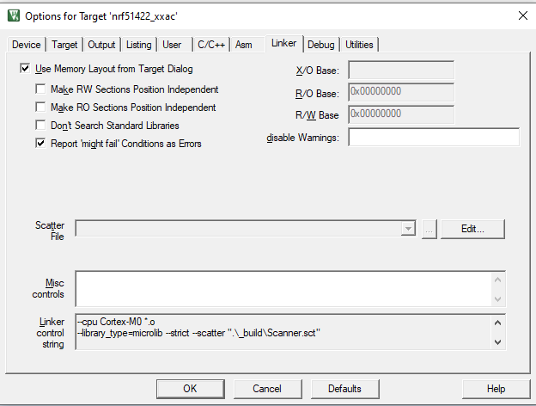

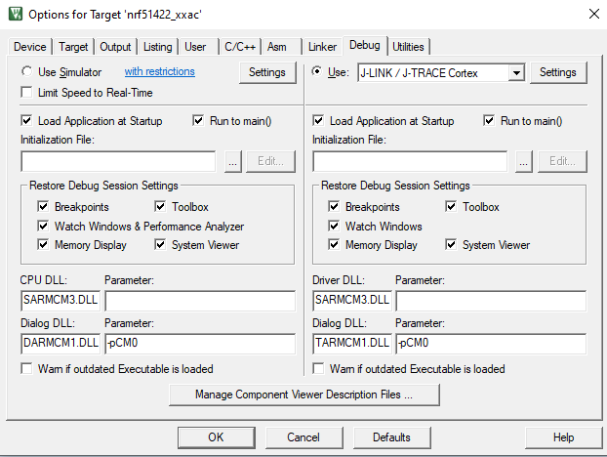

**Scanner.sct :**

|  |
| --- |
| ; *************************************************************  ; *** Scatter-Loading Description File generated by uVision ***  ; *************************************************************  LR_IROM1 0x0001B000 0x00025000 { ; load region size_region  ER_IROM1 0x0001B000 0x00025000 { ; load address = execution address  *.o (RESET, +First)  *(InRoot$$Sections)  .ANY (+RO)  .ANY (+XO)  }  RW_IRAM1 0x20002000 0x00002000 { ; RW data  .ANY (+RW +ZI)  }  } |

