

**College of Engineering**

**Electronics Engineering Department**

**ECE 511L: Transmission Media and Antenna Systems Laboratory**

**Design of Helical Antenna using 4nec2 Antenna Simulation Software**

**SUBMITTED BY:**

**Absalon, John Michael V.**

**Dimabayao, Bryan C.**

**Sabroso, Cez Dominic D.**

**Layug, Peeven G.**

**Date: May 31, 2021**

**SUBMITTED TO:**

**Engr. Henry M. Romero**

**TABLE OF CONTENTS**

**TABLE OF CONTENTS** 1

**LIST OF FIGURE** 2

**ABSTRACT** 3

**TRANSMITTAL LETTER** 3

**ACKNOWLEDGEMENT** 4

**CHAPTER 1** 5

**INTRODUCTION** 5

**OBJECTIVES** 7

**General Objective** 7

**Specific Objectives** 8

**SCOPE OF LIMITATION** 8

**CHAPTER 2** 9

**REVIEW OF RELATED LITERATURE** 9

**History of Antenna** 9

**Short History of Helical Antenna** 11

**THEORETICAL DISCUSSION** 12

**Radio Waves** 12

**Wave Polarization** 13

# **LIST OF FIGURE**

**Figure 2.1. Modern Helical Antenna** 12

**Figure 2.2. A transverse electromagnetic (TEM) wave consists of electric and magnetic fields at right angles to each other and to the direction of wave propagation.** 13

**Figure 2.3. Wave polarization is determined by the direction of the electric field lines of force. (A) Vertically polarized electromagnetic wave. (B) Horizontally polarized wave.** 14

**Figure 2.4. Electric field between conducting plates at various angles in antenna.** 15

**Figure 3.1. Online Calculator for Helical Antenna Design** 18

**Figure 3.2. Helical Antenna Dimensions** 19

**Figure 3.3. Input Parameters of the design to the 4nec2 Editor** 20

**Figure 3.4. 3D Simulated Structure of the Helical Antenna on 4nec2 Software.** 21

**Figure 3.5. 3D Wire Perspective of Radiation Pattern on the Antenna** 22

**Figure 3.6. Radiation Pattern and Gain in Overall Planes** 22

**Figure 3.7. Simulated Radiation Pattern in Three-Dimensional Setting** 23

# **ABSTRACT**

Antenna is a system of elevated conductors, which matches the receiver or transmitter to free space. Antennas are metallic structure designed for radiating and receiving electromagnetic energy. There are many types of antennas used for communication. A helical antenna is an antenna in which a conductor connected to ground plane, is wound into a helical shape. The helix is the simplest antenna which generates circular polarized waves. This paper shows using the design and simulation of helical antenna using 4NEC2 software. Gain, Efficiency, Impedance, Standing Wave Ratio (SWR) and other parameters are analyzed. Thus, a suitable helical antenna is designed and simulated which provides better radiation pattern for effective communication and for use into satellite communication.

An antenna acts as an interface between a guided wave and a free-space wave. The wire antennas are made of thin, conducting, straight or curved wire segments or hollow tubes and are very easy to construct. It is suspended above the ground and the radius of the wire is very small compared to the operating wavelength of the radio waves used. The dipole and monopole are examples of straight wire antennas. The loop antenna is an example of curved wire antenna. The loop antenna is a radiating coil of any convenient cross section of one or more turns carrying radio frequency current. It may assume any shape like rectangular, square, circular, etc. The circular loop antenna is one of the easiest to construct as well as to analyze.

# **TRANSMITTAL LETTER**

Eng’r. Henry M. Romero

Engineering Faculty

Central Colleges of the Philippines

Electronics Engineering Department

Good day Sir.

We, the entire group very pleased to submit this project named “Design of Helical Antenna using 4nec2 Antenna Simulation Software” as partial fulfillment of the subject entitled “Transmission Media and Antenna Systems Laboratory (ECE511L). We applied in this project ever lectures and modules that you have taught us from the beginning, and we mixed it together with some of our own research to be able to make it a successful project.

Respectfully yours,

Absalon, John Michael V.

Dimabayao, Bryan C.

Sabroso, Cez Dominic D.

Layug, Peeven G.

# **ACKNOWLEDGEMENT**

We would like to express our gratitude to Engr. Henry M. Romero for assistance with our supplementary lectures and for comments that greatly improved our project.

We would like to thank our friends for showing their support and sharing their pearls of wisdom with us during those days, we did this project. To our family who been there to support us in financial and give us a moral support. Lastly to our heavenly father who give us the strength and wisdom.

# **CHAPTER 1**

## **INTRODUCTION**

The helical antenna has a long history and has been the object of much study and development over the last half century since its invention in 1946 [Kraus, 1976]. It is an interesting antenna with unique characteristics, being capable of high gain, wide bandwidth, and circular polarization. As a result, it has been used in a wide range of applications including satellite communications, radio astronomy, and wireless networking. This dissertation presents a fundamental advancement of the basic axial mode helix design. This new form of helix antenna, called the Stub Loaded Helix (SLH) antenna, offers the advantage of a significant reduction in helix antenna size with only a relatively small corresponding reduction in performance. The performance reduction in many applications is not relevant and the application requirements are still satisfied. The result is a new antenna design that offers the performance characteristics and advantages of the conventional axial mode helix but in a much more compact physical size envelope.

Helix Antennas usually support wide bandwidths compared to other types of antennas. To the casual observer, they appear as one or more "springs" or helixes mounted against a flat reflecting screen. These antennas emit and respond to electromagnetic fields with circular polarization.

These antennas operate in one of two modes: **normal mode** and **axial mode**. In the **normal mode**, the diameter and pitch of the helix are small in comparison to the wavelength. As a result, the operation is similar to an electrical short monopole or dipole. The radiation would be linearly polarized parallel to the axis of the antenna with maximum radiation taking place at right angles to the helix axis. This mode/configuration has a narrow bandwidth and low efficiency. These are used for compact antennas for portable and mobile two-way radios, and for UHF television broadcasting antennas.

In **axial mode**, the diameter and pitch of the helix is comparable to the wavelength. In this case, it functions as a directional antenna. Unlike the normal mode, simple solutions are not available to determine the radiation properties in the case of axial mode. As a result, for axial mode experimentally determined numerical and analytical techniques are used to determine these factors. This mode/configuration is often used by earth-based stations in satellite communications systems.

Helical antennas are commonly connected together in so-called bays of two, four, or occasionally more elements with a common reflector. The entire assembly can be rotated in the horizontal (azimuth) and vertical (elevation) planes, so the system can be aimed toward a particular satellite. If the satellite is not in a geostationary orbit, the azimuth and elevation rotators can be programmed to follow the course of the satellite across the sky.

# **OBJECTIVES**

## **General Objective**

The main objective of the Transmission Media and Antenna System project is to make a detailed design and consideration with presence of Helical Antenna. The antenna must; receive and reradiate the radio waves from the driven element but in a different phase determined by their exact lengths. Their effect is to modify the driven element's radiation pattern. The waves from the multiple elements superpose and interfere to enhance radiation in a single direction, increasing the antenna's gain in that direction.

## **Specific Objectives**

The specific objective of the project is to make a Helical Antenna Design thru Simulation using 4nec2 software with supporting design parameters of radiation pattern, gain, directivity, beamwidth, front-to-back ratio, major lobe & minor lobes, effective radiated power (ERP), effective isotropic radiated power (EIRP), and impedance.

# **SCOPE OF LIMITATION**

The Transmission Media and Antenna System Project entitled “Design of Helical Antenna using 4nec2 Antenna Simulation Software” is based in current television frequencies in the Philippines from 67.25 MHz to 675.25 MHz the list of current VHF and UHF television stations is located at the Chapter 5 Appendices of this paper. The software used is 4nec2, the software is a completely free Nec2, Nec4 and windows-based tool for creating, viewing, optimizing, and checking 2D and 3D style antenna geometry structures and generate, display, and compare near/far-field radiation patterns for both the starting and experienced antenna modeler.

# **CHAPTER 2**

## **REVIEW OF RELATED LITERATURE**

### **History of Antenna**

According to Carr J. and Hippisley G. (2012), “Useful communication by radio has been with us for the entire twentieth century and shows no sign of abating in the twenty-first. Originally determined to be mathematically “possible” by the Scottish inventor James Clerk Maxwell in the mid-1860s, radio waves remained science fiction until 1887, when a German, Heinrich Hertz, was first to convert Maxwell’s theoretical equations into laboratory experiments that demonstrated and confirmed their existence. Italian Guglielmo Marconi then picked up the ball and through the 1890s took the first productive steps toward making radio communication a popular and commercial success. Along the way, Nikolai Tesla from Serbia, Alexander Fessenden in Canada, Alexander Popov in Russia, and Lee De-Forest in the USA were also early pioneers in advancing the state of the art. Thus, the story of radio’s inception is as international as the wireless long-distance communications it ultimately engendered.

By the turn of the century “wireless telegraphy” as radio was called then was sparking (pun intended) the imaginations of countless people across the world. Radiocommunications began in earnest, however, when Guglielmo Marconi successfully demonstrated wireless telegraphy as a commercially viable technology. The “wireless” aspect so radically changed communications that the word is still used in many countries of the world to denote all radio communications even though today in the United States the term wireless has come to be associated almost entirely with WiFi—the shortrange, very short wavelength method of interconnecting computers and other digital devices. Until Marconi’s successful transatlantic reception of signals near the end of 1901, and despite his earlier success at spanning the English Channel, wireless was widely seen as a neighborhood or cross-town endeavor of limited usefulness. Of course, although ships close to shore or each other could summon aid in times of emergency, the ability to communicate over truly long distances was absent. But all that changed on that fateful December day in Newfoundland when the Morse letter “S” tickled Marconi’s ears.

Wireless telegraphy was immediately pressed into service by shipping companies because it provided an element of safety that had been missing in the pre-wireless days. In fact, some early shipping companies advertised that their ships were safer because of the new wireless installations aboard. It was not until 1909, however, that wireless telegraphy actually proved its usefulness on the high seas. Two ships collided in then foggy Atlantic Ocean and were sinking. All passengers and crew members of both ships were in imminent danger of death in the icy waters, but radio operator Jack Binns became the first man in history to send out a maritime distress call. His call for help in Morse code was received and relayed by nearby ships, allowing another vessel to come to the aid of the stricken pair of ships. All radio communication prior to about 1916 was carried on via telegraphy but one night in 1916 there was more magic.

Radio operators and monitors up and down the Atlantic seaboard from the Midwest to the coast and out to sea for hundreds of miles heard something that must have startled them out of their wits: crackling out of the “ether,” amid the whining of Alexanderson alternators and the zzzchht of spark-gap transmitters, came a new sound—a human voice. Engineers and scientists at the Naval Research Laboratory in Arlington, Virginia, had transmitted the first practical amplitude.

### **Short History of Helical Antenna**

The helical antenna was invented by Kraus in 1946 whose work provided semi-empirical design formulas for input impedance, bandwidth, main beam shape, gain and axial ratio based on a large number of measurements and the antenna array theory. In addition, the approximate graphical solution in (Maclean & Kouyoumjian, 1959) offers a rough but also a fast estimation of helical antenna bandwidth in axial radiation mode. The conclusions in (Djordjevic et al., 2006) established optimum parameters for helical antenna design and revealed the influence of the wire radius on antenna radiation properties. The optimization of a helical antenna design was accomplished by a great number of computations of various antenna parameters providing straightforward rules for a simple helical antenna design.

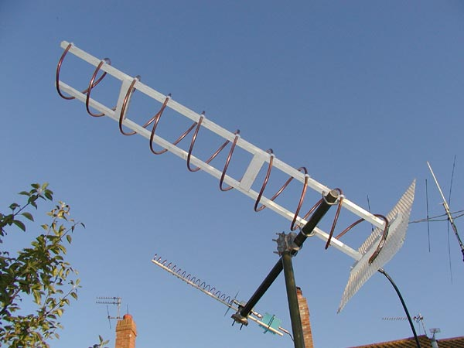

#### **Figure 2.1. Modern Helical Antenna**

## **THEORETICAL DISCUSSION**

### **Radio Waves**

The radio signals travel in a wavelike manner, but that fact was not always so clear. It was well known in the first half of the nineteenth century that wires carrying electrical currents produced an induction field surrounding the wire that was capable of exerting a force over short distances. It was also known that this induction field is a magnetic field, and this knowledge formed the basis for the invention of electrical motors. But it was not until 1887 that German physicist Heinrich Hertz succeeded in demonstrating the ability to transmit and receive radio signals between two separate sets of equipment in his laboratory. In so doing, he confirmed experimentally Maxwell’s theoretical work of a quarter century earlier predicting the existence of previously unimagined radio signals that, like light, were electromagnetic waves.

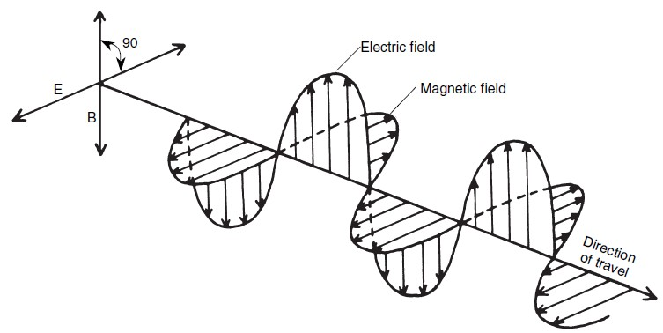

#### **Figure 2.2. A transverse electromagnetic (TEM) wave consists of electric and magnetic fields at right angles to each other and to the direction of wave propagation.**

### **Wave Polarization**

Wave polarization dealing with both antenna theory and radio-wave propagation, a totally fictitious device called an isotropic source or isotropic radiator is sometimes used for the sake of comparison, and for simpler arithmetic. You will see the isotropic model mentioned several places in this book. An isotropic source is a very tiny spherical source that radiates energy equally well in all directions. The radiation pattern is thus a perfect sphere with the isotropic antenna at the center. Because such a spherical source generates uniform output in all directions, and its geometry is easily determined mathematically, the signal intensities at all points can be calculated from basic geometric principles.

The polarization of an EM wave is, by definition, the direction or orientation of the electric field with respect to some agreed-upon reference. In most cases, the reference is the earth’s surface, although that may well be meaningless for antennas in outer space.

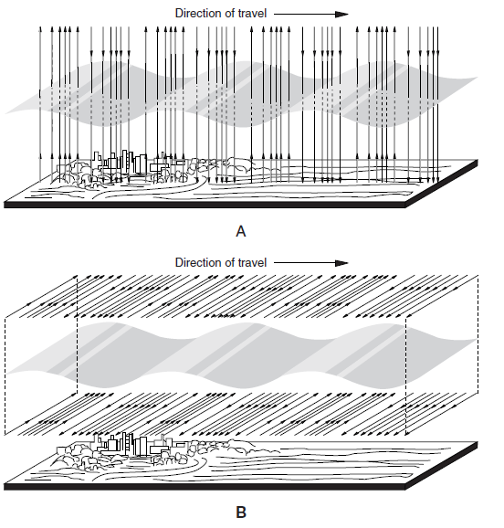

#### **Figure 2.3. Wave polarization is determined by the direction of the electric field lines of force. (A) Vertically polarized electromagnetic wave. (B) Horizontally polarized wave.**

### **Antenna Basics**

An antenna is an example of a transducer, a device that converts one form of energy to another. Other examples include audio loudspeakers electronic signals sound waves, thermocouples as temperature changes electrical signals, and woodstoves as stored chemical energy heat. An antenna converts time-varying electrical currents that are confined and guided within a circuit or transmission line to a radiated electromagnetic wave varying at the same rate and propagating outward through space completely independent of the circuit that produced it.

It is not unreasonable to visualize this process as “freeing” the electromagnetic waves created by the time-varying currents and “launching” them into space much like a slingshot launches a projectile. As we shall see in future chapters, the efficiency with which an antenna performs this conversion is one of the key measures of its “goodness”, and devices that accomplish this conversion efficiently share special physical and geometrical attributes.

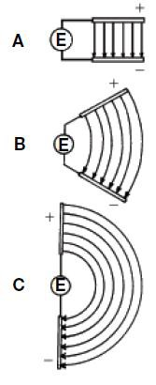

#### **Figure 2.4. Electric field between conducting plates at various angles in antenna.**

# **CHAPTER 3**

## **Project Antenna Design, Analysis and Recommendation**

The project proper of Helical Antenna is composed of radiation pattern, gain, directivity, beamwidth, front-to-back-ratio, major lobe, minor lobes, effective radiated power (ERP), effective isotropic radiated power (EIRP), and impedance matching. These design parameters or antenna characteristics are determined using 4nec2 antenna simulation software. The frequency used for the antenna is from 67.25 MHz to 675.25 MHz of VHF/UHF television analog frequencies.

## **Design Methodology**

The design of helical antenna was based upon the antenna parameters. In order to find any of the parameters, the following set of formulas was considered.

Diameter of the helix = D

Spacing between turns = S

Circumference of helix = C

Total length of antenna L = NS

These are the set of equation used for calculation the parameters needed for the design. It is a quite an interesting construction with just as interesting characteristics. It is a spiral wire with turns a wavelength long at the operating frequency and at least 3 turns. More turns increase the gain and make the beamwidth angle smaller. The typical upward gradient is about ¼ the wavelength and the reflector are arranged at the beginning of the spiral with a diameter of a wavelength.

## **Results**

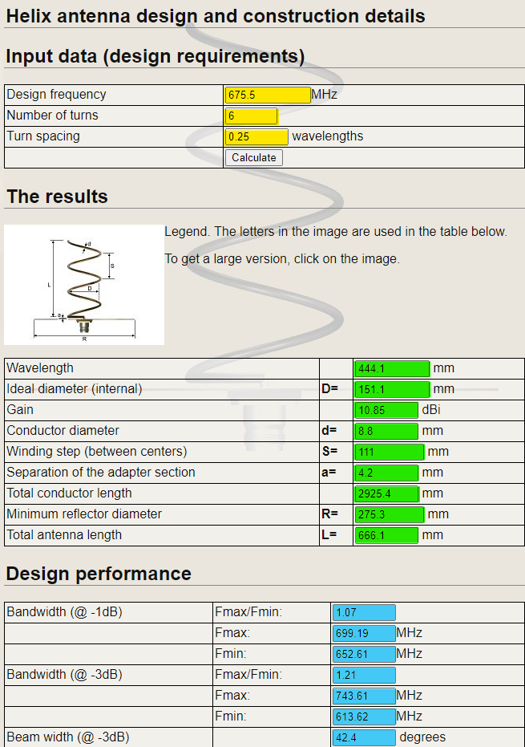

#### **Figure 3.1. Online Calculator for Helical Antenna Design**

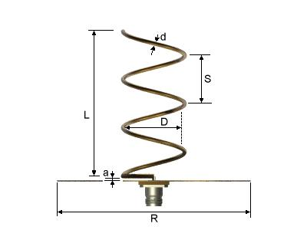

#### **Figure 3.2. Helical Antenna Dimensions**

### **Result Parameters**

* Wavelength = 441.1mm for a Centre frequency of 675.7MHz
* Internal diameter = 151.1mm
* Gain = 10.85 dBi
* Wire size = 8.8mm
* Entire antenna length = 666.1 mm
* Upward gradient (Spacing) = (Entire Antenna Length)666.1 / 6 (Number of Turns) = 111.01 mm
* Minimum reflector diameter = 275.3 mm
* Middle Diameter = 151.1 mm + 8.8 mm = 159.9 mm

**Note:** Dimension Must be in Meter for the compatibility on 4nec2 software.

For this project, the students utilized the use of online Helix Antenna calculator as shown in Figure 3.2 for the specific dimension needed for the design and then will be encoded to the 4nec2 Antenna Simulation Software. The simulation will be run with 100W power supply and an impedance of 150 Ohms.

## **Antenna Simulation with 4nec2**

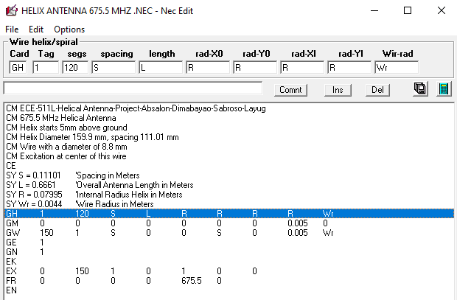

#### **Figure 3.3. Input Parameters of the design to the 4nec2 Editor**

The figure shown above is the set of parameters and dimension values encoded to 4nec2 software.

* **CM** are comment cards.
* **CE** means END comment.
* **SY** are cards that has an assigned value on a specific variable.
* **GH (Geometry of Helix)** specifies the form of the Helix.
* **GM (Geometry Move)** changes the position of the whole antenna. For this particular project, the antenna is pushed upward by 5mm.
* **GW (Geometry of Wire)** in this particular section inputs the specification of wire used in the simulation.
* **GE (Geometry End)** this state the end of the parameters for the antenna and set the ground.
* **GN** sets the type of ground that the antenna will be connected.
* **EK (Extended Kernel)** Extended Thin wire kernel because the use of thick wire.
* **EX** Excitation of the wire. A voltage of 1V in the middle of the wire is applied.
* **FR** is where the frequency is set for the simulation which in this project it is set to 675.7 MHz.
* **EN** End of NEC file.

## **Antenna Simulation Output 4nec2**

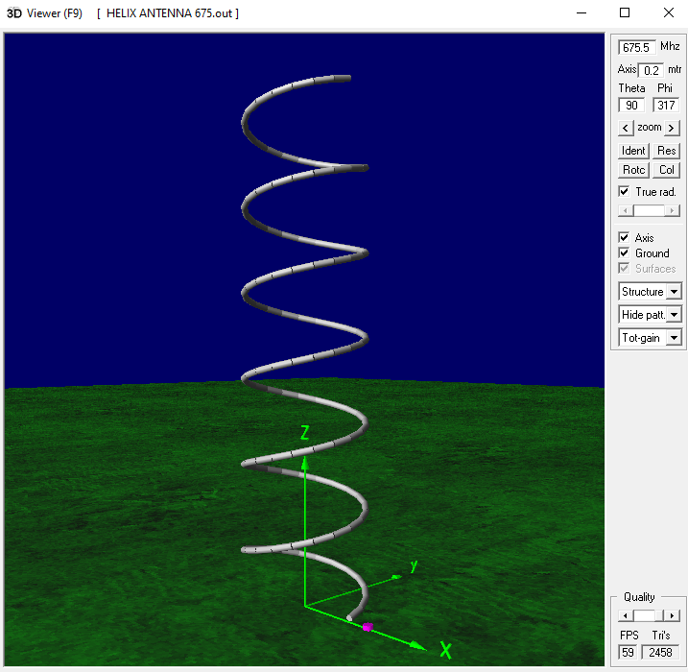

#### **Figure 3.4. 3D Simulated Structure of the Helical Antenna on 4nec2 Software.**

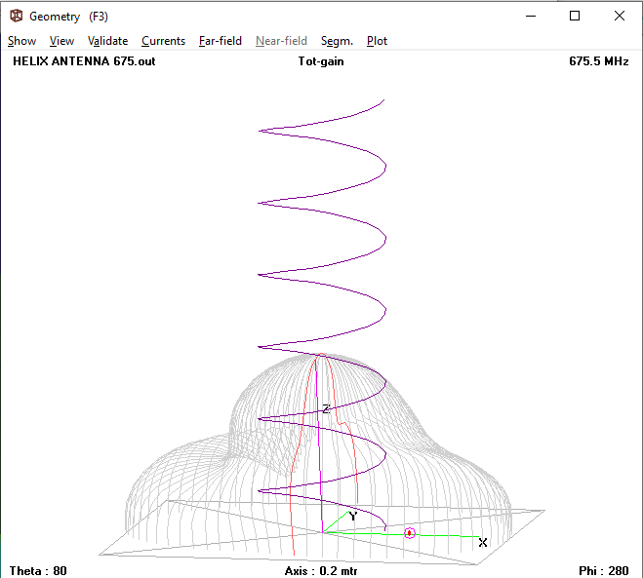

#### **Figure 3.5. 3D Wire Perspective of Radiation Pattern on the Antenna**

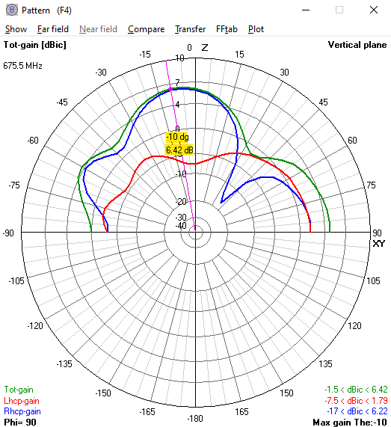

#### **Figure 3.6. Radiation Pattern and Gain in Overall Planes**

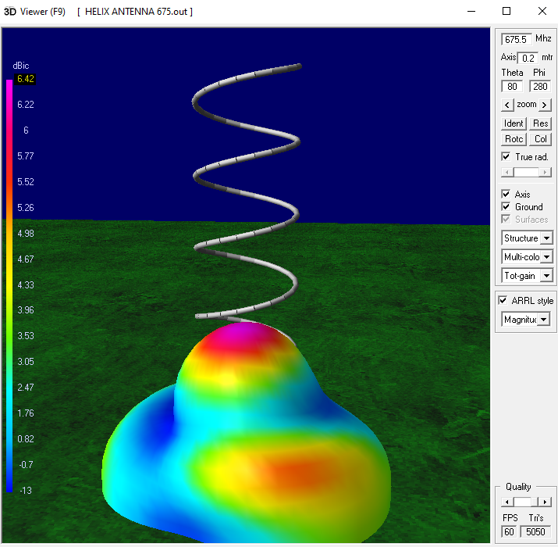

#### **Figure 3.7. Simulated Radiation Pattern in Three-Dimensional Setting**

## **Analysis of Gain Directivity and Radiation Pattern**

Based on the 3D Radiation pattern results from 4nec2 software antenna simulation shown in Figure 3.7. the data shows that the antenna has a gain of 6.42 dBic, dBic is decibel above the gain of an isotrope antenna as a reference where the isotrope antenna has the same circular polarization as the antenna which the gain is expressed and a radiation pattern shape similar to a blob of mass. It can be also observed on what location is the signal is concentrated. The gain of most non uniform helical antenna can be about 2.5 dB higher than the gain of uniform helical antenna of the same axial length. This only proves that the antenna simulated by the students is on the effective side of spectrum.

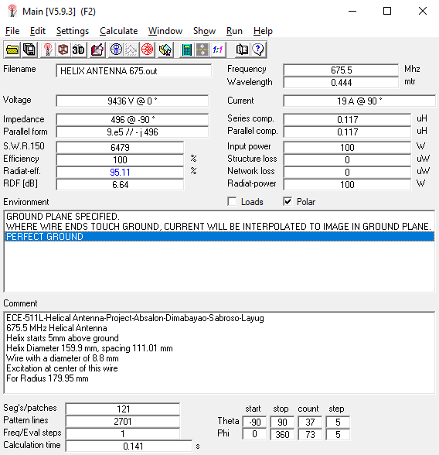

The various parameters of the helical antenna are calculated using wavelength, frequency, no. of. Turns and spacing between the turns. The input power given to the helical antenna is 100W and the output power or radiated power is also 100W. Therefore, the efficiency is 100% without any loss. Also, the radiation efficiency (power loss) is minimum (i.e.) 17.24%. Thus, the calculated parameters match with the simulation results and the newly designed helical antenna is best approximated. It provides good radiation pattern and efficiency for efficient communication.

## **Analysis of Beamwidth**

Front-to-back ratio.

Efficiency

# **CHAPTER 4**

## **CONCLUSION AND RECOMMENDATION**

Conclusion

The helical antenna simulated using 4NEC2 is successful. It has achieved a 100% efficiency for efficient and flawless communication at a frequency of 675.5 MHz without any loss on an ideal simulation. The main goal of this project is to design a suitable helical antenna and analyze the directive gain, beamwidth, front-to-back ratio, and efficiency. The Simulated antenna can be fabricated and used in communication.

# **CHAPTER 5**

## **APPENDICES**

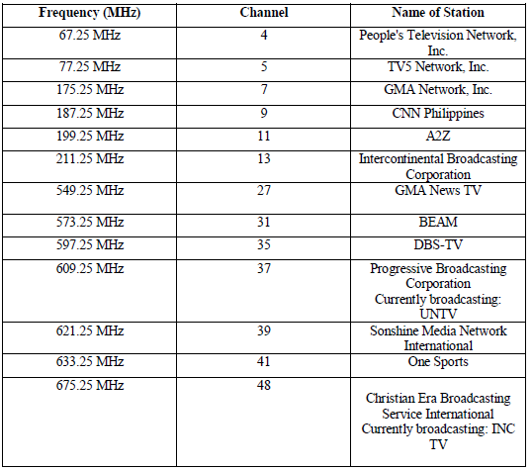

#### **Figure 5.1. List of Current VHF and UHF TV Stations**



#### **Figure 5.2. SWR and Efficiency Chart**



#### **Figure 5.3 Standard VSMR Monograph**

What I have learned?

## **Reference**

Frenzel L. (1995). Communication Electronics. McGraw Hill School International Publishing.

Tomasi W. (2004). Electronic Communications Systems: Fundamentals through Advance (5th ed.). Pearson Education

Carr J. & Hippisley G. (2012). Practical Antenna Handbook. McGraw Hill School International

Publishing.

**RESUMVE/CV**