Grassland Wildfire Modeling and Forest Management in Simplified Ecosystem

Brian Yi, Richard Chen, Doris Chen, Linlin Yang

**Introduction**

Grassland wildfires define the vegetative identity of grasslands and the complex food webs that grasslands give rise to. These regularly occurring wildfires suppress populations of wooded vegetation that if unperturbed would convert a grassland into forest. While the direct cause of wildfire at any given time can be attributed to either humans or lightning strikes, the probability of a wildfire occurring at any given time is random; however, there is a non-random, predictable increase in the underbrush, or the dead and dried vegetation of a grassland, that will drive the increase in the probability of a wildfire occurring given a random chance of a direct cause. Because the grassland vegetation and their ecological webs represent a developmentally arrested landscape between that of a woodland and a desert due to wildfires, it is likely that the grassland biome and its ecosystems are generally sensitive to the frequency of wildfires and the factors that affect the probability of a wildfire occurring. While the contributions of humans to the frequency of wildfires is multifaceted, in the forms of climate change induced desertification, farming practices, etc., our model focuses on the management of underbrush.

At the most direct level, federal wildlife management regularly maintains underbrush levels using controlled burns, thereby controlling the probability of a wildfire occurring. In this model, we probe the behavior of a basic food chain in context of a grassland by modulating the rate at which the probability of a fire increases and the max probability of a fire occurring. We will assume the rate and degree to which underbrush predictably builds up to be the major factor that directly affects the probability of a wildfire in the grassland biome. By modulating the rate and degree to which underbrush builds up and increases the probability of a wildfire, we can abstract different fire probability regimes and track how these different fire probability regimes affect a basic forest ecosystem. Since the predators are key species in an ecosystem, the population size of apex predator is what we basically focused on. The primary focus is to investigate how undergrowth management will prevent the extinction of the apex predator species with the introduction of wildfires in a stochastic fashion into our mathematical model. The secondary focus will address the contrary question of what happens to the ecosystem should the apex predator species go to extinction from wildfires. Ultimately, the outcome of this model has broad impact on our understanding of the relationship between wildfires and grassland identity and could inform federal wildlife management policy and implementation for sustaining grassland biomes.

**The Model and Methods**

We used a discrete model to simulate the populations of grass, rabbits, and eagles. We chose these three species because they represent a basic food chain in forest ecosystem, including producer, primary consumer, and secondary consumer respectively. The following equation is for eagle population:

. (1)

is the eagle population and represents the intrinsic growth rate of the eagle population. The () represents the death rate of the Eagles where is the intrinsic death rate of eagles and is the death rate caused by wildfire for the eagle population. In this simple food chain, rabbits consumed grass while the eagles consumed rabbits, so we implemented the use of the Lotka-Volterra equations to show the interactions among these species. In Equation (1), represents the Lotka-Volterra interaction between the eagles and the rabbits. (1) also employs the Allee Effect to help capture our secondary focus, which is what happens to the ecosystem should the apex predator species die out. The Allee Effect introduces a critical population size in that will drive the eagle population to extinction should its population fall below it. The Allee Effect was added to our eagle population specifically for this purpose and will be elaborated on in the results and discussion.

Similarly, we used the following equations for grass and rabbit populations:

; (2)

. (3)

In Equation (2), represents increase of reproduction rate of grass due to fire, and is the function of occurance of fire. We made a few assumptions to apply the Lotka-Volterra model. We assumed the populations will grow logistically to their carrying capacities without predators. There are no migrations for all three species. The predators cannot adapt and find new sources of food other than their specific prey should their prey go extinct. Predators and prey also move randomly in their niches. We combined encounter rate, conversion rate, handling time between species to a single parameter, the effect species A has on species B in the Lotka-Volterra equations. In addition, we assumed that all the events, such as natural birth, natural death, and death caused by fire, can all happen within each time step. In other words, we did not used a life cycle for the populations in our model.

We also made a few assumptions to apply the Allee Effect into our model. Since eagles migrate individually and travel to their breeding spots alone, we assumed the eagle population would be sparsely populated. We assumed that eagles will need others for more than reproduction such that population will have a strong Allee Effect. Given that there is a strong Allee Effect, we assumed that being below the critical population size will cause the growth rate of (1) to be negative.

Then, we applied a stochastic occurrence of wildfires to our model. We assumed that wildfires can directly reduce the population sizes of grass, rabbits, and eagles. Also, we assumed that moderate wildfires can increase the growth rate of grass through fertilization of the soil and does not have direct effects on the growth rates of rabbits and eagles. The growth rate of grass increases right after a wildfire, and gradually reduces back to its original growth rate after a period. This is explained by the term where , the growth rate of the grass increases by adding the additional growth caused by the term (reproduction due to wildfire). The growth lessens over time because is multiplied by , the function for a wildfire which we coded to decrease over four time-steps. In addition, the probability that a wildfire occurs is dependent on the amount of fuel in the soil. The density of underbrush is directly proportional to the chance of a wildfire. We plotted time vs. probability of wildfire using linear and nonlinear models. The nonlinear models are focused specifically on square root and second order polynomials. After certain number of years, the probability of wildfire goes back to its baseline due to human’s clearing of underbrush. Here we set up the baseline to zero. We changed the number of years between two clearings and we changed how fast the underbrush builds up by changing the slope. For example, in Figure 1 below, the underbrush is clearing to its baseline every 30 years, and the probability of fire is capped at 0.25. Therefore, the lines cap out at 0.25 below, the max probability. With the probability of wildfire, we used stochasticity to model the occurrence of wildfires. We generated a random number between the interval 0 and 1 using the RandomReal function in Mathematica. If this number is smaller than the probability of wildfire, a wildfire will occur, vice versa. Once a wildfire occurs, the growth rate of grass increases to its maximum.

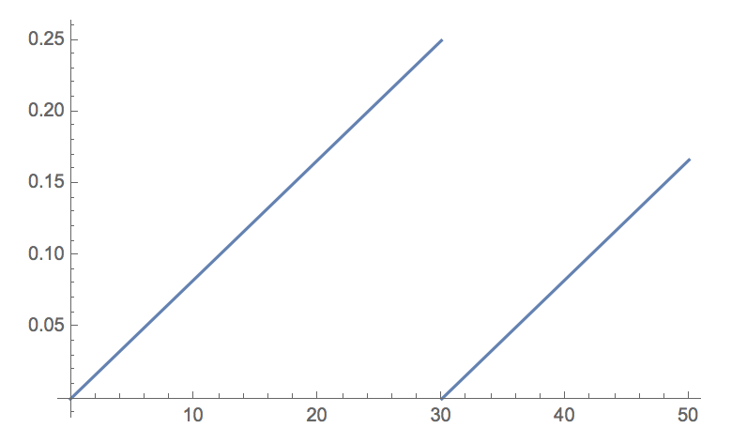

**Figure 1.** Time vs. Probability of Wildfire (Linear Model)

Because we focused on the relationship between underbrush and wildfire in our model, we ignored other factors that also influence the formation of wildfires, such as oxygen and heat sources. When it came to the severity of the fire, we also used the RandomReal function over an interval between 0 and 1 to map its effect on the populations. We have three separately generated random numbers assigned to the terms and. These terms are then subtracted from the three population equations to represent the impact of the wildfires. Essentially, the severity of the wildfires is random as well. In order to find how frequently the underbrush needs to be cleared to avoid extinctions, we applied the Allee Effect. When the population is under a certain critical point, the population will have a negative growth rate, leading to extinction.

**Results**

|  |  |
| --- | --- |
| Parameters | Initial Values |
|  | 4356000 |
|  | 4000 |
|  | 200 |
|  | 0.4 |
|  | 0.3 |
|  | 0.3 |
|  | 0.1 |
|  | 0.25 |
|  | 0.1 |
|  | 0.09 |
|  | 20 |
|  | 0 |
|  | 0 |
|  | 0 |
|  | 0 |
|  | 500 |
|  | 0.00133 |
|  | 25 |
|  | 0.02 |

**Figure 2.** Initial Parameters for All Simulations

|  |  |  |  |
| --- | --- | --- | --- |
| T = 30 (Underbrush Clear Time) | | | |
| Wildfire Max Prob. | 0.50 | 0.25 | 0.125 |
| Eagle Final Pop. | 0 | 0 | 21 |
| Grass Final Pop. | 885 | 1309 | 3496 |
| Rabbit Final Pop. | 1926 | 2334 | 2314 |
| Number of Wildfires | 125/6 | 217/15 | 136/15 |

**Figure 3.** Population dynamics for a constant time step T = 30 and variable underbrush accumulation rates (Linear Model). 

Figure 3 shows the population dynamics at underbrush clear time of 30 time-steps over varying max wildfire probabilities. Our primary focus is to focus on the top row of graphs, which represent the apex predator population over 200 time-steps. For all three max wildfire probabilities, the eagle population is approaching zero. The trend to notice here is that as one decreases the max wildfire probability, it takes longer for the eagle population to reach zero. This makes sense since a smaller probability for a wildfire will result in less wildfires, allowing the populations to survive for a longer period. Looking at all three graphs, a linear wildfire model with an underbrush clear time of 30 does not result in an apex predator equilibrium.

|  |  |  |  |
| --- | --- | --- | --- |
| T = 15 (Underbrush clear time) | | | |
| Wildfire Max Prob. | 0.50 | 0.25 | 0.125 |
| Eagle Final Pop. | 0 | 7 | 86 |
| Grass Final Pop. | 1121 | 1928 | 8487 |
| Rabbit Final Pop. | 2134 | 2274 | 1328 |
| Number of Wildfires | 559/30 | 331/30 | 74/15 |

**Figure 4.** Population dynamics for a constant time step T = 15 and variable underbrush accumulation rates (Linear Model).

Figure 4 shows the population dynamics at underbrush clear time of 15 time-steps over varying max wildfire probabilities. Once again, the primary focus is the top row of eagle populations. There is not much change in the trend between these three graphs and the three graphs from Figure 3. The only thing to note is that the final populations at 200 time-steps is larger than before, indicating that increasing underbrush clear time also increases population survivability. This makes sense biologically since clearing underbrush faster will prevent forest fires from occurring as often, which allows the population to survive longer. Looking at all three graphs, a linear wildfire model at an underbrush clear time of 15 still does not result in an apex predator equilibrium.

|  |  |  |  |
| --- | --- | --- | --- |
| T = 5 (Underbrush clear time) | | | |
| Wildfire Max Prob. | 0.50 | 0.25 | 0.125 |
| Eagle Final Pop. | 62 | 110 | 137 |
| Grass Final Pop. | 6660 | 10452 | 12142 |
| Rabbit Final Pop. | 1564 | 1148 | 798 |
| Number of Wildfires | 98/15 | 119/30 | 47/30 |

**Figure 5.** Population dynamics for a constant time step T = 5 and variable underbrush accumulation rates (Linear Model).

Figure 5 shows the population dynamics at underbrush clear time of 5 time-steps over varying max wildfire probabilities. Once again, the primary focus is the top row of eagle populations. We finally noticed some changes in eagle population sustainability when underbrush clear time is decreased to 5. At a max probability of 0.125, the eagle population seems to be approaching a potential equilibrium of 137 within 200 time-steps. The takeaway is that for linear models, only at an underbrush clear time of 5, can a sustainable eagle population be found within 200 time-steps.

|  |  |  |  |
| --- | --- | --- | --- |
|  | | | |
| Underbrush clear time | 15 | 10 | 5 |
| Number of Wildfires | 154/15 | 55/6 | 29/5 |
| Eagle Final Pop. | 20 | 31 | 80 |

**Figure 6.** Eagle population dynamics for variable underbrush accumulation rates (Square Root Model).

Figure 6 shows the nonlinear square root model of fire regimes at varying underbrush clear times. Within a time period of 200, all three eagle populations are on route to extinction. A nonlinear square root wildfire model seems inadequate in keeping the eagle population alive.

**Figure 7.** Time vs Probability of Wildfire (Square Root Model)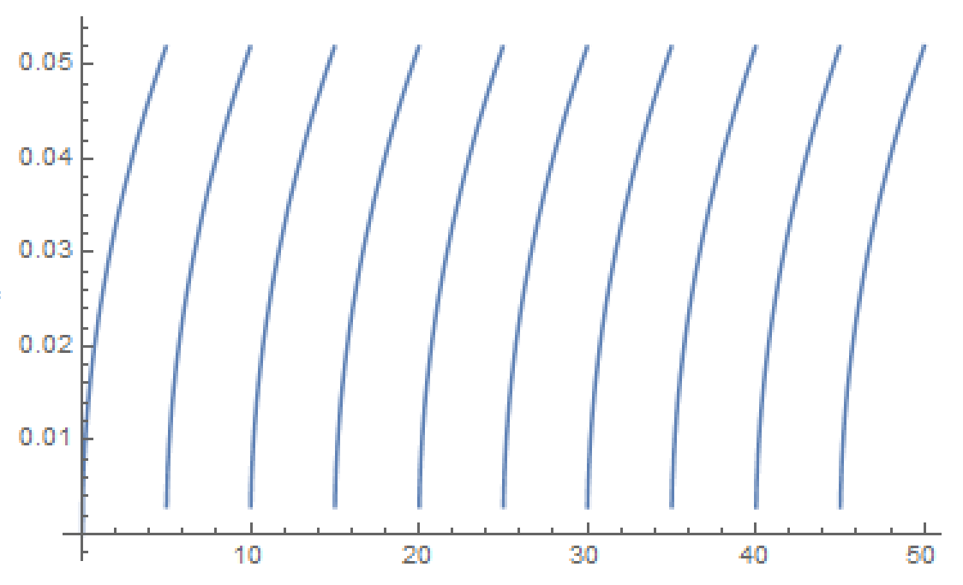

The lines are curved since it represents a square root model of the correlation between max probability and underbrush clear time. In this case, it does not have a linear relationship as compared to Figure 1. In all square root time vs probability graphs, the probability of a wildfire slows down as it increases towards the max. This mathematically checks out as a square root function.

|  |  |  |  |
| --- | --- | --- | --- |
|  | | | |
| Underbrush clear time | 15 | 10 | 5 |
| Number of Wildfires | 43/30 | 17/30 | 7/30 |
| Eagle Final Pop. | 136 | 139 | 141 |

**Figure 8.** Eagle population dynamics for variable underbrush accumulation rates (Polynomial Model).

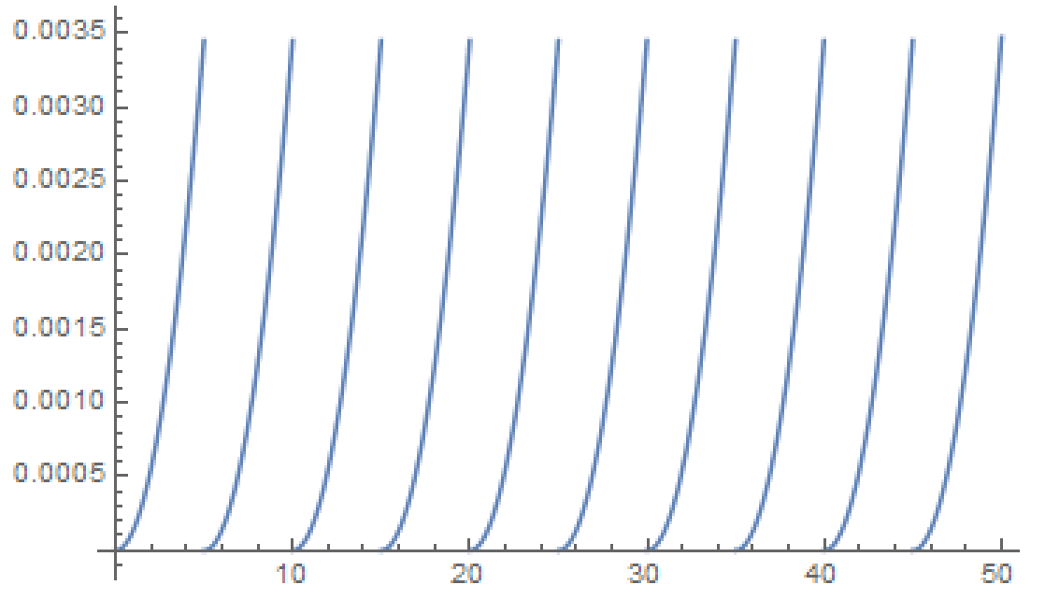 Figure 8 shows the second order polynomial fire regimes at varying underbrush clear times of 30, 15, and 5. For all underbrush clear times, the eagle population seems to begin oscillating towards an equilibrium within 200 time-steps. So far, the second order polynomial model seems best for representing wildfires in this ecosystem when it comes to fulfilling our primary goal of keeping the apex predators, the eagle population, alive.

**Figure 9.** Time vs Probability of Wildfire (Polynomial Model)

The lines are curved in Figure 9 as well since it represents a second order polynomial model of the correlation between max probability and underbrush clear time. In all polynomial time vs probability graphs, the probability of a wildfire increases as it increases towards the max which makes sense as a second order polynomial.

As a brief recap, Figures 3-9 show how the how sustainable the apex predator populations are by varying underbrush clear time along with max probability of fire. This is also compared between linear and nonlinear models. The next few figures focus on what happens when the simulations are run for a longer time step.

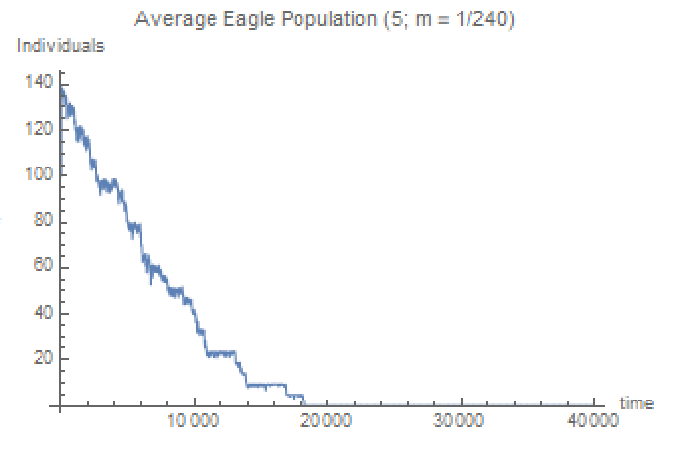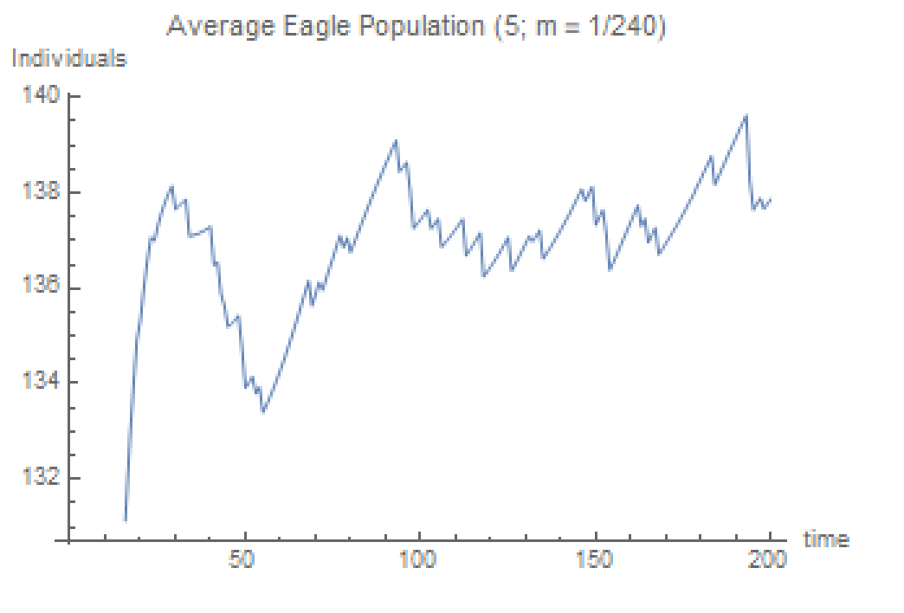While the results above are all done within 200 time-steps, it is important to check the models for a longer period of time. Since our primary focus is to see whether the eagle population avoids extinction, the graphs where the eagle population was sustainable in 200 time-steps are run longer to see if they reach an eventual equilibrium. We ran every graph in a long-term simulation until either the eagle population dies out or reaches an equilibrium. We chose the most sustainable eagle populations for each linear and nonlinear model to show in our results.

**Figure 10.** Eagle population short term (Linear) **Figure 11.** Eagle population long term (Linear)

Both figures are for when T(ub) = 5 (how often underbrush is cleared) and a max probability of wildfire at 12.5%. Figure 10 shows that the eagle population is sustainable and actually increases from its initial population of 100 to approximately 140 within 200 time steps. However, when you run the same model for 20,000 time-steps you notice that the eagle population eventually dies (Figure 11). Although this occurs at 100 times longer than the original period, it is still relevant to note that the eagle population does not reach an equilibrium in the long term when modelling fire regimes in a linear fashion.

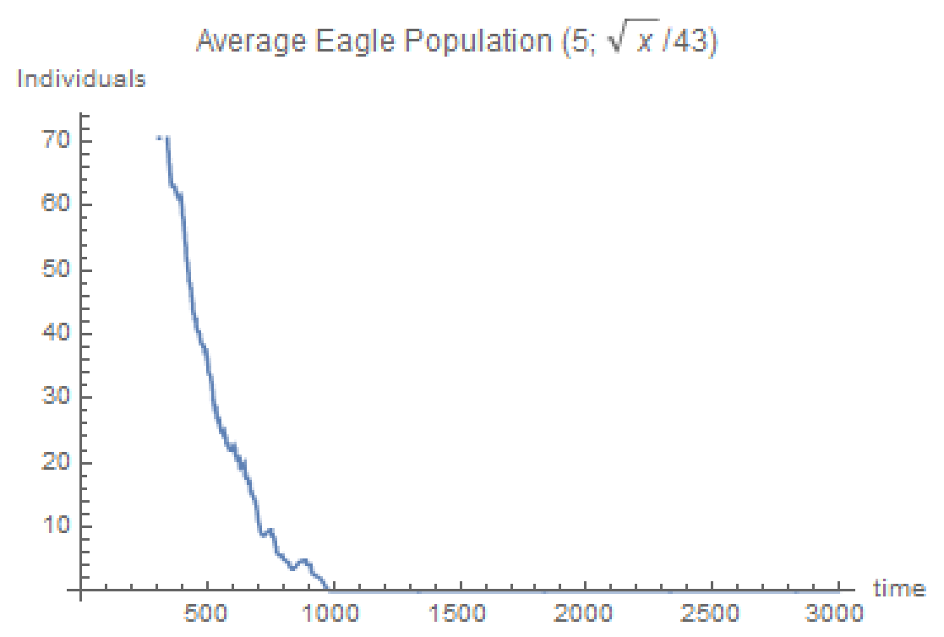We are now continuing to investigate short versus long term differences for fire regimes when modelled in a nonlinear fashion. This is different from Figures 3-9, which investigate everything in the short term (explained in brief recap above). First, we look at the square root function:

**Figure 12.** Eagle population short term (Square Root) **Figure 13.** Eagle population long term (Square Root)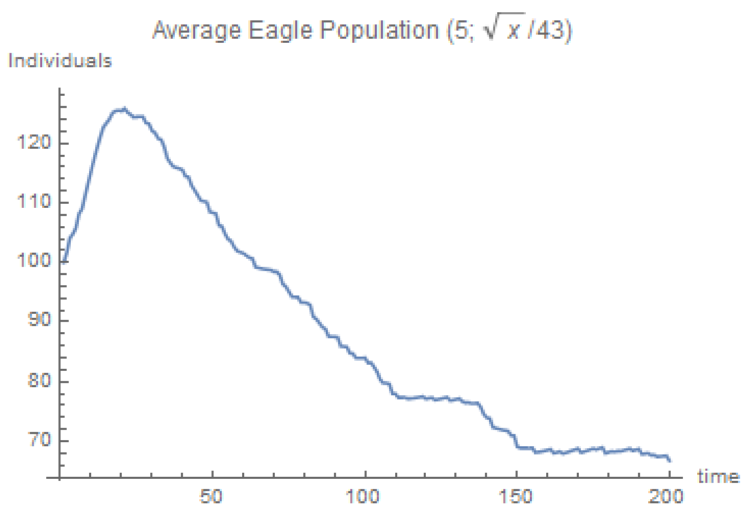

The two figures above are shown at T(ub) = 5 (how often underbrush is cleared). As you can see, Figure 12 already showed that the eagle population decreased to half its size within the 200 time-step. Just to double check that the eagle population did not find an equilibrium afterwards, we extended the time period to T = 3000 to discover that the eagle population does indeed die out as shown by Figure 13.

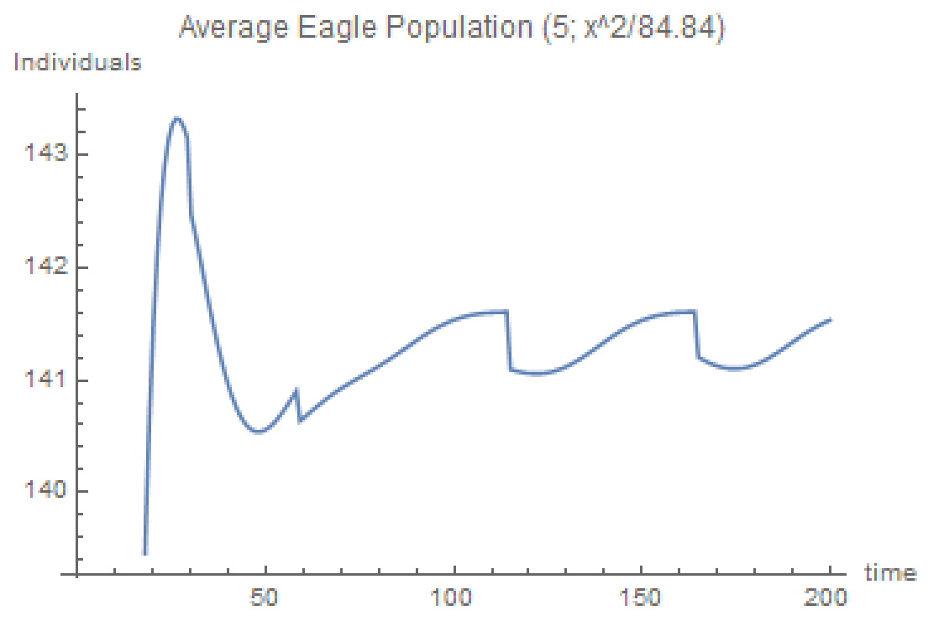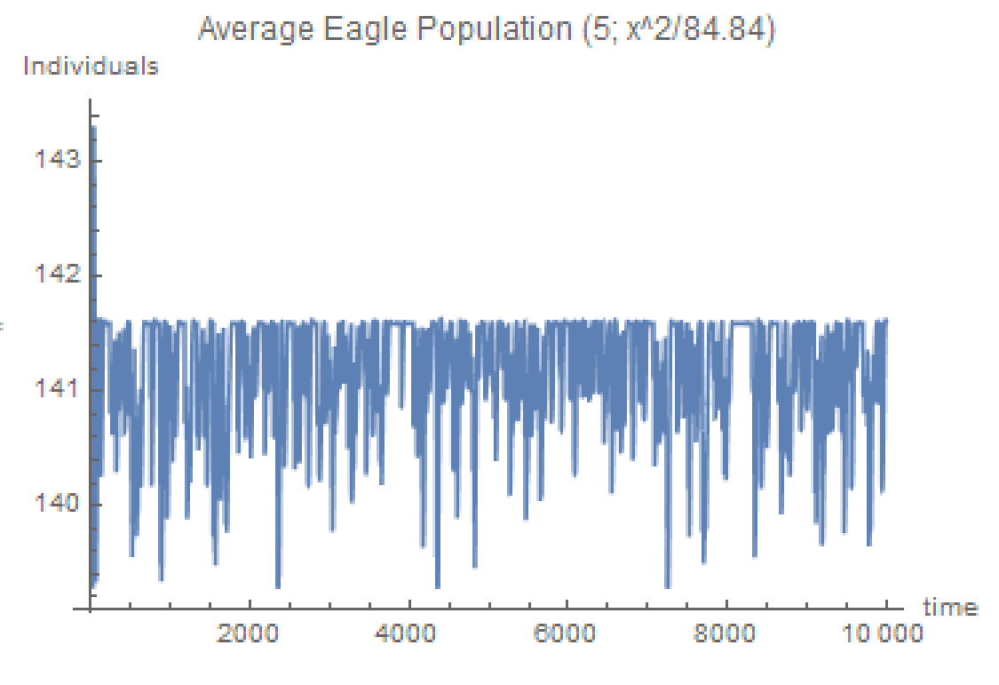Lastly, we will look at the polynomial representation of the fire regime:

**Figure 14.** Eagle population short term (Polynomial) **Figure 15.** Eagle population long term (Polynomial)

The two figures above are shown at T(ub) = 5 (how often underbrush is cleared) with a second order polynomial function. (Do note that Figure 14 is the same graph as the graph in the first row third column of Figure 8. They are slightly different due to the stochasticity of the wildfires.) Figures 14 shows that in the short term the eagle population seems to be already oscillating towards some equilibrium value of approximately 141.5 within 200 time-steps. Figure 15 tells us that this oscillation continues even at 10,000 time-steps, indicating that the eagle population is at an equilibrium. Between the linear, square root, and polynomial representations of wildfire regimes, only in the polynomial representation of a wildfire model did the eagle population survive in the long term. This concludes the results that correlate to our primary focus of whether it is possible to prevent the extinction of the eagle population by adjusting undergrowth clear speeds across various fire regimes.

The following results will discuss data important to our secondary focus of what happens to the ecosystem when the apex predator population goes to extinction. In order to understand the graphs and data, we will first breakdown mathematically the Allee Effect in along with the Lotka-Volterra principle, and explain how our intentions of using the Allee Effect in tangent with wildfires to force the eagles into extinction did not work exactly how we envisioned.

(1)

Revisiting the eagle equation, we see that the change in can be broken down into two parts, , and . The death rate of eagles is represented by , which will always decrease while can increase or decrease depending on whether the population is above the critical point or not. The purpose of Allee Effect in our equation, is to make it so that when the eagle population is under a critical population size, the overall growth rate of the eagle population would be negative or . When the eagle population is below the critical population size, or , is negative which causes to be negative. We now see that the only two values influencing are negative. Thus, , and the eagle population has a negative growth rate when the eagle population is under the critical population size. This worked as intended according to our data. When the population was below the critical population size, the growth rate was always negative.

However, we observed some problems when the eagle population was above the critical population size. Usually when we predicted that the Allee Effect would promote positive eagle population growth (logic is opposite of explained above when ). However, the data showed a negative population growth rate instead. This is because the term responsible for eagle growth in (1), , also had a Lotka-Volterra component: . As decreases, increases, thus decreases such that the overall term, , decreases as well. At a small enough , the growth rate component,, will be small enough such that it will be less than the death rate component, , causing the overall growth rate to become negative whether or not the population is below the critical point or not. The figures below demonstrate this phenomenon:

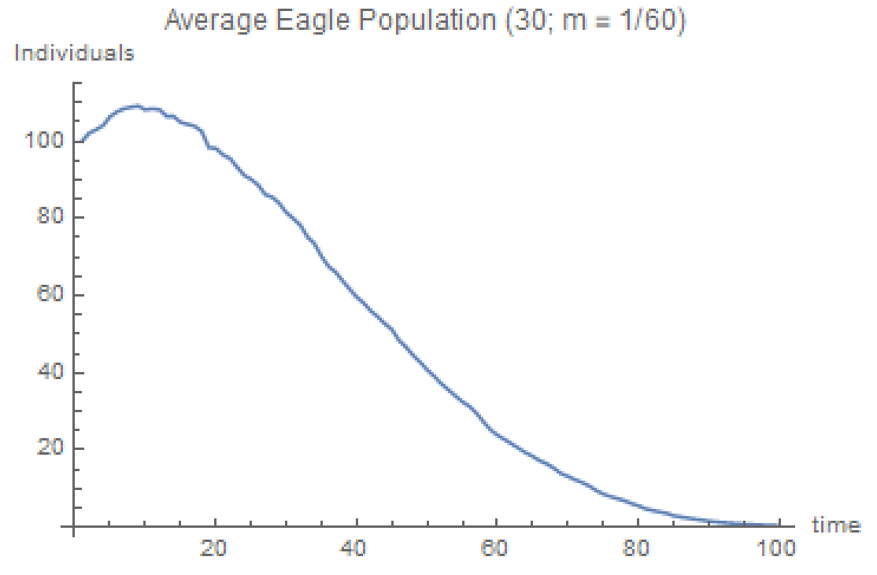 **Figure 16.** Eagle Population (Linear Model) **Figure 17.** Rabbit Population (Linear Model)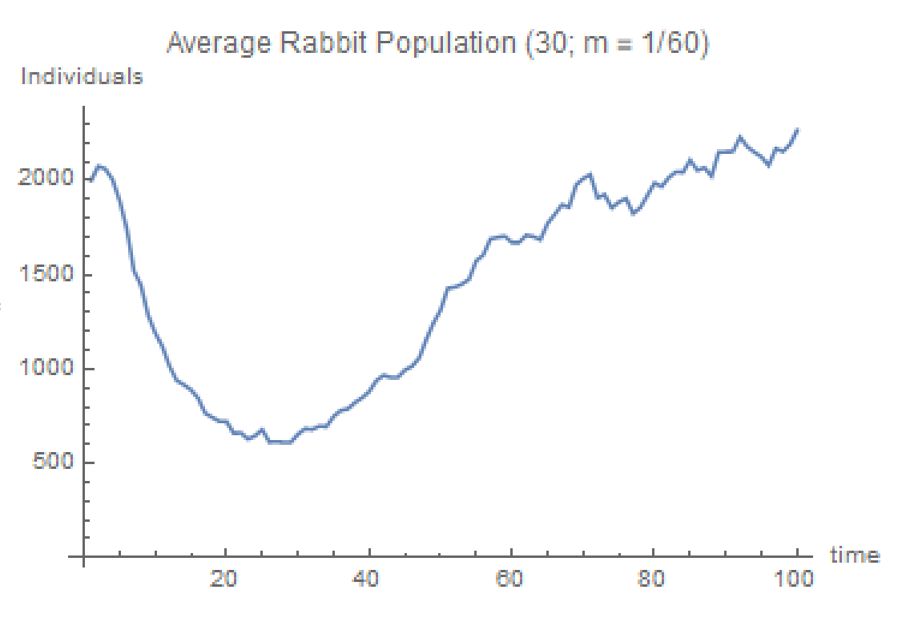

We found that at = 113.905 and = 1201.11, the eagle population started trending downwards permanently. As you can see, when the rabbit population became very small to a value of 1201.11, the eagle population started exhibiting a negative growth rate (These values are picked from an average of 30 stochastic runs where we noticed the eagle population permanently decreasing). This does not follow in line with the Allee Effect since the eagle population at 113.905 is way above the critical population size of 20. We realized that since the Allee Effect is not the only factor here, the Lotka-Volterra element ended up influencing the growth rate much more than the Allee Effect did. Even though ultimately the Allee Effect did not play an instrumental part in forcing our eagle population to extinction, the wildfires alone managed to accomplish it and fulfill our secondary focus.

**Discussion**

Regularly occurring grassland wildfires are important to sustaining the vegetation that defines grasslands and the ecological niches and webs built upon them. As we permanently alter the climate and environment that formed grasslands due to a higher order cause, such as climate change, it is very likely that this will affect the frequency at which grassland wildfires occur. Therefore, the primary goal of our model was to discern the frequency of underbrush clearing necessary to sustain an apex predator population, and ultimately the integrity of a basic food chain, for different underbrush build up rates and regimes. In constructing our model, we assume that there is a regular rate of underbrush accumulation and that it is directly proportional to the probability that a fire will occur from a random event.

Using a linear regime for underbrush build up, we probed our model by varying either time between underbrush clearing events (hereafter referred to as time step) and the linear rate at which the probability of a fire increases with time due to underbrush accumulation. For underbrush build up rates larger than 1/120, we found that there is no reasonably large amount of time step that could sustain our apex predator population. However, it should be noted that the underbrush buildup rates 1/120 and 1/60 correspond to 0.8% and 1.6% increases in the fire probability per unit of time and a max fire probability of 25% and 50% for 30 units of time, respectively; this is likely unrealistic. We then pinpointed an underbrush build up rate of 1/240, which corresponds to a .4% increase in the fire probability per time and a max fire probability of 12.5% for 30 units of time. In comparing the different time step sizes for a buildup rate of 1/240, we were able to increase the final apex predator population size by decreasing the time step size, or in other words, increasing the rate of underbrush clearing events. For our linear regimes, we found that the lowest build up rate of 1/240 paired with the smallest time step of 5 is the only situation in which our model can sustain the apex predator population; despite this, a time step of 5 is logistically, and possibly financially, impossible. In every case, the number of fires increases with larger time step and a larger rate of underbrush accumulation, which is expected.

Following the linear underbrush build up schemes, we were interested in how other underbrush build up regimes may affect the time step size necessary to sustain the apex predator population. We constructed square root and polynomial underbrush build up regimes by normalizing the max fire probability to 12.5% for 30 units of time to match that of our 1/240 linear underbrush build up rate. We then varied time step discern whether there is a reasonably sized time step that can sustain our apex predator population in square root and polynomial underbrush build up regimes. For all time step sizes in our square root regimes, the apex predator population could not be sustained. This makes sense given that the max probability will be reached more quickly and that a larger number of fires might occur. Conversely, for all time step sizes in our polynomial regimes, the apex predator population was sustained as the max probability was reached more slowly with fewer fires occurring.

Overall, the conclusions that can be drawn from our model are limited and not surprising, but given accurate data describing the trends in underbrush build up and more precise parameters, our model could inform wildlife management approaches to deal with forest fires. The rate at which underbrush accumulates impacts the probability of a fire occurring and ultimately the number of fires that occur over a defined amount of time. If we were to establish a baseline for the number of fires that pass through a given area and amount of time, our model could estimate the rate at which underbrush builds up over time and how this rate might change with respect to environmental factors. In tandem with this estimation, our model could approximate the number of underbrush clearing events that may be necessary to generally sustain an apex predator population and the integrity of food webs that depend on a specific frequency of fires.

Our secondary focus is to investigate the ramifications on the ecosystem should the apex predator population go to extinction. This is the contrary to the primary focus in that we create a scenario to see what happens to the ecosystem when the apex predator is eliminated. We used the Allee Effect in our model as a mechanism for our apex predator to go extinct and in turn disrupt the food chain. The Allee Effect is the principle that there is a positive correlation between individual growth and population density. In other words when a population is less dense, its per capita population growth is lower as well. The Allee Effect was chosen since biologically it makes sense since eagles are known to travel separately would be sparsely located throughout the forest. The Allee Effect indicates that at a certain critical population size, the population will be unable to survive and be driven into extinction through a negative population growth rate. This synergizes very well with our wildfire component since the wildfire will aid in driving the eagle population below the critical population size and result in extinction.

For our model, we chose a critical population size of 20 given that our starting parameters for eagles was 100. The Allee Effect was supposed to influence (1) such that the growth rate of the eagle population would be positive when above the critical point and negative when below. Surprisingly, it was the Lotka-Volterra competition component that masked the Allee Effect in our data. The Lotka-Volterra competition between rabbits and eagles ended up causing our inherent growth rate of eagles to be smaller than its inherent death rate when the eagle population was still above the critical population size. Thus, the eagle population experienced negative growth beginning at way above the critical population size that ended up driving it to extinction in every model with a wildfire regime. Although the Allee Effect definitely contributed to the negative growth rate after the eagle population fell below the critical population size, it was unfortunately masked by the Lotka-Volterra aspect of our model overall. In order to fix this this problem in the future, the parameters to the overall equation must be adjusted, or the Lotka-Volterra competition component must be removed for the Allee Effect to be observed with more ease.

**Conclusion**

In this model, we probe the population dynamics of a basic food chain in the grassland biome by modulating the number of fires that occur over a given time frame. Assuming that the rate of underbrush buildup is directly responsible for the increasing the probability of a fire occurring, we can estimate the direct impacts on all populations and the upstream impacts of affects specific to the singular producer in our food chain. Given a simulated or interpolated rate of underbrush build up, we are able to predict the rate of underbrush clearing necessary to sustain the apex predator in our food chain; this could prove to be powerful for addressing logistical issues in managing wildfires due to changing conditions and inform federal wildlife management practices. Although our secondary focus of observing the extinction of the apex predator was not mainly caused by the Allee Effect, the wildfires managed to drive the eagle population to extinction with the help of the Lotka-Volterra component of (1). The various fire regimes showed that it is possible for the ecosystem to thrive with careful underbrush regulation.

**References**

Drake, J. M. & Kramer, A. M. (2011) Allee Effects. Nature Education Knowledge 3(10):2

Thiessen, M. About Wildfires. National Geographic. <https://www.nationalgeographic.com/environment/natural-disasters/wildfires/>

Somvichian-Clausen A. (2017) Wildfires: How They Form, And Why They're So Dangerous. National Geographic.   
<https://news.nationalgeographic.com/2017/10/wildfire-california-danger-environment-spd/>

M. Beals, L. Gross, and S. Harrell. (1999) Predator-Prey Dynamics: Lotka-Volterra. <http://www.tiem.utk.edu/~gross/bioed/bealsmodules/predator-prey.html>