**The Model and Methods**

We used a discrete model to simulate the populations of grass, rabbits, and eagles. We chose these three species because they represent a basic food chain in forest ecosystem, including producer, primary consumer, and secondary consumer respectively. The following equation is for eagle population:

$E_{t+1}=E_{t}-(d_{E}×E_{t}+d_{fE}×E_{t})+(E_{t}×r_{E}×(1-\frac{E_{t} - (a_{ER} × R_{t})}{K_{E}})×(\frac{E_{t} - x_{E}}{K_{E}}))$. (1)

$E_{t}$ is the eagle population and $r_{E}$ represents the intrinsic growth rate of the eagle population. The ($d_{E}{×E}_{t}+d_{fE}×E_{t}$) represents the death rate of the Eagles where $d_{E}$ is the intrinsic death rate of eagles and $d_{fE}$ is the death rate caused by wildfire for the eagle population. In this simple food chain, rabbits consumed grass while the eagles consumed rabbits, so we implemented the use of the Lotka-Volterra equations to show the interactions among these species. In Equation (1), $a_{ER}×R_{t}$ represents the Lotka-Volterra interaction between the eagles and the rabbits. (1) also employs the Allee Effect to help capture our secondary focus, which is what happens to the ecosystem should the apex predator species die out. The Allee Effect introduces a critical population size in $x_{E}$ that will drive the eagle population to extinction should its population fall below it. The Allee Effect was added to our eagle population specifically for this purpose and will be elaborated on in the results and discussion.

Similarly, we used the following equations for grass and rabbit populations:

$G_{t+1}=G_{t}×(r_{G}+α_{fG}×f)×(1-\frac{{Gt+α_{GR}×R_{t}}_{}}{K_{G}})-d_{G}×G_{t}-d_{fG}×G_{t}+G_{t}$; (2)

$R_{t+1}=R_{t}×r_{R}×(1-\frac{R_{t}-(α_{RG}×G_{t})+(α_{RE}×E_{t})}{K_{R}})-d_{R}×R_{t}-d_{fR}×R_{t}+R_{t}$. (3)

In Equation (2), $α_{fG}×f$ represents increase of reproduction rate of grass due to fire, and $f$ is the function of occurance of fire. We made a few assumptions to apply the Lotka-Volterra model. We assumed the populations will grow logistically to their carrying capacities without predators. There are no migrations for all three species. The predators cannot adapt and find new sources of food other than their specific prey should their prey go extinct. Predators and prey also move randomly in their niches. We combined encounter rate, conversion rate, handling time between species to a single parameter, the effect species A has on species B in the Lotka-Volterra equations. In addition, we assumed that all the events, such as natural birth, natural death, and death caused by fire, can all happen within each time step. In other words, we did not used a life cycle for the populations in our model.

We also made a few assumptions to apply the Allee Effect into our model. Since eagles migrate individually and travel to their breeding spots alone, we assumed the eagle population would be sparsely populated. We assumed that eagles will need others for more than reproduction such that population will have a strong Allee Effect. Given that there is a strong Allee Effect, we assumed that being below the critical population size will cause the growth rate of (1) to be negative.

Then, we applied a stochastic occurrence of wildfires to our model. We assumed that wildfires can directly reduce the population sizes of grass, rabbits, and eagles. Also, we assumed that moderate wildfires can increase the growth rate of grass through fertilization of the soil and does not have direct effects on the growth rates of rabbits and eagles. The growth rate of grass increases right after a wildfire, and gradually reduces back to its original growth rate after a period. This is explained by the term $r_{G}+α_{fG}×f$ where $r_{G}$, the growth rate of the grass increases by adding the additional growth caused by the term $α_{fG}$ (reproduction due to wildfire). The growth lessens over time because $α_{fG}$ is multiplied by $f$, the function for a wildfire which we coded to decrease over four time-steps. In addition, the probability that a wildfire occurs is dependent on the amount of fuel in the soil. The density of underbrush is directly proportional to the chance of a wildfire. We plotted time vs. probability of wildfire using linear and nonlinear models. The nonlinear models are focused specifically on square root and second order polynomials. After certain number of years, the probability of wildfire goes back to its baseline due to human’s clearing of underbrush. Here we set up the baseline to zero. We changed the number of years between two clearings and we changed how fast the underbrush builds up by changing the slope. For example, in Figure 1 below, the underbrush is clearing to its baseline every 30 years, and the probability of fire is capped at 0.25. Therefore, the lines cap out at 0.25 below, the max probability. With the probability of wildfire, we used stochasticity to model the occurrence of wildfires. We generated a random number between the interval 0 and 1 using the RandomReal function in Mathematica. If this number is smaller than the probability of wildfire, a wildfire will occur, vice versa. Once a wildfire occurs, the growth rate of grass increases to its maximum.

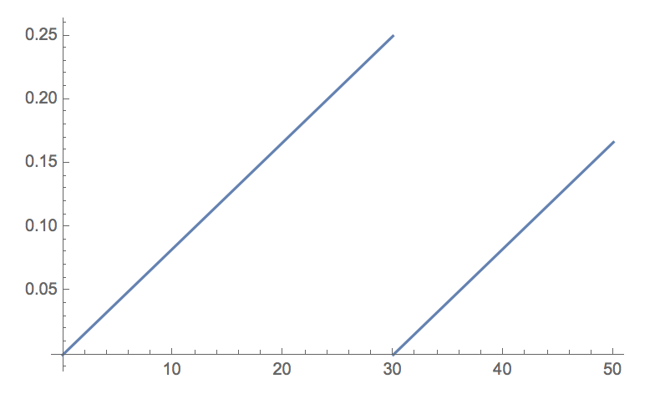

**Figure 1.** Time vs. Probability of Wildfire (Linear Model)

Because we focused on the relationship between underbrush and wildfire in our model, we ignored other factors that also influence the formation of wildfires, such as oxygen and heat sources. When it came to the severity of the fire, we also used the RandomReal function over an interval between 0 and 1 to map its effect on the populations. We have three separately generated random numbers assigned to the terms $d_{fG},{ d}_{fR},$ and $d_{fE}$. These terms are then subtracted from the three population equations to represent the impact of the wildfires. Essentially, the severity of the wildfires is random as well. In order to find how frequent the underbrush needs to be cleared to avoid extinctions, we applied the Allee Effect. When the population is under a certain critical point, the population will have a negative growth rate, leading to extinction.