**Results**

|  |  |
| --- | --- |
| Parameters | Initial Values |
|  | 4356000 |
|  | 4000 |
|  | 200 |
|  | 0.4 |
|  | 0.3 |
|  | 0.3 |
|  | 0.1 |
|  | 0.25 |
|  | 0.1 |
|  | 0.09 |
|  | 20 |
|  | 0 |
|  | 0 |
|  | 0 |
|  | 0 |
|  | 500 |
|  | 0.00133 |
|  | 25 |
|  | 0.02 |

**Figure 2.** Initial Parameters for All Simulations

|  |  |  |  |
| --- | --- | --- | --- |
| T = 30 (Underbrush Clear Time) | | | |
| Wildfire Max Prob. | 0.50 | 0.25 | 0.125 |
| Eagle Final Pop. | 0 | 0 | 21 |
| Grass Final Pop. | 885 | 1309 | 3496 |
| Rabbit Final Pop. | 1926 | 2334 | 2314 |
| Number of Wildfires | 125/6 | 217/15 | 136/15 |

**Figure 3.** Population dynamics for a constant time step T = 30 and variable underbrush accumulation rates (Linear Model). 

Figure 3 shows the population dynamics at underbrush clear time of 30 time-steps over varying max wildfire probabilities. Our primary focus is to focus on the top row of graphs, which represent the apex predator population over 200 time-steps. For all three max wildfire probabilities, the eagle population is approaching zero. The trend to notice here is that as one decreases the max wildfire probability, it takes longer for the eagle population to reach zero. This makes sense since a smaller probability for a wildfire will result in less wildfires, allowing the populations to survive for a longer period. Looking at all three graphs, a linear wildfire model with an underbrush clear time of 30 does not result in an apex predator equilibrium.

|  |  |  |  |
| --- | --- | --- | --- |
| T = 15 (Underbrush clear time) | | | |
| Wildfire Max Prob. | 0.50 | 0.25 | 0.125 |
| Eagle Final Pop. | 0 | 7 | 86 |
| Grass Final Pop. | 1121 | 1928 | 8487 |
| Rabbit Final Pop. | 2134 | 2274 | 1328 |
| Number of Wildfires | 559/30 | 331/30 | 74/15 |

**Figure 4.** Population dynamics for a constant time step T = 15 and variable underbrush accumulation rates (Linear Model).

Figure 4 shows the population dynamics at underbrush clear time of 15 time-steps over varying max wildfire probabilities. Once again, the primary focus is the top row of eagle populations. There is not much change in the trend between these three graphs and the three graphs from Figure 3. The only thing to note is that the final populations at 200 time-steps is larger than before, indicating that increasing underbrush clear time also increases population survivability. This makes sense biologically since clearing underbrush faster will prevent forest fires from occurring as often, which allows the population to survive longer. Looking at all three graphs, a linear wildfire model at an underbrush clear time of 15 still does not result in an apex predator equilibrium.

|  |  |  |  |
| --- | --- | --- | --- |
| T = 5 (Underbrush clear time) | | | |
| Wildfire Max Prob. | 0.50 | 0.25 | 0.125 |
| Eagle Final Pop. | 62 | 110 | 137 |
| Grass Final Pop. | 6660 | 10452 | 12142 |
| Rabbit Final Pop. | 1564 | 1148 | 798 |
| Number of Wildfires | 98/15 | 119/30 | 47/30 |

**Figure 5.** Population dynamics for a constant time step T = 5 and variable underbrush accumulation rates (Linear Model).

Figure 5 shows the population dynamics at underbrush clear time of 5 time-steps over varying max wildfire probabilities. Once again, the primary focus is the top row of eagle populations. We finally noticed some changes in eagle population sustainability when underbrush clear time is decreased to 5. At a max probability of 0.125, the eagle population seems to be approaching a potential equilibrium of 137 within 200 time-steps. The takeaway is that for linear models, only at an underbrush clear time of 5, can a sustainable eagle population be found within 200 time-steps.

|  |  |  |  |
| --- | --- | --- | --- |
|  | | | |
| Underbrush clear time | 15 | 10 | 5 |
| Number of Wildfires | 154/15 | 55/6 | 29/5 |
| Eagle Final Pop. | 20 | 31 | 80 |

**Figure 6.** Eagle population dynamics for variable underbrush accumulation rates (Square Root Model).

Figure 6 shows the nonlinear square root model of fire regimes at varying underbrush clear times. Within a time period of 200, all three eagle populations are on route to extinction. A nonlinear square root wildfire model seems inadequate in keeping the eagle population alive.

**Figure 7.** Time vs Probability of Wildfire (Square Root Model)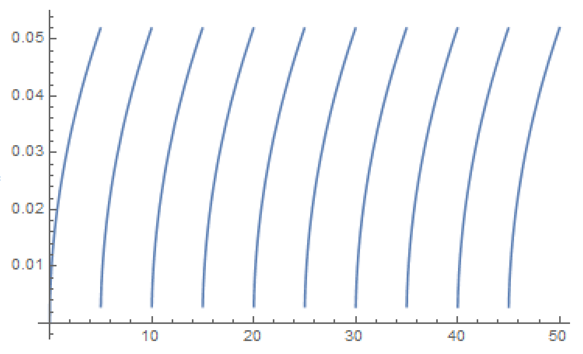

The lines are curved since it represents a square root model of the correlation between max probability and underbrush clear time. In this case, it does not have a linear relationship as compared to Figure 1. In all square root time vs probability graphs, the probability of a wildfire slows down as it increases towards the max. This mathematically checks out as a square root function.

|  |  |  |  |
| --- | --- | --- | --- |
|  | | | |
| Underbrush clear time | 15 | 10 | 5 |
| Number of Wildfires | 43/30 | 17/30 | 7/30 |
| Eagle Final Pop. | 136 | 139 | 141 |

**Figure 8.** Eagle population dynamics for variable underbrush accumulation rates (Polynomial Model).

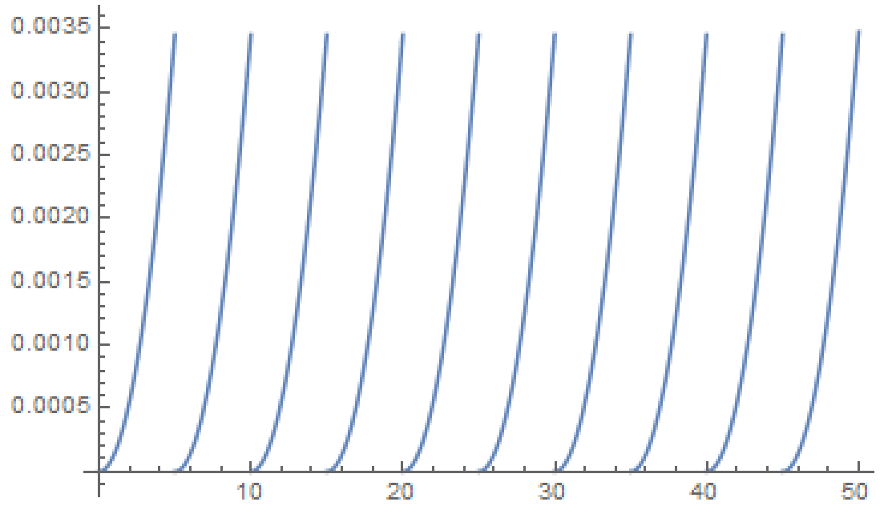 Figure 8 shows the second order polynomial fire regimes at varying underbrush clear times of 30, 15, and 5. For all underbrush clear times, the eagle population seems to begin oscillating towards an equilibrium within 200 time-steps. So far, the second order polynomial model seems best for representing wildfires in this ecosystem when it comes to fulfilling our primary goal of keeping the apex predators, the eagle population, alive.

**Figure 9.** Time vs Probability of Wildfire (Polynomial Model)

The lines are curved in Figure 9 as well since it represents a second order polynomial model of the correlation between max probability and underbrush clear time. In all polynomial time vs probability graphs, the probability of a wildfire increases as it increases towards the max which makes sense as a second order polynomial.

As a brief recap, Figures 3-9 show how the how sustainable the apex predator populations are by varying underbrush clear time along with max probability of fire. This is also compared between linear and nonlinear models. The next few figures focus on what happens when the simulations are run for a longer time step.

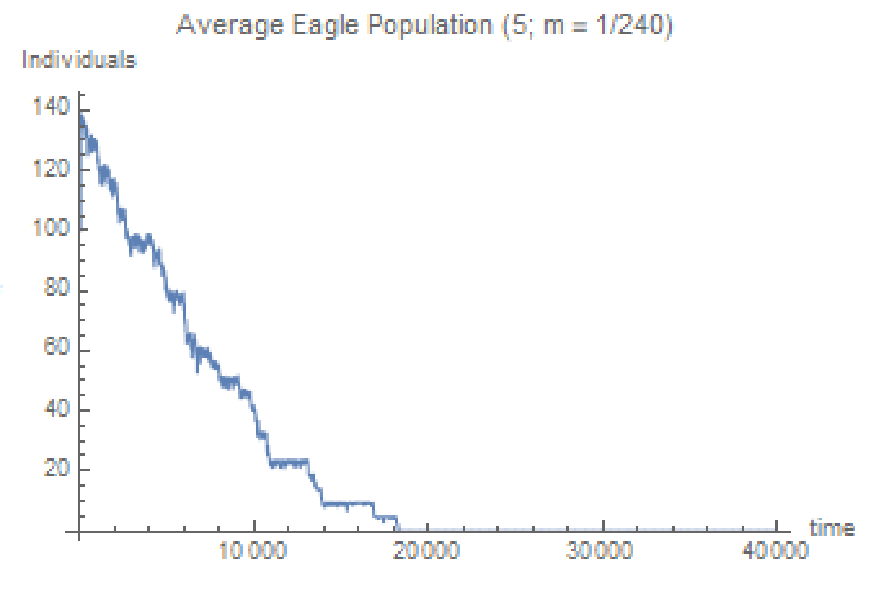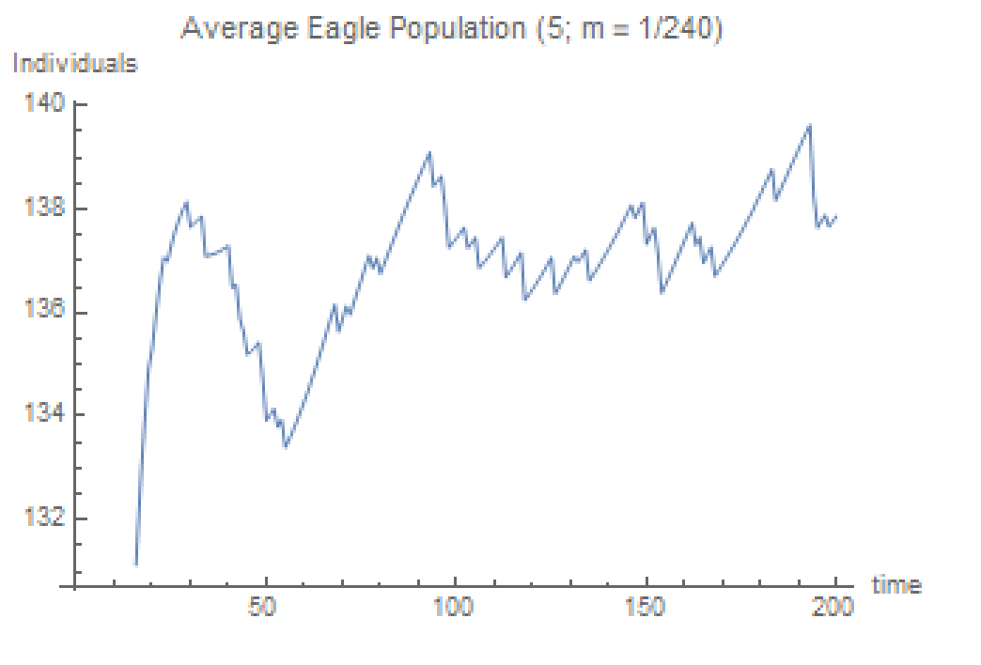While the results above are all done within 200 time-steps, it is important to check the models for a longer period of time. Since our primary focus is to see whether the eagle population avoids extinction, the graphs where the eagle population was sustainable in 200 time-steps are run longer to see if they reach an eventual equilibrium. We ran every graph in a long-term simulation until either the eagle population dies out or reaches an equilibrium. We chose the most sustainable eagle populations for each linear and nonlinear model to show in our results.

**Figure 10.** Eagle population short term (Linear) **Figure 11.** Eagle population long term (Linear)

Both figures are for when T(ub) = 5 (how often underbrush is cleared) and a max probability of wildfire at 12.5%. Figure 10 shows that the eagle population is sustainable and actually increases from its initial population of 100 to approximately 140 within 200 time steps. However, when you run the same model for 20,000 time-steps you notice that the eagle population eventually dies (Figure 11). Although this occurs at 100 times longer than the original period, it is still relevant to note that the eagle population does not reach an equilibrium in the long term when modelling fire regimes in a linear fashion.

We are now continuing to investigate short versus long term differences for fire regimes when modelled in a nonlinear fashion. This is different from Figures 3-9, which investigate everything in the short term (explained in brief recap above). First, we look at the square root function:

**Figure 12.** Eagle population short term (Square Root) **Figure 13.** Eagle population long term (Square Root)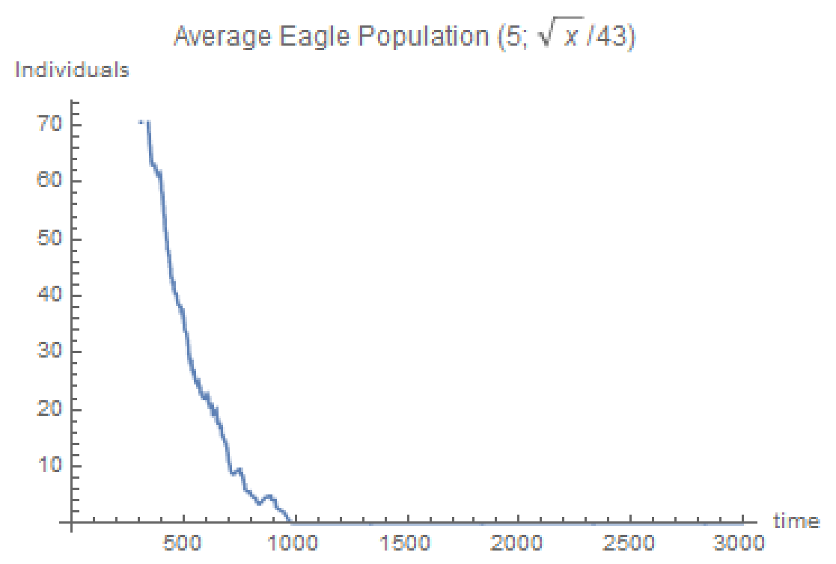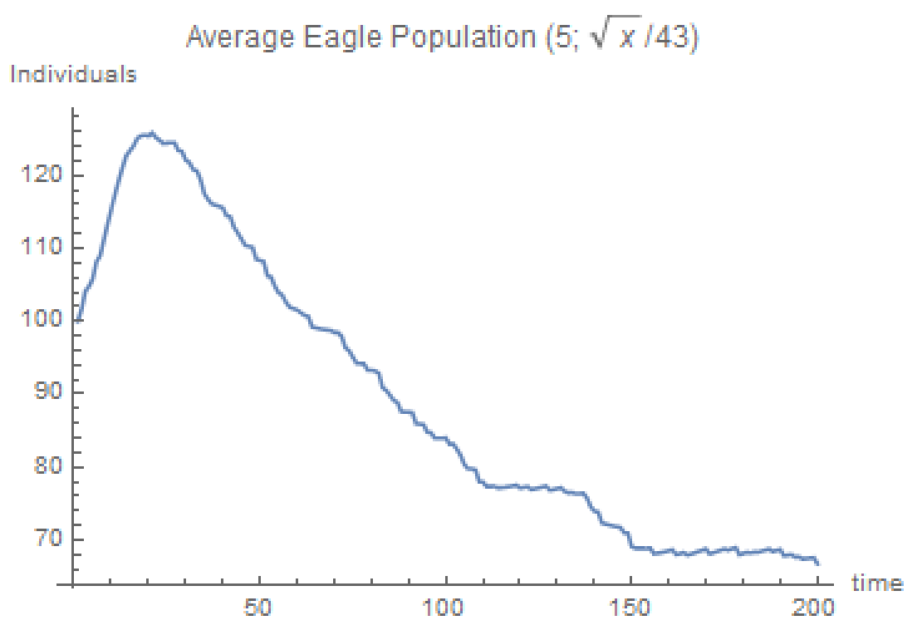

The two figures above are shown at T(ub) = 5 (how often underbrush is cleared). As you can see, Figure 12 already showed that the eagle population decreased to half its size within the 200 time-step. Just to double check that the eagle population did not find an equilibrium afterwards, we extended the time period to T = 3000 to discover that the eagle population does indeed die out as shown by Figure 13.

Lastly, we will look at the polynomial representation of the fire regime:

**Figure 14.** Eagle population short term (Polynomial) **Figure 15.** Eagle population long term (Polynomial)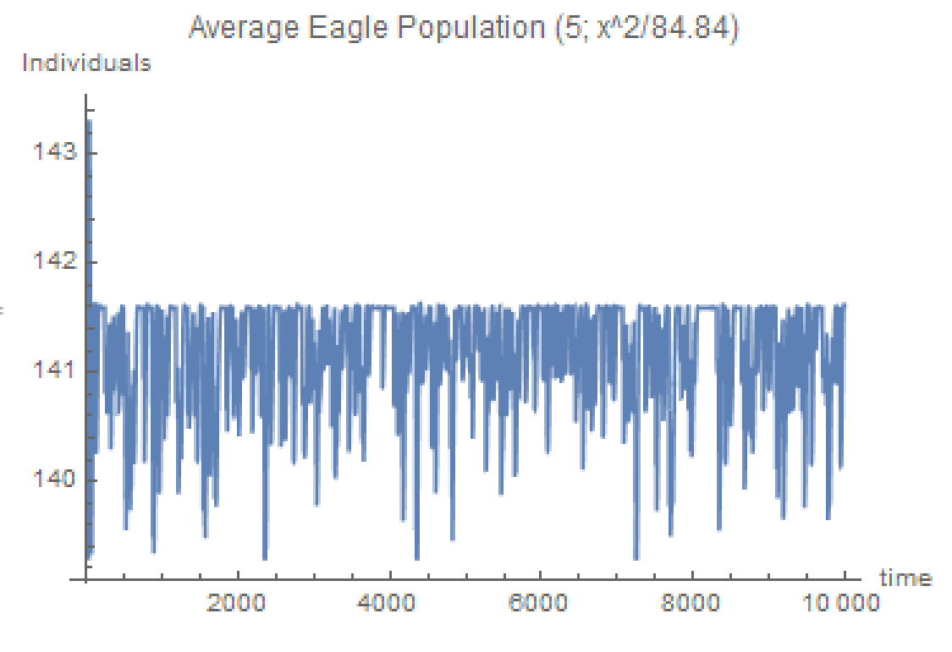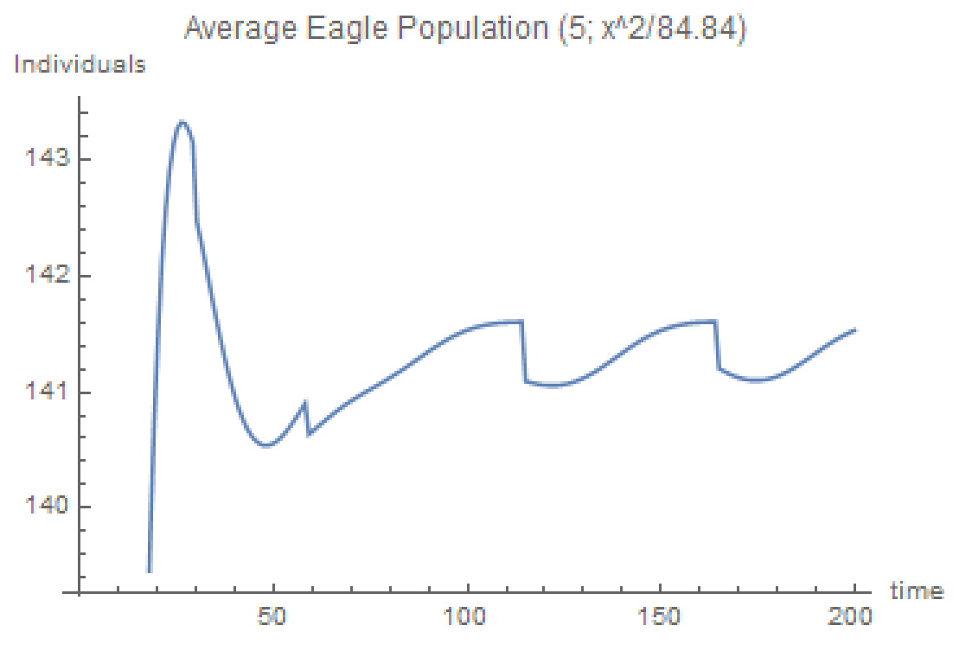

The two figures above are shown at T(ub) = 5 (how often underbrush is cleared) with a second order polynomial function. (Do note that Figure 14 is the same graph as the graph in the first row third column of Figure 8. They are slightly different due to the stochasticity of the wildfires.) Figures 14 shows that in the short term the eagle population seems to be already oscillating towards some equilibrium value of approximately 141.5 within 200 time-steps. Figure 15 tells us that this oscillation continues even at 10,000 time-steps, indicating that the eagle population is at an equilibrium. Between the linear, square root, and polynomial representations of wildfire regimes, only in the polynomial representation of a wildfire model did the eagle population survive in the long term. This concludes the results that correlate to our primary focus of whether it is possible to prevent the extinction of the eagle population by adjusting undergrowth clear speeds across various fire regimes.

The following results will discuss data important to our secondary focus of what happens to the ecosystem when the apex predator population goes to extinction. In order to understand the graphs and data, we will first breakdown mathematically the Allee Effect in along with the Lotka-Volterra principle, and explain how our intentions of using the Allee Effect in tangent with wildfires to force the eagles into extinction did not work exactly how we envisioned.

(1)

Revisiting the eagle equation, we see that the change in can be broken down into two parts, , and . The death rate of eagles is represented by , which will always decrease while can increase or decrease depending on whether the population is above the critical point or not. The purpose of Allee Effect in our equation, is to make it so that when the eagle population is under a critical population size, the overall growth rate of the eagle population would be negative or . When the eagle population is below the critical population size, or , is negative which causes to be negative. We now see that the only two values influencing are negative. Thus, , and the eagle population has a negative growth rate when the eagle population is under the critical population size. This worked as intended according to our data. When the population was below the critical population size, the growth rate was always negative.

However, we observed some problems when the eagle population was above the critical population size. Usually when we predicted that the Allee Effect would promote positive eagle population growth (logic is opposite of explained above when ). However, the data showed a negative population growth rate instead. This is because the term responsible for eagle growth in (1), , also had a Lotka-Volterra component: . As decreases, increases, thus decreases such that the overall term, , decreases as well. At a small enough , the growth rate component,, will be small enough such that it will be less than the death rate component, , causing the overall growth rate to become negative whether or not the population is below the critical point or not. The figures below demonstrate this phenomenon:

**Figure 16.** Eagle Population (Linear Model) **Figure 17.** Rabbit Population (Linear Model)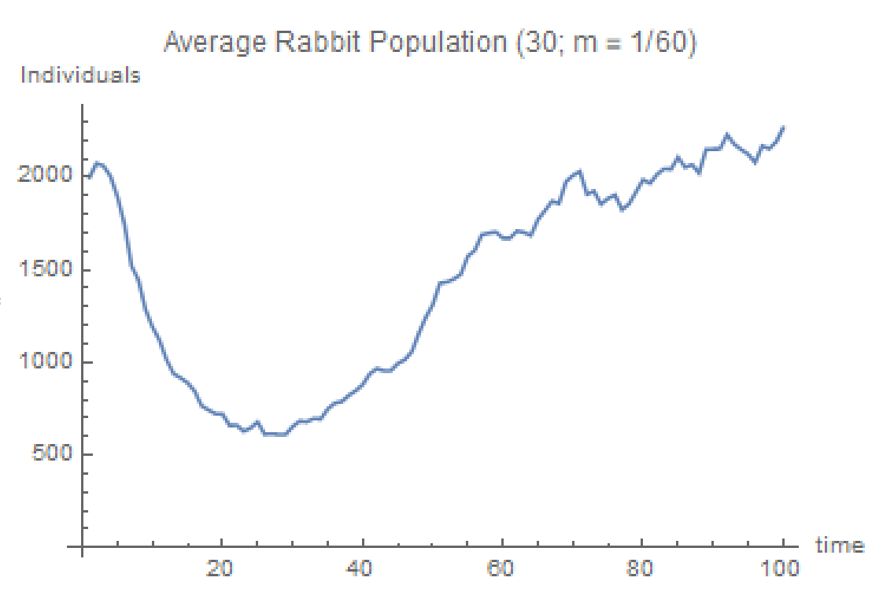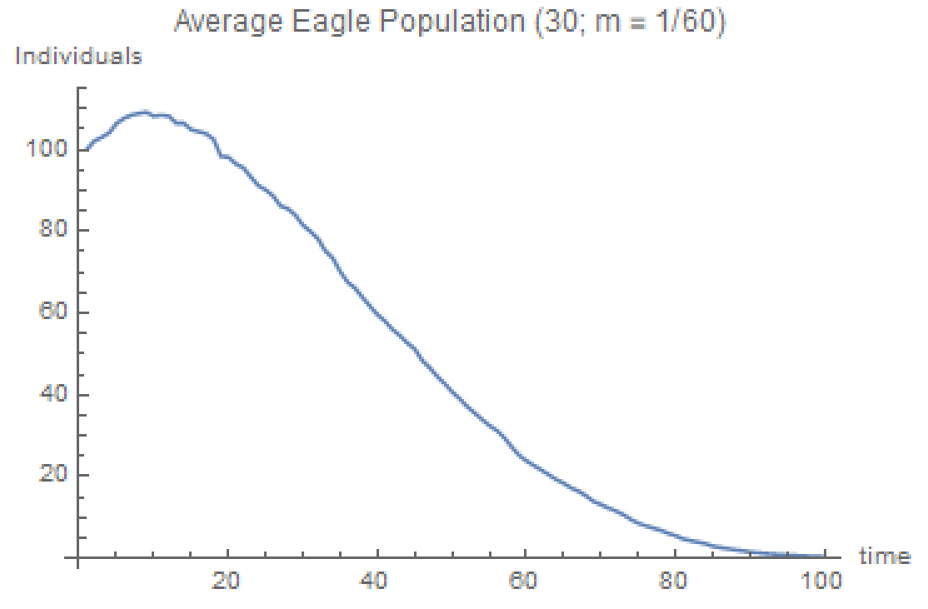

We found that at = 113.905 and = 1201.11, the eagle population started trending downwards permanently. As you can see, when the rabbit population became very small to a value of 1201.11, the eagle population started exhibiting a negative growth rate (These values are picked from an average of 30 stochastic runs where we noticed the eagle population permanently decreasing). This does not follow in line with the Allee Effect since the eagle population at 113.905 is way above the critical population size of 20. We realized that since the Allee Effect is not the only factor here, the Lotka-Volterra element ended up influencing the growth rate much more than the Allee Effect did. Even though ultimately the Allee Effect did not play an instrumental part in forcing our eagle population to extinction, the wildfires alone managed to accomplish it and fulfill our secondary focus.