ISTE-230 Introduction to Database and Data Modeling

## Homework # 2 – Interpret, Transpose, and Implement a Single Entity E-R Diagram in MySQL

DUE:

**Name:** Brian Zarzuela

**Submit to the Homework #2 dropbox, this document edited to include your answers AND the script file created for Part 3.**

**Part 1 – 20 points**

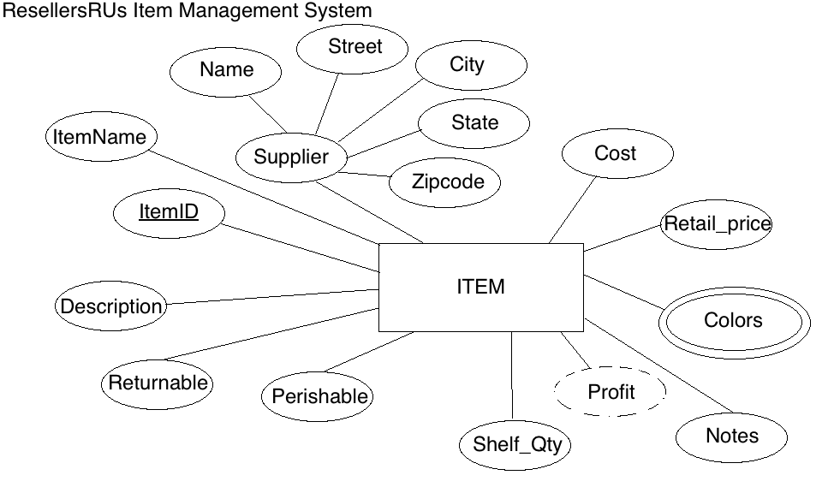

For the table below, please classify each attribute specified based on the E-R diagram above. Please place the best answer for each column that best describes the attribute.

|  |  |  |  |  |
| --- | --- | --- | --- | --- |
| Attribute | **Composite or Simple** | **Single-valued or Multi-valued** | **Stored or Derived** | **Identifier ? (Yes or no)** |
| Profit | Simple | Single-valued | Derived | No |
| Street | Simple | Single-valued | Stored | No |
| ItemID | Simple | Single-valued | Stored | Yes |
| Supplier | Composite | Single-valued | Stored | No |
| Colors | Simple | Multi-valued | Stored | No |

**Part 2 – 19 points**

Using relational structure notation, transpose the E-R diagram below and normalize to 1NF.



**Your Answer:** ITEM(ItemID, ItemName, Name, Street, City, State, Zipcode, Cost, Retail_Price, Color1, Color2, Color3, Notes, Shelf_Qty, Perishable, Returnable, Description)

**Part 3 – 61 points**

Create a script that includes the statements that will create a database called ‘HW2’ that includes a table for ITEM, based the relation above in Part 2 and the specifications in the table below. Use ONLY the data types discussed so far (CHAR, VARCHAR, INT, and DATE).

|  |  |
| --- | --- |
| **Attribute(s)** | **Data type description** |
| ItemID; ItemName; Name; Street; City; Color(s) | Variable-length string up to 25 characters |
| State | Fixed-length string of 2 characters |
| Zipcode | A string that could accommodate either of the formats below: ‘#####-####’ or ‘#####’ |
| Cost; Retail_price | Variable-length string up to 10 characters |
| Notes; Description | Variable-length string up to 255 characters |
| Returnable; Perishable | Will store one character |
| Shelf_Qty | A whole number between 0 and 50000 |