ISTE-230 Introduction to Database & Data Modeling

## Homework # 4 – Normalization

DUE: 28 February 2020

**Name:** Brian Zarzuela

**Submit this document edited to include your answers, for the six tasks, to the HW#4 Dropbox by the stated deadline.**

**Task #1 (12 points)**

MUSIC(Title, Artist, NumGrpMembers, Year, Producer, ProducerURL, Category, CategorySales, Media, MediaPrice )

Business Rules:

1. Each “album” (CD) is uniquely identified by its title. Note that, for the rest of the business rules, the “Title” attribute of MUSIC refers to the name of the “album”.
2. An artist may either be a single person or a band made up of multiple members (the count being recorded in NumGrpMembers, which can be 1).
3. Each album has one release year.
4. Each album is produced by one music production company (producer).
5. Each producer has one company URL.
6. A specific album has only one artist.
7. Each album is classified into one music category (Rock, Country, etc.)
8. Each category is associated with one category sales value, which is the year-to-date sales for that given category.
9. For convenience, the music company sells all of its music at the same price based on the media type. For example, all cassettes are $9.99, all CDs are $16.99, etc.

List ALL **functional** dependencies for the MUSIC relation above, according only to the business rules listed. Use the format A → B. Then, for each functional dependency denote with a ‘Y’ or ‘N’ if the respective functional dependency causes 2NF or 3NF violation in the MUSIC relation.

|  |  |  |
| --- | --- | --- |
| **Functional Dependencies** | **Partial Dependency?** | **Transitive Dependency?** |
| Artist → NumGrpMembers | N | **Y** |
| Title → Year | **Y** | N |
| Title → Producer | **Y** | N |
| Producer → ProducerURL | N | **Y** |
| Title → Artist | **Y** | N |
| Title → Category | **Y** | N |
| Category → CategorySales | N | **Y** |
| Media → MediaPrice | **Y** | N |

**Task #2 (9 points)**

For the relation below, determine the *highest* normal form the relation is in, the reason, **and** if necessary normalize the relation, and all resulting relations, through BCNF. Use proper relational notation and include reference statements for any foreign keys.

Q1( a, b, c, d )

Functional Dependencies:

a, b 🡪 c, d

c 🡪 d

**YOUR ANSWER:**

The highest normal fom that Q1 is in is 2NF. The functional dependency c 🡪 d is a transitive dependency and causes a 3NF violation.

Q1(a, b, *c*)

Q1(c) mei A1(c)

A1(c, d)

**Task #3 (12 points)**

For the relation below, determine the *highest* normal form the relation is in, the reason, **and** if necessary normalize the relation, and all resulting relations, through BCNF. Use proper relational notation and include reference statements for any foreign keys.

Q2(a, b, c, d)

Functional dependencies:

a, b 🡪 c, d

a 🡪 c

b 🡪 d

**YOUR ANSWER:**

The highest normal form that Q2 is in is 1NF. The functional dependencies a 🡪 c and b 🡪 d are partial dependencies and cause a 2NF violation.

Q2(*a, b*)

Q2(a) mei A2(a)

Q2(b) mei B2(b)

A2(a, c)

B2(b, d)

**Task #4 (17 points)**

Given the E-R diagram, the resulting relation, and the functional dependencies below, normalize the ITEM relation and resulting relations through BCNF. Be sure to use proper relational notation and reference statements for foreign keys.

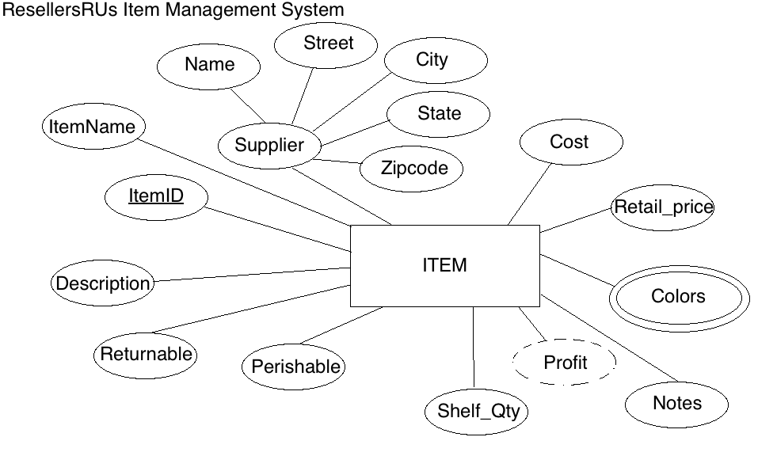

Resulting Relation:

ITEM(ItemID, ItemName, Name, Street, City, State, Zipcode, Cost, Retail_price, Color1, Color2, Notes, Shelf_Qty, Perishable, Returnable, Description)

Functional Dependencies:

ItemID 🡺 ItemName, Name, Street, City, State, Zipcode, Cost, Retail_price, Color1, Color2, Notes, Shelf_Qty, Perishable, Returnable, Description

Name 🡺 Street, City, State, Zipcode

**YOUR ANSWER (Final set of relations normalized to BCNF):**

ITEM(ItemID, ItemName, *Name*, Cost, Retail_price, Notes, Shelf_Qty, Perishable, Returnable, Description)

ITEM(Name) mei SUPLIER(Name)

SUPLIER(Name, Street, City, State, Zipcode)

ITEM-COLOR(*ItemID*, Color)

ITEM-COLOR(ItemID) mei ITEM(ItemID)

**Task #5 (23 points)**

Given the relation and functional dependencies below, normalize the SALE relation and resulting relations through BCNF. Be sure to use proper relational notation and reference statements for foreign keys.

SALE(Invoice#, Item#, CustID, CustName, CustAddress, ItemName, ItemPrice, ItemQtyPurch, Salesperson#, SalespersonName, Subtotal, Tax, TotalDue)

Functional Dependencies:

Invoice#, Item# 🡪 CustID, CustName, CustAddress, ItemName, ItemPrice, ItemQtyPurch, Salesperson#, SalespersonName, Subtotal, Tax, TotalDue

Item# 🡪 ItemName, ItemPrice

Invoice# 🡪 CustID, CustName, CustAddress, Salesperson#, SalespersonName, Subtotal, Tax, TotalDue

CustID 🡪 CustName, CustAddress

Salesperson# 🡪 SalespersonName

**YOUR ANSWER (Final set of relations normalized to BCNF):**

SALE(*Invoice#, Item#*, ItemQtyPurch)

SALE(Invoice#) mei INVOICE(Invoice#)

SALE(Item#) mei ITEM(Item#)

ITEM(Item#, ItemName, ItemPrice)

INVOICE(Invoice#, *CustID*, *Salesperson*#, Subtotal, Tax, TotalDue)

INVOICE(CustID) mei CUSTOMER(CustID)

INVOICE(Salesperson#) mei SALESPERSON(Salesperson#)

CUSTOMER(CustID, CustName, CustAddress)

SALESPERSON(Salesperson#, SalespersonName)

**Task #6 (27 points)**

Given the relation and functional dependencies below, normalize the relation and resulting relations through BCNF. Be sure to use proper relational notation and reference statements for foreign keys.

A(1, 2, 3, 4, 5, 6, 7, 8, 9, 10)

Functional Dependencies:

1, 2, 3, 4->5, 6, 7, 8, 9, 10

1->5, 6

5->1,6

2,3->7,8

7->8

4->9,10

9->10

10->9

**YOUR ANSWER (Final set of relations normalized to BCNF):**

A(*1, 2, 3, 4*)

A(1) mei B(1)

A(2, 3) mei C(2, 3)

A(4) mei D(4)

B(1, 5, 6)

C(2, 3, *7*)

C(7) mei E(7)

D(4, *9*)

D(9) mei F(9)

E(7, 8)

F(9, 10)