ISTE-230 Introduction to Database & Data Modeling

## Homework # 6 – Transposing

DUE: Monday, April 6, 2020 by 11:59pm

**Name:** Brian Zarzuela

**Submit this document edited to include your answers, for the two parts, to the HW#6 Dropbox by the stated deadline.**

(It may be helpful to right-click on the  icon and select Hide Spelling Errors and Hide Grammatical Errors.)

**Part #1 – 50 points**

1. (45 points) Transpose the E-R diagram above into relations, implementing all relationships. Denote primary keys and foreign keys appropriately. Use proper relation notation. You need to provide reference statements.

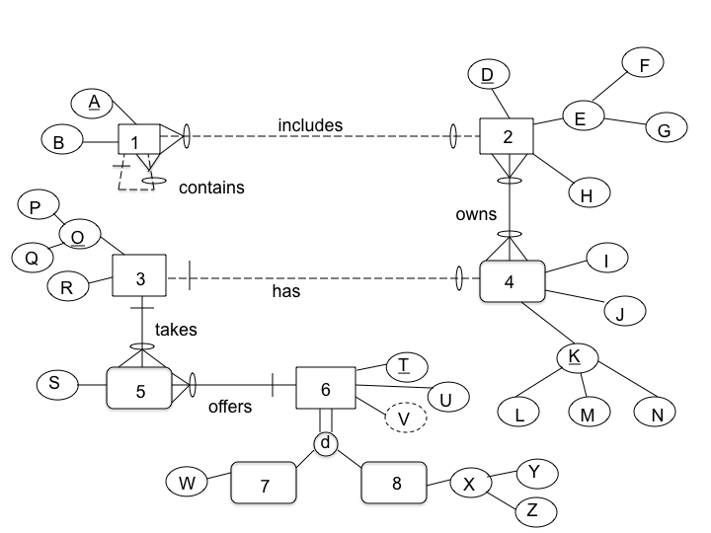

**YOUR TRANSPOSED RELATIONS:**

1(A, B, *D, Ab*)

1(D) mei 2(D)

1(Ab) mei 1(A)

2(D, F, G, H)

3(P, Q, R)

4(L, M , N, I, J, *P, Q*)

4(P, Q) mei 3(P, Q)

5(S, *P, Q, T*)

5(P, Q) mei 3(P, Q)

5(T) mei 6(T)

6(T, U)

7(T, W)

7(T) mei 6(T)

8(T, Y, Z)

8(T) mei 6(T)

2_4(*D, L, M , N*)

2_4(D) mei 2(D)

2_4(L, M, N) mei 4(L, M, N)

2. (2 points) Using the E-R diagram above, please explain why entity 7 is weak and what the specific term for that type of entity is.

**REASON:** 7 is weak because an instance can’t exist without participating in the relationship with 6

**TERM:** 7 is a subtype entity

3. (2 points) Using the E-R diagram above, please explain why entity 5 is weak and what the specific term for that type of entity is.

**REASON:** 5 Is weak because in order for an instance to exist it must participate in the relationships with 3 and 6

**TERM:** 5 is an ID-dependant entity

4. ( 1 point) Using the E-R diagram above, please explain what relationship makes entity 4 weak and what about that relationship causes it to be weak.

**EXPLANATION:** 4 is weak because the lists relationship requires total participation from 4

**Part 2 – RIT Savings and Loan (50 points)**

1. (50 points) Transpose the E-R diagram above into relations, implementing all relationships. Denote primary keys and foreign keys appropriately. Use proper relation notation. You need to provide reference statements.

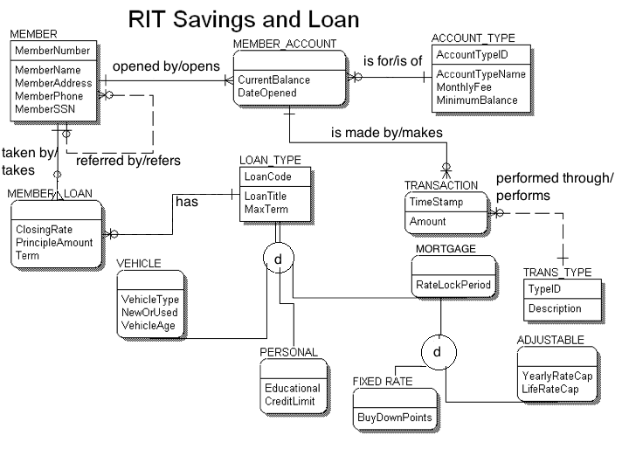**YOUR TRANSPOSED RELATIONS:**

MEMBER(MemberNumber, MemberName, MemberAddress, MemberPhone, MemberSSN, *ReffererMemberNumber*)

MEMBER(ReffererMemberNumber) mei MEMBER(MemberNumber)

MEMBER_ACCOUNT(*MemberNumber, AccountTypeID*, CurrentBalance, DateOpened)

MEMBER_ACCOUNT(MemberNumber) mei MEMBER(MemberNumber)

MEMBER_ACCOUNT(AccountTypeID) mei ACCOUNT_TYPE(AccountTypeID)

ACCOUNT_TYPE(Account_Type, AccountTypeName, MonthlyFee, MonthlyBalance)

TRANSACTION(TimeStamp, *MemberNumber, AccountTypeID*, Amount, *TypeID*)

TRANSACTION(MemberNumber, AccountTypeID) mei

MEMBER_ACCOUNT(MemberNumber, AccountTypeID)

TRANSACTION(TypeID) mei TRANS_TYPE(TypeID)

TRANS_TYPE(TypeID, Description)

MEMBER_LOAN(*MemberNumber, LoanCode*, ClosingRate, PrincipleAmount, Term)

MEMBER_LOAN(MemberNumber) mei MEMBER(MemberNumber)

MEMBER_LOAN(LoanCode) mei LOAN_TYPE(LoanCode)

LOAN_TYPE(LoanCode, LoanTitle, MaxTerm)

VEHICLE(*LoanCode*, VehicleType, NewOrUsed, VehicleAge)

VEHICLE(LoanCode) mei LOAN_TYPE(LoanCode)

PERSONAL(*LoanCode*, Educational, CreditLimit)

PERSONAL(LoanCode) mei LOAN_TYPE(LoanCode)

MORTGAGE(*LoanCode*, RateLockPeriod)

MORTGAGE(LoanCode) mei LOAN_TYPE(LoanCode)

FIXED_RATE(*LoanCode*, BuyDownPoints)

FIXED_RATE(LoanCode) mei MORTGAGE(LoanCode)

ADJUSTABLE(*LoanCode*, YearlyRateCap, LifeRateCap)

ADJUSTABLE(LoanCode) mei MORTGAGE(LoanCode)