Instructions:

How to compile python code:

I used Jupyter notebook to compile my python code. After you open my code in jupyter notebook and try to compile them. You need to run all the cells.

Result:

1. Egg holder function:

Hill climbing search distribution:

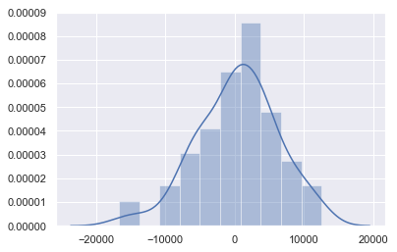

Differential Evolution distribution:

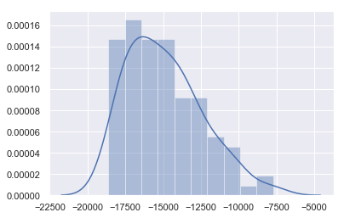

Time consuming chart:

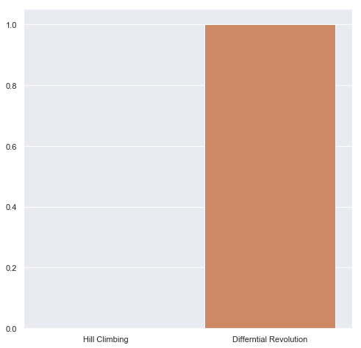

Conclusion: Differential revolution will spend much more time.