CS580 Introduction to Artificial Intelligence

## Assignment 4

Total Points: 100

Due date: 11/6/2018

1. Connect Four

Your task in this assignment is to create an AI program that can masterfully play Connect Four. Connect Four is a two-player game in which the two players take turns dropping colored discs from the top into a 7-column, 6-row vertically suspended grid. The pieces fall straight down, occupying the next available space within the column. The object of the game is to connect four of one's own discs (of the same color) next to each other vertically, horizontally, or diagonally before your opponent does.

(Source: <http://en.wikipedia.org/wiki/Connect_Four>)

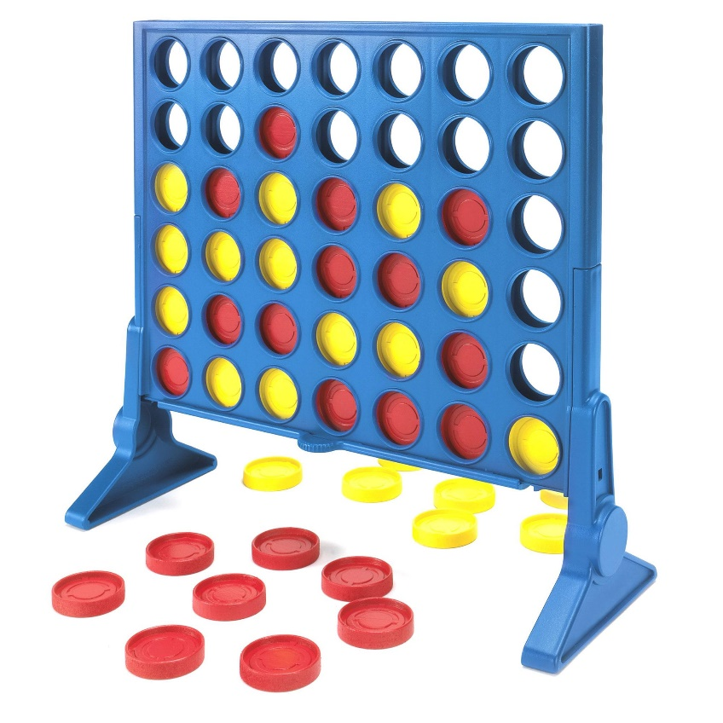

Here are the tasks:

1. Implement a connect-four game playing interface that one can play the game.
2. Design an evaluation function for the intermediate states.
3. Implement your program using the minimax algorithm.
4. (bonus) Enhance your program using alpha-beta pruning algorithm.
5. Analyze your program. For example, can MAX find a strategy that guarantees winning?

What to Hand in

1. Demonstrate your program to the instructor.
2. Design of your program, including the evaluation function.
3. Solutions you obtained for the connect-four game and your analysis.

Please send your programs and analysis report to yalan001@odu.edu before the assignment due date.