1. My homework submission including 3 code files. They are named as Breath_first_search.ipynb, Depth_first_search.ipynb and informed_search.ipynb. To compile and execute the code, you need to install jupyter notebook on your computer and use jupyter notebook open these files. After you open jupyter notebook, you need to run all the cell to get the result. After you run the code. The result will show how many nodes computer searched and give you solution computer got. If there is no solution, the computer will show how many nodes it search and print out there is no solution. Moreover, the result will also tell you running time.

2. I will use Words.txt as dictionary and search “stone” to “fifth” as sample solution and attach result picture in read me file.

This is breath first search result.



This is depth search result.

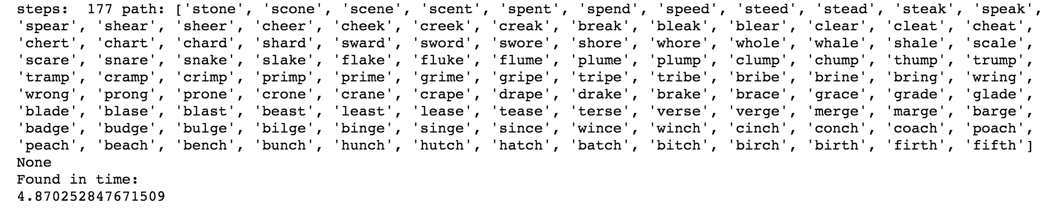

This is informed search result



3 Analysis

Those 3 search provide the same answers all the time.

The length of path BFS will always shorter or same with DFS. Because BFS will always find the best solution and DFS will find fastest solution.

The length of path BFS and informed search are same length. They will always find best solution.

4. compare 100 times using randomly choose

I wrote down a function called random100() for each search. The results are below.

This is result for depth first search:

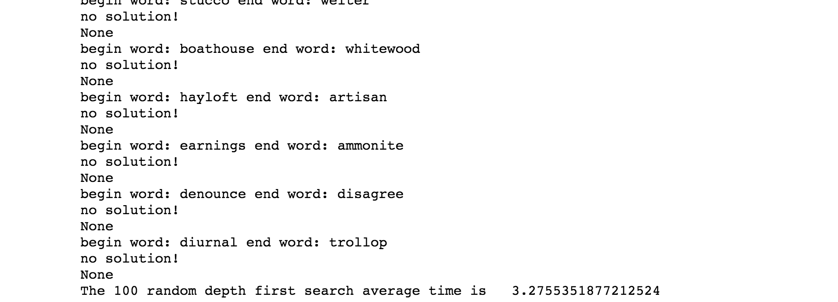

This is result for breath first search:

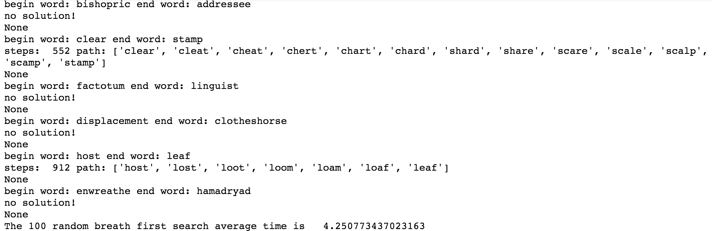

This is result for informed search:

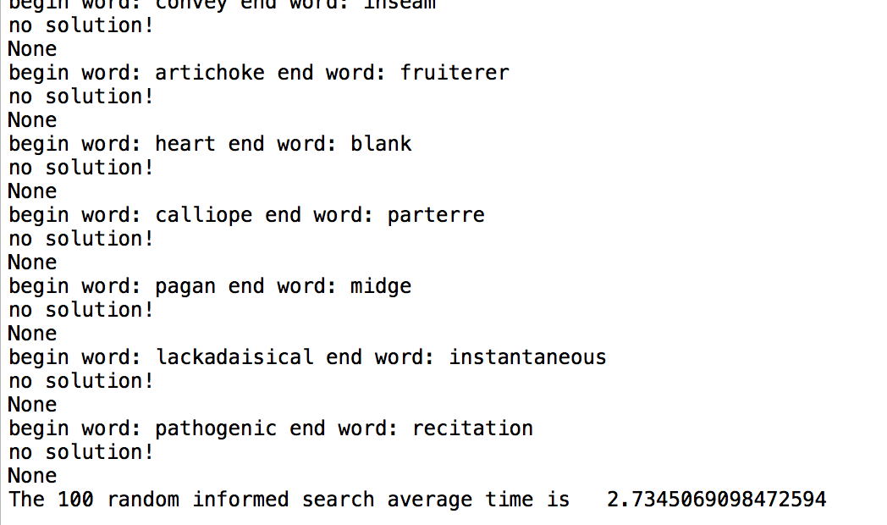

The conclusion is that informed search used least time. Depth first search used second least time. Breath first search used most time.

PS. I comment out the single word test if you want to test the single word. Just get rid of comment sign.