**Briana Olsen**

**Cryptocurrency Exchange Rate Tracker**

## **Purpose**

The purpose of my project would be to compare cryptocurrency price between exchanges.

## **Audience**

Cryptocurrency traders or those interested in cryptocurrency rates.

## **Data sources**

APIs from Binance, Coinbase Pro, and Bittrex.

## **Initial Module list**

Main.js

Coin.js – handles APIs for each exchange

LocalStorage.js – handles saved coins list

## **Wireframes for each view of your application**

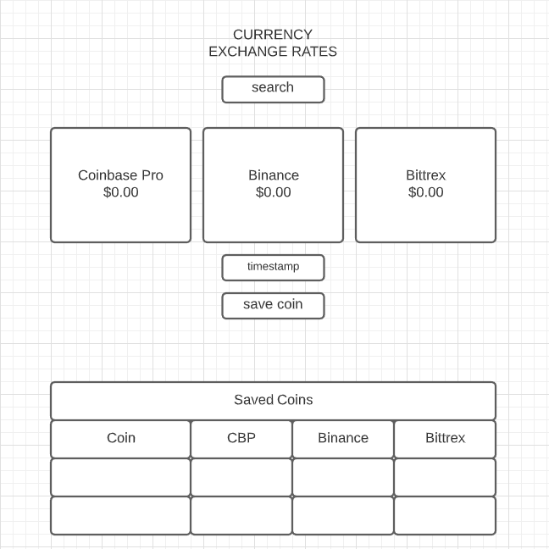

## **Colors/Typography/specific Element styling**



Google Fonts: Raleway

## **Schedule to provide yourself mile markers along the way to help you stay on target.**

Week 10 – APIs

Week 11 – UI

Week 12 – LocalStorage

Week 13 – Second Page or catch up

Week 14 – Finishing UI touches