**Basic XSS with BurpSuite**

* Download the FoxyProxy extension for Firefox
* Add a new proxy in FoxyProxy with the following settings

* Ensure Interception is on in BurpSuite

* Navigate to test URL where form is located

* Client-side filtering is enabled on this form

* Enter information that abides by content filtering rules. Click “Submit Query!”

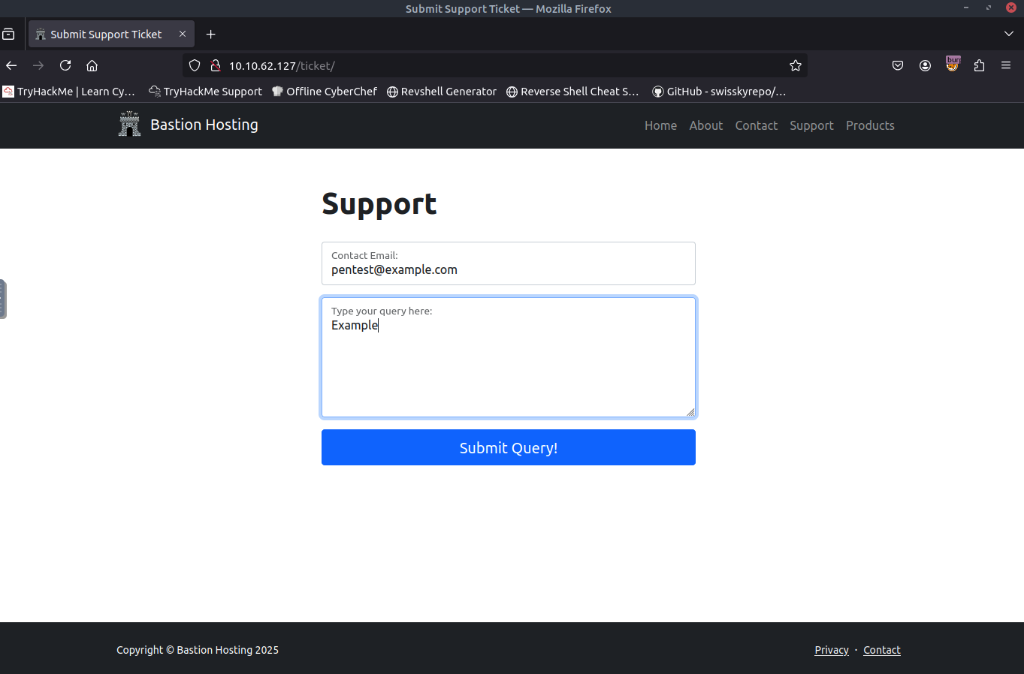

* Locate the HTTP request in BurpSuite and enter the script information in place of the email address. Click the “Forward” button at the top to proceed.

