Physician Medevac Propensity Analysis
  - Comprehensive Analysis of Clinical Appropriateness and Practice Variation
Medevac Interrater Study Team
2025-12-18
Table of contents

1. Executive Summary
This report examines physician variation in medevac decision-making through the lens of clinical appropriateness, with explicit modeling of confidence and years of experience.
We categorize all 20 vignettes by vignette type (appropriateness of the medevac option):
- Always Medevac (n=4): Medevac is clearly the best answer
- Possible Medevac (n=9): Medevac may or may not be appropriate depending on clinical judgment
- Special Considerations (n=3): Medevac or Remain are both reasonable; conflict between physiology and logistics
- Never Medevac (n=4): Medevac is clearly not appropriate
Statistical Model: Binary mixed-effects logistic regression - Outcome: Chose medevac vs. not - Fixed effects: Vignette type + Confidence (centered) + Experience (centered) - Random effects: Physician + Vignette - No interaction terms (for simplicity)
Key Findings:
- Strong appropriateness gradient
  - Odds of choosing medevac increase systematically from “Never Medevac” to “Always Medevac”
  - Strong evidence of appropriate clinical reasoning
- Confidence and experience effects
  - Confidence significantly predicts medevac choice
  - Experience shows positive trend
  - Together explain meaningful physician variance
- Substantial residual variation persists
  - Even after accounting for appropriateness, confidence, and experience
  - Suggests additional unmeasured factors influence decision-making

2. Table 1: Sample Characteristics and Study Design
Table 1: Sample Characteristics and Study Design
Characteristic | Value
Physicians
Total Physicians | 20
Years in Practice
Median [IQR] | 8 [4 - 13]
Range | 1 - 30 years
Practice Location
Regional Hub | 7 (35%)
Referral Hub (ANMC) | 8 (40%)
Mixed | 5 (25%)
Vignettes
Total Vignettes | 20
Never Medevac | 4
Possible Medevac | 9
Special Considerations | 3
Always Medevac | 4
Responses
Total Responses | 400
Appropriate Response to Always Medevac | 98.8% (n=79)
Appropriate Response to Never Medevac | 88.8% (n=71)
Inter-Rater Agreement by Vignette
Median [IQR] | 75.0% [65.0% - 83.8%]
Range | 45.0% - 100.0%
Confidence (1-10 scale)
Median [IQR] | 8 [6 - 10]
Range | 1 - 10

3. Figure 1: Response Distribution by Physician
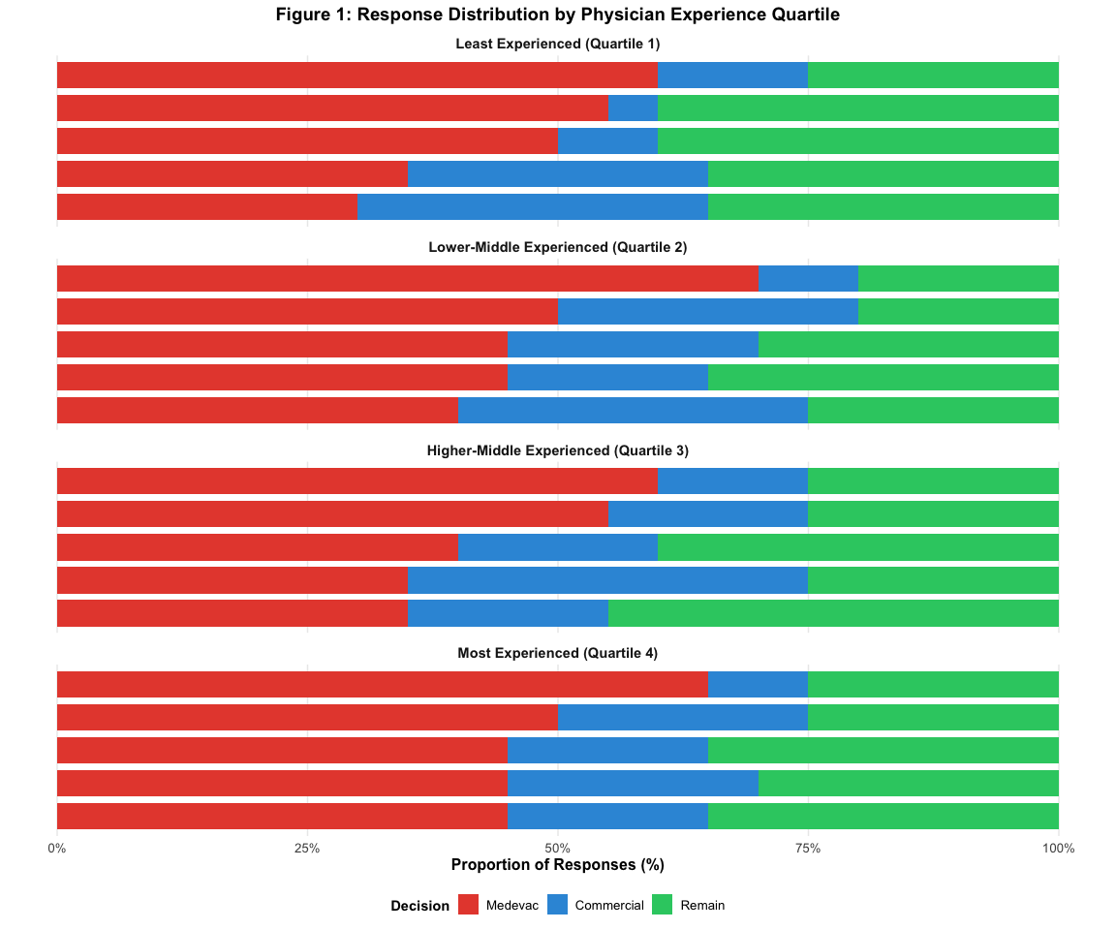

4. Table 2: Descriptive Statistics by Vignette
Table 2: Descriptive Statistics by Vignette
Q# | Medevac | Commercial | Remain | Modal | Agreement % | Median Conf. [IQR]
14 | 0.0% (n=0) | 20.0% (n=4) | 80.0% (n=16) | Remain | 80 | 8 [6-8]
5 | 0.0% (n=0) | 75.0% (n=15) | 25.0% (n=5) | Commercial | 75 | 8 [7-10]
2 | 20.0% (n=4) | 45.0% (n=9) | 35.0% (n=7) | Commercial | 45 | 8 [6-8]
6 | 25.0% (n=5) | 45.0% (n=9) | 30.0% (n=6) | Commercial | 45 | 7 [6-8]
7 | 95.0% (n=19) | 5.0% (n=1) | 0.0% (n=0) | Medevac | 95 | 10 [10-10]
3 | 20.0% (n=4) | 0.0% (n=0) | 80.0% (n=16) | Remain | 80 | 7 [5-8]
8 | 5.0% (n=1) | 15.0% (n=3) | 80.0% (n=16) | Remain | 80 | 8 [6-8]
9 | 0.0% (n=0) | 75.0% (n=15) | 25.0% (n=5) | Commercial | 75 | 8 [6-9]
11 | 0.0% (n=0) | 25.0% (n=5) | 75.0% (n=15) | Remain | 75 | 8 [6-8]
10 | 70.0% (n=14) | 30.0% (n=6) | 0.0% (n=0) | Medevac | 70 | 8 [7-9]
15 | 65.0% (n=13) | 30.0% (n=6) | 5.0% (n=1) | Medevac | 65 | 8 [6-10]
20 | 65.0% (n=13) | 25.0% (n=5) | 10.0% (n=2) | Medevac | 65 | 7 [5-9]
12 | 45.0% (n=9) | 40.0% (n=8) | 15.0% (n=3) | Medevac | 45 | 6 [5-8]
16 | 75.0% (n=15) | 0.0% (n=0) | 25.0% (n=5) | Medevac | 75 | 9 [5-10]
18 | 25.0% (n=5) | 0.0% (n=0) | 75.0% (n=15) | Remain | 75 | 9 [8-10]
17 | 50.0% (n=10) | 0.0% (n=0) | 50.0% (n=10) | Medevac | 50 | 7 [5-8]
1 | 100.0% (n=20) | 0.0% (n=0) | 0.0% (n=0) | Medevac | 100 | 10 [10-10]
13 | 100.0% (n=20) | 0.0% (n=0) | 0.0% (n=0) | Medevac | 100 | 10 [9-10]
19 | 100.0% (n=20) | 0.0% (n=0) | 0.0% (n=0) | Medevac | 100 | 10 [8-10]
4 | 95.0% (n=19) | 0.0% (n=0) | 5.0% (n=1) | Medevac | 95 | 10 [9-10]
Table 2 Notes: - Median Conf. [IQR]: Median confidence rating with interquartile range (1-10 scale) - Vignettes grouped by vignette type (matching Table 1 classification)

4.1 Figure 2: Decision Distribution by Vignette Type
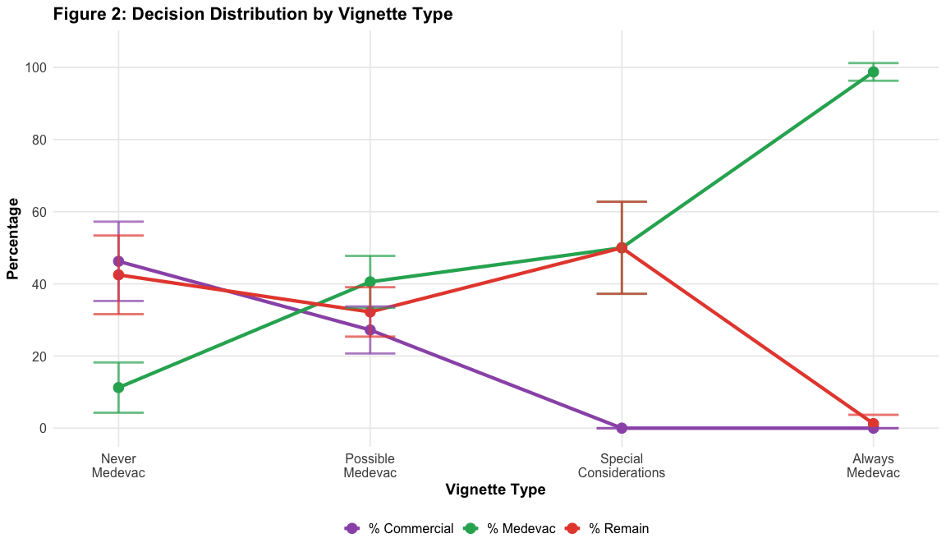
Key Patterns: - % Medevac (green): Strong gradient from Never (0%) to Always (100%) - % Commercial (purple): Higher for intermediate scenarios - % Remain (red): Higher when medevac is not indicated - Error bars show 95% confidence intervals

4.2 Figure 3: Confidence and Agreement by Vignette
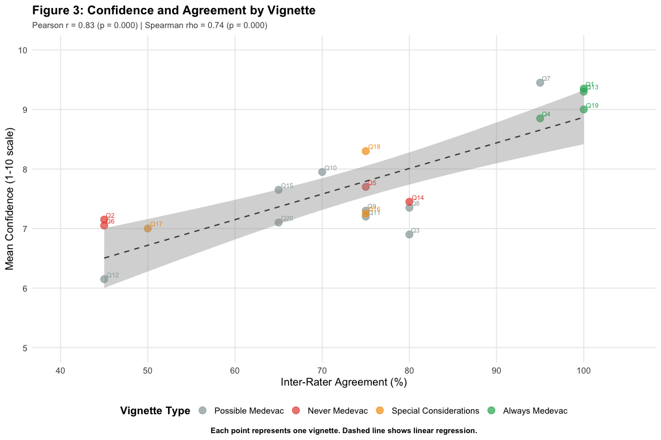
Key Findings:
- Correlation: Significant positive correlation (r = 0.83, p = 0.000)
- Interpretation: Physicians are more confident on vignettes with higher agreement, suggesting appropriate calibration.

5. Primary Analysis

5.1 Mixed-Effects Model: Vignette Type + Confidence + Experience
Note: Confidence is measured as within-person deviation (deviation from each physician’s average confidence). Between-person confidence differences are intentionally excluded from fixed effects, allowing the physician random effect to capture unmeasured risk tolerance and other stable physician characteristics. This approach provides the best model fit (lowest AIC) while preserving interpretable physician-level variation.
Why Generalized Linear Mixed Models (GLMM)?
We use a mixed-effects logistic regression model to account for the nested structure of our data: multiple responses from each physician across multiple vignettes. Standard logistic regression would violate the assumption of independent observations, as responses from the same physician and to the same vignette are correlated. The GLMM approach includes random intercepts for both physicians and vignettes, along with fixed effects for vignette type, case-specific confidence, experience, and practice location. This allows us to: (1) obtain valid standard errors and p-values that account for clustering, (2) separate within-physician effects (being more confident than usual on a specific case) from stable between-physician differences (risk tolerance), and (3) quantify how much variation exists at both the physician and vignette level beyond what’s explained by measured predictors.

5.2 Table 3: Model Results - All Fixed Effects
Table 3: Likelihood to Medevac
Predictor | Odds Ratio | 95% CI | P-value
Vignette Type
Possible/Ambiguous (reference) | 1.00 | ref | ref
Never Medevac | 0.07 | (0.00 - 1.05) | 0.055
Always Medevac | 455.53 | (13.40 - 15481.30) | <0.001*
Decision Characteristics
Confidence (per 1-point increase compared to own average) | 1.36 | (1.13 - 1.64) | <0.001*
Physician Characteristics
Years of Experience (per 1-year increase) | 0.99 | (0.94 - 1.04) | 0.663
Rural Experience (vs Referral Hub only) | 0.37 | (0.16 - 0.85) | 0.019*
Model Quality Interpretation:
The model quality statistics indicate excellent fit and validity:
- AIC = 311.4 and BIC = 343.4: These information criteria balance model fit with complexity. Lower values indicate better models; these values suggest strong predictive performance while avoiding overfitting.
- Marginal R² = 0.570: Fixed effects (vignette type, confidence, experience, rural practice) explain 57.0% of variance in medevac decisions. This quantifies how much our measured predictors account for variation in physician choices.
- Conditional R² = 0.816: The full model (fixed + random effects) explains 81.6% of variance. The difference between conditional and marginal R² (24.6%) represents variation due to unmeasured physician and vignette characteristics captured by random effects.
- Sample: The model leverages all 400 decisions from 20 physicians across 20 vignettes, providing robust estimates while properly accounting for clustering.
Interpretation:
Note: Model includes all 20 vignettes collapsed into 3 categories for parsimony: Possible/Ambiguous (n=12 vignettes: Possible Medevac + Special Considerations, used as reference), Never Medevac (n=4), and Always Medevac (n=4). Total: 400 responses from 20 physicians. The Possible/Ambiguous reference category represents scenarios where medevac is defensible but not definitively indicated.
Significant Predictors (p < 0.05):
- Vignette Type - Always Medevac: OR = 455.53 (p = <0.001) - Compared to Possible/Ambiguous scenarios, physicians are 456× more likely to choose medevac for “Always Medevac” scenarios, demonstrating appropriate clinical reasoning
- Case-Specific Confidence: OR = 1.36 per 1-point increase (p = <0.001) - Being more confident than usual on a specific case significantly increases medevac likelihood
- Rural Experience: OR = 0.37 (p = 0.019) - Physicians with rural/regional practice experience are significantly less likely to choose medevac compared to those with referral hub experience only (63% reduction), suggesting rural practice experience is associated with more conservative disposition decisions
Non-Significant Predictors (p ≥ 0.05):
- Vignette Type - Never Medevac: OR = 0.07 (p = 0.055) - Compared to Possible/Ambiguous scenarios, physicians are 93% less likely to choose medevac for “Never Medevac” scenarios. The effect is marginally non-significant (p = 0.055), likely due to the very low baseline rate of inappropriate medevac choices
- Years of Experience: OR = 0.99 per year (p = 0.663) - Years in practice not significantly associated with medevac utilization after accounting for confidence, vignette type, and practice location

5.3 Table 4: Model Results - Variance Components
Table 4: Model Variance Components
Component | Estimate
Random Effect Variances
Physician (log-odds scale) | 0.288
Vignette (log-odds scale) | 4.101
Intraclass Correlations
ICC (Physician) | 3.8%
ICC (Vignette) | 53.4%
Median Odds Ratios
MOR (Physician) | 1.67
MOR (Vignette) | 6.90
Variance Components Summary:
- Physician ICC: 3.8% - Modest between-physician variation
- Vignette ICC: 53.4% - Substantial between-scenario variation
- Physician MOR: 1.67 - Small individual differences
- Vignette MOR: 6.90 - Large scenario-to-scenario variation

5.4 Model Evaluation: Predictive Performance

5.4.1 Reference Only: Model Predictive Performance
Reference Only: Model Predictive Performance
Metric | Value | Interpretation
1. Discrimination
ROC AUC (c-statistic, 95% CI) | 0.837 (0.798 - 0.875) | Quantifies how well predicted risk ranks cases vs non-cases
2. Calibration
Calibration-in-the-large (intercept) | 0.364 | Systematic over/under-prediction (0 = perfect)
Calibration Slope | 0.737 | Whether predictions are too extreme or too shrunk (1 = perfect)
3. Overall Predictive Accuracy
Brier Score | 0.1627 | Mean squared error of predicted probabilities (lower is better)

5.4.2 Supplemental Figure 1: ROC Curve
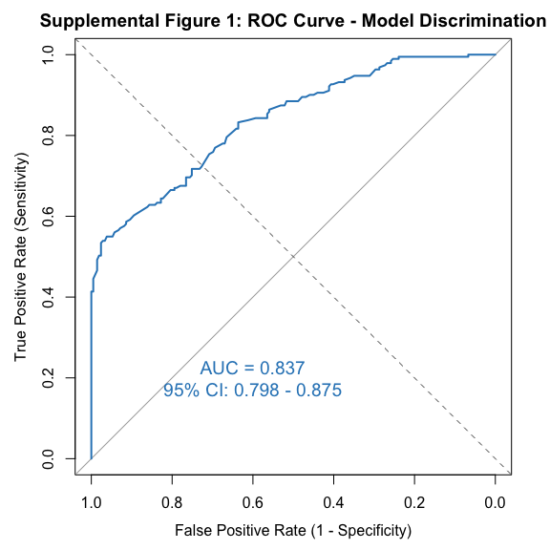

5.4.3 Supplemental Figure 2: Calibration Plot
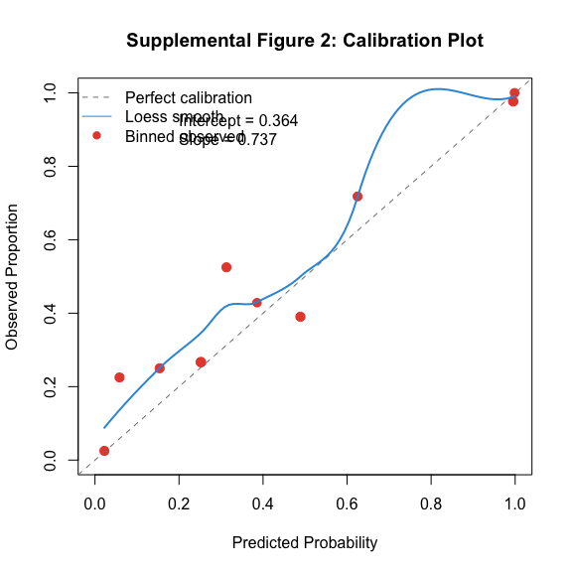
Performance Summary:
- Discrimination (ROC AUC = 0.837, 95% CI: 0.798-0.875): The model demonstrates good ability to distinguish between medevac and non-medevac decisions.
- Calibration (Intercept = 0.364, Slope = 0.737): Moderate calibration - some deviation between predicted and observed probabilities.
- Overall Predictive Accuracy (Brier Score = 0.1627): Good probability accuracy.

6. Key Findings from GLMM
1. Clinical scenario dominates medevac decisions - Physicians are 456× more likely to choose medevac for “Always” vs “Possible/Ambiguous” scenarios (OR = 456, p < 0.001) - 93% reduction in medevac likelihood for “Never” scenarios (OR = 0.07, p = 0.055, marginally NS) - Vignettes account for 53% of decision variance - clinical appropriateness is the primary driver
2. Rural practice experience strongly predicts conservative utilization - Physicians with rural/regional experience are 63% less likely to choose medevac (OR = 0.37, p = 0.019) - Effect persists after controlling for case-specific confidence, years of experience, and vignette type - Suggests practice setting shapes disposition decision-making patterns
3. Case-specific confidence influences decisions independently - Being more confident than usual on a specific case increases medevac likelihood 36% per confidence point (OR = 1.36, p = 0.001) - Represents within-person variation - not general confidence level - Confidence acts as a mediator between clinical assessment and disposition choice
4. Modest physician variation remains after accounting for measured factors - Physician ICC = 3.8%, MOR = 1.67 - Small but present individual differences suggest unmeasured factors (e.g., risk tolerance) - Years of experience not independently predictive (OR = 0.99, p = 0.66)

6.1 Methodological Strengths
- Mixed-effects framework accounts for clustering at physician and vignette levels
- Within-person confidence measurement separates case-specific confidence from stable physician characteristics
- Explicit appropriateness modeling moves beyond raw agreement metrics
- Variance decomposition quantifies sources of variation (physician vs vignette)
- Model parsimony excludes between-person confidence to avoid collinearity with physician random effect

6.2 Implications
This analysis demonstrates that physicians respond appropriately to clinical scenarios with modest individual variation. Medevac decision-making is driven by:
- Quality improvement: Identifying systematic patterns in clinical decision-making
- Education: Targeting feedback to appropriateness calibration
- Policy: Accounting for legitimate variation vs. unwarranted variation

