D424 – Software Engineering
Task 3
Capstone Proposal Project Name: |   Hermes: A Language Learning App
Student Name: | Brice Colby

Table of Contents
Create a professional looking Table of contents that includes your main and subheadings and the related page numbers. Use the automatic TOC generating function of Word or other word processing packages to make the process easier.
The headings that follow are only examples of what might be included. You will need to create headings that are appropriate for your application and process.
Remember that this needs to be a professionally formatted document with detailed information about your project that is easily accessible.

Task 3 Design Document

Application Design and Testing

Class Design
The class diagrams below represents the core object-oriented design used to model users and practice activities in Hermes. The design centers on an abstract PracticeItem base class the defines a common interface for evaluating learner responses across multiple practice formats. Concrete practice item types (flashcard, multiple choice, and cloze) inherit from this base class, allowing the practice system to support multiple activity types while maintaining a consistent evaluation workflow. A PracticeSession coordiante the delivery and evaluation of practice items, while the User class encapsulates learner state such as experience points, level, stamina, and streak information.
Inheritance is implemented through the abstract PracticeItem class and its concrete subclasses: FlashcardBasicPracticeItem, McqBasicPracticeItem, and ClozeFreeFillPracticeItem. Each subclass inherits shared structure and behavior from PracticeItem while adding fields and logic specific to its practice format. This avoids duplication of common functionality and supports extension by allowing new practice item types to bea dded without modifying existing code.
Polymoprhism is demonstrated through the PracticeSession, which operates on a collection of PracticeItem objects rather than concrete subclasses. When a response is submitted, the session invokes evaluate() on the base PracticeItem reference. At runtime, the appropriate subclass implementation is executed based on the actual item type, enabling different evaluation strategies wihtout conditional logic.
Encapsulation is enforced by restricting direct access to internal state and exposing behavior through public methods. Internal fields in classes such as User and PracticeItem are marked as private or protected, while state changes occur through methods like addXP(), spendStamina(), and evaluate(). This ensures domain rules are applied consistently and prevents external components from modifying internal state directly.
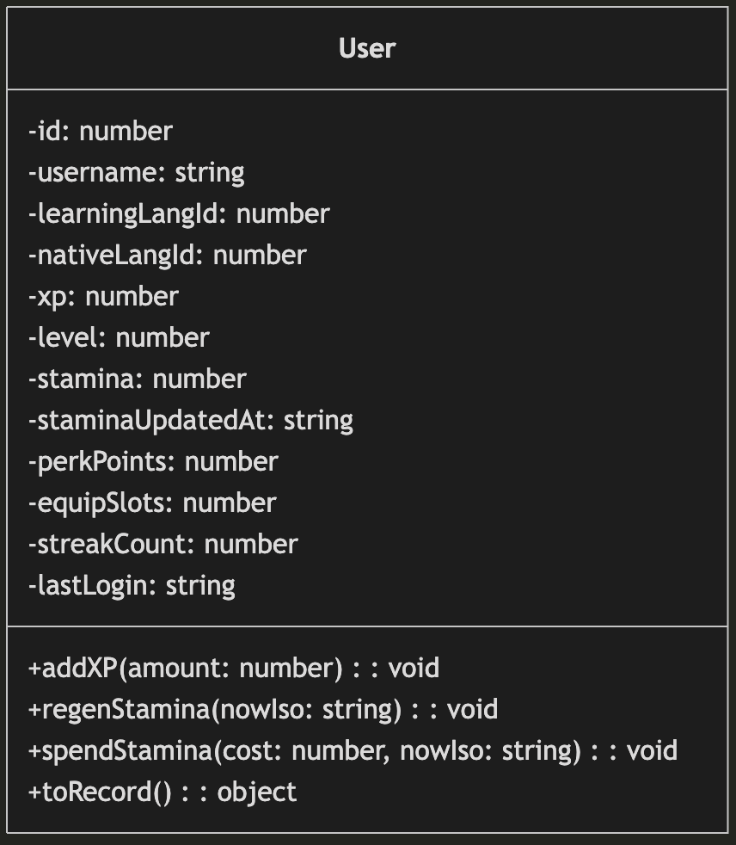
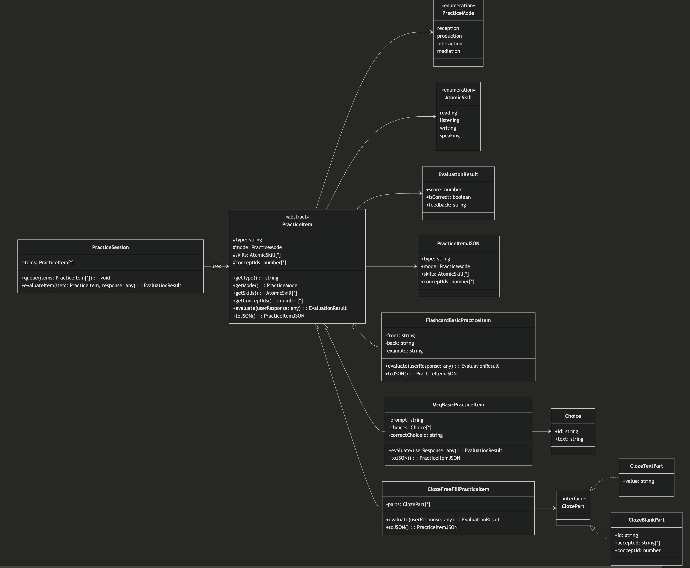

UI Design
Hermes provides a modern and minimal design for practicing a language. Hermes begins with a screen where a user can select one of their active language profiles or choose to start a new profile for a new language. After that, the user is taken to the main screen where they have a few options. First, they can engage in two types of practice: memorization or applied practice.
Memorization takes them to flashcards that they can quickly swipe through or use the buttons at the bottom to mark the cards as correct or incorrect. Practice has a similar flow except multiple question types are available and is meant to be more applied practice. Practice also uses a local Large Language Model (LLM) to generate question types based on the focus word or grammar point the learner is trying to practice. The LLM also contextualizes the output to vocabulary or grammar points the learner already knows so that they are not overwhelmed by new concepts.
The app also contains vocab and grammar libraries that are aligned with the Common European Framework of Reference for Languages (CEFR). The learner can navigate to these to see specific details, translations, definitions, examples, and even analytics for that particular vocab or grammar. Additionally, analytics pages are provided at the end of each memorization and practice session, as well as an analytics page for all sessions within a date range.
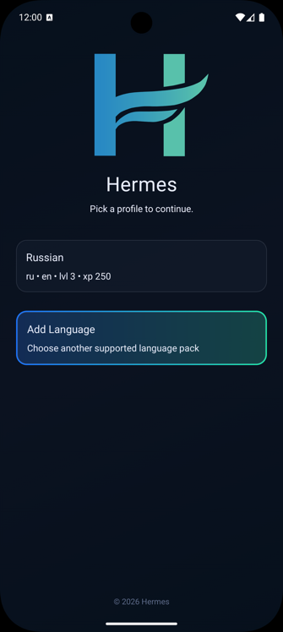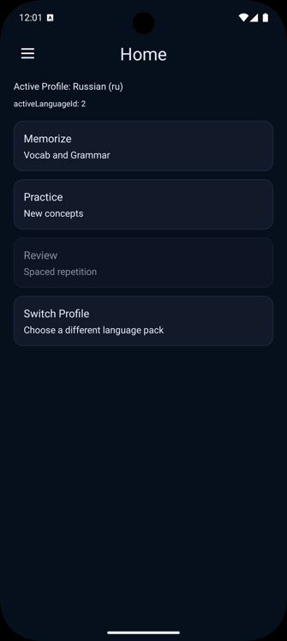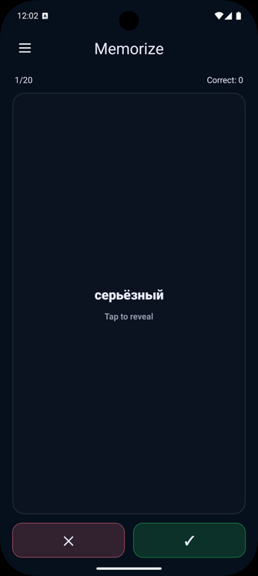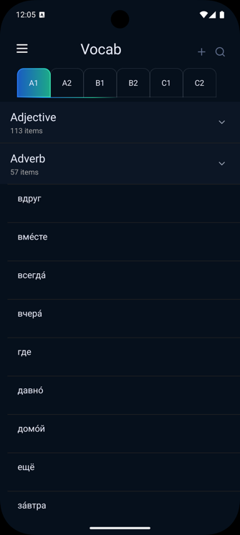
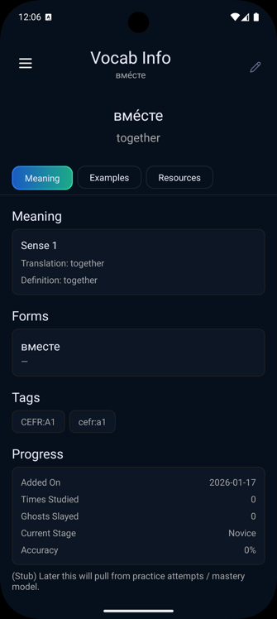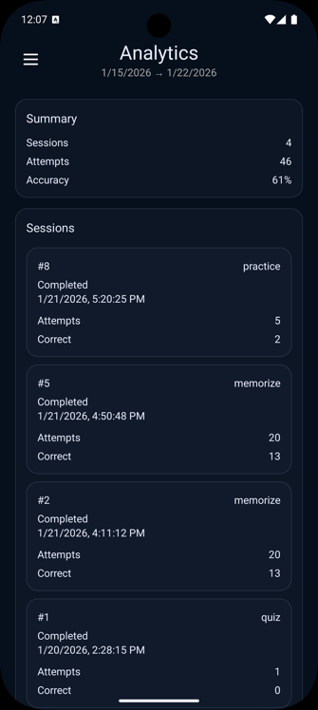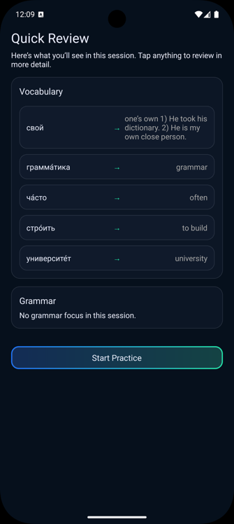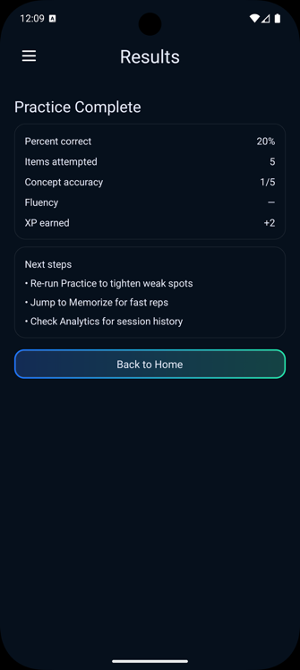

Unit Test Plan

Introduction

Purpose
Hermes uses automated tests to validate core domain logic that must be reliable regardless of the UI state: user progression/stamina, streak rules, practice item construction and evaluation, and practice session persistence logic. The tests primarily use unit tests for deterministic business rules and a light end-to-end style harness for practice items to ensure each practice item can be constructed from JSON and can score both correct and incorrect submissions.

Overview
Testing focuses on parts of the application where correctness matters more than presentation. For example, user progression and stamina behavior are deterministic and ideal for unit tests. Practice items are created from JSON and evaluated against sample submissions to verify that each item type produces consistent scoring outputs. And repository logic is testing with a lightweight fake database to validate SQL-path behavior. The practice item tests are somewhat unique because Hermes supports multiple practice types under a shared interface; the tests verify both shared invariants and type-specific evaluation behavior.

Test Plan

Items
Three things are required to run the test: a node.js environment capable of running the project test runner (e.g., npm test), a test runner configured for JavaScript/TypeScript (e.g., Jest), and JSON fixtures for practice items and submissions.

Features
The following functions/features are covered in the tests:
- User Progression/Stamina: constructing a user from minimal required fields, XP gain and level progression, and stamina regen/spend.
- Streak Rules: starting a streak, increment/reset behavior across days, and XP multiplier calculation based on streak count.
- Practice Item Evaluation: constructing practice items from JSON by type, evaluating good vs. bad submissions, and shared invariants across all item types.
- Repository Logic: creating/saving sessions and attempts via repository calls, and ensuring expected inserts occur using a fake database.

Deliverables
The testing process produced several concrete artifacts that support verification and future maintenance of the system. The primary deliverables were the test source files themselves, including unit tests for core domain logic and fixture-driven tests for practice item evaluation. In cases where regressions or unexpected behavior occurred, console output from failing test runs served as diagnostic evidence and guided remediation. As new practice item types or evaluation scenarios are introduced, JSON fixture files are updated or extended to ensure continued coverage of expected and edge-case behaviors.

Tasks
The following tasks outline the required steps to perform unit testing for the Hermes application. These tasks define the prerequisites and actions needed to execute the test plan, independent of the specific results obtained.
- Set up the development environment with the required tools, including Node.js and the project’s configured JavaScript/TypeScript testing framework.
- Install all project dependencies and verify that the test runner is able to execute .test.js and .test.ts files.
- Ensure that the unit test files exist for core domain logic, including user progression rules, streak computation, practice item evaluation, and repository persistence behavior.
- Prepare the representative test data, including JSON fixture files for practice items and corresponding submission inputs used to validate evaluation behavior.
- Configure any required test support utilities, such as fake or in-memory database objects for repository-level tests.
- Execute the test suite using the project’s test command and collect test output for review.

Needs
To perform testing, the project’s dependencies must be installed using the standard package installation process (i.e., npm install). The test runner must be configured to execute both JavaScript and TypeScript test files (e.g., .test.js and .test.ts). Repository-level tests require a fake or in-memory database object to simulate persistence behavior without relying on a device emulator or physical SQLite database. Practice item evaluation test additionally require access to JSON fixture files that define practice items and corresponding submission inputs.

Pass/Fail Criteria
A test run is considered a pass when all tests complete without failures and expected assertions are met. For practice item evaluation, this includes verifying that the evaluation result reflects the correct practice item type, produces a bounded score between 0 and 1, and includes at least one concept-level result. For rule- and entity-based tests (such as streak or stamina logic), outputs must match expected values for each defined scenario, including edge cases such as same-day completions or day-boundary transitions.
A test run is considered a fail if any assertion fails or if an exception is thrown during construction, evaluation, or persistence operations. When a failure occurs, remediation involves fixing the smallest responsible unit (such as a rule function, entity method, evaluator, or repository method). If the failure reveals an untested edge case, a new fixture or test case is added to prevent recurrence. All fixes are documented through commit messages that reference the failing test and the scenario being addressed.

Specifications
Below are some examples of test case screenshots from Hermes.
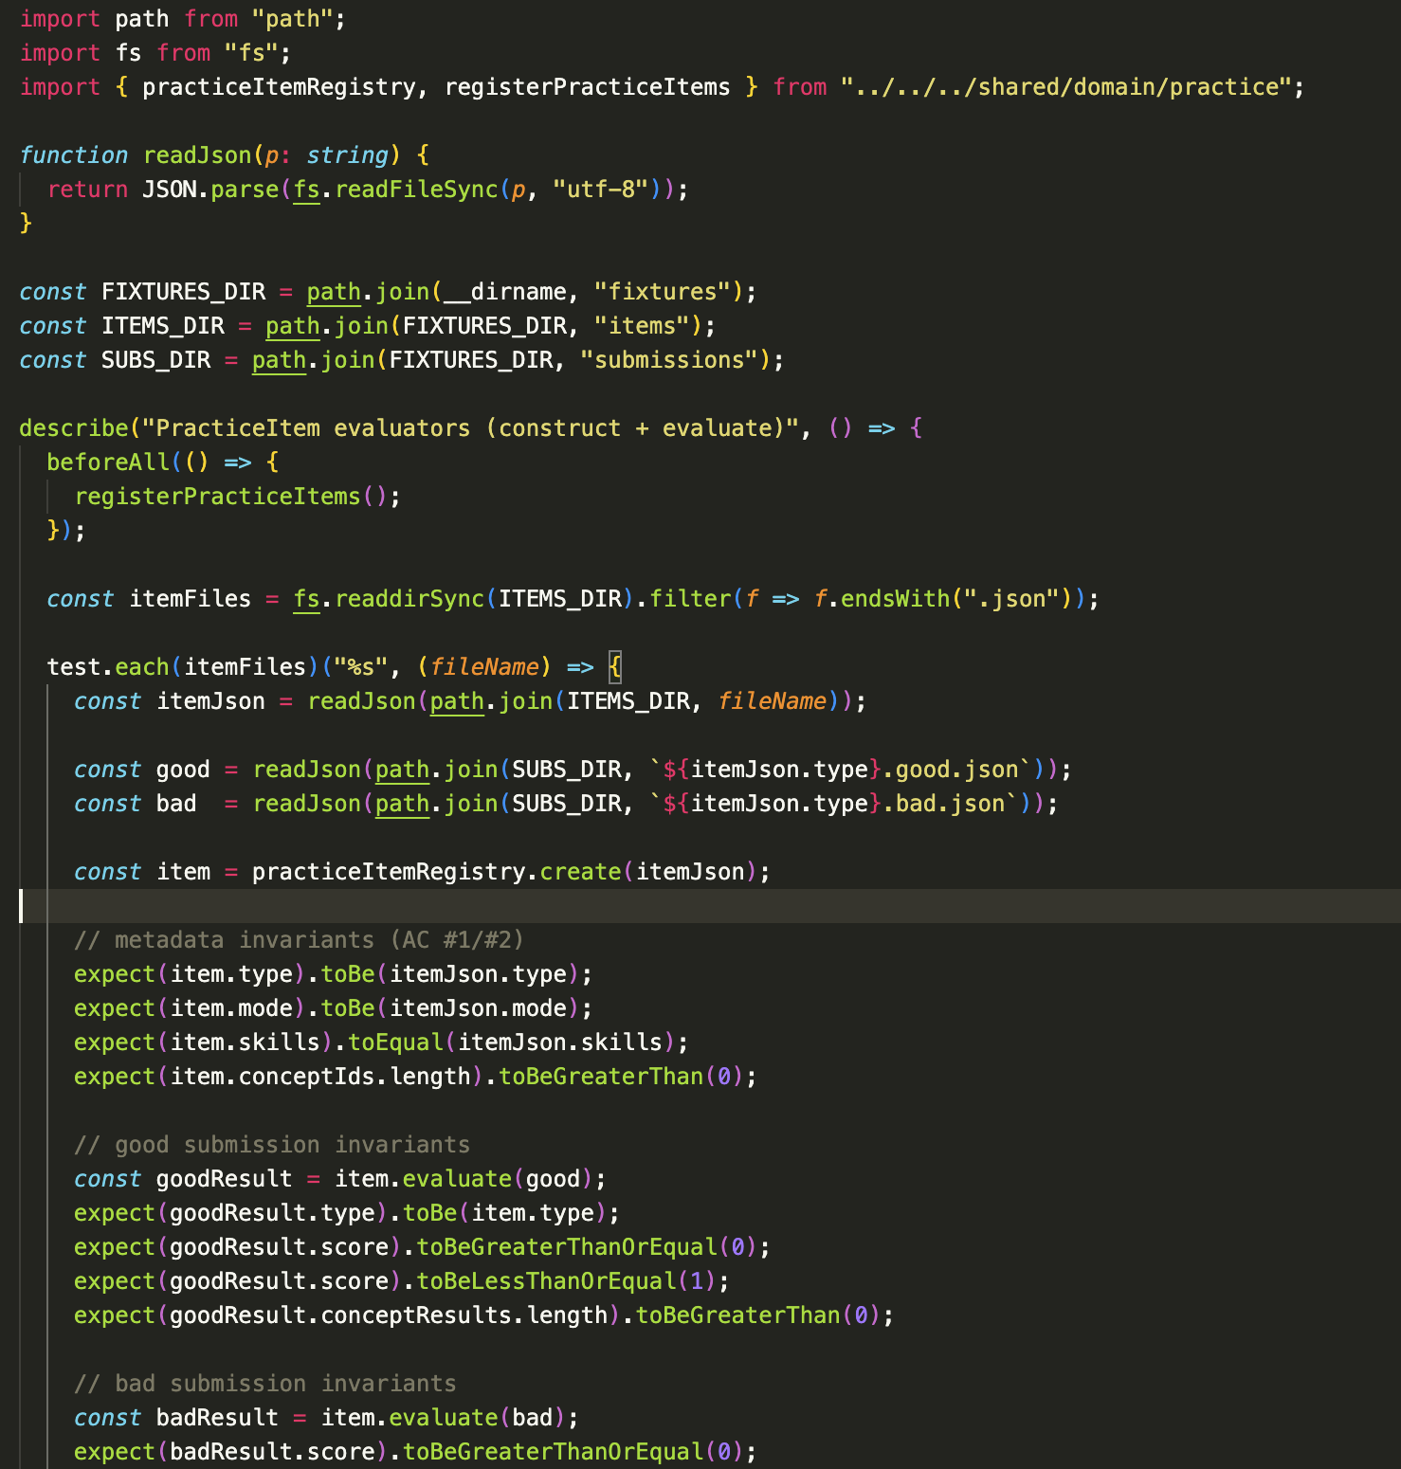
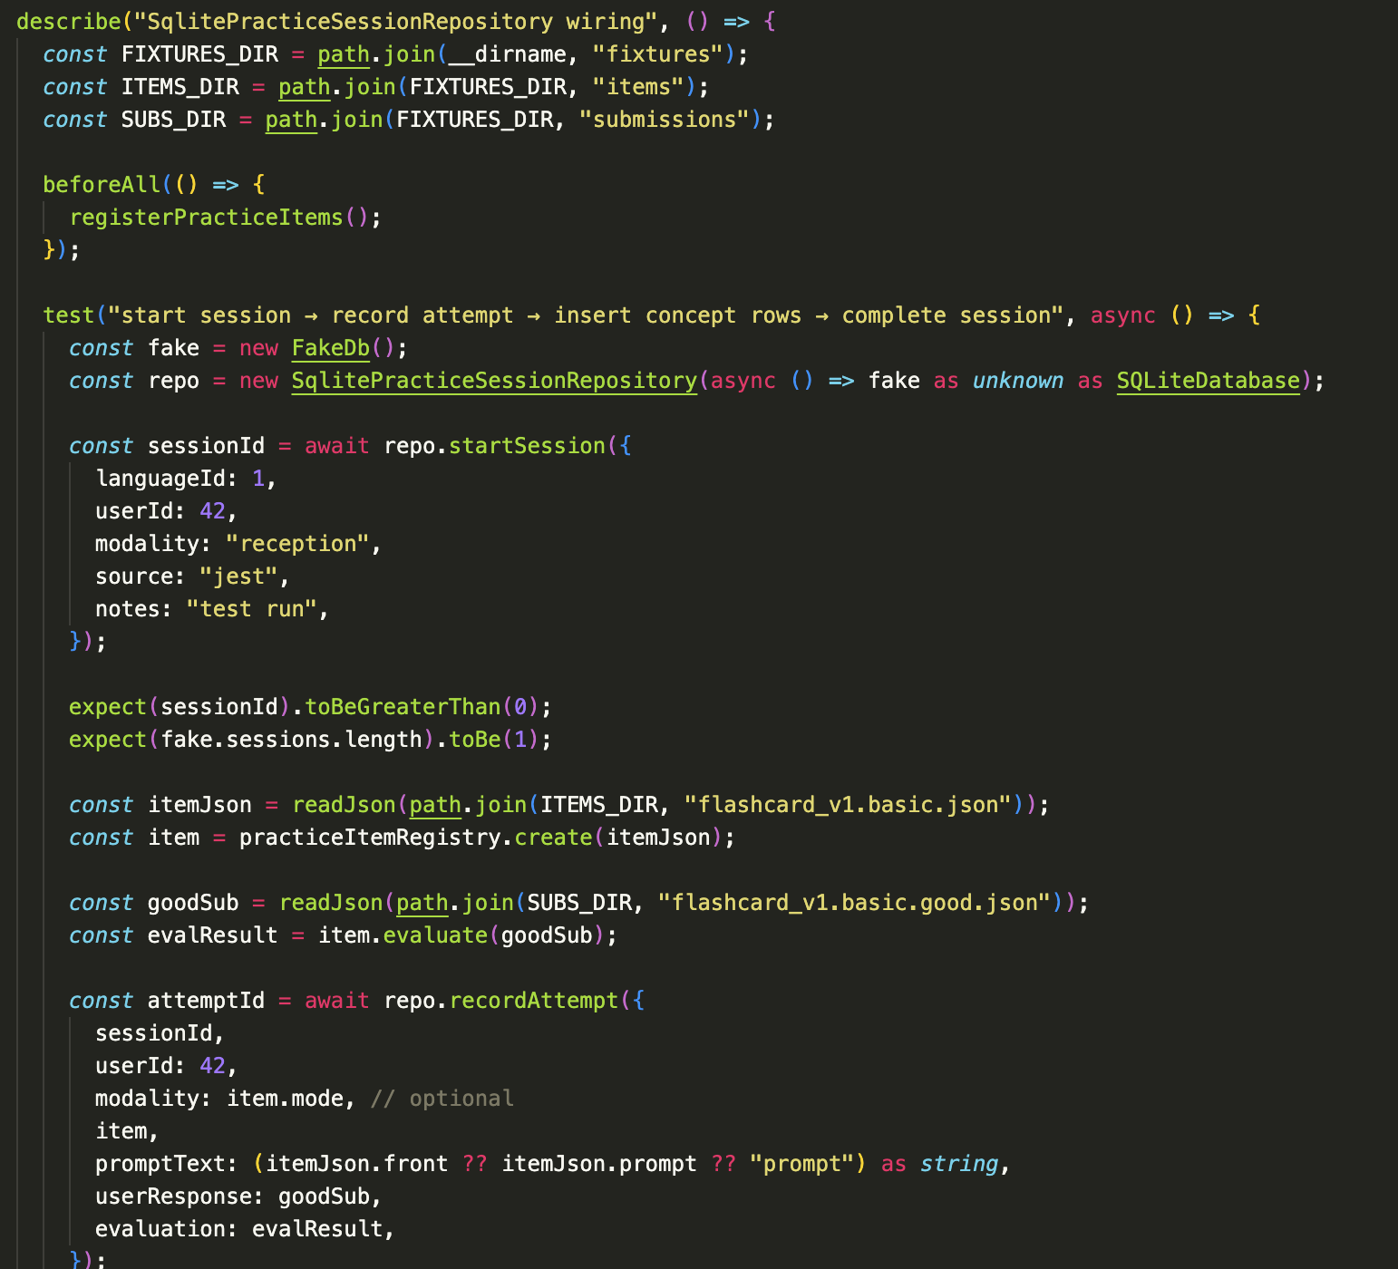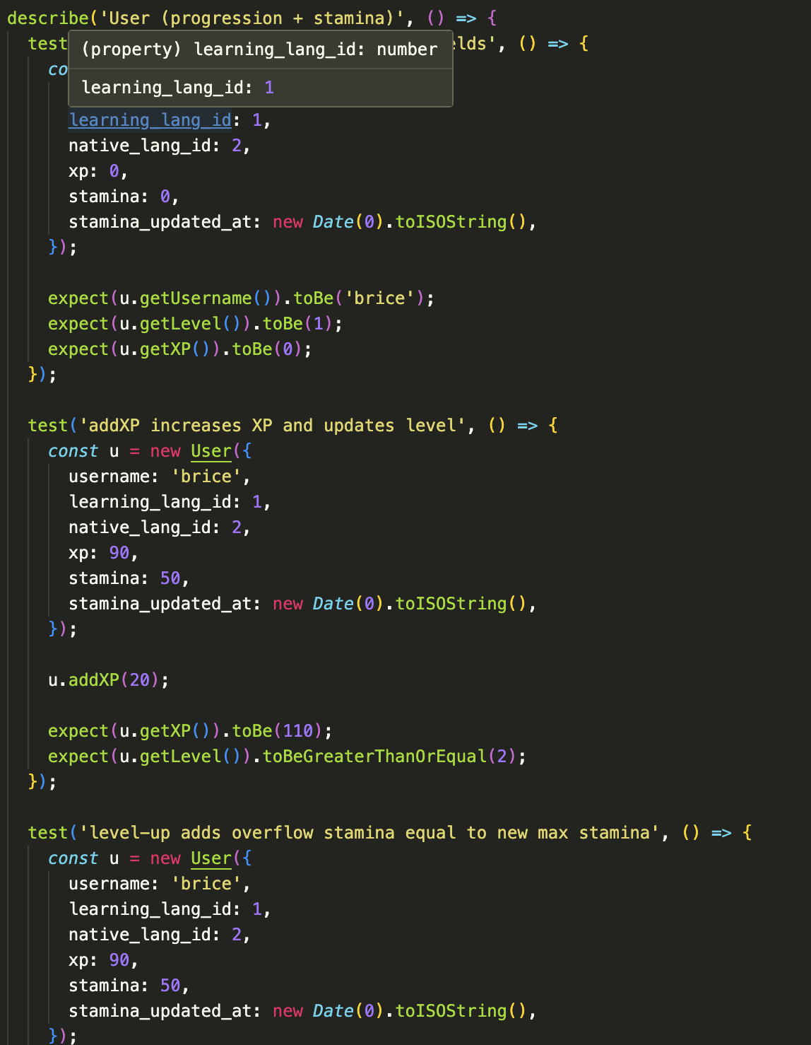

Procedures
The testing procedures implemented for this project followed the tasks outlined above and were carried out iteratively throughout development.
Test case preparation focused on identifying critical application behaviors that required validation, including user state updates, streak logic, and polymorphic evaluation of practice items. Existing unit tests were reviewed and supplemented with fixture-driven tests to ensure consistent behavior across different practice item types.
The test environment was prepared by installing project dependencies and confirming that the test runner was properly configured to execute both JavaScript and TypeScript test files. For persistence-related tests, a fake or in-memory database implementation was used to simulate repository behavior without requiring an emulator or physical database.
Test execution involved running the full test suite locally and reviewing console output to determine pass or fail status. When failures occurred, the process described above was followed: the failing test name and stack trace were used to isolate the source of the issue and remediation was performed by correcting the smallest responsible unit of code, such as an entity method, evaluator, or repository function.
Following remediation, the test suite was re-run to confirm that the issue was resolved and that no regressions were introduced. Final test outcomes were reviewed and documented, and test fixtures or cases were updated as needed to reflect the corrected behavior.

Results
The test results for Hermes were obtained after executing the unit test suite using the project’s configured JavaScript/TypeScript testing framework. The following examples summarize representative test results.
User progression and streak rules tests passed when experience points, level progression, stamina updates, and streak calculations behaved as expected according to the rules defined for it. Assertions confirmed correct handling of day boundaries, prevention of duplicate streak increments, and valid stamina bounds.
Practice item construction tests passed when practice items were successfully instantiated from their JSON definitions using the practice item registry. Metadata such as item type, mode, skills, and concept identifiers matched the source definitions.
Practice item evaluation tests passed when evaluating both good and bad submissions for each practice item type. Valid submissions produced bounded scores between 0 and 1 with associated concept-level results, while invalid submissions were handled safely and returned structured evaluation results without runtime errors.
Results screenshot: all tests passed
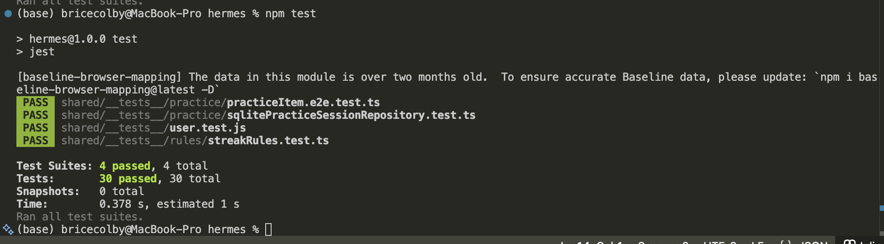
Results screenshot: practice item test failed because the schema had evolved, but the test json had not been updated to meet the new schema.
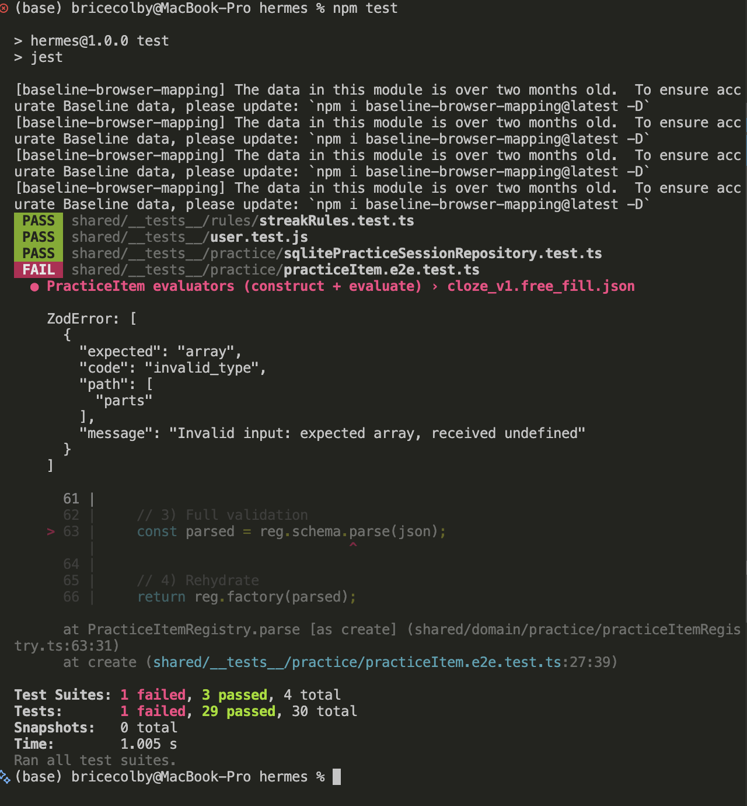

GitLab Repository & Branch History
https://gitlab.com/wgu-gitlab-environment/student-repos/bcolby7/d424-software-engineering-capstone/-/tree/working?ref_type=heads
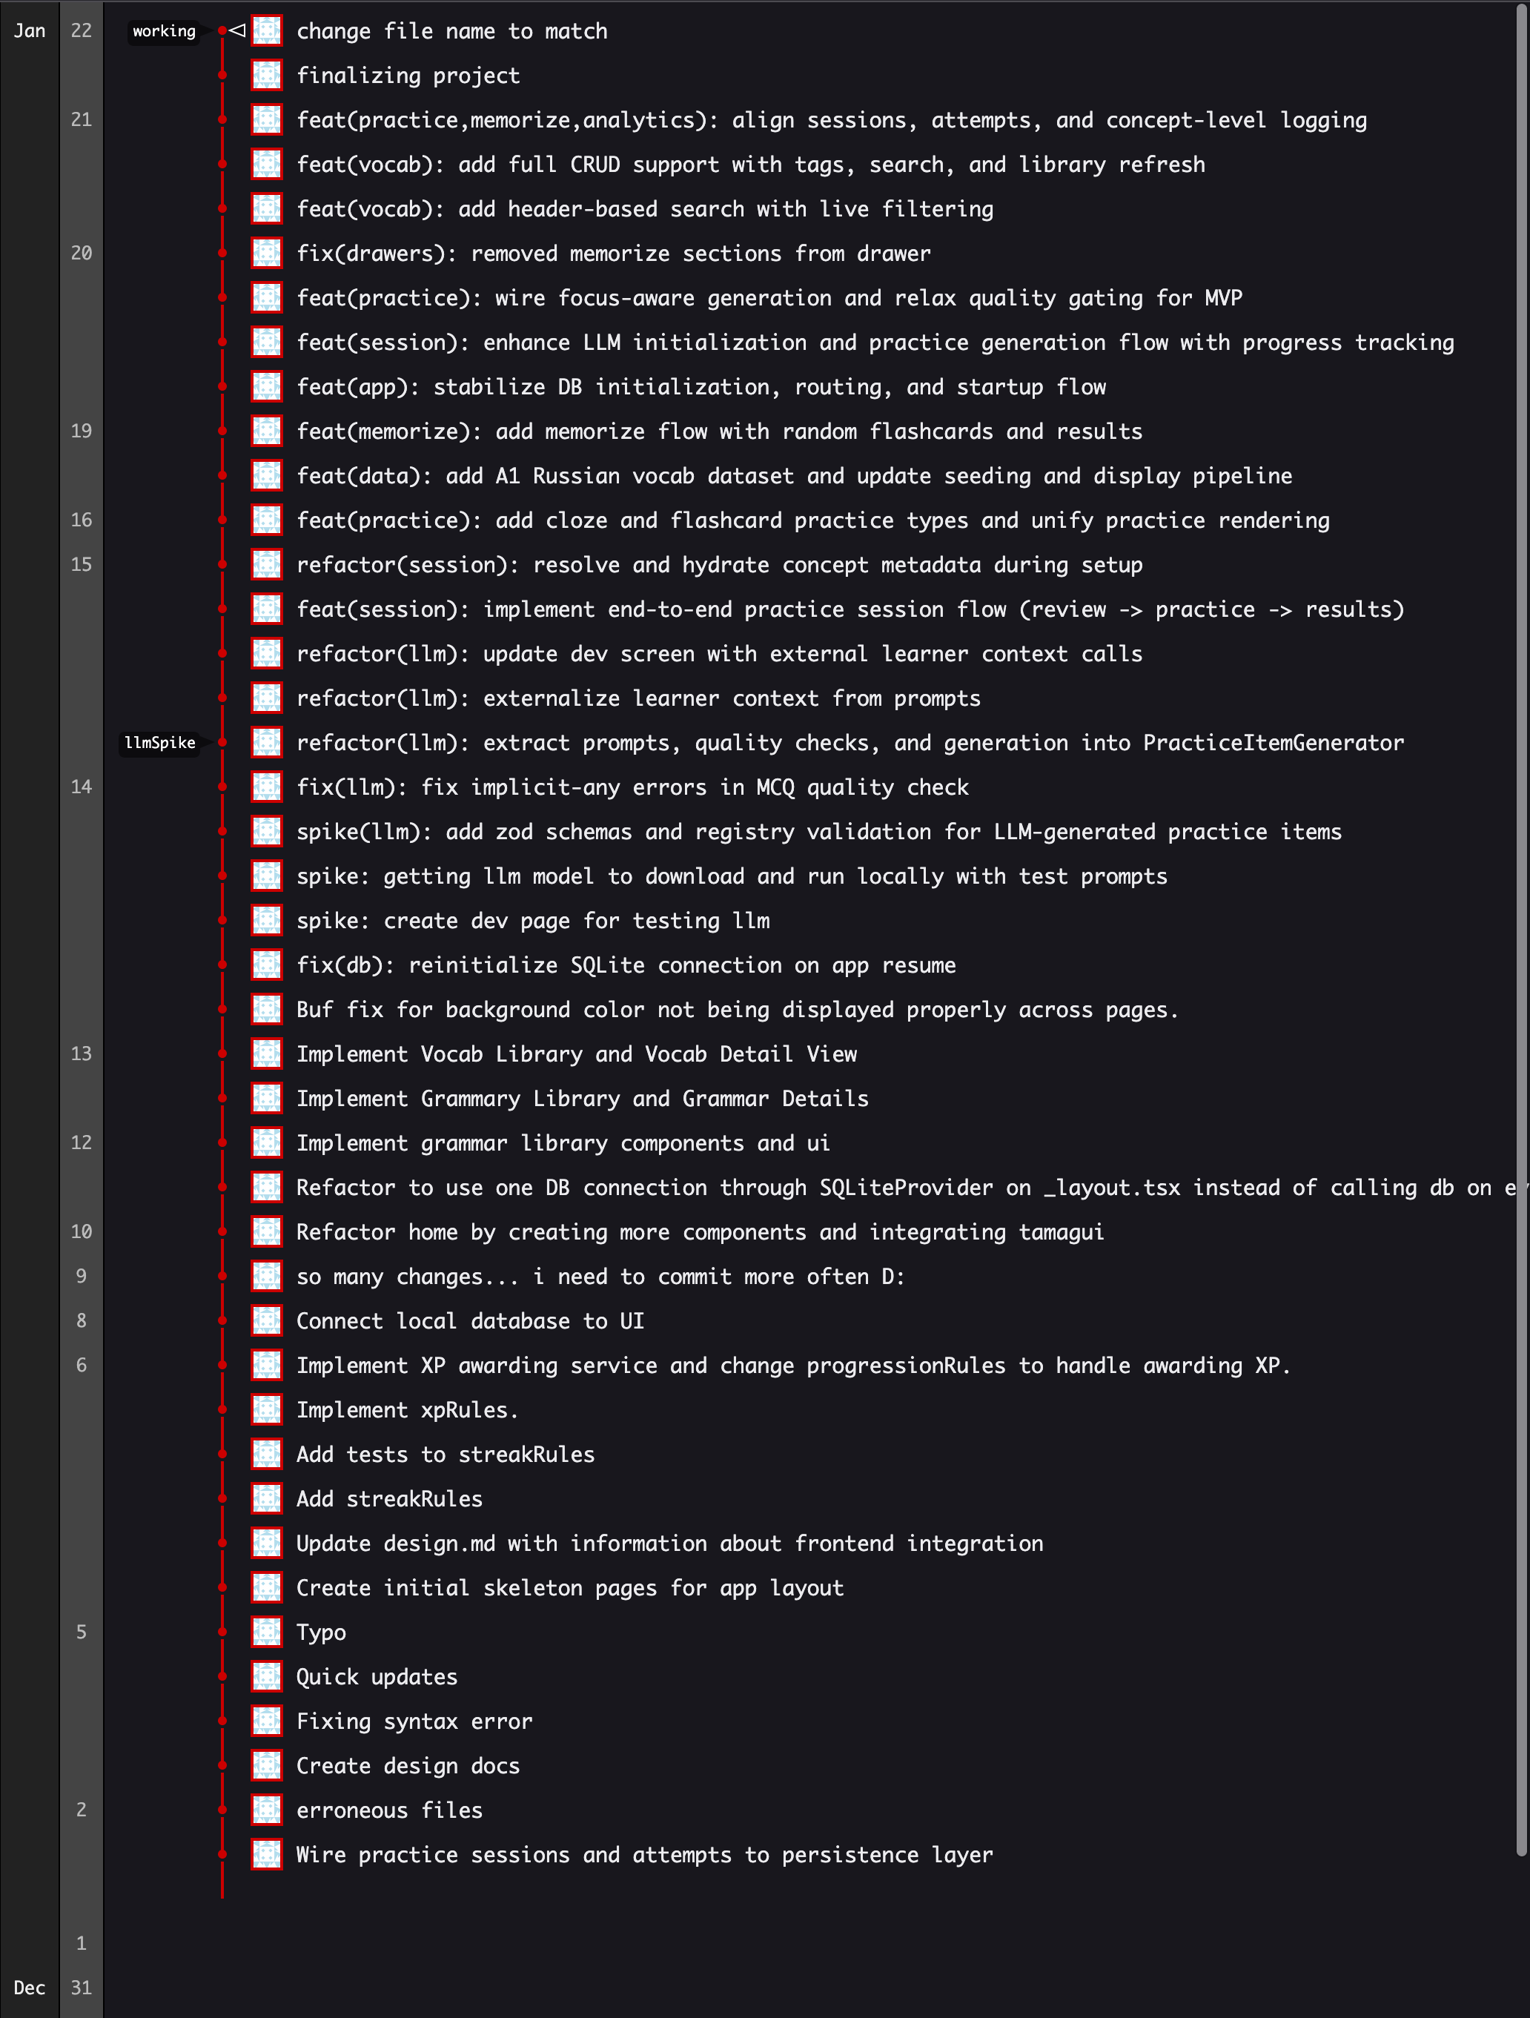

Panopto Video Link
https://wgu.hosted.panopto.com/Panopto/Pages/Viewer.aspx?id=23acf83b-3777-4935-9f2d-b3db00160882

User Guide: Application Setup and Maintenance

Overview
This guide describes how to set up, run, and maintain the Hermes application from a maintenance or developer perspective. Hermes is a mobile application built using Expo and React Native, designed to run locally during development and deployed to app stores for end users. The application uses a local SQLite database and a local LLM for generating practice content.
This guide assumes familiarity with basic command-line usage and Node.js-based development workflows.

Environment Setup
To run Hermes locally for development or maintenance purposes, the following prerequisites are required:
- Node.js installed on the system
- Expo CLI available via npx
- Project dependencies installed via npm install
The application uses an .env file to manage environment-specific configuration. This file must be present in the project root before starting the application.

Running the Application Locally
Hermes is started locally using the Expo development server. To launch the application:
- Navigate to the project root directory.
- Install dependencies if they are not already installed: npm install
- Start the Expo development server: npx expo start
- Use the Expo interface to launch the application on an emulator or physical depending on the available options.
Upon launch, the application automatically initializes its local SQLite database. The database is created on first run and is seeded with initial content to support immediate use of the application.

Database and Data Management
Hermes uses a local SQLite database for storing user profiles, vocabulary, grammar items, practice sessions, and evaluation results. The database is created automatically when the application is first run and does not require manual setup.
For maintenance purposes:
- Clearing or resetting the database can be done by removing the local SQLite file or reinstalling the application in the development environment.
- Seed data is currently sued to populate vocabulary and grammar content for demonstration and testing purposes.
- As the application evolves, seed data may be replaced or supplemented with additional content sources.

Testing and Validation
Maintenance tasks include running the automated test suite to validate core functionality. Tests are executed locally using the project’s configured test runner and cover user logic, practice item evaluation, and persistence behavior.
Tests should be run after making changes to domain logic, practice evaluation, or database interaction code to ensure regressions are not introduced.

Deployment and Distribution
For user testing and distribution, Hermes is deployed via Apple TestFlight. TestFlight allows the application to be installed on physical iPhones without requiring the app to be publicly released on the App Store. Builds are generated using expo’s iOS build workflow. TestFlight is used to distribute pre-release versions of the application to testers. To distribute a new version of Hermes to users, use Expo and EAS to generate iOS builds.
Before creating a new build, ensure that:
- All intended code changes have been committed to the repository.
- The .env file contains the appropriate configuration for the target build environment.
- The application version has been updated if required (e.g., in app.json or related configuration files.
To create a new iOS build, the maintener runs the Expo build command using EAS (npx eas build --platform ios and npx submit --platform ios). This process packages the application, compiles the iOS binary, and uploads it to Apple’s build services. Once the build process completes successfully, the build is automatically uploaded to App Store Connect.
After the build is uploaded, it becomes available in App Store Connect under the TestFlight section of the application. From there, the maintainer can assign the build to internal or external users, add or update release notes describing the changes in the new version, or enable the build for testing.
Once a build is approved by Apple for TestFlight use, it becomes available to testers through the TestFlight app. Testers are notified that a new version is ready to install or update.

User Guide: End User Perspective

Overview
Hermes is a language-learning application designed to provide focused, structured practice through a modern and minimal interface. The application supports multiple language profiles and offers both memorization and applied practice activities aligned with the Common European Framework of Reference for Languages (CEFR).
Hermes is distributed to users through Apple TestFlight and runs directly on iPhones. No technical setup is required by the user beyond installing the app through TestFlight.

Installing Hermes via TestFlight
Hermes is distributed as a beta application using Apple TestFlight. To install Hermes on an iPhone, the user must first install the TestFlight app from the Apple App Store. Once TestFlight is installed, the user can download the beta app through the following link:
https://testflight.apple.com/join/s4VhW4UE
When this link is opened on the iPhone, TestFlight automatically launches, the Hermes app is displayed as an available beta app, and the user can now download the app. Updates are released through the same platform and the user will receive a notification when an update is available. Updates are installed through TestFlight.

Getting Started
When Hermes is launched, the user is prompted to select an existing language profile or create a new profile for a different language. Each language profile tracks progress independently, allowing users to practice multiple languages without mixing progress.
After selecting a profile, the user is taken to the main screen, which provides access to practice modes, libraries, and analytics.

Practice Modes
Hermes provides two primary practice modes: memorization and applied practice. Memorization mode focuses on rapid recall using flashcards. Learners can swipe through cards or use on-screen controls to mark responses as correct or incorrect. This mode is designed for quick, low friction review of vocabulary and concepts the learner has already encountered. Applied practice offers a more varied and challenging experience. In this mode, learners encounter multiple question types, such as multiple-choice, fill-in-the-blank (cloze), and more. Practice questions are generated using a local LLM, which tailors questions to the learner’s current vocabulary and grammar knowledge. This adaptive behavior helps reinforce known concepts without overwhelming the learner with unfamiliar material.

Vocab and Grammar Libraries
Hermes includes dedicated vocab and grammar
libraries aligned with CEFR levels. From these libraries, learners can:
- View definitions, translations, and usage examples
- Explore grammar explanations and patterns
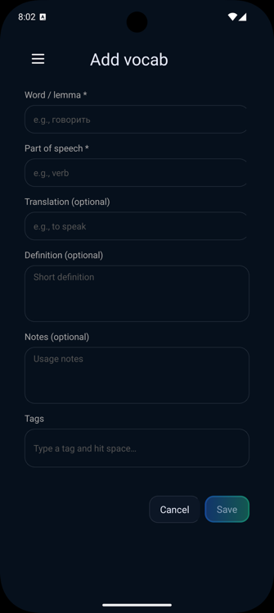
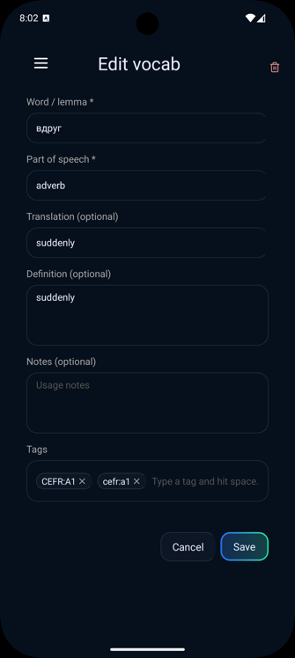
- Review analytics related to specific vocab or grammar items.
These libraries allow learners to explore content intentionally, outside of active practice sessions.
Hermes also allows users to create, edit, or remove their own vocab entries. Users can add new vocabulary by opening the Add Vocab screen from the vocabulary section. Required fields include the word (lemma) and part of speech, while translation, definition, usage notes, and tags are optional. Once saved, the vocabulary item is stored locally and becomes available for practice and review. Selecting an existing vocabulary entry opens the Edit Vocab screen with all fields pre-filled. Users can update spelling, translations, definitions, notes, or tags, and save changes to immediately update the item throughout the app. Vocabulary items can be deleted from the Edit Vocab screen using the delete option. Deleted entries are removed from the local database and no longer appear in practice sessions or libraries.

Feedback and Analytics
At the end of each memorization or practice session, Hermes provides an analytics screen
summarizing performance. This includes correctness, progress indicators, and concept-level feedback. Learners can also access analytics for all sessions within a selected date range, allowing them to monitor progress over time and identify areas for improvement.

General Usage Notes
Hermes is designed to be intuitive and self-guided. Most actions are accessible through clear navigation options, and no external accounts or logins are required. All progress is stored locally on the device, enabling offline use and fast interaction.

