**End of study project 4th Year Master Degree.**

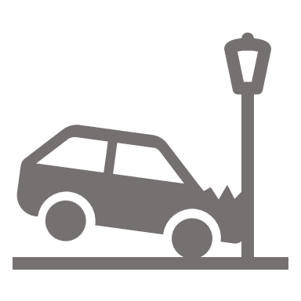

*Mentor*: Fabrice NOLACK

*Realize by*: Fabrice NOLACK

**Car Accident Detection.**

**2023 – 2024**

**Car Accident Detection Model**

In order to reduce intervention time in the event of a road accident, ‘SPF Mobilité et Transport’ has decided to launch a new project: ***a car accident detection system***. Use the live car accident detection system on the traffic camera system installed in Brussels, in order to detect, alert and inform the relevant services and the public in the event of a road accident. The first stage of this project is to detect accidents.

To achieve this, the aim is to deploy the beta version of the system in Brussels, and if the results are positive, to gradually roll out the system in all regions of the country.

**Project Description:**

The aim of this project is to develop an ***intelligent car accident detection system*** leveraging machine learning techniques. The system should detect any car accident in live video sequence.

**Objectives:**

1. *Data Preprocessing*: The dataset provide for the project contain images and some videos sequence of traffic road.
2. *Feature Engineering*: Extract meaningful features from the provided data to represent different types of driving behaviors and events.
3. *Machine Learning Model Development*: Build and train a machine learning model capable of detecting and classifying car accidents based on the generated features.
4. *Model Integration and Real-time Detection*: Integrate the trained model into a real-time detection system to identify potential accidents using incoming sensor data.
5. *Evaluation and Testing*: Evaluate the accuracy, precision, and recall of the model in detecting accidents. Test the system using simulated or real-world scenarios to validate its effectiveness.

**Key Tasks:**

1. *Data Collection and Processing*: You can add any other dataset to the provided dataset. But keep in mind to introduce the dataset you add in the document you will write.
2. *Feature Extraction and Selection*: Identify and extract pertinent features from the sensor data that could indicate potential accidents or unusual driving patterns.
3. *Model Training*: Utilize supervised learning techniques to train a classification model capable of recognizing accident patterns from the selected features.
4. *Real-time Integration*: Develop a real-time system that can continuously process a video to detect accident.
5. *Testing and Validation*: Evaluate the model's performance using appropriate metrics and conduct comprehensive testing to ensure the accuracy and reliability of the detection system.

**Expected Deliverables:**

At the end of you project in the respected delay, you will deliver (directly on <https://exams.ecole-it.com>) *a zip file* containing:

1. *Trained machine learning model and code source (any notebook)* capable of accurately detecting car accidents.
2. *Detailed* *documentation (docx, md or latex)* of data preprocessing, model development, and model improvement.

Between 2 to 10 pages describing any steps used to solve each problems, and any additional features (improvements) you did.

Used the following specification:

For title:

font=Times New Roman,

size=16,

style=Bold, center, underline.

For paragraph:

font=Times New Roman,

size=12,

style=justify.

1. *Presentation (pptx, canvas, Prezi)* summarizing the project's objectives, methodologies, results, and challenges faced.

RESPECT THE DEADLINE MENTION ON <https://exams.ecole-it.com>

**Skills and Technologies Involved:**

* *Data preprocessing* and *feature engineering,*
* *Machine learning algorithms* (classification models like Random Forest, SVM, or Neural Networks),
* *Python programming language and relevant libraries/*frameworks (e.g., Pandas, Scikit-learn, TensorFlow),
* *Real-time data processing* and *system integration*.

**Evaluation Criteria:**

The project will be evaluated based on the following criteria:

1. The *functionality and usability* of the Model **(60 pts)**,
2. The *documentation* *quality* **(10 pts)**,
3. The *presentation* of the *project's outcomes* **(20 pts)**,
4. All *improvements* you did on your project (only if *it is well documented*) **(10 pts)**.

**Resources:**

Access to the provided :

1. *The dataset* : do not work on the git, fork the dataset on your git before make any changes, available on the github at the url: <https://github.com/FabriceNolack/PFE_23-24_4eme.git>
2. *Programming tools* : the notebook in python (you can use google colab or any other similar tool),
3. *Libraries* : all libraries suitable for the purpose,
4. *Mentorship & support* : I will be available throughout the project duration.

**Recommendations**:

You can use any knowledges and materials you got during your courses (all level included) at Ecole-IT or eithers to make your project.

You can cross borders and propose more features in your project, but just keep in mind to include it in the document. Any improvements not documented will not be considered.

Citations and references are highly recommended. Source code and Capture are not welcome in your documentation.

Believe you can and you will.

**GOOD LUCK !!!**