4x03 a1 hardcopy chiuh1

400054774

PLOT for 3

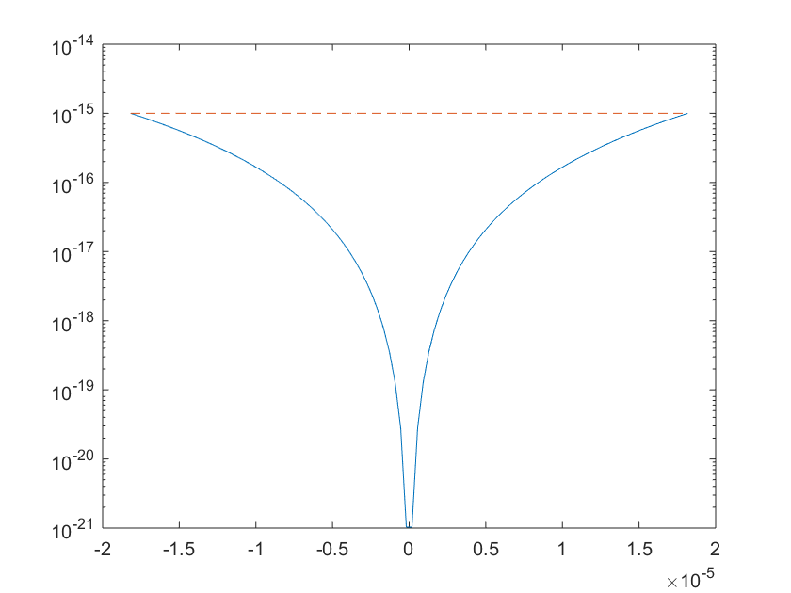

**gauss.m code:**

function A = gauss(A)

s = size(A);

s = s(1);

U = A;

L = eye(s);

for i = 1:s-1

for j = i+1:s

a = -U(j,i);

b = U(i,i);

if a~=0 && b~=0

fact = a/b; %% multiplication factor

U(j,:) = fact*U(i,:) + U(j,:);

L(j,i) = -fact;

end

end

end

A = L - eye(s) +U;

end

**gauss_p.m code:**

function [A l] = gauss_p(A)

s = size(A);

s = s(1);

U = A;

A1 = A;

L = zeros(s);

scal = max(abs(U),[],2); %make scale

l = 1:1:s; %index array

for i = 1:s-1

check = abs(A1(:,i))./scal;

[~,piv] = max(check()); %index to swap

ind = find(l == piv);

A1(piv,:) = [0]; %% 0 row

l([ind i]) = l([i ind]); %swap

for j = i+1:s %%%%%%%row reduce%%%%%%%%

ni = l(i);

nj = l(j); %% use l as hash table

a = -U(nj,i);

b = U(ni,i);

if a~=0 && b~=0

fact = a/b;

U(nj,:) = fact*U(ni,:) + U(nj,:);

L(nj,i) = -fact;

end

end

end

P = zeros(s);

cnt = 1;

for i = l

P(cnt,i) = 1;

cnt = cnt + 1;

end

%%L = P+L;

%%L = P*L;

%%U = P*U;

A = L +U;

end

**backward code:**

function x = backward(A,b,l)

s = size(A);

s = s(1);

for k = 1:s-1

for i = k+1:s

ni = l(i);

nk = l(k);

b(ni) = b(ni) - A(ni,k)*b(nk);

end

end

ns = l(s);

x(s) = b(ns)/A(ns,s);

for i = s-1:-1:1

ni = l(i);

sum = b(ni);

for j = i+1:s

sum = sum - A(ni,j)*x(j);

end

x(i) = sum/A(ni,i);

end

end

**main.m code:**

function main()

fprintf('n\t\tAb\t\t\t\tno piv\t\t\t\tno piv\t\t\tcond(A)\n');

fprintf('-----------------------------------------------------------------\n');

for s = 2:20

H = hilb(s);

b = sum(H,2);

x = ones(s,1);

A = gauss(H);

l = 1:1:s;

[Ap lp] = gauss_p(H);

xn = backward(A,b,l)';

xp = backward(Ap,b,lp)';

Ab = norm(H\b - x)/norm(x);

err = norm(xn - x)/norm(x);

errp = norm(xp - x)/norm(x);

con = cond(H);

fprintf('%d\t%e\t%e\t%e\t%e\n', s,Ab,err,errp,con);

end

end

**main2.m code:**

function main2()

fprintf('n\t\tAb\t\t\t\tno piv\t\t\t\tpiv\t\t\tcond(A)\n');

fprintf('-----------------------------------------------------------------\n');

for s = 1:5

A = rand(500);

b = sum(A,2);

x = ones(500,1);

A = gauss(A);

l = 1:1:500;

[Ap lp] = gauss_p(A);

xn = backward(A,b,l)';

xp = backward(Ap,b,lp)';

Ab = norm(A\b - x)/norm(x);

err = norm(xn - x)/norm(x);

errp = norm(xp - x)/norm(x);

con = cond(A);

fprintf('%d\t%e\t%e\t%e\t%e\n', 500,Ab,err,errp,con);

end

end