SFWR 4X03 Assignment 3

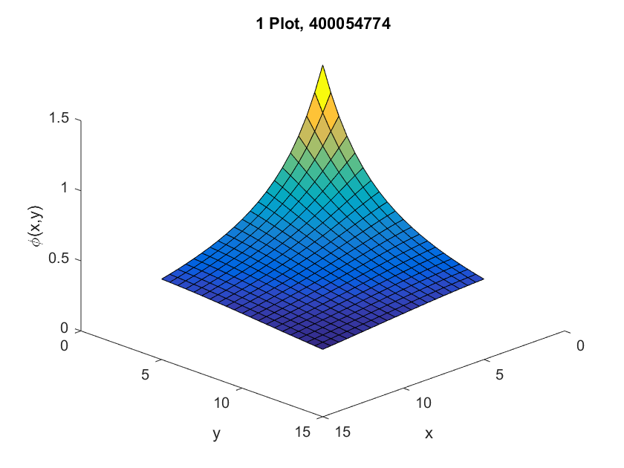1.

**Phi.m Code:**

function f = phi(xhat,yhat)

%%%%%%%%%%%%% parameters %%%%%%%%%%%%

a = -1;

b = 1;

tol = 0.00001;

level = 0;

max = 100;

%%%%%%%%%% function %%%%%%%%%%%%%%%%%

fun = @(x,y) 1./sqrt((xhat-x).^2 + (yhat-y).^2);

inner_integral = @(y) adsimpson(@(x) fun(x,y),a,b,tol,level,max); %% do innerloop with respect to x, make function of y

f = adsimpson(inner_integral,a,b,tol,level,max); %% do with respect to y

end

2 a)

**midpoint.m code:**

function [Q] = midpoint(f,a,b,n)

h = (b-a)/n;

i = 1:n; %% summation bounds

fi = f(a+(i-0.5).*h); %%vectorized compute

Q = h*sum(fi); %%add

End

**Trapezoid.m code:**

function [Q] = trapezoid(f,a,b,n)

h = (b-a)/n;

i = 1:n-1;

ti = a+ i.*h; %%make ti

Q = (h/2)*(f(a) + f(b)) + h*sum(f(ti)); %%sum and eq

end

**Simpson.m code:**

function [Q] = simpson(f,a,b,n)

h = (b-a)/n;

i = 1:n/2;

i1 = 1:n/2 -1;

t2i = a+ (2.*i1).*h;

t2iMinus1 = a+(2.*i -1).*h;

Q = (h/3)*(f(a) + 2*sum(f(t2i)) + 4*sum(f(t2iMinus1)) + f(b));

end

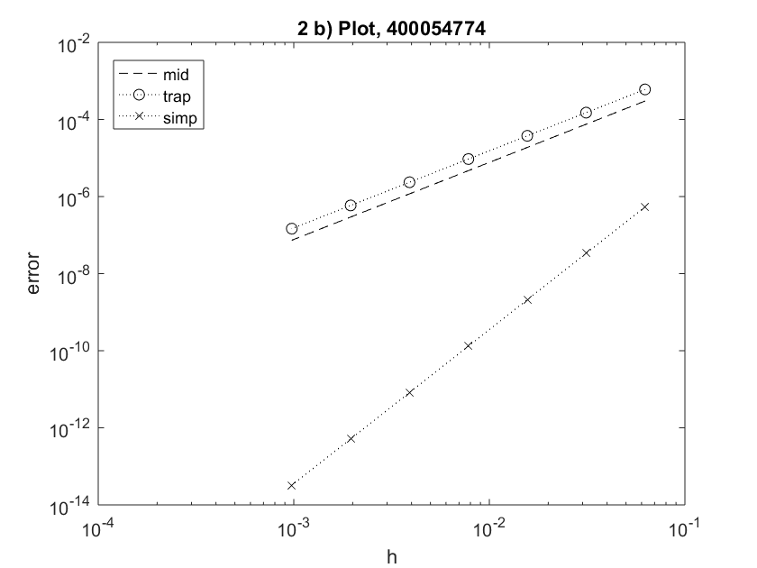

2b)

Trapezoid is the worst method, and midpoint is not much better. Simson is significantly better than the both. All methods are better as we use more intervals n.

2 c) we know: $err=ch^{p}$

So: $\log\left(err\right)=\log\left(c\right)+ p*log⁡(h)$

In the form of y = mx + b where: y = $\log\left(err\right)$, and x = $p*log⁡(h)$

This means p is the slope = $\frac{\log\left(err2\right)-log⁡(err1) }{\log\left(h2\right)- log⁡(h1)}$

Find p then sub p and a point to find c.

**Findconstants.m Code:**

function [c,p] = findconstants(rule,f,a,b)

actual = integral(f,a,b);

n1 = 2^4; %%use two points

n2 = 2^10;

h1 = 1/n1;

h2 = 1/n2;

err1 = abs(rule(f,a,b,n1) - actual);%% get error

err2 = abs(rule(f,a,b,n2) - actual);

p = log(err2/err1)/log(h2/h1); %% slope is p

c = err2/(h2^p); %%sub p in to find c

end

**Output on given equation:**

RULE C P

midpoint 0.076919 1.999906

trapezoid 0.153881 1.999946

Simpson 0.034631 3.995839

3.

Used findconstant.m and solved for error using err = ch^p

N = 18599

Err = 9.9995e-11

4 a)

|  |  |  |  |  |  |
| --- | --- | --- | --- | --- | --- |
| Planets | a | b | c | d | e |
| Jupiter | -1.1854e+00 | 2.2029e-02 | -4.9504e-01 | -1.4505e-01 | 2.6982e+01 |
| Saturn | -1.1667e+00 | 3.5963e-02 | 1.1673e-01 | -1.0899e+00 | 9.0382e+01 |
| Uranus | -1.1941e+00 | 1.1627e-02 | 1.8271e+00 | -2.5926e-01 | 3.6727e+02 |
| Neptune | -1.1671e+00 | 2.0704e-02 | -3.9269e-01 | -4.2316e-01 | 9.0381e+02 |
| Pluto | -1.0033e+00 | 2.3883e-01 | 1.1847e+01 | 1.2717e+01 | 1.2907e+03 |

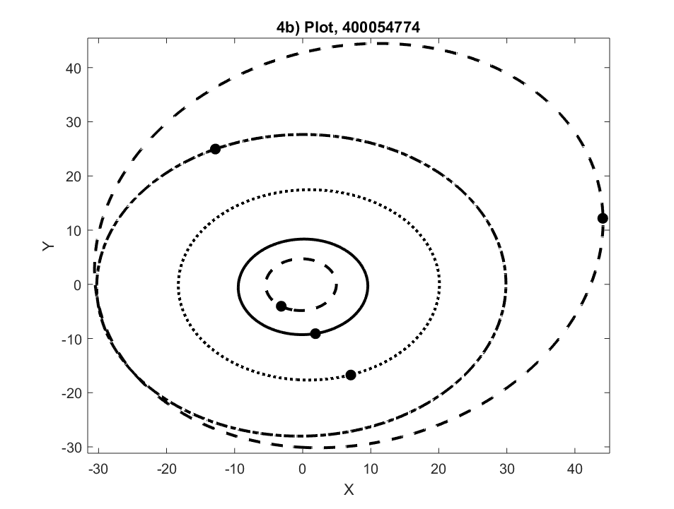4b)