**МИНОБРНАУКИ РОССИИ**

**Санкт-Петербургский государственный**

**электротехнический университет**

**«ЛЭТИ» им. В.И. Ульянова (Ленина)**

**Кафедра Вычислительной техники**

отчет

**по лабораторной работе № 1**

**по дисциплине «Операционные системы»**

Тема: **«Управление файловой системой»**

|  |  |  |
| --- | --- | --- |
| Студент гр. 3311 | Баймухамедов Р. Р. |  |
| Преподаватель | Тимофеев А. В. |  |

Санкт-Петербург

2024

**Цель работы**

Исследовать управление файловой системой спомощью Win32 API

**Задание**

Управление дисками, каталогами и файлами.

**Постановка задачи и описание решения**

Для выполнения данной лабораторной работы необходимо разработать консольное приложение с меню (каждая выполняемая функция и/или операция должна быть доступна по отдельному пункту меню), которое выполняет:

* Вывод списка дисков
* Для одного из выбранных дисков вывод информации о диске и размер свободного пространства
* Создание и удаление заданных каталогов
* Создание файлов в новых каталогах
* Копирование и перемещение файлов между каталогами с возможностью выявления попытки работы с файлами, имеющими совпадающие имена
* Анализ и изменение атрибутов файлов

**Примеры выполнения программы**

Примеры работоспособности консольного приложения продемонстрированы на рис. 1-4

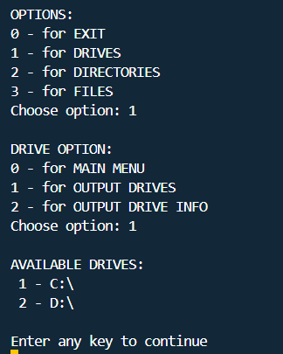

Рисунок .1 (Вывод дисков)

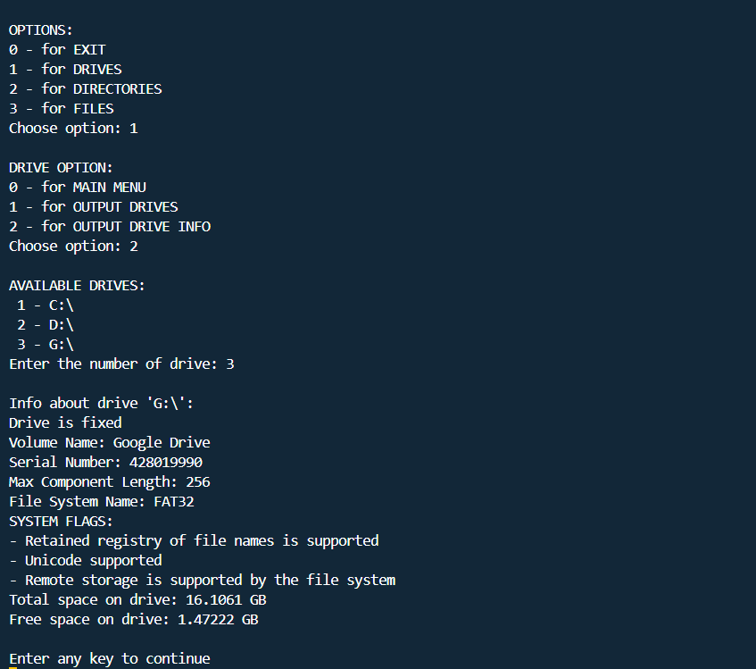

Рисунок .2 (Вывод информации о диске)

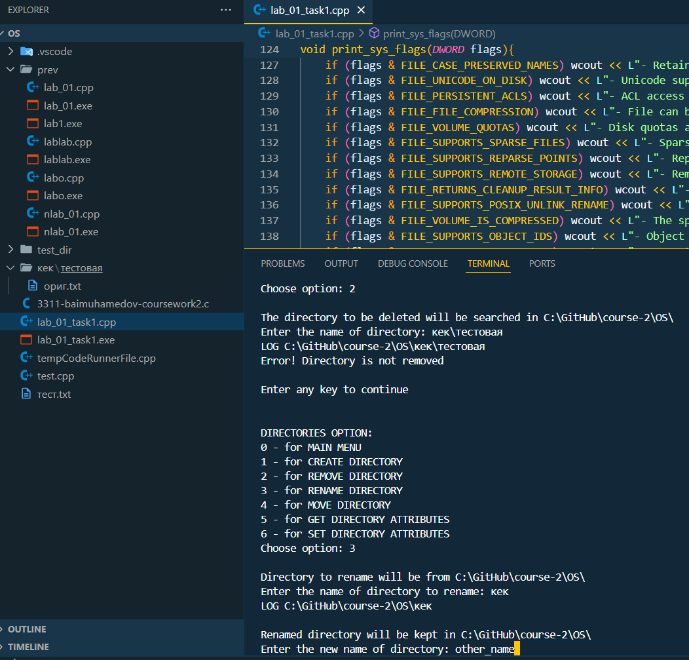

Рисунок .1 (до изменения названия папки)

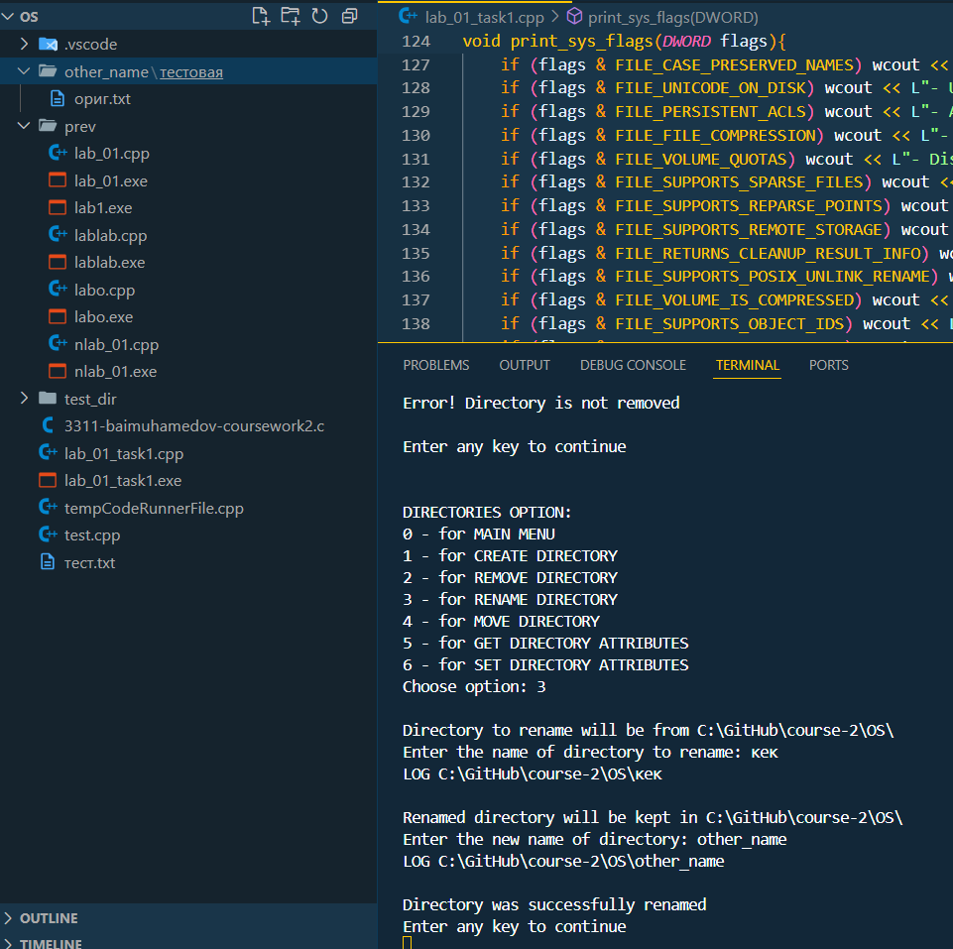

Рисунок 2.2 (после изменения названия папки)

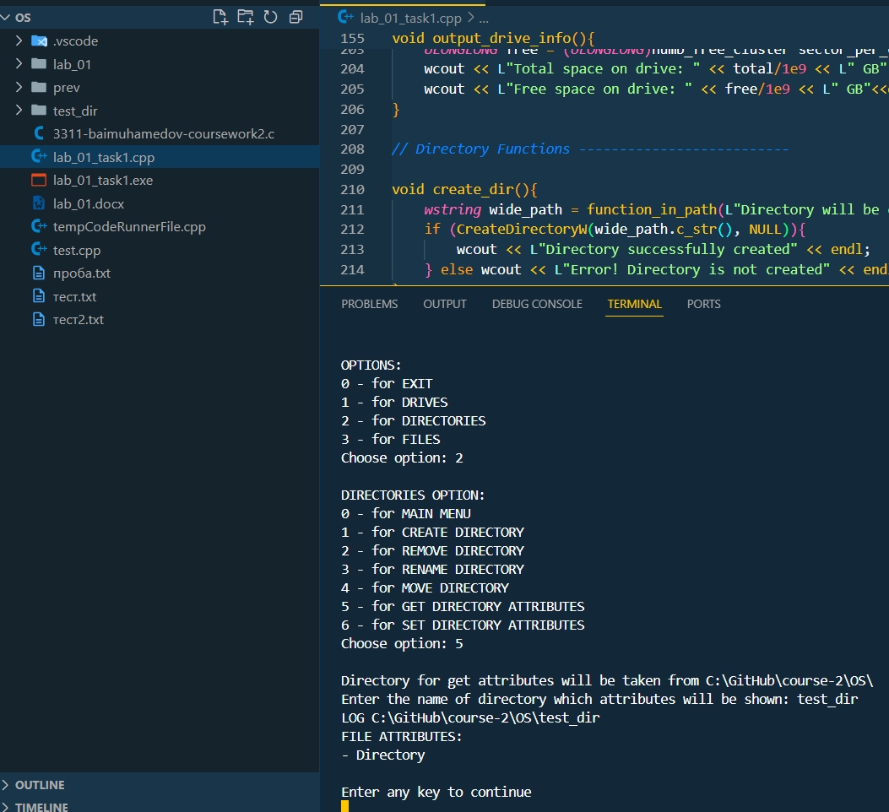

Рисунок .3 (Атрибуты папки до изменения)

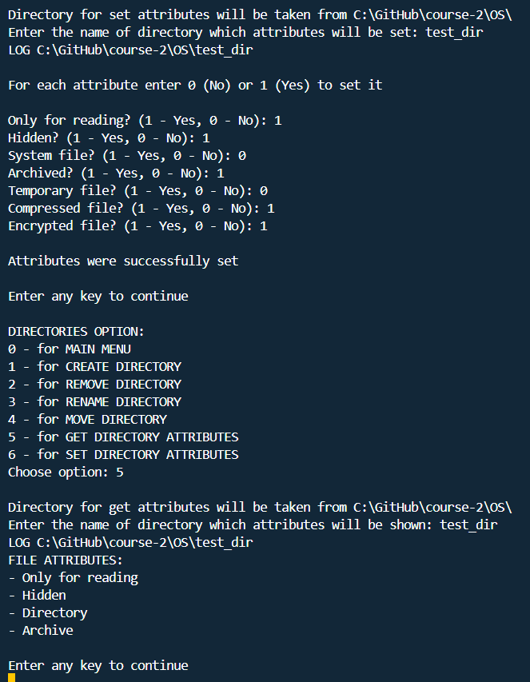

Рисунок 2.4 (Изменение атрибутов папки и их просмотр)

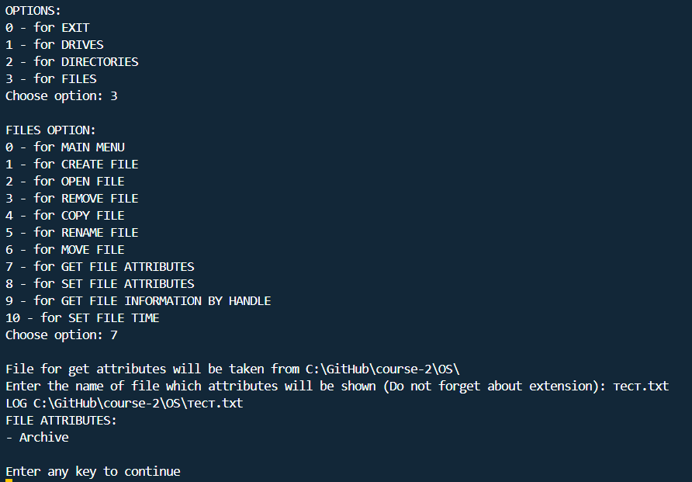

Рисунок 3.1 (Просмотр атрибутов файла)

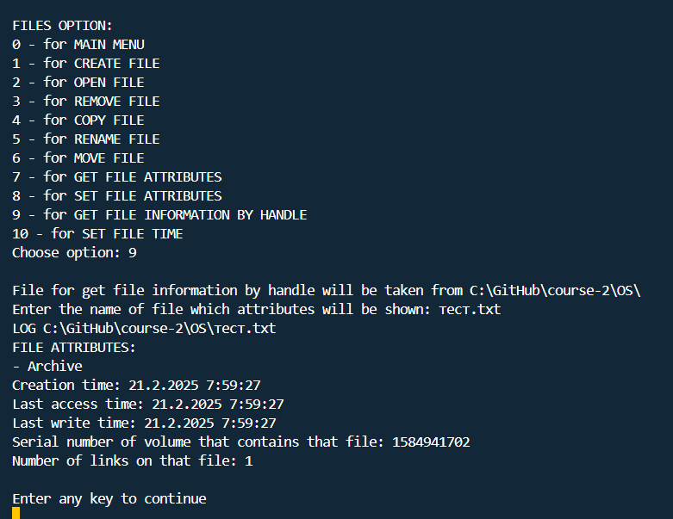

Рисунок .2 (Просмотр атрибутов файла при помощи дескриптора)

Win32 API – это низкоуровневый интерфейс, позволяющий точно управлять ресурсами операционной системы. В отличие от стандартных библиотек высокого уровня, он дает полный контроль над памятью, вводом-выводом, синхронизацией потоков и другими аспектами программирования.

Функции Win32 API (Windows Application Programming Interface) представляют собой фундаментальный набор инструментов, обеспечивающий взаимодействие программного обеспечения с операционной системой Windows. Этот интерфейс предоставляет разработчику доступ к управлению файлами, процессами, потоками, графической системой, сетевыми соединениями и множеством других аспектов работы системы.

Для упрощенного взаимодействия с приложением было введено “меню”, содержащее в себе 3 пункта: диски, папки, файлы. В каждом из пунктов добавлены соответствующие по заданию варианты действий.

Консольное приложение поддерживает работу с латиницей и кириллицей. Также в работе с приложением в некоторых действиях применяется относительный путь. Для относительного пути существует последовательность ../ обозначающая переход на один уровень вверх по каталогу, позволяя обращаться к родительским директориям относительно текущего расположения файла или исполняемой программы.

**Заключение**

В ходе лабораторной работы было исследовано управление файловой системой с помощью Win32 API. Win32 API предоставляет широкий набор функций для взаимодействия с операционной системой Windows на низком уровне. Оно охватывает работу с файлами, процессами, потоками, памятью, графикой и сетевыми операциями, обеспечивая точный контроль над ресурсами системы.

**Текст программы**

#include <windows.h>

#include <iostream>

#include <string>

#include <locale>

#include <fcntl.h>

#include <io.h>

using namespace std;

*// Helpful functions ---------------------------*

int enter_integer(*const* *wstring&* message, int a, int b) {

*wstring* input;

    int number;

    while (true) {

        wcout << message;

        getline(wcin, input);

        try {

            number = stoi(input);

            if (number >= a && number <= b) break;

            else wcout << L"Entered value is not in the range [" << a << L", " << b << L"]. Please try again!" << endl;

        } catch (...) {

            wcout << L"Error! Please try again" << endl;

        }

        wcin.clear();

    }

    return number;

}

void clear_screen() {

#if defined(_WIN32) || defined(_WIN64)

    system("cls");

#else

    system("clear");

#endif

}

int main_menu() {

    wcout << L"\nOPTIONS:" << endl;

    wcout << L"0 - for EXIT" << endl;

    wcout << L"1 - for DRIVES" << endl;

    wcout << L"2 - for DIRECTORIES" << endl;

    wcout << L"3 - for FILES" << endl;

    return enter_integer(L"Choose option: ", 0, 3);

}

int drive_menu() {

    wcout << L"\nDRIVE OPTION:" << endl;

    wcout << L"0 - for MAIN MENU" << endl;

    wcout << L"1 - for OUTPUT DRIVES" << endl;

    wcout << L"2 - for OUTPUT DRIVE INFO" << endl;

    return enter_integer(L"Choose option: ", 0, 2);

}

int dir_menu() {

    wcout << L"\nDIRECTORIES OPTION:" << endl;

    wcout << L"0 - for MAIN MENU" << endl;

    wcout << L"1 - for CREATE DIRECTORY" << endl;

    wcout << L"2 - for REMOVE DIRECTORY" << endl;

    wcout << L"3 - for RENAME DIRECTORY" << endl;

    wcout << L"4 - for MOVE DIRECTORY" << endl;

    wcout << L"5 - for GET DIRECTORY ATTRIBUTES" << endl;

    wcout << L"6 - for SET DIRECTORY ATTRIBUTES" << endl;

    return enter_integer(L"Choose option: ", 0, 6);

}

int file_menu() {

    wcout << L"\nFILES OPTION:" << endl;

    wcout << L"0 - for MAIN MENU" << endl;

    wcout << L"1 - for CREATE FILE" << endl;

    wcout << L"2 - for OPEN FILE" << endl;

    wcout << L"3 - for REMOVE FILE" << endl;

    wcout << L"4 - for COPY FILE" << endl;

    wcout << L"5 - for RENAME FILE" << endl;

    wcout << L"6 - for MOVE FILE" << endl;

    wcout << L"7 - for GET FILE ATTRIBUTES" << endl;

    wcout << L"8 - for SET FILE ATTRIBUTES" << endl;

    wcout << L"9 - for GET FILE INFORMATION BY HANDLE" << endl;

    wcout << L"10 - for SET FILE TIME" << endl;

    return enter_integer(L"Choose option: ", 0, 10);

}

void wait_reaction(){

    wcout << L"\nEnter any key to continue" << endl;

    wcin.ignore();

*// getwchar();*

}

*wstring* get_current_dir(){

    wchar_t buffer[MAX_PATH];

*DWORD* len = GetCurrentDirectoryW(MAX_PATH, buffer);

    if (len==0) return L"";

    else return *wstring*(buffer);

}

*wstring* function_in_path(*const* *wstring&* msg_to_path = L"Function will be executed in that path: ", *const* *wstring&* msg_to_enter = L"Enter the name: ") {

*wstring* path = get_current_dir();

*wstring* name;

    wcout << L"\n" << msg_to_path << path << L"\\" << endl;

    wcout << msg_to_enter;

    getline(wcin, name);

*wstring* wide_path = path + L"\\" + name;

    wcout << L"LOG " << wide_path << endl;

    return wide_path;

}

*// Drives Functions ---------------------------*

*DWORD* get_logical_drives(){

*DWORD* drives_bm = GetLogicalDrives();

    int count=1;

    wcout << L"\nAVAILABLE DRIVES:\n";

    for (int i=0; i<sizeof(*DWORD*)*8; i++){

        if (drives_bm & (1<<i)){

            wchar_t drive = L'A'+i;

            wcout << L" " << count << L" - " << drive << L":\\\n";

            count++;

        }

    }

    return drives_bm;

}

void print_sys_flags(*DWORD* flags){

    wcout << L"SYSTEM FLAGS:" << endl;

    if (flags & FILE_CASE_SENSITIVE_SEARCH) wcout << L"- File sensitive to uppercase and lowercase" << endl;

    if (flags & FILE_CASE_PRESERVED_NAMES) wcout << L"- Retained registry of file names is supported" << endl;

    if (flags & FILE_UNICODE_ON_DISK) wcout << L"- Unicode supported" << endl;

    if (flags & FILE_PERSISTENT_ACLS) wcout << L"- ACL access supported" << endl;

    if (flags & FILE_FILE_COMPRESSION) wcout << L"- File can be compressed" << endl;

    if (flags & FILE_VOLUME_QUOTAS) wcout << L"- Disk quotas are supported on the specified volume" << endl;

    if (flags & FILE_SUPPORTS_SPARSE_FILES) wcout << L"- Sparse files are supported on the volume" << endl;

    if (flags & FILE_SUPPORTS_REPARSE_POINTS) wcout << L"- Reparse points are supported on the specified volume" << endl;

    if (flags & FILE_SUPPORTS_REMOTE_STORAGE) wcout << L"- Remote storage is supported by the file system" << endl;

    if (flags & FILE_RETURNS_CLEANUP_RESULT_INFO) wcout << L"- File system returns cleanup result info on successful cleanup" << endl;

    if (flags & FILE_SUPPORTS_POSIX_UNLINK_RENAME) wcout << L"- POSIX-style unlink and rename operations are supported" << endl;

    if (flags & FILE_VOLUME_IS_COMPRESSED) wcout << L"- The specified volume is a compressed volume" << endl;

    if (flags & FILE_SUPPORTS_OBJECT_IDS) wcout << L"- Object identifiers are supported on the specified volume" << endl;

    if (flags & FILE_SUPPORTS_ENCRYPTION) wcout << L"- Encrypted file system (EFS) is supported on the specified volume" << endl;

    if (flags & FILE_NAMED_STREAMS) wcout << L"- Named streams are supported on the specified volume" << endl;

    if (flags & FILE_READ_ONLY_VOLUME) wcout << L"- The specified volume is read-only" << endl;

    if (flags & FILE_SEQUENTIAL_WRITE_ONCE) wcout << L"- Sequential write-once is supported on the specified volume" << endl;

    if (flags & FILE_SUPPORTS_TRANSACTIONS) wcout << L"- Transactions are supported on the specified volume" << endl;

    if (flags & FILE_SUPPORTS_HARD_LINKS) wcout << L"- Hard links are supported on the specified volume" << endl;

    if (flags & FILE_SUPPORTS_EXTENDED_ATTRIBUTES) wcout << L"- Extended attributes are supported on the specified volume" << endl;

    if (flags & FILE_SUPPORTS_OPEN_BY_FILE_ID) wcout << L"- Opening by FileID is supported by the file system" << endl;

    if (flags & FILE_SUPPORTS_USN_JOURNAL) wcout << L"- Update Sequence Number (USN) journaling is supported on the specified volume" << endl;

    if (flags & FILE_SUPPORTS_INTEGRITY_STREAMS) wcout << L"- Integrity streams are supported by the file system" << endl;

    if (flags & FILE_SUPPORTS_BLOCK_REFCOUNTING) wcout << L"- Logical cluster sharing between files on the same volume is supported" << endl;

    if (flags & FILE_SUPPORTS_SPARSE_VDL) wcout << L"- Sparse valid data length (VDL) tracking is supported by the file system" << endl;

    if (flags & FILE_DAX_VOLUME) wcout << L"- The specified volume is a Direct Access (DAX) volume" << endl;

    if (flags & FILE_SUPPORTS_GHOSTING) wcout << L"- Ghosting is supported by the file system" << endl;

}

void output_drive_info(){

*// Drive select*

    wchar_t disk;

    wchar_t path[4];

    int option, counter=0;

*DWORD* options = get_logical_drives();

    for (int i=0; i<sizeof(*DWORD*)*8; i++){

        if (options & 1<<i) counter++;

    }

    option = enter_integer(L"Enter the number of drive: ", 1, counter);

    counter = 1;

    for (int i=0; i<sizeof(*DWORD*)*8; i++){

        if (options & 1<<i){

            if (counter==option){

                disk = L'A'+i;

                break;

            } else counter++;

        }

    }

    wcout << L"\nInfo about drive '" << (wchar_t)disk << L":\\\':" << endl;

    swprintf(path, 4, L"%c:\\", disk);

*// Drive info*

    int drive_type = GetDriveTypeW(path);

    switch (drive_type){

    case 0: wcout << L"Unknown type of drive" << endl; break;

    case 1: wcout << L"Incorrect root" << endl; break;

    case 2: wcout << L"Drive is removable" << endl; break;

    case 3: wcout << L"Drive is fixed" << endl; break;

    case 4: wcout << L"Drive is remotable" << endl; break;

    case 5: wcout << L"Drive is CD-ROM" << endl; break;

    case 6: wcout << L"Drive is RAM disk" << endl; break;

    }

    wchar_t volume_name[MAX_PATH], file_system_name[MAX_PATH];

*DWORD* serial_number, max_length, sys_flags;

    if (GetVolumeInformationW(path, volume_name,sizeof(volume_name), &serial_number, &max_length, &sys_flags, file_system_name, sizeof(file_system_name))){

        wcout << L"Volume Name: " << volume_name << endl;

        wcout << L"Serial Number: " << serial_number << endl;

        wcout << L"Max Component Length: " << max_length << endl;

        wcout << L"File System Name: " << file_system_name << endl;

        print_sys_flags(sys_flags);

    } else wcout << L"Error! Please try again";

*DWORD* sector_per_cluster, bytes_per_sector, numb_free_cluster, numb_total_cluster;

    GetDiskFreeSpaceW(path, &sector_per_cluster, &bytes_per_sector, &numb_free_cluster, &numb_total_cluster);

*ULONGLONG* total = (*ULONGLONG*)numb_total_cluster*sector_per_cluster*bytes_per_sector;

*ULONGLONG* free = (*ULONGLONG*)numb_free_cluster*sector_per_cluster*bytes_per_sector;

    wcout << L"Total space on drive: " << total/1e9 << L" GB" << endl;

    wcout << L"Free space on drive: " << free/1e9 << L" GB"<<endl;

}

*// Directory Functions --------------------------*

void create_dir(){

*wstring* wide_path = function_in_path(L"Directory will be created in ", L"Enter the name of directory: ");

    if (CreateDirectoryW(wide_path.c_str(), NULL)){

        wcout << L"Directory successfully created" << endl;

    } else wcout << L"Error! Directory is not created" << endl;

}

void remove_dir(){

*wstring* wide_path = function_in_path(L"The directory to be deleted will be searched in ", L"Enter the name of directory: ");

    if (RemoveDirectoryW(wide_path.c_str())){

        wcout << L"Directory is successfully removed" << endl;

    } else wcout << L"Error! Directory is not removed" << endl;

}

*// File Functions --------------------------------*

void create_file(int action_mode_choise){ *// 0 - to create file, 1 - to open file*

    int access_mode_choise, share_mode_choise;

*DWORD* access_mode, share_mode, action_mode;

*wstring* wide_path;

    if (action_mode_choise==0) wide_path = function_in_path(L"File will be created in ", L"Enter the name of file (Do not forget about extension): ");

    else {

        wide_path = function_in_path(L"File will be opened in ", L"Enter the name of file (Do not forget about extension): ");

    }

    wcout << L"\nACCESS MODE\n1 - only for READ\n2 - only for WRITE\n3 - for READ and WRITE\n";

    access_mode_choise = enter_integer(L"Choose access mode: ", 1, 3);

    switch(access_mode_choise){

        case 1: access_mode = GENERIC_READ; break;

        case 2: access_mode = GENERIC_WRITE; break;

        case 3: access_mode = GENERIC_READ | GENERIC_WRITE; break;

    }

    wcout << L"\nSHARE MODE\n1 - for NOT ALLOWED\n2 - for READ\n3 - for WRITE\n4 - for DELETE\n";

    share_mode_choise = enter_integer(L"Choose share mode: ", 1, 4);

    switch(share_mode_choise){

        case 1: share_mode= 0; break;

        case 2: share_mode= FILE_SHARE_READ; break;

        case 3: share_mode= FILE_SHARE_WRITE; break;

        case 4: share_mode= FILE_SHARE_DELETE; break;

    }

    if (action_mode_choise==0) action_mode = CREATE_NEW;

    else action_mode = OPEN_EXISTING;

*HANDLE* new_file = CreateFileW(wide_path.c_str(), access_mode, share_mode, NULL, action_mode, FILE_ATTRIBUTE_NORMAL, NULL);

    if (new_file == INVALID_HANDLE_VALUE) {

*DWORD* error = GetLastError();

        if (error == ERROR_FILE_EXISTS) {

            wcout << L"\nFile with equal name exists. Do you want to rewrite?\n1 - YES\n2 - NO\nYour choice: ";

            int rewrite_choise;

            wcin >> rewrite_choise;

            if (rewrite_choise == 1){

                if (action_mode_choise==0) action_mode = CREATE_ALWAYS;

                else action_mode = OPEN_ALWAYS;

                new_file = CreateFileW(wide_path.c_str(), access_mode, share_mode, NULL, action_mode, FILE_ATTRIBUTE_NORMAL, NULL);

                if (new_file == INVALID_HANDLE_VALUE) {

                    wcout << L"\nError! Failed to rewrite file" << endl;

                } else {

                    wcout << L"\nFile successfully rewritten" << endl;

                    CloseHandle(new_file);

                }

            } else wcout << L"File not rewritten." << endl;

        } else {

            if (error!=0){

                wcout << L"Error! Please try again";

            }

        }

    } else {

        if (action_mode_choise==0){

            wcout << L"\nFile successfully created!" << endl;

        } else wcout << L"\nFile successfully opened!" << endl;

        CloseHandle(new_file);

    }

}

void remove_file(){

*wstring* wide_path = function_in_path(L"File will be deleted in ", L"Enter the name of file (Do not forget about extension): ");

    if(DeleteFileW(wide_path.c_str())){

        wcout << L"\nFile was successfully removed\n";

    } else wcout << L"Error! File was not removed";

}

void copy_file(){

*wstring* wide_path = function_in_path(L"File will be copied from ", L"Enter the name of file to copy (Do not forget about extension): ");

*wstring* wide_repath = function_in_path(L"File will be pasted in ", L"Enter the new name of copied file: ");

    if(CopyFileW(wide_path.c_str(), wide_repath.c_str(), TRUE)){

        wcout << L"\nFile was successfully copied\n";

    } else {

        wcout << L"\nFile with equal name exists. Do you want to rewrite?\n1 - YES\n2 - NO\nYour choice: ";

        int rewrite_choise;

        wcin >> rewrite_choise;

        if (rewrite_choise == 1){

            if(CopyFileW(wide_path.c_str(), wide_repath.c_str(), FALSE)){

                wcout << L"File was successfully copied";

            }

            else wcout << L"Error! Please try again";

        }

    }

}

void rename(int is_dir){

*wstring* wide_path, wide_repath;

    if(is_dir==0){

        wide_path = function_in_path(L"File to rename will be from ", L"Enter the name of file to rename (Do not forget about extension): ");

        wide_repath = function_in_path(L"Renamed file will be kept in ", L"Enter the new name of file: ");

    } else {

        wide_path = function_in_path(L"Directory to rename will be from ", L"Enter the name of directory to rename: ");

        wide_repath = function_in_path(L"Renamed directory will be kept in ", L"Enter the new name of directory: ");

    }

    if(MoveFileW(wide_path.c_str(), wide_repath.c_str())){

        if (is_dir==0) wcout << L"\nFile was successfully renamed";

        else wcout << L"\nDirectory was successfully renamed";

    } else {

        if (is_dir==0) wcout << L"\nFile was not renamed";

        else wcout << L"\nDirectory was not renamed";

    }

}

void move(int is_dir){

*wstring* path = get_current_dir();

*wstring* name, repath;

    if (is_dir==0) {

        wcout << L"\nFile will be moved according to this path: " << path << L"\\" << endl;

        wcout << L"Enter the name of file that will be moved (Do not forget about extension): ";

    }

    else {

        wcout << L"\nDirectory will be moved according to this path: " << path << L"\\" << endl;

        wcout << L"Enter the name of directory that will be moved: ";

    }

    getline(wcin, name);

*wstring* wide_path = path + L"\\" + name;

    wcout << L"Specify a relative path to move: ";

    getline(wcin, repath);

*wstring* wide_repath = path + L"\\" + repath + L"\\" + name;

    if(MoveFileW(wide_path.c_str(), wide_repath.c_str())){

        wcout << L"File was successfully moved";

    } else {

        if (GetLastError() == ERROR_ALREADY_EXISTS){

            int replace = enter_integer(L"File with equal name exists. Do you want to replace it? (0 - for NO / 1 - for YES):",0, 1);

            if (replace==0) wcout << L"Operation of moving is canceled";

            else MoveFileExW(wide_path.c_str(), wide_repath.c_str(), 0x01);

        }

    }

}

void print_file_attr(*DWORD* attributes) {

    wcout << L"FILE ATTRIBUTES:" << endl;

    if (attributes & FILE_ATTRIBUTE_READONLY) wcout << L"- Only for reading" << endl;

    if (attributes & FILE_ATTRIBUTE_HIDDEN) wcout << L"- Hidden" << endl;

    if (attributes & FILE_ATTRIBUTE_SYSTEM) wcout << L"- System file" << endl;

    if (attributes & FILE_ATTRIBUTE_DIRECTORY) wcout << L"- Directory" << endl;

    if (attributes & FILE_ATTRIBUTE_ARCHIVE) wcout << L"- Archive" << endl;

    if (attributes & FILE_ATTRIBUTE_NORMAL) wcout << L"- Default file" << endl;

    if (attributes & FILE_ATTRIBUTE_TEMPORARY) wcout << L"- Temporary file" << endl;

    if (attributes & FILE_ATTRIBUTE_COMPRESSED) wcout << L"- Compressed" << endl;

    if (attributes & FILE_ATTRIBUTE_ENCRYPTED) wcout << L"- Encrypted" << endl;

    if (attributes & FILE_ATTRIBUTE_VIRTUAL) wcout << L"- Virtual file" << endl;

}

void get_file_attr(int is_dir){

*wstring* wide_path;

    if(is_dir==0){

        wide_path = function_in_path(L"File for get attributes will be taken from ", L"Enter the name of file which attributes will be shown (Do not forget about extension): ");

    } else {

        wide_path = function_in_path(L"Directory for get attributes will be taken from ", L"Enter the name of directory which attributes will be shown: ");

    }

*DWORD* attributes = GetFileAttributesW(wide_path.c_str());

    if (attributes == INVALID_FILE_ATTRIBUTES) wcout << L"Error! Please try again";

    else print_file_attr(attributes);

}

void set_file_attr(int is_dir){

*wstring* wide_path;

    if (is_dir==0){

        wide_path = function_in_path(L"File for set attributes will be taken from ", L"Enter the name of file which attributes will be set (Do not forget about extension): ");

    } else {

        wide_path = function_in_path(L"Directory for set attributes will be taken from ", L"Enter the name of directory which attributes will be set: ");

    }

*DWORD* attributes = GetFileAttributesW(wide_path.c_str());

    if (attributes == INVALID_FILE_ATTRIBUTES) {

        wcout << L"\nError! Please try again\n";

        return;

    }

    wcout << L"\nFor each attribute enter 0 (No) or 1 (Yes) to set it\n";

    int choice;

    wcout << L"\nOnly for reading? (1 - Yes, 0 - No): ";

    wcin >> choice;

    if (choice == 1) attributes |= FILE_ATTRIBUTE_READONLY;

    else attributes &= ~FILE_ATTRIBUTE_READONLY;

    wcout << L"Hidden? (1 - Yes, 0 - No): ";

    wcin >> choice;

    if (choice == 1) attributes |= FILE_ATTRIBUTE_HIDDEN;

    else attributes &= ~FILE_ATTRIBUTE_HIDDEN;

    wcout << L"System file? (1 - Yes, 0 - No): ";

    wcin >> choice;

    if (choice == 1) attributes |= FILE_ATTRIBUTE_SYSTEM;

    else attributes &= ~FILE_ATTRIBUTE_SYSTEM;

    wcout << L"Archived? (1 - Yes, 0 - No): ";

    wcin >> choice;

    if (choice == 1) attributes |= FILE_ATTRIBUTE_ARCHIVE;

    else attributes &= ~FILE_ATTRIBUTE_ARCHIVE;

    wcout << L"Temporary file? (1 - Yes, 0 - No): ";

    wcin >> choice;

    if (choice == 1) attributes |= FILE_ATTRIBUTE_TEMPORARY;

    else attributes &= ~FILE_ATTRIBUTE_TEMPORARY;

    wcout << L"Compressed file? (1 - Yes, 0 - No): ";

    wcin >> choice;

    if (choice == 1) attributes |= FILE_ATTRIBUTE_COMPRESSED;

    else attributes &= ~FILE_ATTRIBUTE_COMPRESSED;

    wcout << L"Encrypted file? (1 - Yes, 0 - No): ";

    wcin >> choice;

    if (choice == 1) attributes |= FILE_ATTRIBUTE_ENCRYPTED;

    else attributes &= ~FILE_ATTRIBUTE_ENCRYPTED;

    if (SetFileAttributesW(wide_path.c_str(), attributes)) {

        wcout << L"\nAttributes were successfully set\n";

    } else wcout << L"Error! Attributes were not set. Please try again";

}

void print_filetime(*const* *FILETIME&* ft) {

*SYSTEMTIME* st;

    FileTimeToSystemTime(&ft, &st);

    wcout << st.wDay << L"." << st.wMonth << L"." << st.wYear << L" ";

    wcout << st.wHour << L":" << st.wMinute << L":" << st.wSecond << endl;

}

*FILETIME* systime_to_filetime(*const* *SYSTEMTIME&* st) {

*FILETIME* ft;

    SystemTimeToFileTime(&st, &ft);

    return ft;

}

void get_file_info_by_handle(){

*wstring* wide_path = function_in_path(L"File for get file information by handle will be taken from ", L"Enter the name of file which attributes will be shown: ");

*HANDLE* handle_file = CreateFileW(wide_path.c_str(), GENERIC_READ, FILE_SHARE_READ, NULL, OPEN_EXISTING, FILE_ATTRIBUTE_NORMAL, NULL);

    if (handle_file == INVALID_HANDLE_VALUE) {

*DWORD* error = GetLastError();

        if (error == ERROR_FILE_NOT_FOUND){

            wcout << L"Error! File to get info is not exist" << endl;

        }

        if (error == ERROR_ACCESS_DENIED) {

            wcout << L"Access denied. You do not have permission to open this file" << endl;

        } else if (error == ERROR_SHARING_VIOLATION) {

            wcout << L"File is being used by another process and cannot be opened" << endl;

        } else {

            wcout << L"Failed to open file" << endl;

        }

        return;

    }

*BY_HANDLE_FILE_INFORMATION* file_info;

*FILETIME* creation_time, laccess_time, lwrite_time;

    if (GetFileInformationByHandle(handle_file, &file_info)){

        print_file_attr(file_info.dwFileAttributes);

        if (GetFileTime(handle_file, &creation_time, &laccess_time, &lwrite_time)){

            wcout << L"Creation time: ";

            print_filetime(creation_time);

            wcout << L"Last access time: ";

            print_filetime(laccess_time);

            wcout << L"Last write time: ";

            print_filetime(lwrite_time);

        } else {

            wcout << L"Error! Cant get file time" << endl;

        }

        wcout << L"Serial number of volume that contains that file: " << file_info.dwVolumeSerialNumber << endl;

        wcout << L"Number of links on that file: " << file_info.nNumberOfLinks << endl;

    }

    CloseHandle(handle_file);

}

void set_file_time(){

*wstring* wide_path = function_in_path(L"File for set file time will be taken from ", L"Enter the name of file which file time will be set (Do not forget about extension): ");

*HANDLE* handle_file = CreateFileW(wide_path.c_str(), FILE_WRITE_ATTRIBUTES, FILE_SHARE_WRITE, NULL, OPEN_EXISTING, FILE_ATTRIBUTE_NORMAL, NULL);

    if (handle_file == INVALID_HANDLE_VALUE) {

        wcout << L"Error! Please try again" << endl;

        return;

    }

*SYSTEMTIME* st;

*FILETIME* ftCreation, ftLastAccess, ftLastWrite;

    int choice = enter_integer(L"Set new creation time? (1 - yes, 0 - no): ",0, 1);

    if (choice) {

        wcout << L"Enter creation date (YYYY MM DD HH MM SS): ";

        wcin >> st.wYear >> st.wMonth >> st.wDay >> st.wHour >> st.wMinute >> st.wSecond;

        ftCreation = systime_to_filetime(st);

    } else {

        ftCreation.dwLowDateTime = 0;

        ftCreation.dwHighDateTime = 0;

    }

    wcout << L"Set new last access time? (1 - yes, 0 - no): ";

    wcin >> choice;

    if (choice) {

        wcout << L"Enter last access date (YYYY MM DD HH MM SS): ";

        wcin >> st.wYear >> st.wMonth >> st.wDay >> st.wHour >> st.wMinute >> st.wSecond;

        ftLastAccess = systime_to_filetime(st);

    } else {

        ftLastAccess.dwLowDateTime = 0;

        ftLastAccess.dwHighDateTime = 0;

    }

    wcout << L"Set new last write time? (1 - yes, 0 - no): ";

    wcin >> choice;

    if (choice) {

        wcout << L"Enter last write date (YYYY MM DD HH MM SS): ";

        wcin >> st.wYear >> st.wMonth >> st.wDay >> st.wHour >> st.wMinute >> st.wSecond;

        ftLastWrite = systime_to_filetime(st);

    } else {

        ftLastWrite.dwLowDateTime = 0;

        ftLastWrite.dwHighDateTime = 0;

    }

    if (SetFileTime(handle_file, (ftCreation.dwLowDateTime == 0 && ftCreation.dwHighDateTime == 0) ? NULL : &ftCreation, (ftLastAccess.dwLowDateTime == 0 && ftLastAccess.dwHighDateTime == 0) ? NULL : &ftLastAccess, (ftLastWrite.dwLowDateTime == 0 && ftLastWrite.dwHighDateTime == 0) ? NULL : &ftLastWrite)) {

        wcout << L"File time successfully updated" << endl;

    } else wcout << L"Error! File time was not updated" << endl;

    CloseHandle(handle_file);

}

*// main -----------------------------------------*

int main() {

    _setmode(_fileno(stdout), _O_U16TEXT);

    _setmode(_fileno(stdin), _O_U16TEXT);

    int option;

    do {

        option = main_menu();

        switch (option) {

            case 1: {

                int drive_option;

                do {

                    drive_option = drive_menu();

                    switch(drive_option){

                    case 0: break;

                    case 1: get_logical_drives(); wait_reaction(); break;

                    case 2: output_drive_info(); wait_reaction(); break;

                    }

                } while (drive_option != 0);

                break;

            }

            case 2: {

                int dir_option;

                do {

                    dir_option = dir_menu();

                    switch(dir_option){

                    case 0: break;

                    case 1: create_dir(); wait_reaction(); break;

                    case 2: remove_dir(); wait_reaction(); break;

                    case 3: rename(1); wait_reaction(); break;

                    case 4: move(1); wait_reaction(); break;

                    case 5: get_file_attr(1); wait_reaction(); break;

                    case 6: set_file_attr(1); wait_reaction(); break;

                    }

                } while (dir_option != 0);

                break;

            }

            case 3: {

                int file_option;

                do {

                    file_option = file_menu();

                    switch (file_option){

                    case 0: break;

                    case 1: create_file(0); wait_reaction(); break;

                    case 2: create_file(1); wait_reaction(); break;

                    case 3: remove_file(); wait_reaction(); break;

                    case 4: copy_file(); wait_reaction(); break;

                    case 5: rename(0); wait_reaction(); break;

                    case 6: move(0); wait_reaction(); break;

                    case 7: get_file_attr(0); wait_reaction(); break;

                    case 8: set_file_attr(0); wait_reaction(); break;

                    case 9: get_file_info_by_handle(); wait_reaction(); break;

                    case 10: set_file_time(); wait_reaction(); break;

                    }

                } while (file_option != 0);

                break;

            }

        }

    } while (option != 0);

    wcout << L"\nGoodbye!\n" << endl;

    return 0;

}