**Building a BI Dashboard Using SQL Query, Google Data Studio and BigQuery**

## Usecase

For this lab, you'll be a manager of tree services for a large city. You make important decisions based on usage logs data, stored in large (multiple TBs) date-partitioned tables in a BigQuery dataset called "Trees".

To get business value out of that data as quickly as possible, build a dashboard for analysts that provides visualizations of trends and patterns in your data.

## Solution overview

Typically, a dashboard shows an aggregated view of usage — it doesn't need details all the way to the level of an order ID, for instance. So, to reduce query costs, you'll first aggregate your needed logs into another dataset called "Reports" then create a table of aggregated data. You'll query the table from the Data Studio dashboard. This way, when your dashboard is refreshed, the reporting dataset queries process less data. Since usage logs from the past never change, you'll only refresh new usage data into the Reports dataset.

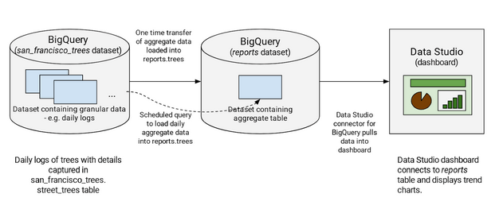

## Task 1. Uploading queryable data

## Task 2. Create a reports dataset in BigQuery

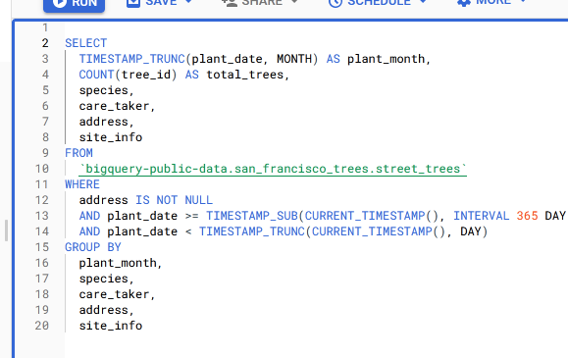

## Task 3. Query the dashboard data

Next you run a one-time query to pull the data for the last year, summarizing:

* The number of trees planted each month
* Which species of trees were planted
* Who the caretaker of the trees is
* Address of the planted trees
* Tree site information

## Task 4. Scheduling queries in BigQuery

Now you add a query that checks each day for new data. When new trees are planted, you'll get the additional stats updated directly into the Reports.Trees table.

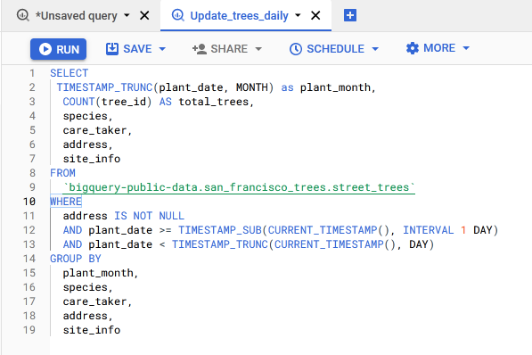

## Task 5. Create new data sources in Data Studio

## Task 6. Create a new report in Data Studio

