A

*powerful attraction*

exists, therefore, to the promotion of a

STUDY *and* DUTIES   
 of all others engrossing the time most completely, and which

is less benefitted than most

others by any acquaintance with

SCIENCE.

­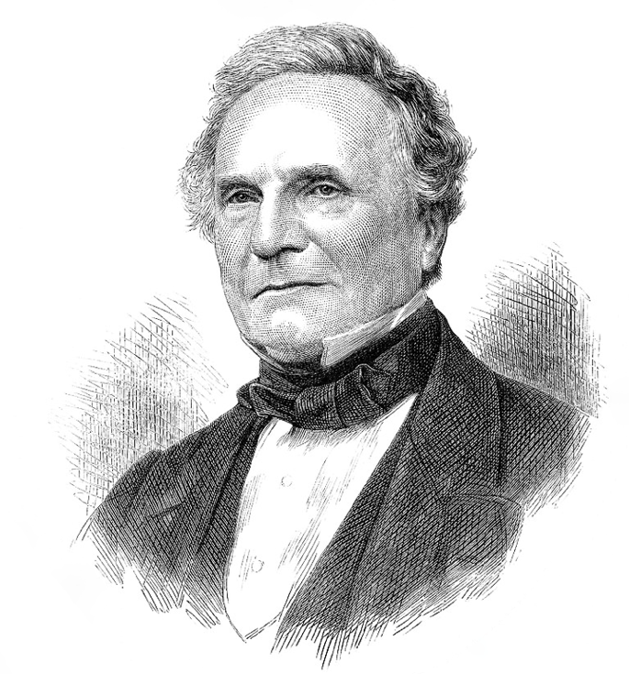

Charles Babbage (1791-1871)