To Run samples in our distribution (tuscany-sca-2.0-DU/samples) in your virtual machine, you need to make sure the following things:

1. Setup your environment path

set PATH=%PATH%;/home/nju/tuscany-sca-2.0-DU/bin

1. use nat network, and make sure your virtual machine's ip address is 10.0.2.15, because our binding uri is this ip.
2. First, start the domain manager in terminal like this:

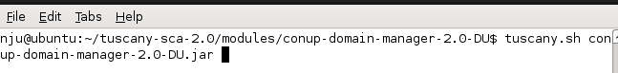

1. Start all other four nodes in your terminals like the following figures.

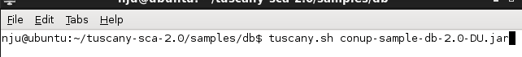







1. After all nodes are started, we can type installed in terminal to see which nodes we have started

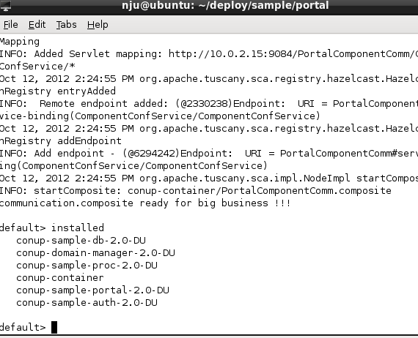

1. Invoke services
2. Invoke PortalComponent’s PortalService

invoke PortalComponent/PortalService execute nju cs



1. OndemandSetup

if you want to set up these dynamic dependencies, you can invoke ondemandSetup service provided by domain manager like this:

invoke DomainManagerComponent/DomainComponentUpdateService onDemandRequest AuthComponent ConcurrentVersion

the last two parameter are which component you want to start this onDemandSetup, and which policy you want to achieve freeness. After this invocation, your component status will be changed to valid(normal->valid).

1. After ondemandSetup, we can check component’s status by invoking its ComponentConfService getCurrentStatus method to get its status(it should be valid)



1. Update your component, in paper example, we update AuthComponent, we put our new serviceImpl in one folder like following figure:

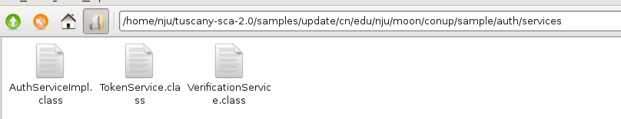

And we invoke Auth’s update service to invoke update.

invoke AuthComponentComm/ComponentUpdateService update /home/nju/deploy/sample/update cn.edu.nju.moon.conup.sample.auth.services.AuthServiceImpl conup-sample-auth-2.0-DU auth.composite

when you finish updating, you can invoke Portal service to test whether your update is right.

Note:

Because we use tools to analyze our source code and insert some information to help us implement our algorithm in this platform, so you need to use the jars in clean folder to replace the old jar.

