Trading AI Web Application – UI Refactor Brief

1. Purpose
This document provides an overview of how the current UI for the Trading AI Web Application is implemented and used. It also outlines the goals and expectations for a full UI improvement and modernization effort. The goal is not to prescribe a specific technology stack or framework, but to give clear direction on how the UI should evolve — with emphasis on mobile compatibility, modern design, and an AI-driven look and feel.

2. Current UI Overview
The application is a Flask-based web interface that connects to multiple backend services and data sources. Each page focuses on a specific analytical or operational function, and users navigate through a series of dashboards, tables, modals, and data visualizations.
Page | Access Point | Purpose & Core Features
Dashboard | / | Main landing hub for running standard and enhanced AI sentiment analyses. Includes status tracking, progress feedback, and a “How It Works” walkthrough.
Stocks | /stocks | Displays top market movers with sentiment summaries, refresh controls, and auto-update options.
Crypto | /crypto | Provides real-time crypto market sentiment with opportunity cards and risk distribution charts.
Portfolio | /portfolio | Simulated trading portfolio with KPIs, position tables, and performance visualizations (demo data).
Foreign Markets Overview | /foreign_markets_overview | Monitors global market performance with filters and regional breakdowns.
Opportunities | /opportunities | AI-powered opportunity scanner with toggleable views (news vs. watchlist).
Weekly Plan | /weekly_plan | Week-based planner combining watchlist insights and activity tracking.
Logs | /logs | Real-time operational log viewer with advanced filtering and export capabilities.
Recommendations | /recommendations | Aggregates AI recommendations into charts and sortable performance tables.
Reporting | /reporting | Generates configurable analytics and risk reports with multiple visualization types.
Backtest | /backtest | Runs and displays results of historical strategy backtests.
Scalping Signals | /scalping_signals | Shows near-real-time trading signals and triggers for high-frequency trading.
System Status | /system_status | Monitors system health, API uptime, and cache statistics.

3. Navigation Flow

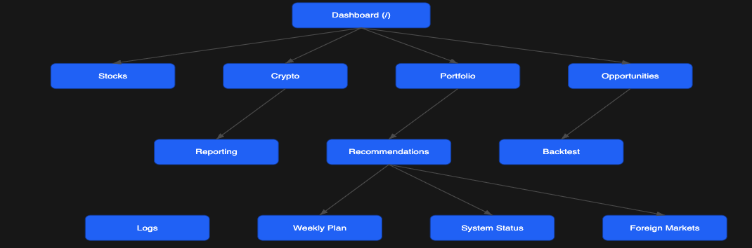

4. Current Design Characteristics
- Frontend Framework: Bootstrap 5 with vanilla JavaScript
- Layout & Components: Tables, cards, modals, and forms using Bootstrap defaults
- Design Style: Functional but dated — desktop-centric and minimal visual hierarchy
- Responsiveness: Limited — not optimized for mobile or smaller viewports
- Branding & Experience: Focused on analytics rather than conveying an AI-centric aesthetic
Overall, the existing design effectively presents data but lacks a cohesive visual identity or the responsiveness expected from modern web applications.

5. Refactor Objectives
The primary goal is to refresh the entire UI layer to feel more modern, intelligent, and fluid — while maintaining the current functionality and workflows.
- Key Objectives:
1. Modern AI Look and Feel
- Introduce visual polish, modern typography, and a sense of “intelligent motion.”
- Make the interface feel like a smart AI companion — clean, intuitive, and responsive.
- Improve hierarchy and consistency across all pages.
2. Mobile Responsiveness
- The application must adapt seamlessly to mobile and tablet devices.
- All key workflows (dashboard, stocks, crypto, portfolio, logs) should remain accessible and usable on small screens.
- Support both portrait and landscape orientations with adaptive layouts.
3. User Experience & Usability Enhancements
- Simplify navigation and improve discoverability of key functions.
- Introduce consistent spacing, contrast, and component reuse.
- Maintain or improve load performance and accessibility (WCAG 2.1 AA target).
4. Maintainability & Scalability
- The new design should be modular and easy to extend as new pages are added.
- Align styling conventions and reduce custom CSS drift.
- Preserve current backend integrations and routes.

6. Desired Outcomes
By the end of this refactor, the application should:
- Present a modern, AI-driven visual identity that feels polished and cohesive.
- Be fully responsive and mobile-ready across major browsers and device types.
- Retain existing core functionality and backend routes.
- Improve usability, accessibility, and perceived performance.

7. Summary
This project is an opportunity to elevate the UI experience of a high-functioning AI trading platform. The current structure and routing are solid — the focus is purely on design modernization, mobile adaptation, and creating a cohesive AI-first visual identity that enhances trust, clarity, and engagement for end users.

