**Student: Benjamin Chang**

**Research using Unsupervised Monocular Depth Estimation with Left-Right Consistency – Godard**

1. Testing cityscape depth estimation model on online test image

Input: test_image.jpg Output: test_image_disp.png

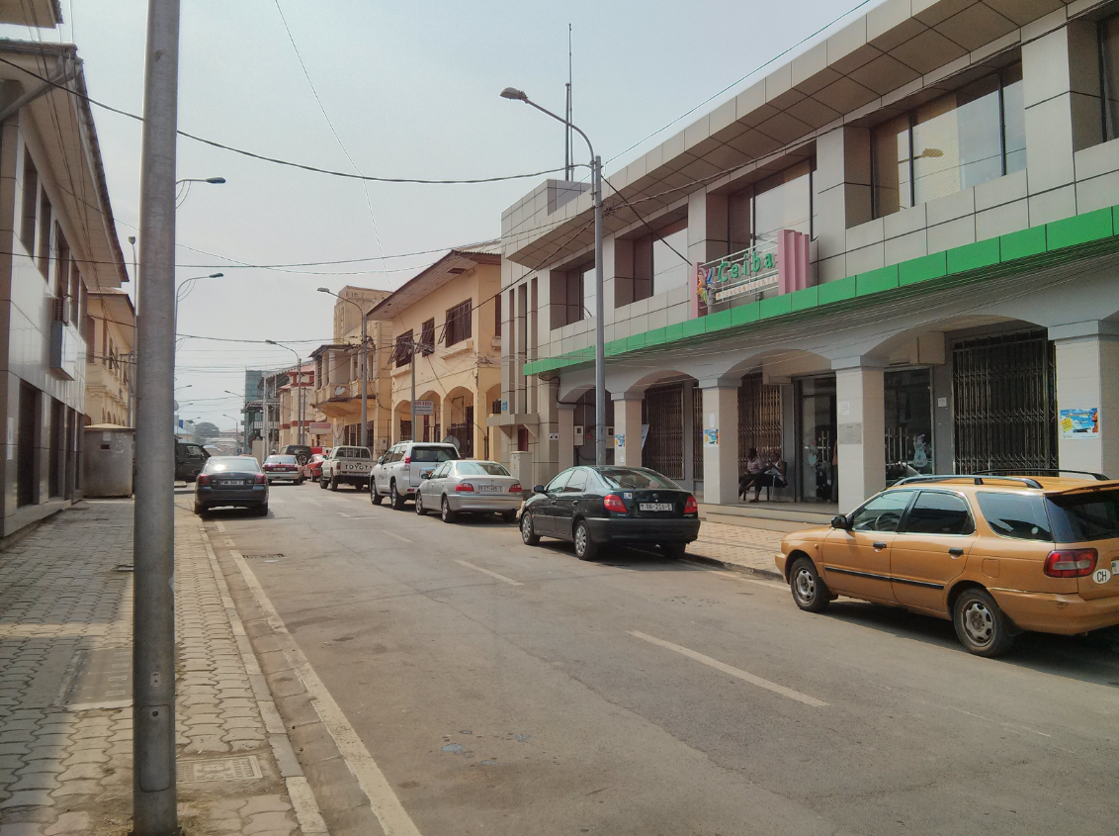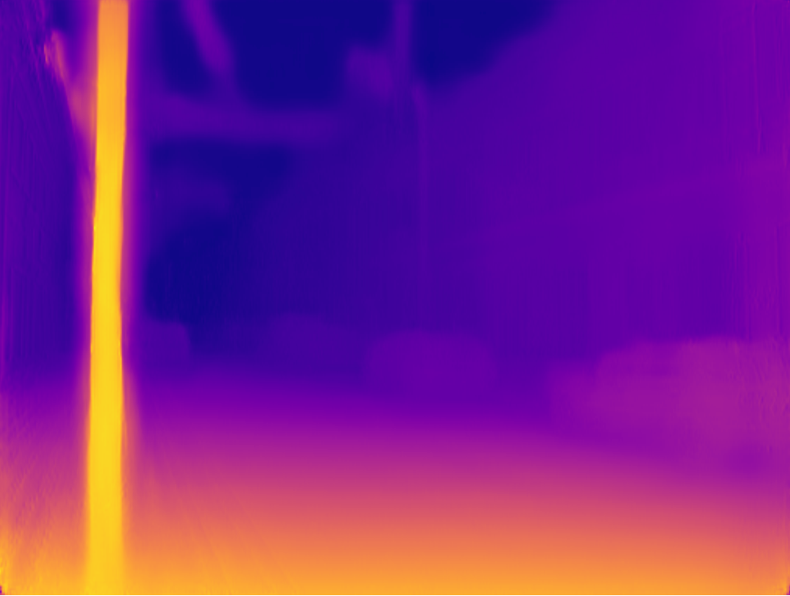

* Created ‘monodepth_simple_multiple_images.py’ which is a modified version of ‘monodepth_simple.py’ that can process multiple images
  + Code run in Linux using Ubuntu
* Added specification of an output_path
* Code can be found on Github: <https://github.com/bricksaver/monodepth-master>
* Created ‘view_depth_cam_modified.py’ which can be used to display depth output image and/or depth output image values using numpy
  + Code run in Python IDLE environment

2. Test Results:

Cityscapes model tested on kitti_2015 data: <https://www.youtube.com/watch?v=7rOBTIMN7-Y>

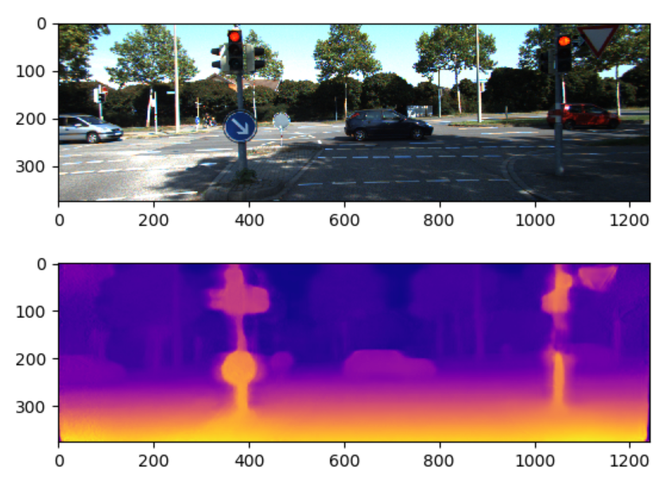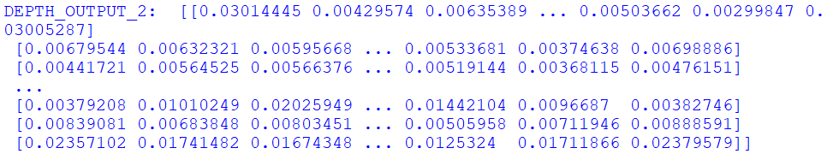

Cityscapes model tested on cam_data_1: <https://www.youtube.com/watch?v=PztsHI6CR0o&t=1s>

Cityscapes model tested on cam_data_2: <https://www.youtube.com/watch?v=yg7dn7FZ95I>

3. Training custom models on gathered and prepared training data using GPU

* Proof of Concept – trained 4999 steps. Model saved after 2500 steps. Trained on 200 stereo pair images from KITTI_2015 dataset.

