**Harry’s notes for software development**

Table of Contents

1 Microservices 1

1.1 Definition 1

2 GitHub related 1

2.1 Git clone 1

2.2 Create gitignore for .NET 2

3 API (.NET) 3

3.1 Create API 3

4 Controller – .NET for API 4

4.1 What make the controller to be a controller 4

4.2 What make an end point to be an end point 5

4.3 Handling return of status codes 5

4.4 Document the return status of end point in Swagger 5

5 Visual Studio Code 5

5.1 Suggested Setting on VS Code 5

5.2 If not .vscode folder generated 5

6 Dotnet CLI commands 5

7 Items is being Looked for solutions 6

# Microservices

## Definition

Microservices have the architectural style that structures an application as a collection of independently deployable services that are modeled around a business domain and are usually owned by a small team.

# GitHub related

## Git clone

git clone <<URL of git repository, see screenshot below>>

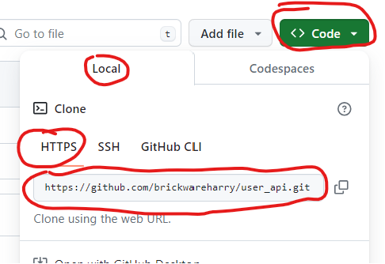 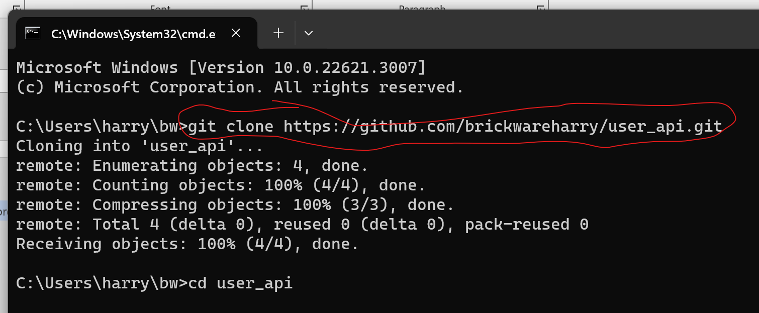

## Create gitignore for .NET

Give command “dotnet new gitignore” in the Command Prompt of the local repository, see screenshot below

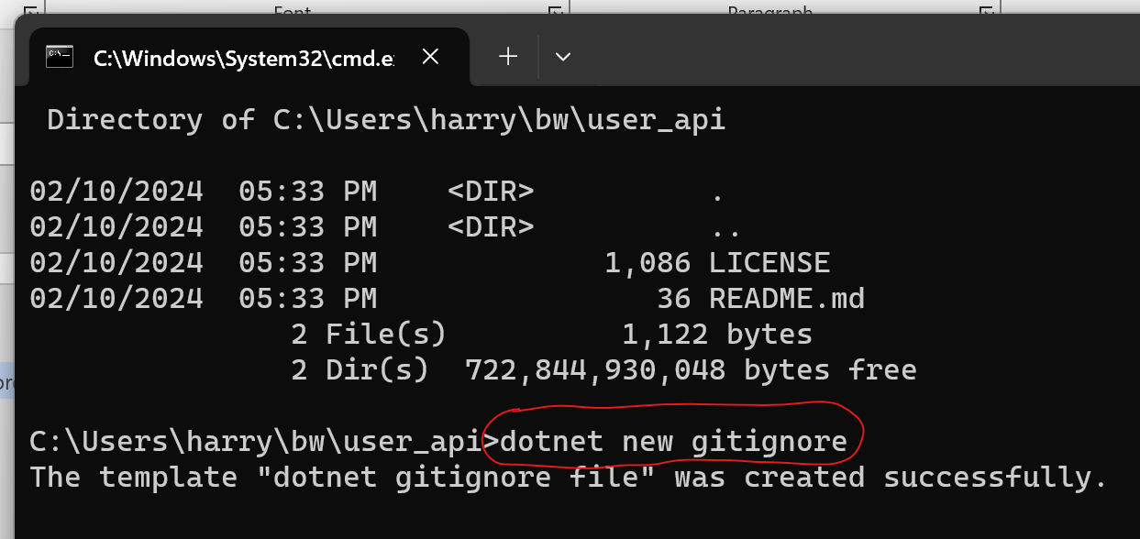

# API (.NET)

## Create API

* Create a new ASP.NET Core Web API project in Visual Studio

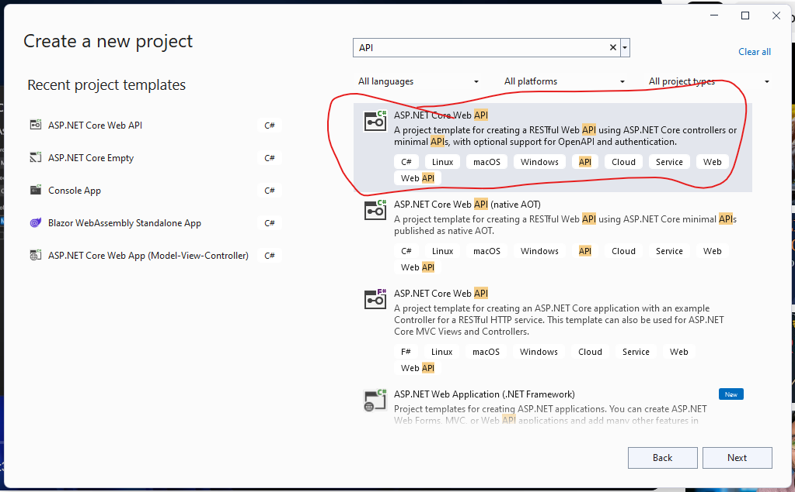

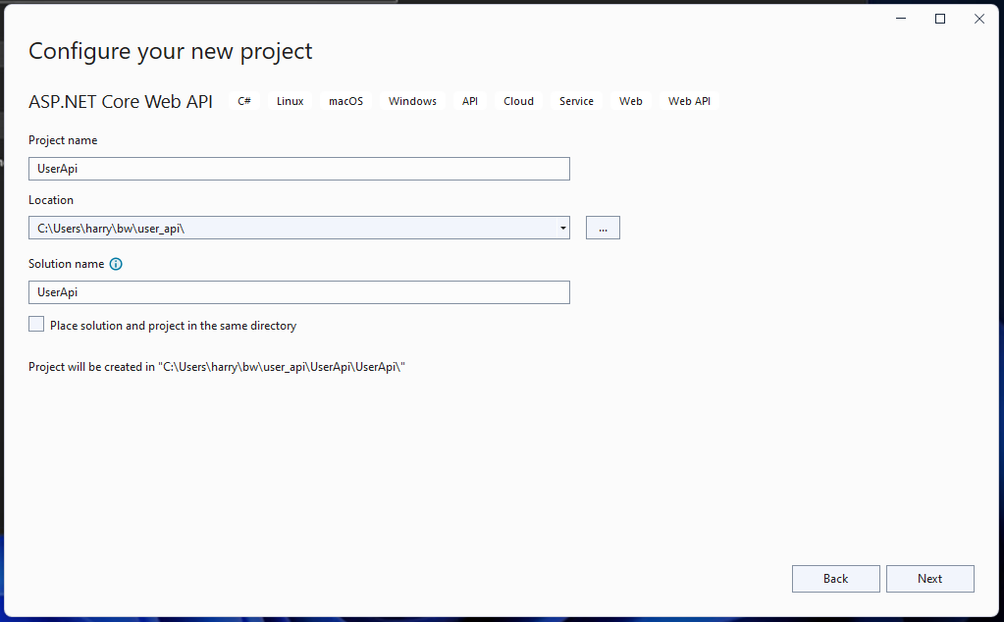 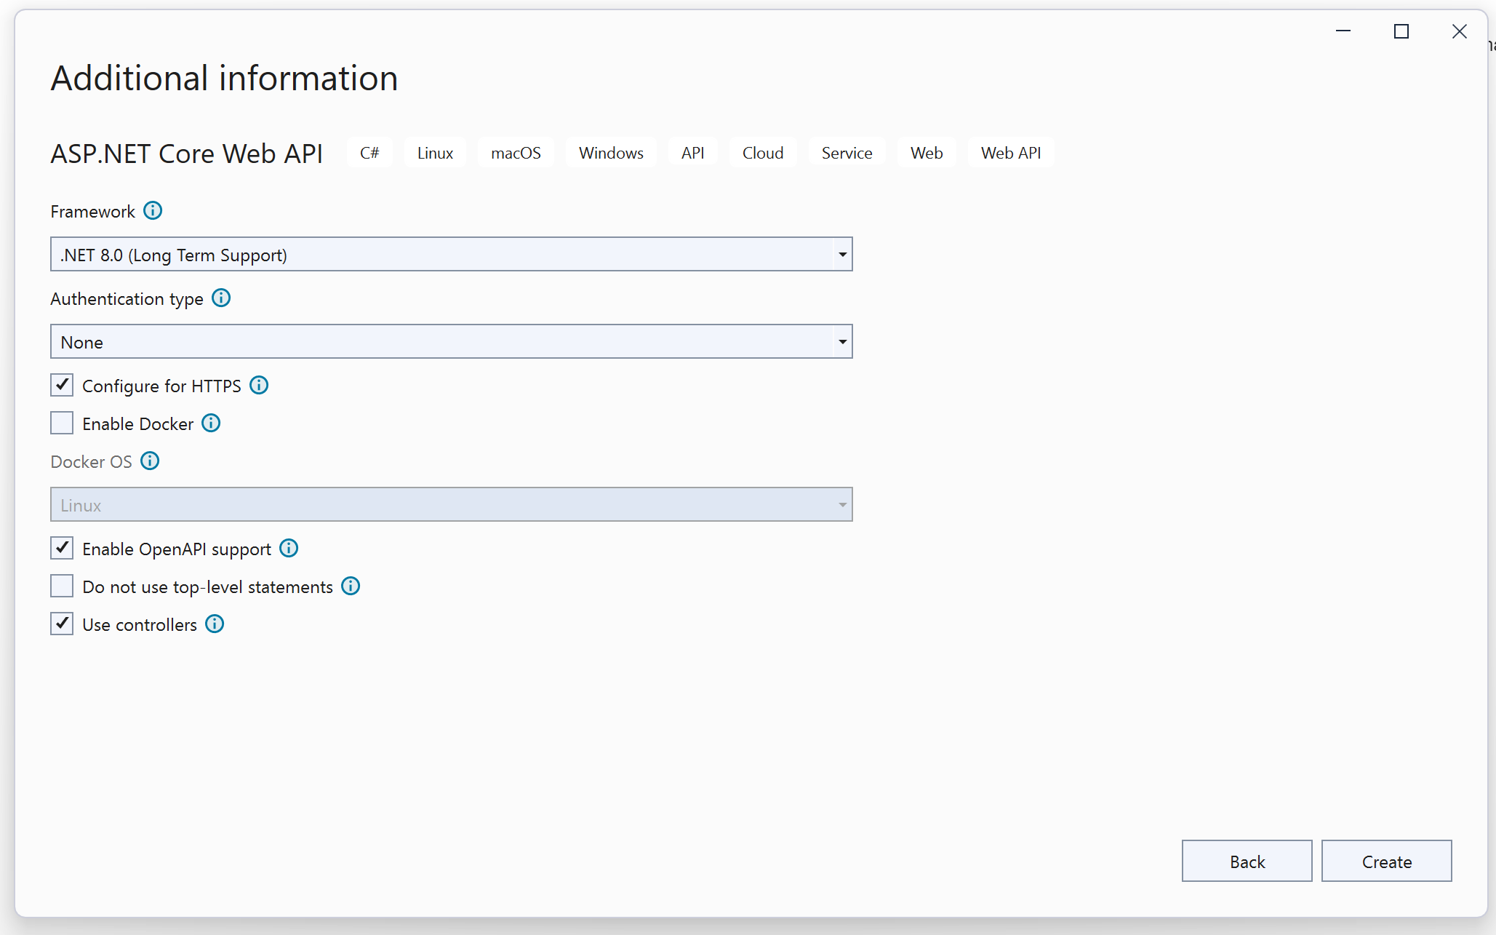

# Controller – .NET for API

## What make the controller to be a controller

* Has a suffix of Controller in the name of the class and file
  + Example: UserApiController
* Derive from the ControllerBase class under namespace of Microsoft.AspNetCore. Mvc
  + Example: public class UserApiController:ControllerBase
  + A using statement is needed below:
    - Example: using Microsoft.AspNetCore.Mvc;
* Need a controller attribute placed above the class
  + Example: [ApiController]
* Need a route attribute placed above the class
  + Example: [Route("api/UserApi")] or [Route("api/[Controller]")]

## What make an end point to be an end point

* Need a verb attribute place above the function of the end point
  + Example: [HttpGet] or [HttpGet(“{id:int}”)]

## Handling return of status codes

* Return type at the function of the end point should be ActionResult<return type of object>, e.g. ActionResult<UserDto> and ActionResult<IEnumerable<UserDto>>
* Verification of the return value can specify the return status, e.g.:
  + If(id == 0){return BadRequest()};
  + If(user == null){return NotFound()};
  + return Ok();

## Document the return status of end point in Swagger

* Attributes [ProducesResponseType(status code)] are needed for documenting the status above the function of end point, e.g.
  + [ProducesResponseType(200)] or [ProducesResponseType(StatusCodes.Status200OK)]
  + [ProducesResponseType(400)] or [ProducesResponseType(StatusCodes.Status400BadRequest)]
  + [ProducesResponseType(404)] or [ProducesResponseType(StatusCodes.Status404NotFound)]

## HTTP PATCH using JsonPatch

PATCH request is for updating one property only

For creating this endpoint of PATCH request, two nuget packages below are required.

* <https://jsonpatch.com/> is a format for describing changes to a JSON document
  + Need NuGet package: Microsoft.AspNetCore.JsonPatch
* Microsoft.AspNetCore.Mvc.NewtonsoftJson (this is not compatible with .net 8)
  + For .net 8, a built-in system.text.Json library can be used

# Visual Studio Code

## Suggested Setting on VS Code

* File -> Auto Save
* File -> Preferences -> Settings -> Text Editor -> Formatting -> Format On Save
* File -> Preferences -> Settings -> Search(place open brace on new line)-> JavaScript …. Place Open Brace on New Line For Control Blocks
* File -> Preferences -> Settings -> Search(place open brace on new line)-> JavaScript …. Place Open Brace on New Line For Functions
* File -> Preferences -> Settings -> Search(place open brace on new line)-> TypeScript …. Place Open Brace on New Line For Control Blocks
* File -> Preferences -> Settings -> Search(place open brace on new line)-> TypeScript …. Place Open Brace on New Line For Functions

## If not .vscode folder generated

* Generate the .vscode folder manually by opening your Command Palette (CTRL + SHIFT + P) and then select .NET: Generate Assets For Build And Debug.
* The .vscode folder has launch.json and tasks.json

# Dotnet CLI commands

* dotnet new –list
  + list all the template projects which can be built
* dotnet new webapi -n <<project name>> -controllers
  + create an webapi project with the given project name
* dotnet new console –name <<project name>> --use-program-main
  + this creates a project with the name and also create a new folder holding the project
  + if --name <<project name>> is not provided, the project will be created in current folder and the folder name will be the project name
  + --use-program-main for not using top level statement (i.e. there is static void Main(string[] args) in program.cs)

# Items is being Looked for solutions