Week of 9/22-9/29
- Research (on ASME portal) on assistive devices and interview portions of “Background Research and Discovery”
- Missed meeting with Gina Snyder, took notes based on documentation video
- Received ISO 10535 2022 edition from James Malin (significantly updated from old reference)

International Organization for Standardization (2006), Hoists for the Transfer of Disabled Persons- Requirements and Test Methods, ISO 10535:2006
Shiraishi, R., Kawamoto, H., and Sankai, Y. (September 20, 2019). "Integrated Wheelchair-Compatible Support System for Sit-To-Stand Movements Support." ASME. J. Med. Devices. December 2019; 13(4): 044501. https://doi.org/10.1115/1.4044001
Bostelman, R., Ryu, J., Chang, T., Johnson, J., and Agrawal, S. K. (March 26, 2010). "An Advanced Patient Lift and Transfer Device for the Home." ASME. J. Med. Devices. March 2010; 4(1): 011004. https://doi.org/10.1115/1.4001255
Gu, Ruijie, Jiameng Gao, Shuaifeng Zhao, and Hao Xing. 2025. "Research and Mechanism Design Analysis of Leg Lifting Device Based on Human Body Stretching" Machines 13, no. 2: 78. https://doi.org/10.3390/machines13020078
Quintero, H. A., Farris, R. J., and Goldfarb, M. (October 11, 2012). "A Method for the Autonomous Control of Lower Limb Exoskeletons for Persons With Paraplegia." ASME. J. Med. Devices. December 2012; 6(4): 041003. https://doi.org/10.1115/1.4007181

Week of 9/29-10/6
- Team meeting to fill out contract/agreement
- Have been reading the ISO 2020 edition to inform safety requirements of standards for assistive devices, many general guidelines but also specific updated lift types (figure out design goals of team)
- Continued researching
Afsar, M. R., Ashiquzzaman, A., Martelli, D., and Shen, X. (May 15, 2023). "SW-SiStA2: A New-Generation Semi-Wearable Device for Sit-to-Stand Assistance." ASME. J. Med. Devices. September 2023; 17(3): 031001. https://doi.org/10.1115/1.4062337
Chen, M., Li, S., Yang, Z., Liu, Q., and Guo, S. (November 23, 2023). "Human-Comfort Evaluation for a Patient-Transfer Robot Through a Human–Robot Mechanical Model." ASME. ASME J. Risk Uncertainty Part B. March 2024; 10(1): 011203. https://doi.org/10.1115/1.4063796

Shen, T., Afsar, M. R., Haque, M. R., McClain, E., Meek, S., and Shen, X. (September 20, 2021). "Quadrupedal Human-Assistive Robotic Platform (Q-HARP): Design, Control, and Preliminary Testing." ASME. J. Mechanisms Robotics. April 2022; 14(2): 021004.

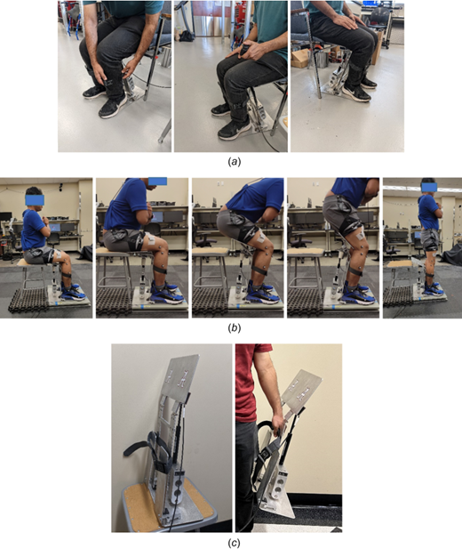
Allen, T., and Sprigle, S. (August 4, 2025). "Design Approaches and Decisions Employed During Low-Volume Product Development: A Case Series of Assistive Technology Commercialization." ASME. J. Mech. Des. October 2025; 147(10): 101403. https://doi.org/10.1115/1.4069151
