Beetle Elytra-Inspired Protection for FWMAVs
Brianna Connors and Perla Berkovitz
Bio-Inspired Robotics, ME-459
May 2026
The Cooper Union for the Advancement of Science and Art
New York, NY, USA
Elytra Drop - Documentation

Abstract — Flapping-wing micro air vehicles (FWMAVs) are susceptible to structural damage due to the constraint of lightweight materials. This study investigated the effect of beetle elytra-inspired interlocking shell geometries on impact mitigation and structural robustness for FWMAV protective structures. Four wing configurations – a fully solid control shell, butt joint, x-y interlocking jigsaw joint, and x-y-z interlocking jigsaw joint – were fabricated in polylactic acid (PLA) and thermoplastic polyurethane (TPU) using fused deposition modeling (FDM) with rectilinear infill geometry at 15% infill density. Static mechanical characterization was performed using a pseudo three-point bend test apparatus to estimate effective stiffness values. Dynamic drop testing compared impact absorption and structural performance across all wing geometries using accelerometer measurements. Results showed that TPU geometries improved load distribution. PLA specimens exhibited higher stiffness but more brittle failure behavior, while TPU specimens demonstrated increased compliance and energy absorption. The butt-joint configuration provided the best overall balance between stiffness, deformation, and survivability during impacts.
Keywords—bio-inspired robotics, elytra, impact protection, additive manufacturing, three-point bending

INTRODUCTION
Flapping-wing micro air vehicles (FWMAVs) are increasingly studied for applications involving confined navigation, environmental monitoring, search-and-rescue operations, and biologically inspired autonomous flight. Their lightweight structures and compliant wings allow highly maneuverable flight, but these same characteristics make them particularly vulnerable to damage and failure upon impacts. Due to strict mass constraints, FWMAVs possess limited protective casing, often exposing fragile onboard electronics. As a result, even relatively low-energy impacts can produce mechanical failure of critical components.
Biological organisms provide numerous examples of lightweight protective systems capable of surviving repeated impacts without significant structural damage. Many beetle species possess hardened forewings, known as elytra, that shield fragile hindwings and internal tissues while maintaining low overall mass. Elytra combine geometric reinforcement, layered material organization, and interlocking joint interfaces to resist fracture and distribute localized loads.
Additional biological investigations identified that the mechanical performance of beetle elytra is strongly influenced by interlocking interfaces and layered composite geometries that reduce stress concentrations and delay crack propagation [3] – [5]. Biomimetic interlocking geometries have also been shown to improve fracture resistance compared to conventional planar joints in tensile testing of nickel superalloys [6].
Despite these advances, relatively little research has experimentally quantified how elytra-inspired shell geometries influence impact mitigation and load transmission in robotic systems. Most previous work has focused primarily on aerodynamic feasibility and joint actuation. The protective nature of the shell is referenced in both current implementations, yet material properties and impact performance are uncharacterized. The present study addresses this gap by investigating how bio-inspired interlocking geometries affect stiffness, deformation, and impact energy absorption in protective wing structures.
The guiding research question for this project was: How can beetle elytra-inspired shell designs enhance the structural robustness and failure resistance of flapping-wing micro air vehicles (FWMAVs)?
To answer this question, four interchangeable wing shell configurations were fabricated using additive manufacturing and evaluated under both static and dynamic loading conditions. Static pseudo three-point bending tests were used to quantify stiffness and deformation behavior, while guided drop tests evaluated shock mitigation performance during impact events. Both rigid (PLA) and compliant (TPU) materials were investigated to compare the tradeoff between stiffness and energy absorption. This report describes the biological inspiration behind the designs, fabrication, testing methodology, resulting mechanical performance, and the implications for future bio-inspired protective systems in aerial robotics.

Design

Elytra-Inspired Structural Design - Perla
The primary design objective was to create lightweight protective wing structures capable of distributing impact loads while minimizing stress concentrations and catastrophic failure. Diabolical ironclad beetle, Phloeodes diabolicus, elytra served as the central source of inspiration because their overlapping and interlocking geometries allow beetles to withstand repeated mechanical loading while protecting delicate internal flight wings [4]. The design process focused specifically on the role of joint geometry in controlling stiffness, deformation, and load transfer. In an effort to reproduce the layered microstructures of beetle elytra, shown in Figure 1 below, with geometric infill, the elytra wings were fabricated via fused-deposition modeling (FDM) additive manufacturing, with infill density and geometry defined using the slicer software.
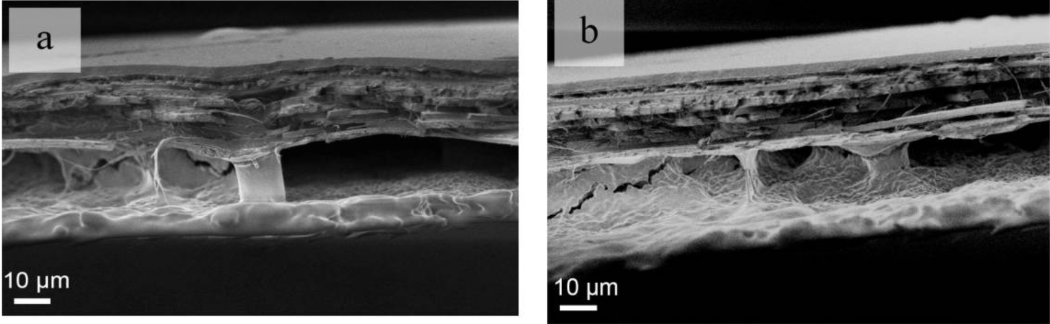
Figure 1: Honeycomb structures in the C. septempunctata elytra, (a,b) columns in the elytra [8]
Infill density was set to 15% for all test samples because it offers an optimal balance between structural integrity, part weight, and fabrication time. For ease of analysis and theoretical modeling, samples are constructed with rectilinear (grid) infill geometry. Test samples are constructed in both PLA and TPU to evaluate the tradeoffs between a more traditional rigid plastic and a compliant shell material. Prior studies have analyzed using fibers and composite materials to better mimic the beetle elytra material, [4], [7], but we selected to use PLA and TPU for ease of fabrication and iteration of joint geometries.
Initial joint geometry designs utilized a bio-mimicry approach, with an attempt to replicate the exact elytra geometry shown in Figure 2.
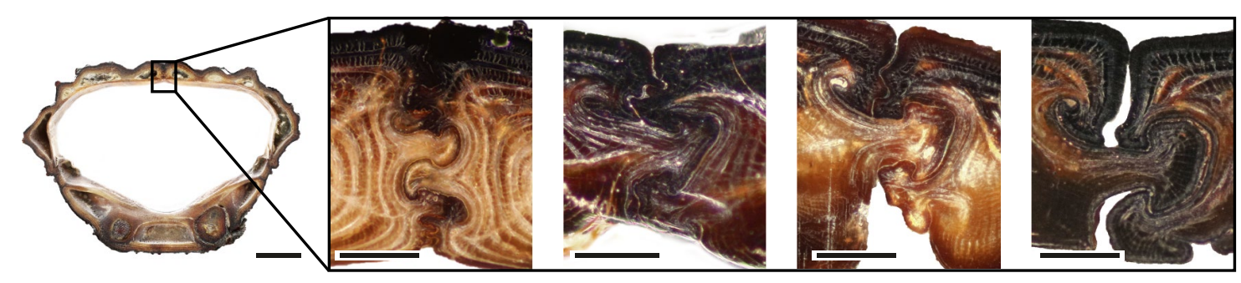
Figure 2: Optical micrographs of cross-sections of elytra from Ironclad beetles (P. diabolicus) [4]
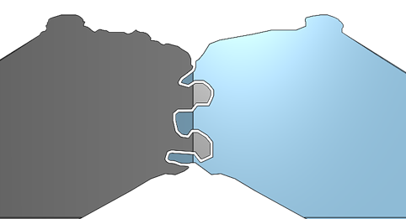
Figure 3: Bio-Mimcry Joint Design
Prototypes printed in TPU showed poor joint meshing due to print resolution and quality. This then led to a more bio-inspired approach, shown in Figure 4.
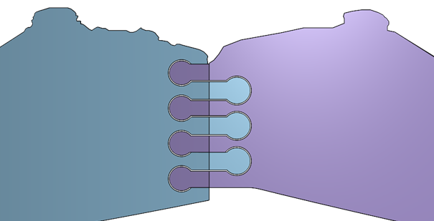
Figure 4: Bio-Inspired Joint Design
While providing significantly increased joint strength in manual analysis, these bio-inspired joints proved to be too challenging to reliably open and close, especially if the wings were actuated via small motors. After further considerations, the full elytra design shifted to better align with prior research. The final elytra designs are shown in Figure 5.
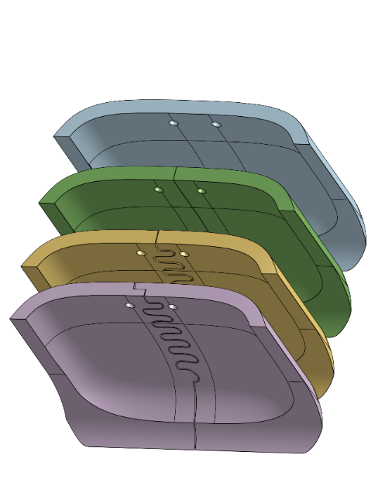
Figure 5: Elytra test geometries - full shell, butt joint, X-Y joint, X-Y-Z joint (top to bottom)
Multiple joint geometries were incorporated into this simplified shell model, including a fully solid shell, shown in blue, a traditional flat butt joint, shown in green, an X-Y constrained puzzle joint, shown in yellow, and an X-Y-Z constrained puzzle joint, shown in purple. The X-Y-Z constrained joint uses the same X-Y constraint but adds a stepover to constrain the wings in Z. This design allows the wings to easily rotate open about the central screw points, which could be used for future actuation efforts. Once finalized, each wing was fabricated using the previously described infill settings in PLA and TPU for Instron characterization and drop analysis.

Electronics Sled and Curved Panel Design – Bri
The curved panels were inspired by current elytra implementations, given the basis on aerodynamic performance [1], [2]. Figure 6 visualizes the rotation about a pin hinge, required for actuation by two paired revolute joints to allow motion between the dihedral lifting surface and closed protective shell positions.
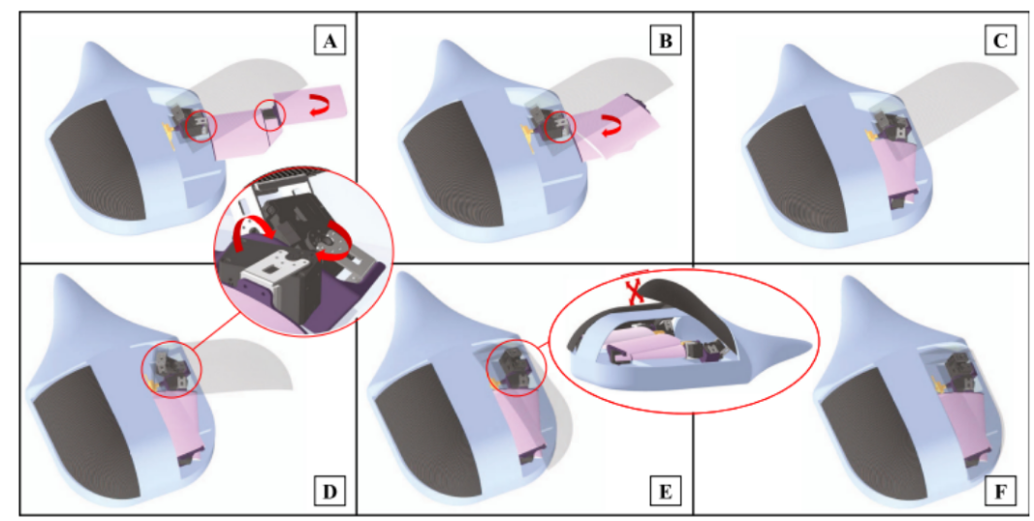
Figure 6: HercuLIS implementation by Vourtsis et al. [1] moving between dihedral (A) to closed position (F)
The drop rig was developed using ASTM D 5276, Standard Test Method for Drop Test of Loaded Containers by Free Fall, as a design reference. Since this study focused on collecting acceleration data from the elytra panel impact test rather than the robustness of container packaging, the rig is not fully complaint. However, several criteria were adapted to improve repeatability. The electronics sled was guided using two stainless steel wires passing through Delrin bushings, to maintain a vertical path and constrain the impact orientation, following 5.1.1 and 8.4.1. Drop height was controlled by positioning the bottom of the sled against inch markers, abiding to Section 5.1.2 and 8.5. The acrylic mounting plate used to space and fastened the wires was placed onto concrete to act as a rigid surface and provide a stable impact target; however, ASTM specifies concrete or steel in section 5.1.5.4.
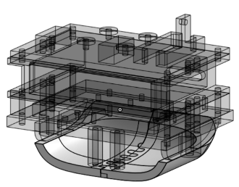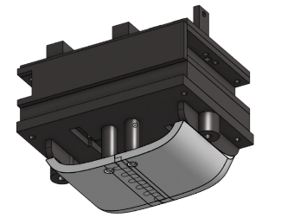
Figure 7: Electronics drop sled and Elytra panel
The ADXL accelerometer was mounted on a rigid plate with double sided tape, in the air gap between the elytra plates and upper portion of the sled. An ESP32 board controlled data logging, powered by battery pack. Acceleration data was sampled into both RAM buffers during trials over SPI, then transferred after the event to maintain the highest possible sampling rate (3200 Hz) and allow wireless data collection. After the trial was complete, the ESP transferred the data through microSD breakout module, saving each file as a csv. For consistiency, timing was controlled by button, and the start of data logging was indicated by the green light flashing a countdown until the red light signaled the optimal drop time.
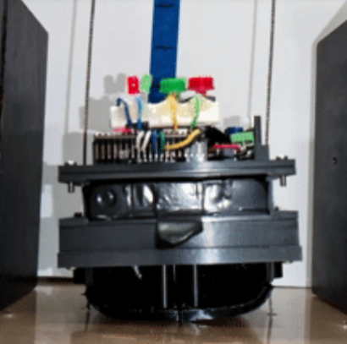
Figure 8: Drop Rig and Sled

Literature Review
Robotic implementations demonstrate that servo-actuated elytra mechanisms can be integrated into MAVs without compromising flight performance, establishing their feasibility at the system level. Results from wind tunnel experiments on an elytron attached to a fixed airfoil demonstrate that the panel generates non-negligible aerodynamic lift [1]. The maximum lift to drag ratio was approximately 21.15 at 6º angle of attack, 12º dihedral, and 0º angle of incidence. The final prototype, HercuLIS, is actuated using 2-axis servos and the material is 3d printed ABS, with spring loaded stationary wings.
Another fixed-wing drone, Ely, deomonstrates that servo-actuated elytra can allow self-righting in the event the MAV is wing down on the ground [2].
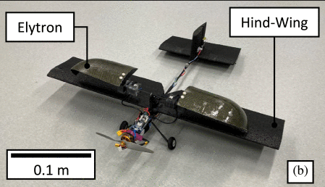
Figure 9: Ely implementation by Vourtsis et al. [2]
The study extensively characterizes the flipping maneuver, effective motor torques, and the aerodynamic performance in a wind tunnel at varying dihedral angles. The lift to drag ratios for elytra ranging from a span of 11-17 cm at an angle of attack from 0-7.5 degrees demonstrate a 60-80% increase compared to the bare wing. Although the elytra are relatively small compared to the lifting surface, this improvement shows that they provide aerodynamic benefit when coupled with a larger lifting surface.
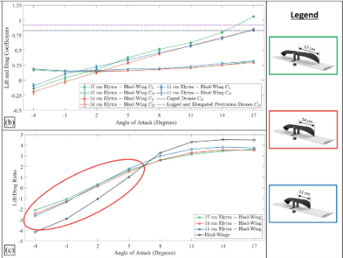
Figure 10: Aerodynamic Basis: lift to drag ratio from Vourtsis [1]
Overall, HercuLIS and Ely provide foundational basis for implementation into a robot, but do not explicitly characterize the structural protection.
Mechanical performance of beetle elytra is governed by joint and internal geometry rather than panel stiffness alone. Lomakin et al. show that the layered composite structure of the elytra enhances bending stiffness and crack resistance through specific fiber orientation [3]. Rivera et al. demonstrate that interlocking joint interfaces in ironclad beetle elytra redistribute compressive stresses to promote non-catastrophic failures over repeated loading [4]. Dai and Young reported that overlapping and coupled elytra increases resistance to separation under bending and compression without significant mass increase. [5]. Zheng et al. then used these principles to find that biomimetic interlocking geometries improve tensile fracture resistance compared to conventional flat joints [6]. Collectively, these studies tell us that interlocking and overlapping geometries can help to improve load transfer, reduce stress concentrations, and enhance overall toughness. A major component of our research will include looking at elytra-inspired interlocking joints to quantify any differences in stiffness, strain distributions, and failure behavior when compared to simple lap joints.
Prior studies have demonstrated the aerodynamic and structural advantages of elytra-inspired designs, yet their combined role in stress distribution and crash mitigation remains largely unquantified. Existing implementations focus primarily on flight or actuation performance, without investigation into shock transmission reduction or dynamic impact response using instrumentation. Material-level studies of elytra provide a strong mechanical basis for the use of layered, interlocking joint geometries. However, translation of these material and geometric principles to full-system dynamic impact scenarios has not been experimentally validated. Consequently, the protective efficacy of elytra-inspired shells under transient loading conditions remains an open research question.

Methodology

Instron Testing – Perla
Instron testing of wing samples provides a direct characterization of joint and wing stiffness. Each wing sample (solid shell, butt joint, X-Y joint, X-Y-Z joint) was loaded onto the drop sled mounting plate and fixed using pins at the center support columns to prevent x-displacement during compression tests. This mounting acts as a pseudo three-point-bend test setup, where the wings are simply supported at the edges and a load is applied directly at the center, with the added supports offset from the press head. The full setup is shown in Figure 11.
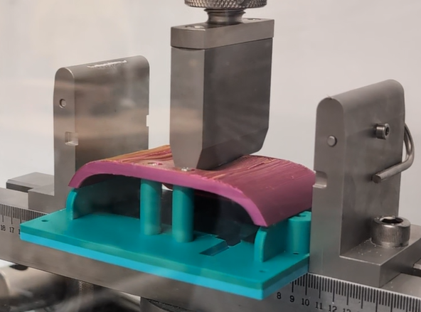
Figure 11: Instron Test Setup with PLA Full Shell Sample
Force and displacement data is collected via the Instron load cell. The press head travel speed was set to 10 mm/min, acting more as a slowly applied bending load instead of a sudden impact. The slope of the linear region on the force/displacement plot provides the effective stiffness, k, of the wing samples.

Drop Testing - Bri
Dynamic drop tests evaluate the ability of elytra-inspired shells in mitigating shock transmission to internal components during impacts, and accelerometer data will validate the feasibility of deployment.
Drop height was theoretically determined using the Lagrange Energy Method as described in Appendix II, ranging from 10-20” depending on the stopping distance. Initial bare sled testing at 15” was utilized to experimentally determine the maximum height where acceleration experienced was within the ±200g range. The wing mounting plate was removed, to allow a flat face drop without elytra panels.
A lower maximum measurement would indicate that the internal components experience a lower peak force. The duration of contact demonstrates whether the shell is effectively distributing force, since the impulse would be spread over time during the collision. Finally, damped rebound kinematics indicate that there is more energy dissipated into the shell and less returned elastically into a bounce or throughout the sled and electronics.

Results

Instron Test Results - Perla
Force/displacement curves for each geometry and material are plotted in Figures 12 and 13 below. Approximate wing stiffnesses are given in Table I.
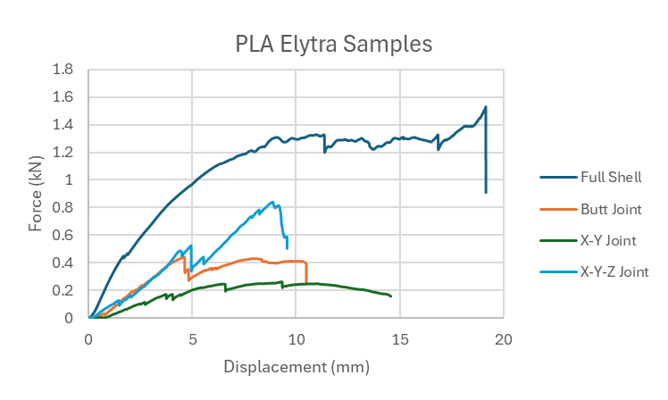
Figure 12: PLA Elytra Instron Test Results
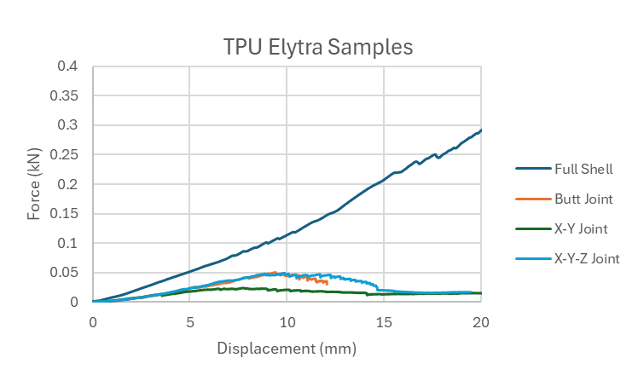
Figure 13: TPU Elytra Instron Test Results
- Estimated Wing Stiffness (kN/mm)
k-values (kN/mm) | Full | Butt | X-Y | X-Y-Z
PLA | 0.1748 | 0.1144 | 0.0494 | 0.1123
TPU | 0.0093 | 0.0029 | 0.0032 | 0.0032

Figure 13 shows standard linear material behavior, where there is a linear region prior to yield and a clear failure point, which correlates with prior knowledge of PLA material properties. A sample PLA wing after testing is shown in Figure 14, where the failure is clearly evident after the load is removed from the sample.

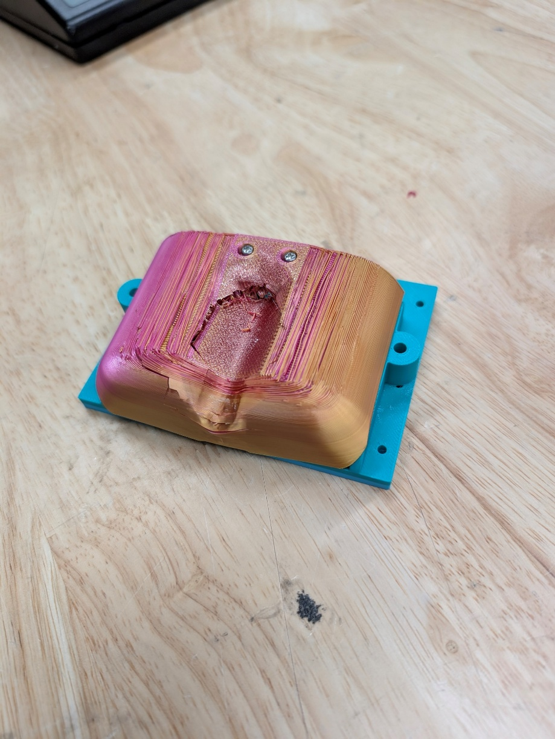
Figure 14: PLA full shell sample after Instron testing
The force/displacement curves in Figure 13 show more non-linear behavior, where the material continuously deforms without reaching a clear failure point. TPU wing samples deflected away from the press head until the press head reached the base plate (~20mm total displacement). After the load was removed, TPU wing samples exhibited no clear damage or wear marks from the press head. Stiffness approximates for the TPU wing samples were calculated between 0 and 2.5mm displacement, which had the most linear behavior for all samples.
Table I shows that all PLA samples exhibited significantly greater stiffness than TPU samples, consistent with the expected compliance of TPU. Among PLA configurations, the X-Y joint produced the lowest stiffness (0.0494 kN/mm), representing a 71% reduction relative to the solid PLA shell, while the butt joint was the stiffest, with stiffness 35% below the solid shell. The TPU butt joint was the most compliant overall, exhibiting 95% greater compliance than the PLA X-Y joint. PLA and TPU did not exhibit consistent stiffness trends across joint geometries, likely due to differences in material behavior under compressive loading. Additional testing is required to establish geometry-dependent trends for both materials.

Drop Test Acceleration Results - Perla
Total acceleration for each wing sample is shown in Figures 10 and 11.
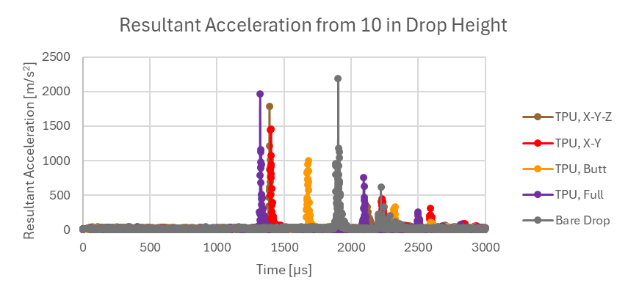
Figure 6: TPU Drop Test Acceleration Peaks
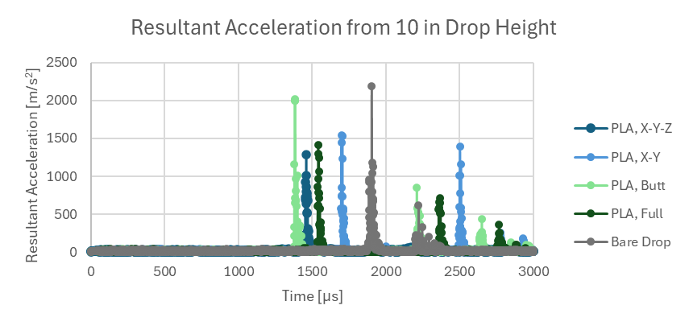
Figure 7: PLA Drop Test Acceleration Peaks
A summary of peak acceleration values for each test sample can be found in Table II below. Bare drops from 10”, where the wing mounting plate was removed to provide a more uniform contact area resulted in peak acceleration of 2194.73 m/s² (~223.72g).
- Peak Total Acceleration (m/s²)
Peak total acceleration (m/s²) | Full | Butt | X-Y | X-Y-Z
PLA | 1409.96 | 2022.08 | 1540.42 | 1286.13
TPU | 1968.55 | 1002.22 | 1459.53 | 1784.02
Table II shows substantial variation in peak acceleration across materials and joint geometries. For PLA configurations, the X-Y-Z joint produced the lowest peak acceleration (1286.13 m/s²), corresponding to a 41% reduction relative to the unprotected bare drop, while the butt joint exhibited the highest acceleration, only 8% below the bare drop. The comparatively low peak acceleration of the PLA full-shell sample is unexpected and requires additional testing for validation. The TPU butt joint demonstrated the greatest impact attenuation overall, with peak acceleration reductions of 54% relative to the bare drop and 22% relative to the PLA X-Y-Z joint. Reduced peak acceleration corresponds to lower impact force transmission to sensitive internal components.

Vibrational Analysis – Bri
To analyze the material properties of the wing and resulting vibrational response, the time domain acceleration data was converted to the frequency domain through the Fast Fourier transform in MATLAB.
Figure 12 characterizes the dominant peak of the fully solid PLA shell, occuring near resonance of the response at 998 Hz.
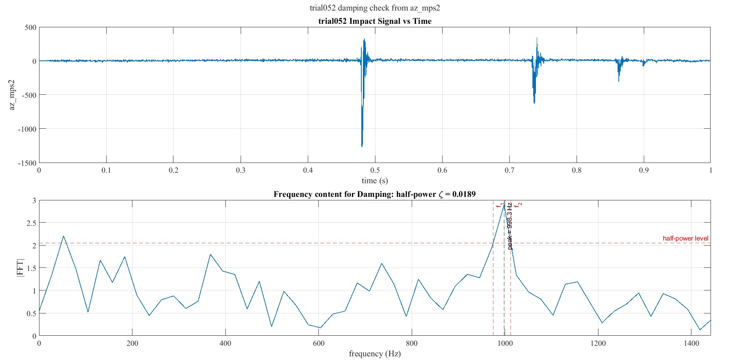
Figure 12: PLA Time and Frequency Domain Peaks
Utilizing the half power method yeilded a damping ratio of 0.0189, indicating a lightly damped response. The equivalent stiffness used for the material model was 174,800 N/m with an equivalent damping coefficient of 2.2148 Ns/m. The calculated undamped natural frequency was 2983.3 rad/s corresponding to a natural frequency of 474.81 Hz. Since the damping ratio was small, the damped natural frequency remained nearly the same, 2982.8 rad/s and 474.73 Hz, respectively.
Figure 13 demonstrates that the frequency response of the fully solid TPU shell resonance peak occurs near 919.5 Hz.
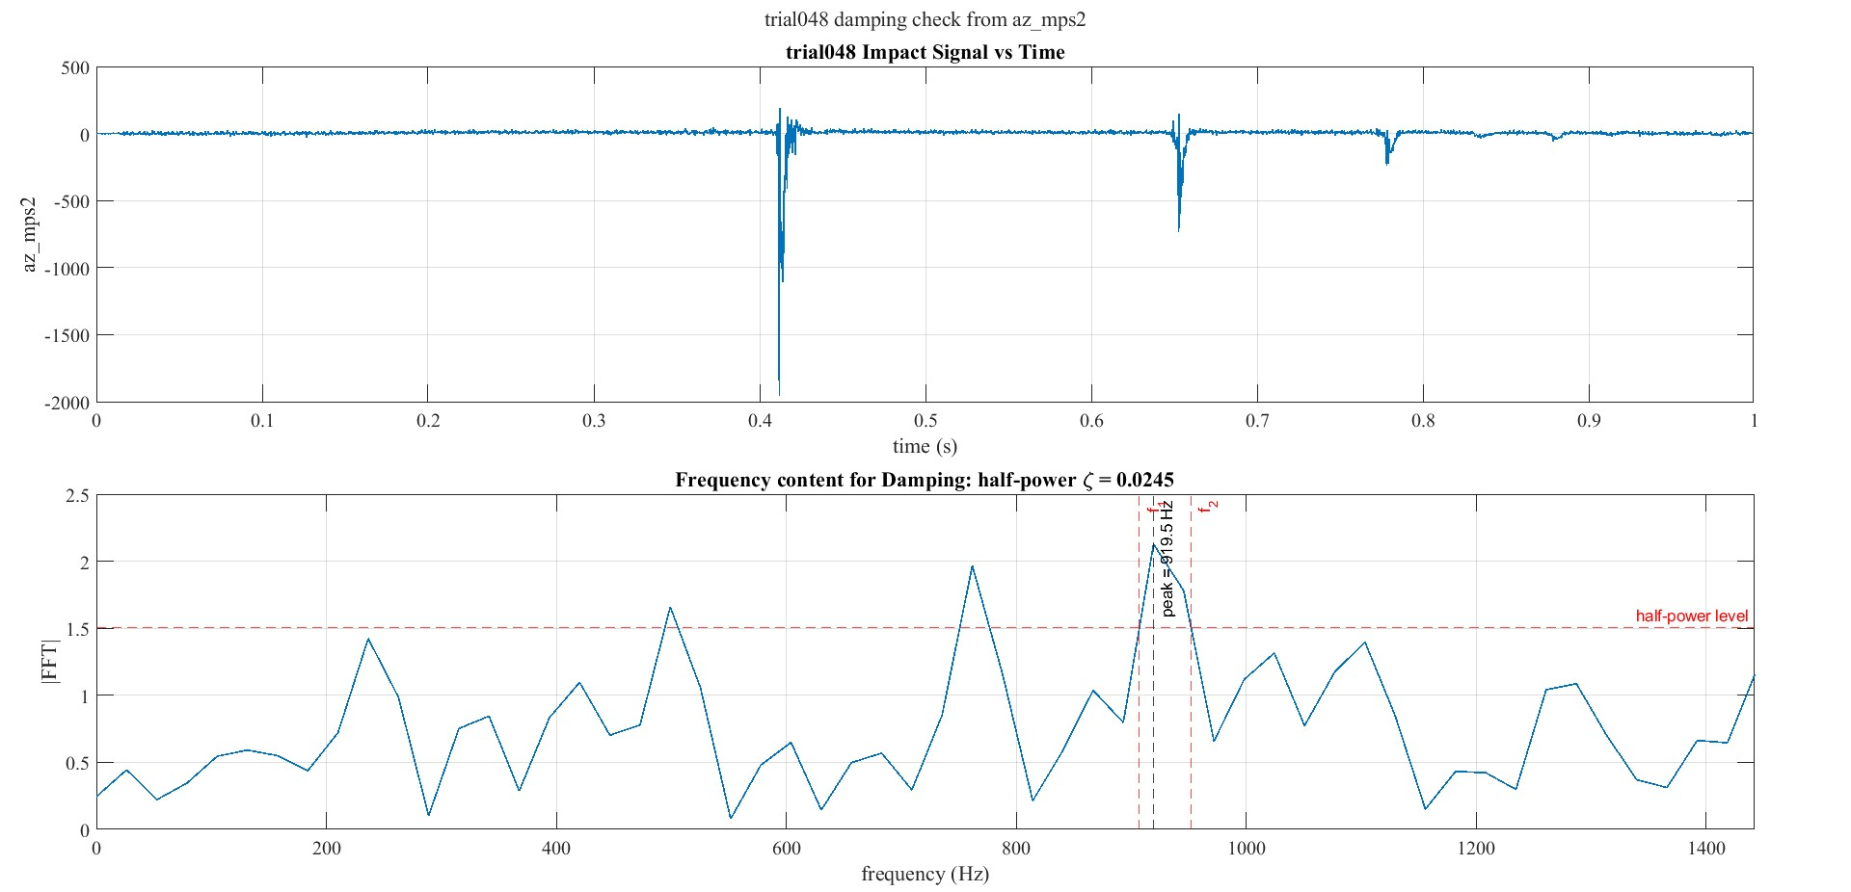Figure 13: TPU Time and Frequency Domain Peaks
For TPU, the half-power method yielded a damping ratio of 0.0245, indicating a lightly damped response with slightly more damping than PLA. The equivalent stiffness used for the TPU material model was 9300 N/m with an equivalent damping coefficient of 0.06622 Ns/m. The calculated undamped natural frequency was 688.13 rad/s, corresponding to 109.52 Hz. Since the damping ratio was small, the damped natural frequency remained nearly the same, as 687.92 rad/s and 109.49 Hz.
Compared with PLA, TPU had a lower stiffness and lower natural frequency, but a slightly higher damping ratio.

Conclusion and Future Work

Key Conclusions - Perla
Peak acceleration results indicate that the TPU butt joint wings provide the greatest impact attenuation, consistent with the low stiffness measured during Instron testing.

Future Work Opportunities - Perla
Future work should include additional Instron and drop-test samples to improve statistical confidence and establish more robust performance trends. The Instron setup could be modified to better approximate a three-point bending test by improving edge constraints and removing the central support pillars. During drop testing, significant lateral (X-Y) motion was observed in addition to the intended Z-direction impact due to poor cable tensioning, introducing variability in impact orientation. Future studies may benefit from an impact attenuation drop rig in which weights are guided directly onto the elytra wings to ensure more consistent loading conditions. Evaluation of alternative materials, including composites, could reduce overall drop sled mass, enabling higher drop heights and improved characterization for FWMAV applications.

Bri’s Conclusions and Future Work
The instrumented drop sled successfully created a repeatable method for collecting dynamic acceleration data from elytra-inspired wing panels. By using a guided sled, controlled drop height, and onboard ADXL/ESP32 data logging, the setup allowed impact response to be evaluated beyond visual damage or static stiffness alone. Although the rig was ASTM-informed rather than fully ASTM-compliant, it provided a platform for comparing shock transmission, contact behavior, and post-impact vibration response.

Future testing could focus on iterating different materials and geometries, to characterize whether TPU, PLA, or other materials perform better when the thickness is reduced. Given the similarity between effective damping coefficients, the potential benefits offered by TPU may be negated when the infil is higher due to the wall thickness.
Additionally, the drop sled could be constrained along another wire to offer more resistance to twisting about the drop plane.

Acknowledgment
The authors thank Dr. Michelle Rosen and Michael Giglia for their guidance and support throughout this project.

References
- G. Vourtsis, W. Stewart, and D. Floreano,
“Robotic elytra: Insect-inspired protective wings for resilient and multi-modal drones,”
Bioinspiration & Biomimetics, vol. 16, no. 6, 2021, doi: 10.1088/1748-3190/ac1bb1.
- C. Vourtsis, V. Casas Rochel, F. Ramirez Serrano, W. Stewart, and D. Floreano,
“Insect-inspired self-righting for fixed-wing drones,”
IEEE Robotics and Automation Letters, vol. 6, no. 4, pp. 7618–7625, 2021,
doi: 10.1109/LRA.2021.3096159.
- J. Lomakin, P. A. Huber, C. Eichler, Y. Arakane, K. J. Kramer, R. W. Beeman, M. R. Kanost, and S. H. Gehrke, “Mechanical Properties of the Beetle Elytron, a Biological Composite Material,” Biomacromolecules, Vol. 12, No. 2, pp. 321–335, 2011, doi:10.1021/bm1009156.
- J. Rivera, M. S. Hosseini, D. Restrepo, S. Murata, D. Vasile, D. Y. Parkinson, H. S. Barnard, A. Arakaki, P. Zavattieri, and D. Kisailus, “Toughening Mechanisms of the Elytra of the Diabolical Ironclad Beetle,” Nature, Vol. 586, No. 7830, pp. 543–547, 2020, doi:10.1038/s41586-020-2813-8.
- Z. Dai and Z. Yang, “Macro-/Micro-Structures of Elytra, Mechanical Properties of the Biomaterial and the Coupling Strength Between Elytra in Beetles,” Journal of Bionic Engineering, Vol. 7, No. 1, pp. 6–12, 2010, doi:10.1016/S1672-6529(09)60187-6.
- D. Zheng, R. Zhang, X. Zhu, et al., “Effect of Biomimetic Structures on the Tensile Fracture Behavior of TLP Joints for GH4169,” Crystals, Vol. 15, No. 12, Article 1026, 2025, doi:10.3390/cryst15121026.
- S. Lai et al., "Beetle elytra-inspired shear-stiffening warp-knitted spacer fabric composites with enhanced impact resistance," Composite Structures, vol. 286, p. 115286, Apr. 2022, doi: 10.1016/j.compstruct.2022.115286
- H. Hao, X. Li, J. Zhang, and K. Du, “Investigation on microstructure of beetle elytra and energy absorption properties of bio-inspired honeycomb thin-walled structure under axial dynamic crushing,” Nanomaterials, vol. 8, no. 9, p. 667, Aug. 2018, doi: 10.3390/nano8090667.

Appendix: Calculations
Drop height was estimated using a simplified spring-damper impact model for the sled and elytra contact. Before impact, the sled was treated as a falling mass, so the impact velocity was estimated from free-fall kinematics as
$$v_{i}=\sqrt{2gh}$$
where $h$is the drop height and $g$is gravitational acceleration. During impact, the elytra contact was approximated as a spring-damper system with effective stiffness $k$, damping coefficient $R$, and compression distance $x$. Using $x$as the impact compression coordinate, the kinetic energy, potential energy, and Rayleigh damping terms were written as
$$T=\frac{1}{2}m{\dot{x}}^{2},V=\frac{1}{2}kx^{2}-mgx,D=\frac{1}{2}R{\dot{x}}^{2}$$
Using the Lagrange Energy Method, kinetic and potential energy are defined along with damping in terms of the response:
$$Lagrange Energy:\left\{\begin{aligned}T=\frac{1}{2}m{\dot{x}}^{2} \\ V=\frac{1}{2}kx^{2}-mgx \\ D=\frac{1}{2}R{\dot{x}}^{2}\end{aligned}\right.$$
The Lagrangian is defined as:
$$L=T-V$$
According to Euler-Lagrange:
$$\frac{d}{dt}\left(\frac{∂L}{∂\dot{x}}\right)-\frac{∂L}{∂x}+\frac{∂D}{∂\dot{x}}=0$$
$$\frac{d}{dt}\left(m\dot{x}\right)-\left(-kx+mg\right)+R\dot{x}=0$$
which gives the contact equation
$$m\ddot{x}+R\dot{x}+kx=mg.$$
To estimate a safe drop height, the maximum contact force was limited by the accelerometer range, $F_{max}=Gmg$. Approximating the contact force as the spring and damping contribution gives
$$R\sqrt{2gh}+kx≈Gmg$$
and therefore
$$h≈\frac{1}{2g}{\left(\frac{Gmg-kx}{R}\right)}^{2}.$$
This relationship was used to select the initial 10–20 in. drop-height range by estimating the compression distance and limiting the predicted acceleration to remain within the ±200 g accelerometer range.

