NOTIFIABLE MEDICAL CONDITIONS SURVEILLANCE SYSTEM

the National Institute for Communicable Diseases

# Introduction

This report summarizes data from the National Notifiable Medical Conditions Surveillance System (NMCSS) on cases notified during **November 2023**. Additionally, this report includes information on the distribution of case notifications by sources, such as clinical or laboratory notifications, merged cases (**see Appendix no. 3**), and the number of reported deaths. It monitors the use of the electronic NMC Reporting Application (App) for notification, data quality, specifically the completeness and timeliness of clinical diagnosis and notifications over time, and back-captured cases notified in November 2023 (**see Appendix nos. 1 and 3**). Category 4 NMCs, COVID-19, and multi-system inflammatory syndrome (MIS-C) have been excluded from this report.

## Highlights

* A total of 11642 cases were notified in November 2023 and the majority were category 2 conditions.
* There were 445 average active users of the NMC App in November 2023
* Category 1 cases were reported in median (IQR) of zero (0, 1) days.

## NMC Reporting application

* NMC Reporting App is available on both web and mobile platforms
* Use recommended browsers in order to access NMC reporting App for notifications, searching of cases and reports.
* Register if you have no NMC account and you can reset the password if you have not used the application over 12 months. 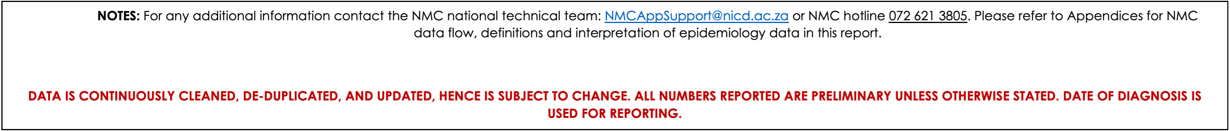

## Category 1 Conditions at a glance

Table 1: The number of notifications that are suspected and confirmed for category 1 conditions.

| Condition | **Suspected**,  N = 12621 | **Confirmed**,  N = 6391 |
| --- | --- | --- |
| Acute Flaccid Paralysis | 23 | 0 |
| Acute rheumatic fever | 1 | 0 |
| Cholera | 1 | 0 |
| Congenital rubella syndrome | 1 | 32 |
| Diphtheria | 23 | 6 |
| Enteric fever (typhoid or paratyphoid fever) | 1 | 12 |
| Food borne illness outbreak | 292 | 0 |
| Listeriosis | 4 | 5 |
| Malaria | 59 | 183 |
| Measles | 492 | 47 |
| Meningococcal Disease | 30 | 4 |
| Pertussis | 105 | 64 |
| Rabies | 3 | 1 |
| Rubella | 227 | 285 |
| 1n | | |

# NMC data summary, November 2023

A total of n=12756 cases were notified to the NMCSS in November 2023 **(See Appendix no.3 for definitions)**. There were 11642 current notifications; the majority (n=9 613, 83%) were category 2 conditions. The provinces with the highest number of notifications were KZN (2 672, 23%), GP (2 558, 22%), and WC (2 532, 22%). The provinces with the least number of notifications were NW (390, 3.4%), and MP (400, 3.4%). (**Figure 1**) There were 1114 back captured clinical notifications diagnosed between February, 2021 and November 2023 and only notified in November 2023. The majority (812, 73%) of those notifications were cases TB:pulmonary notifications. (**See Appendix no.1**).

Table 2: Description of NMC notifications by case source

| **NMC Category** | **Overall**, N = 11 642 | **Clinical notifications**,  n = 8427 | **Laboratory notifications**,  n = 2696 | **Merged Cases**,  n = 519 |
| --- | --- | --- | --- | --- |
| Category 1 | 1 901 (16%) | 1 264 (15%) | 377 (14%) | 260 (50%) |
| Category 2 | 9 613 (83%) | 7 163 (85%) | 2 210 (82%) | 240 (46%) |
| Category 3 | 128 (1.1%) | 0 (0%) | 109 (4.0%) | 19 (3.7%) |

## App use

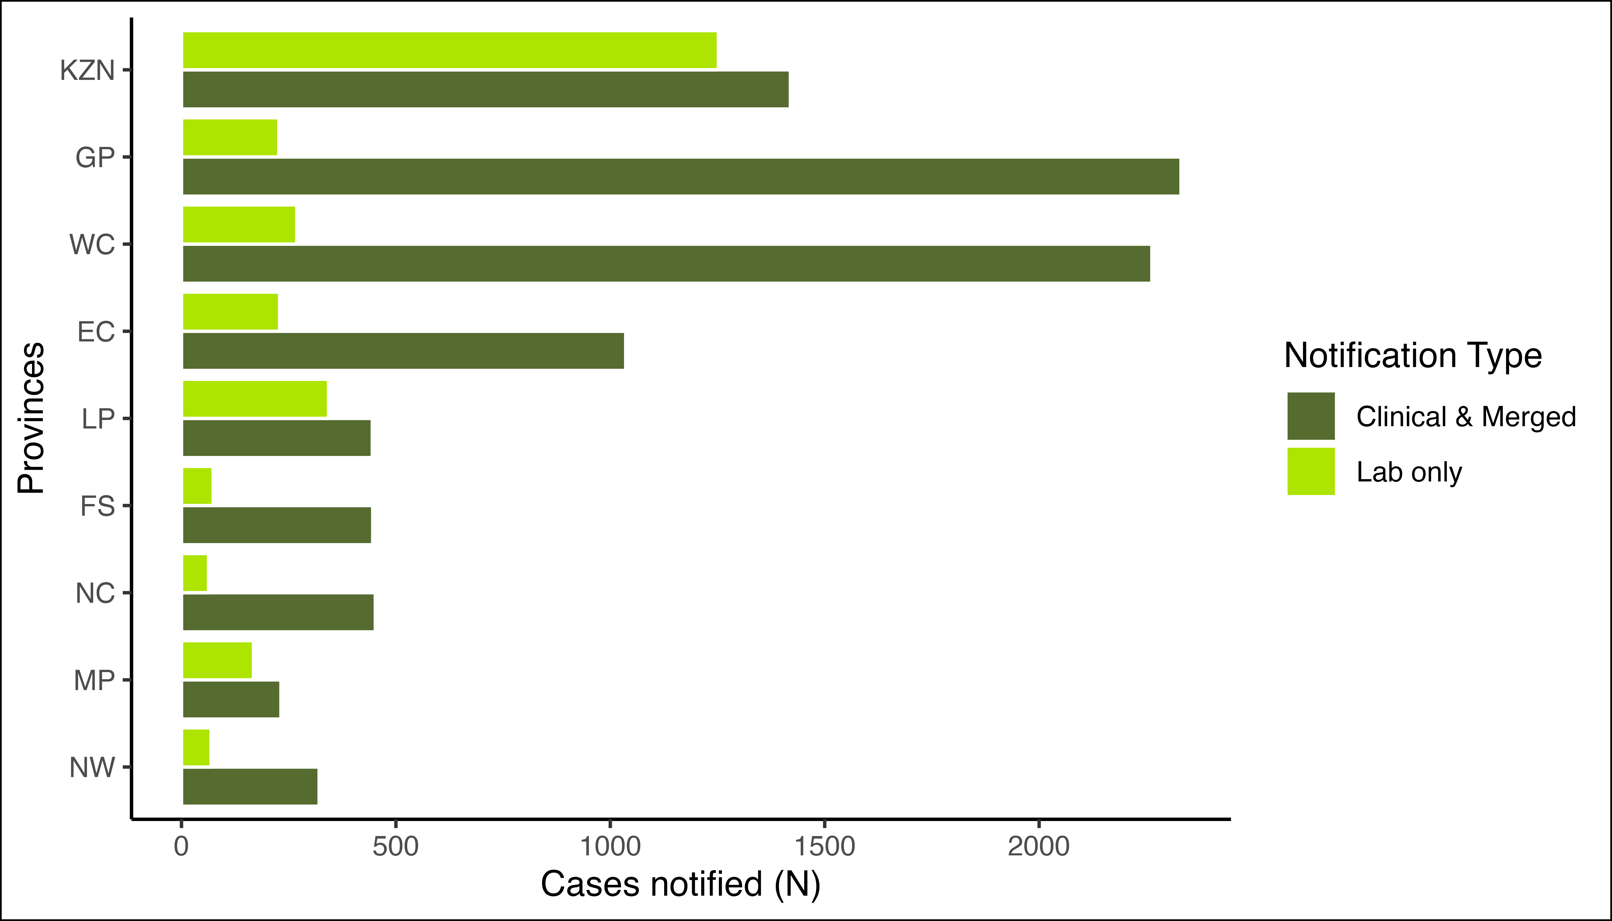

Figure 1: Distribution of notifications by province and notification type

There were 689 (7.7%) Clinical notifications from from the private sector (i.e. private hospitals, private practice and mining industry) compared to 8 253 (92%) in the public sector. Clinical notifications using the NMC Reporting Application made up 8452 (99%) (see Table 3 ).

Table 3: Clinical notifications notified by provinces, reporting platform, and sector

| **Province** | **Overall**, N = 8 578 | **App - Private**,  n = 684 | **App - Public**,  n = 7768 | **Paper-based - Private**,  n = 4 | **Paper-based - Public**,  n = 122 |
| --- | --- | --- | --- | --- | --- |
| GP | 2 257 (100%) | 234 (10%) | 2 021 (90%) | 2 (<0.1%) | 0 (0%) |
| WC | 2 174 (100%) | 96 (4.4%) | 1 982 (91%) | 0 (0%) | 96 (4.4%) |
| KZN | 1 307 (100%) | 139 (11%) | 1 165 (89%) | 0 (0%) | 3 (0.2%) |
| EC | 1 026 (100%) | 53 (5.2%) | 966 (94%) | 1 (<0.1%) | 6 (0.6%) |
| FS | 442 (100%) | 41 (9.3%) | 401 (91%) | 0 (0%) | 0 (0%) |
| LP | 416 (100%) | 18 (4.3%) | 397 (95%) | 0 (0%) | 1 (0.2%) |
| NC | 415 (100%) | 22 (5.3%) | 393 (95%) | 0 (0%) | 0 (0%) |
| NW | 321 (100%) | 60 (19%) | 244 (76%) | 1 (0.3%) | 16 (5.0%) |
| MP | 220 (100%) | 21 (9.5%) | 199 (90%) | 0 (0%) | 0 (0%) |

The majority of the notified cases were Males n(%) 6 917 (59%). Individuals in the 35-39 year age group represented the majority (1 211 (10%)) of notified cases (Table 3). At the time of notificaiton, approximately 2 602 (22%) of the notified cases were hospitalized, while 75 (0.6%) were transferred to another healthcare facility. There were 74 deaths notified during the reporting period with case fatality rate of 0.6%.

## Hospital Form Completeness

Table 4: Completion of hospitalisation form for notificatiosn reported as inpatients with category 1 conditions. Comlpete refers to >80% of variables completed.

| **Hospital Form Completed** | **Complete**, n = 27 (7.3%) | **Incomplete**, n = 86 (23%) | **Only Symptoms completed**, n = 169 (46%) | **Not Attempted**, n = 88 (24%) |
| --- | --- | --- | --- | --- |
| Acute Flaccid Paralysis | 3 (11%) | 4 (4.7%) | 12 (7.1%) | 1 (1.1%) |
| Congenital rubella syndrome | 0 (0%) | 0 (0%) | 1 (0.6%) | 0 (0%) |
| Diphtheria | 1 (3.7%) | 3 (3.5%) | 6 (3.6%) | 0 (0%) |
| Enteric fever (typhoid or paratyphoid fever) | 0 (0%) | 1 (1.2%) | 2 (1.2%) | 1 (1.1%) |
| Food borne illness outbreak | 6 (22%) | 19 (22%) | 40 (24%) | 33 (38%) |
| Listeriosis | 1 (3.7%) | 1 (1.2%) | 2 (1.2%) | 2 (2.3%) |
| Malaria | 5 (19%) | 18 (21%) | 45 (27%) | 21 (24%) |
| Measles | 0 (0%) | 4 (4.7%) | 9 (5.3%) | 7 (8.0%) |
| Meningococcal Disease | 2 (7.4%) | 5 (5.8%) | 13 (7.7%) | 4 (4.5%) |
| Pertussis | 8 (30%) | 29 (34%) | 36 (21%) | 18 (20%) |
| Rabies | 0 (0%) | 0 (0%) | 2 (1.2%) | 0 (0%) |
| Rubella | 1 (3.7%) | 2 (2.3%) | 1 (0.6%) | 1 (1.1%) |

## Distribution of Category 1 NMCs by province and case definition

The majority of category 1 notifications were for Measles n(%) 539 (28%). The majority of Measles cases were notified in WC n(%) 369(72.4%).

Table 5: The number of notifications by province and the number of notifications by case definition and vital status of category 1 conditions.

|  | **Provinces** | | | | | | | | | **Cases** | | **Deaths** | |
| --- | --- | --- | --- | --- | --- | --- | --- | --- | --- | --- | --- | --- | --- |
| Condition | **EC**1 | **FS**1 | **GP**1 | **KZN**1 | **LP**1 | **MP**1 | **NC**1 | **NW**1 | **WC**1 | **Suspected$** | **Confirmed**1 | **Suspected$** | **Confirmed**1 |
| Acute Flaccid Paralysis | 0 | 2 | 7 | 8 | 1 | 1 | 0 | 0 | 4 | 23 | 0 |  |  |
| Acute rheumatic fever | 0 | 0 | 0 | 0 | 1 | 0 | 0 | 0 | 0 | 1 | 0 |  |  |
| Cholera § | 0 | 0 | 1 | 0 | 0 | 0 | 0 | 0 | 0 | 1 | 0 |  |  |
| Congenital rubella syndrome | 0 | 0 | 0 | 3 | 0 | 0 | 10 | 0 | 20 | 1 | 32 |  |  |
| Diphtheria * | 0 | 0 | 0 | 1 | 0 | 1 | 0 | 0 | 27 | 23 | 6 |  |  |
| Enteric fever (typhoid or paratyphoid fever) | 2 | 1 | 5 | 2 | 0 | 0 | 0 | 0 | 3 | 1 | 12 |  |  |
| Food borne illness outbreak | 191 | 12 | 27 | 23 | 2 | 32 | 1 | 0 | 4 | 292 | 0 |  |  |
| Listeriosis | 0 | 0 | 3 | 1 | 1 | 0 | 0 | 0 | 4 | 4 | 5 |  |  |
| Malaria | 2 | 1 | 72 | 13 | 82 | 49 | 3 | 6 | 14 | 59 | 183 | 1 | 3 |
| Measles | 5 | 12 | 63 | 32 | 4 | 2 | 51 | 1 | 369 | 492 | 47 |  |  |
| Meningococcal Disease | 3 | 2 | 11 | 2 | 2 | 0 | 1 | 3 | 10 | 30 | 4 | 4 | 0 |
| Pertussis | 13 | 18 | 64 | 30 | 5 | 10 | 0 | 1 | 27 | 105 | 64 | 1 | 1 |
| Rabies | 3 | 0 | 1 | 0 | 0 | 0 | 0 | 0 | 0 | 3 | 1 | 0 | 1 |
| Rubella | 2 | 6 | 6 | 0 | 2 | 1 | 105 | 0 | 390 | 227 | 285 |  |  |
| 1n(%);  $ suspected cases are both suspected and probable; * Toxin producing results not available on NMC;  § Serotype information not avaialble on NMC; | | | | | | | | | | | | | |

## Distribution of Category 2 NMCs by province and case definition

Table 6: Distribution of Category 2 NMC by Province

The majority of category 2 notifications were for Tuberculosis:pulmonary n(%) 6 193 (58%). The majority of Tuberculosis:pulmonary cases were notified in GP n(%) 1395(25.6%).

Table 7: The number of notifications by province and the number of notifications by case definition and vital status of category 2 conditions.

|  | **Provinces** | | | | | | | | | **Case** | | **Deaths** | | | |
| --- | --- | --- | --- | --- | --- | --- | --- | --- | --- | --- | --- | --- | --- | --- | --- |
| Condition | **EC**1 | **FS**1 | **GP**1 | **KZN**1 | **LP**1 | **MP**1 | **NC**1 | **NW**1 | **WC**1 | **Suspected**1 | **Confirmed**1 | **Suspected**1 | **Confirmed**1 | | |
| Agricultural or stock remedy poisoning | 3 | 14 | 60 | 1 | 1 | 3 | 1 | 3 | 9 | 95 | 0 | 8 | 0 | |
| Bilharzia (schistosomiasis) | 71 | 0 | 43 | 468 | 266 | 105 | 1 | 1 | 23 | 47 | 932 | 0 | 1 | | |
| Brucellosis | 0 | 0 | 0 | 0 | 2 | 0 | 1 | 0 | 0 | 3 | 0 |  |  | | |
| Congenital syphilis | 1 | 0 | 4 | 15 | 1 | 4 | 1 | 1 | 13 | 10 | 30 | 0 | 1 | | |
| Haemophilus influenzae type B | 0 | 6 | 1 | 4 | 0 | 0 | 0 | 0 | 0 | 11 | 0 |  |  | | |
| Hepatitis A | 47 | 14 | 184 | 150 | 55 | 30 | 17 | 21 | 94 | 93 | 519 |  |  | | |
| Hepatitis B | 88 | 42 | 64 | 767 | 8 | 13 | 7 | 48 | 13 | 90 | 960 | 3 | 2 | | |
| Hepatitis C | 1 | 0 | 7 | 1 | 1 | 1 | 0 | 0 | 2 | 11 | 2 |  |  | | |
| Hepatitis E | 0 | 0 | 5 | 0 | 0 | 0 | 0 | 2 | 0 | 0 | 7 |  |  | | |
| Legionellosis | 1 | 0 | 0 | 0 | 0 | 0 | 0 | 2 | 1 | 2 | 2 | 0 | 1 | | |
| Maternal death (pregnancy, childbirth and puerperium) | 0 | 0 | 1 | 1 | 3 | 0 | 0 | 0 | 0 | 5 | 0 | 4 | 0 | | |
| Soil transmitted helminths | 0 | 0 | 1 | 0 | 0 | 0 | 0 | 0 | 1 | 2 | 0 |  |  | | |
| Tetanus | 0 | 0 | 0 | 0 | 1 | 0 | 0 | 0 | 0 | 1 | 0 |  |  | | |
| Tuberculosis: extensively drug -resistant (XDR -TB) | 1 | 0 | 4 | 0 | 1 | 1 | 1 | 0 | 2 | 10 | * |  | * | | |
| Tuberculosis: multidrug- resistant (MDR -TB) | 25 | 5 | 37 | 26 | 4 | 1 | 1 | 5 | 23 | 127 | * | 3 | * | | |
| Tuberculosis:extra-pulmonary | 114 | 77 | 485 | 173 | 44 | 30 | 48 | 66 | 236 | 1 273 | * | 11 | * | | |
| Tuberculosis:pulmonary | 661 | 305 | 1 394 | 945 | 300 | 115 | 266 | 230 | 1 165 | 5 381 | * | 27 | * | | |
| 1n(%);  ** TB module is under development to align with laboratory confirmed TB cases. | | | | | | | | | | | | | |

## The average active users on the NMC App

## Data quality

**Completeness** refers to the proportion of complete data entries per variable in the dataset among clinical and merged notifications. In November 2023, there was an increase in completeness of date of diagnosis and patient folder number, while demographic details and patient vital status remain high.

**Timeliness** is measured by the number of days from the time of diagnosis of the NMC to the time of notification. Overall, it took a median (IQR) of zero (0, 1) days to report category 1 NMCs.

Table 8: NMC data completeness of clinical notifications on both reporting platforms

|  | **App**, N = 8 455 | **Paper-based**, N = 127 |
| --- | --- | --- |
| **Folder Number** | 6 922 (82%) | 106 (83%) |
| **First Name** | 8 455 (100%) | 127 (100%) |
| **Surname** | 8 455 (100%) | 127 (100%) |
| **Symptom Onset Date** | 8 440 (100%) | 127 (100%) |
| **Date of Diagnosis** | 8 454 (100%) | 127 (100%) |
| **Outcome** | 8 455 (100%) | 127 (100%) |

### ID number completeness

Table 9: Length of ID numbers inputted on NMC system

| **Length of ID number** | **Android**, N = 2 9311 | **Microstrategy/SDW**, N = 3 0601 | **Paper-based**, N = 1271 | **Web**, N = 4 8841 | **iOS**, N = 6401 |
| --- | --- | --- | --- | --- | --- |
| 0 | 1 132 (39%) | 2 977 (97%) | 93 (73%) | 1 724 (35%) | 299 (47%) |
| 3 | 0 (0%) | 0 (0%) | 0 (0%) | 1 (<0.1%) | 0 (0%) |
| 5 | 0 (0%) | 0 (0%) | 0 (0%) | 1 (<0.1%) | 0 (0%) |
| 6 | 3 (0.1%) | 16 (0.5%) | 0 (0%) | 418 (8.6%) | 56 (8.8%) |
| 7 | 0 (0%) | 0 (0%) | 0 (0%) | 11 (0.2%) | 1 (0.2%) |
| 8 | 0 (0%) | 0 (0%) | 0 (0%) | 50 (1.0%) | 3 (0.5%) |
| 9 | 0 (0%) | 0 (0%) | 0 (0%) | 34 (0.7%) | 0 (0%) |
| 10 | 0 (0%) | 0 (0%) | 0 (0%) | 79 (1.6%) | 2 (0.3%) |
| 11 | 0 (0%) | 0 (0%) | 0 (0%) | 3 (<0.1%) | 0 (0%) |
| 12 | 0 (0%) | 0 (0%) | 0 (0%) | 33 (0.7%) | 0 (0%) |
| 13 | 1 796 (61%) | 67 (2.2%) | 34 (27%) | 2 530 (52%) | 279 (44%) |
| Unknown | 0 | 0 | 0 | 0 | 0 |
| 1n (%) | | | | | |

### Symptomatology

Table 10: Symptoms of patients clinically notified and merged with lab notifications to the NMC

| **Characteristic** | **Overall**, N = 8 9461 | **Category 1**, N = 1 5241 | **Category 2**, N = 7 4031 | **Category 3**, N = 191 |
| --- | --- | --- | --- | --- |
| Cough | 4 143 (46%) | 274 (18%) | 3 869 (52%) | 0 (0%) |
| No Symptoms Reported | 2 852 (32%) | 784 (51%) | 2 052 (28%) | 16 (84%) |
| Loss of weight | 2 492 (28%) | 0 (0%) | 2 491 (34%) | 1 (5.3%) |
| Loss of appetite | 1 859 (21%) | 15 (1.0%) | 1 844 (25%) | 0 (0%) |
| Night Sweats | 1 610 (18%) | 0 (0%) | 1 610 (22%) | 0 (0%) |
| Fever | 1 536 (17%) | 372 (24%) | 1 164 (16%) | 0 (0%) |
| Chest pains | 1 230 (14%) | 0 (0%) | 1 230 (17%) | 0 (0%) |
| Shortness of breath | 631 (7.1%) | 0 (0%) | 631 (8.5%) | 0 (0%) |
| Flu like symptoms | 591 (6.6%) | 12 (0.8%) | 579 (7.8%) | 0 (0%) |
| Weakness | 580 (6.5%) | 0 (0%) | 580 (7.8%) | 0 (0%) |
| Muscle weakness | 541 (6.0%) | 21 (1.4%) | 520 (7.0%) | 0 (0%) |
| Other | 538 (6.0%) | 46 (3.0%) | 489 (6.6%) | 3 (16%) |
| Maculopapular rash | 411 (4.6%) | 411 (27%) | 0 (0%) | 0 (0%) |
| Conjuctivitis | 213 (2.4%) | 213 (14%) | 0 (0%) | 0 (0%) |
| Vomiting | 107 (1.2%) | 107 (7.0%) | 0 (0%) | 0 (0%) |
| Paroxysmal coughing | 50 (0.6%) | 50 (3.3%) | 0 (0%) | 0 (0%) |
| Headache | 43 (0.5%) | 43 (2.8%) | 0 (0%) | 0 (0%) |
| Inspirational whoop | 34 (0.4%) | 34 (2.2%) | 0 (0%) | 0 (0%) |
| Tiredness / Body malaise | 24 (0.3%) | 24 (1.6%) | 0 (0%) | 0 (0%) |
| Acute febrile illness | 19 (0.2%) | 19 (1.2%) | 0 (0%) | 0 (0%) |
| Rice-water stools | 0 (0%) | 0 (0%) | 0 (0%) | 0 (0%) |
| Coryza (running nose) | 0 (0%) | 0 (0%) | 0 (0%) | 0 (0%) |
| 1n (%) | | | | |

# Conclusion

The majority of notifications were clinical notifications. The increase in average active users and newly registered users over time is an indication of an increase in the acceptance of the NMC App in the provinces. The completeness of patient clinical details and patient demographic details have improved, due to the application of mandatory fields on the NMC App. There was a delay in reporting tuberculosis cases. The data harmonization processes between the current and improved NMC system are underway to improve reporting.

# Recommendations

* We recommend the expedition of NMC App “whitelisting” on the provincial departmental intranet to make the electronic notification platform more accessible to health facilities.
* We recommend that clinicians should complete all patient clinical and demographic details to improve completeness.
* NMC Trainers to emphasize the importance of timeous reporting of Category 1 and 2 NMCs, in order to ensure real-time availability of data for public health action.

# Appendices

## Appendix no.1: Back captured clinical notifications

Table 11: Back captured notifications by reporting province

|  | **Overall** | **Province** | | | | | | | | | **Case Source** | | | | |
| --- | --- | --- | --- | --- | --- | --- | --- | --- | --- | --- | --- | --- | --- | --- | --- |
| **Condition** | **Overall**, n = 1114 | **EC**, n = 220 | **FS**, n = 62 | **GP**, n = 374 | **KZN**, n = 177 | **LP**, n = 18 | **MP**, n = 10 | **NC**, n = 76 | **NW**, n = 31 | **WC**, n = 146 | **Android**,  n = 318 | **Microstrategy/SDW**,  n = 3 | **Paper-based**,  n = 4 | **Web**,  n = 754 | **iOS**,  n = 35 |
| Acute rheumatic fever | 1 (<0.1%) | 0 | 0 | 0 | 0 | 0 | 0 | 0 | 0 | 1 | 0 | 0 | 0 | 1 | 0 |
| Bilharzia (schistosomiasis) | 2 (0.2%) | 0 | 0 | 0 | 1 | 1 | 0 | 0 | 0 | 0 | 0 | 2 | 0 | 0 | 0 |
| Congenital syphilis | 3 (0.3%) | 1 | 0 | 0 | 0 | 0 | 0 | 0 | 0 | 2 | 0 | 0 | 0 | 3 | 0 |
| Food borne illness outbreak | 6 (0.5%) | 0 | 0 | 6 | 0 | 0 | 0 | 0 | 0 | 0 | 0 | 0 | 0 | 6 | 0 |
| Hepatitis B | 16 (1.4%) | 2 | 0 | 10 | 3 | 0 | 0 | 1 | 0 | 0 | 7 | 0 | 0 | 9 | 0 |
| Hepatitis C | 3 (0.3%) | 0 | 0 | 3 | 0 | 0 | 0 | 0 | 0 | 0 | 0 | 0 | 0 | 3 | 0 |
| Malaria | 1 (<0.1%) | 0 | 0 | 0 | 0 | 0 | 0 | 0 | 0 | 1 | 0 | 0 | 0 | 1 | 0 |
| Maternal death (pregnancy, childbirth and puerperium) | 2 (0.2%) | 0 | 0 | 1 | 0 | 0 | 0 | 1 | 0 | 0 | 0 | 0 | 0 | 2 | 0 |
| Measles | 1 (<0.1%) | 0 | 0 | 0 | 0 | 0 | 0 | 0 | 0 | 1 | 0 | 0 | 0 | 0 | 1 |
| Meningococcal Disease | 2 (0.2%) | 0 | 0 | 1 | 0 | 1 | 0 | 0 | 0 | 0 | 1 | 0 | 0 | 1 | 0 |
| Pertussis | 1 (<0.1%) | 0 | 0 | 0 | 1 | 0 | 0 | 0 | 0 | 0 | 0 | 1 | 0 | 0 | 0 |
| Tuberculosis: extensively drug -resistant (XDR -TB) | 3 (0.3%) | 0 | 0 | 2 | 0 | 0 | 0 | 1 | 0 | 0 | 1 | 0 | 0 | 2 | 0 |
| Tuberculosis: multidrug- resistant (MDR -TB) | 19 (1.7%) | 2 | 0 | 10 | 3 | 0 | 1 | 0 | 0 | 3 | 7 | 0 | 0 | 11 | 1 |
| Tuberculosis:extra-pulmonary | 242 (22%) | 36 | 4 | 147 | 21 | 2 | 1 | 7 | 6 | 18 | 33 | 0 | 0 | 199 | 10 |
| Tuberculosis:pulmonary | 812 (73%) | 179 | 58 | 194 | 148 | 14 | 8 | 66 | 25 | 120 | 269 | 0 | 4 | 516 | 23 |

## Appendix no.2: Summary of NMCSS Data Flow

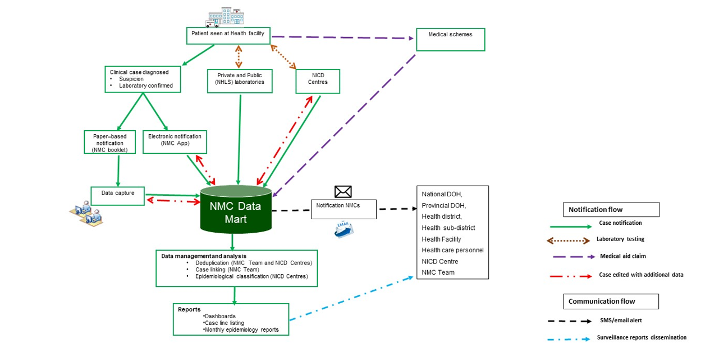

## Appendix no.3: NMC Categories, and Case Classification definitions

**NMC categories**

**Category 1**: NMCs notified by the most rapid means available upon diagnosis, followed by a written or electronic notification to the Department of Health within 24 hours of diagnosis by healthcare providers, private health laboratories or public health laboratories. These conditions must be notified based on clinical suspicion irrespective of laboratory confirmation.

**Category 2**: NMCs notified through a written or an electronic notification to the Department of Health of clinical or laboratory diagnosis within 7 days by healthcare providers, private health laboratories or public health laboratories.

**Category 3**: NMCs notified through a written or electronic notification to the Department of Health within 7 days of diagnosis by public and private health laboratories.

**Category 4**: NMCs notified through a written or electronic notification to the Department of Health within 1 month of diagnosis by public and private health laboratories.

**Case Classification definitions**

**Clinical case**: are cases reported to the NMC by health care providers at facilities, either through completion of a paper form that is faxed, emailed to National Institute of Communicable Diseases (NICD), or by direct data entry into the NMC application on a PC, laptop or mobile device. The diagnosis is made by the clinician on the basis of case definitions published on the NICD website.

**Laboratory case**: are cases that are downloaded into the NMC database directly from the National Health Laboratory Services (NHLS) laboratory information system. The NMC application applies the case definitions that are published on the NICD website. Private sector data is being sourced.

**Merged cases**: are cases where a case was notified by health care provider at the facility (a ‘clinical case’) AND the laboratory issued a report with a positive result for the same case (a ’laboratory case). The NMC App is set up to automatically detect and link clinical and laboratory case notifications. The NICD specialist Centres and NMC data team review all cases and manually link any remaining clinical and laboratory cases

**Notification capture times definitions**

**Current notification**: All cases diagnosed and notified in the current month

**Delayed notification**: All cases diagnosed in the last 14 days from the previous month

**Back capture notification**: All cases diagnosed in previous months and before the last 14 days of the previous month.

## Appendix no.4: IDSR reporting template for IDSR conditions existing on NMC by under-5 and 5-and-over years and vital status.

Table 12: The number of IDSR conditions laboratory notified to the NMC using the IDSR reporting template of under and 5-and-above years by vital status.

|  | Notified/Suspected | | | | Confirmed |
| --- | --- | --- | --- | --- | --- |
| Condition | **Under 5 A**,  N = 3191 | **5 & over A**,  N = 9231 | **5 & over D**,  N = 41 | **Under 5 D**,  N = 21 | **N = 639**1 |
| Acute Flaccid Paralysis | 13 | 9 | 0 | 0 | 0 |
| Acute rheumatic fever | 0 | 1 | 0 | 0 | 0 |
| Cholera | 1 | 0 | 0 | 0 | 0 |
| Congenital rubella syndrome | 1 | 0 | 0 | 0 | 32 |
| Diphtheria | 1 | 22 | 0 | 0 | 6 |
| Enteric fever (typhoid or paratyphoid fever) | 0 | 1 | 0 | 0 | 12 |
| Food borne illness outbreak | 7 | 285 | 0 | 0 | 0 |
| Listeriosis | 1 | 3 | 0 | 0 | 5 |
| Malaria | 5 | 53 | 1 | 0 | 183 |
| Measles | 164 | 324 | 0 | 0 | 47 |
| Meningococcal Disease | 3 | 22 | 3 | 1 | 4 |
| Pertussis | 42 | 59 | 0 | 1 | 64 |
| Rabies | 0 | 3 | 0 | 0 | 1 |
| Rubella | 81 | 141 | 0 | 0 | 285 |
| 1A = Cases who are alive.  D = Cases who are deceased. | | | | | |

**END**