YAML Template for Managing Affiliations

YAML Code

Duke A Caboom, MD1,✉, and Justin d'Ottawa, PhD2

1 University of Tuktoyaktuk, CXVG+62 Tuktoyaktuk, Inuvik, Unorganized, NT Canada  
2 University of Ottawa, 75 Laurier Ave E, Ottawa, ON K1N 6N5, Canada

✉ Correspondence: [Duke A Caboom, MD <[duke.a.caboom@utuktoyaktuk.edu](mailto:duke.a.caboom@utuktoyaktuk.edu)>](mailto:duke.a.caboom@utuktoyaktuk.edu)

**Introduction**: There’s a big scientific problem out there. I know how to fix it.

**Methods**: My experiments are pure genius.

**Results**: Now you have your proof.

**Conclusion**: Give me more grant money.

Page break

# Installation

Software Requirements for using this Temaplate:

* [R Language](https://www.r-project.org/)
* [R Studio](https://www.rstudio.com/)
* LaTeX markup language: [Click here for Mac Users](http://www.tug.org/mactex/), [Click here for Windows Users](https://miktex.org/download)
* [Pandoc](https://pandoc.org/)

Over and above the usual tools above, you will also need:

* the [lua language](https://www.lua.org/download.html) which allows pandoc to call lua scripts that
* [pandoc-crossref](https://github.com/lierdakil/pandoc-crossref) which makes table and figure cross-references within the document work. Prebuilt binaries are available [here](https://github.com/lierdakil/pandoc-crossref/releases/tag/v0.3.4.1a).

Page break

# Cross Referencing a Figure

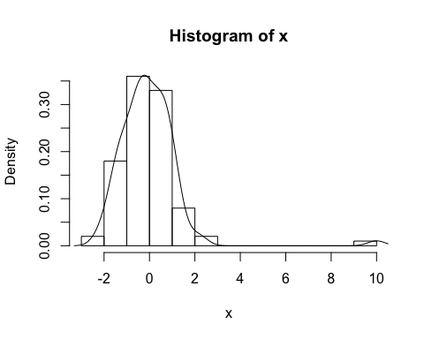

Figure 1: Here is an awesome figure caption.

Please see my science in figure 1.

## Figures from a file

Sometimes you want to include a figure from a file, for example a picture of Darth Vader is shown in figure 2.

Figure 2: I find your lack of faith disturbing.

Figure 2: I find your lack of faith disturbing.

## Cross Reference of a Table

Of course, tables can be cross referenced in the same manner as figures. Here is a cross reference to table 1.

You can also take the output of a statistical analysis and put it into a table as shown in table ??:

Table 1: A more complex table

|  |  |  |  |  |
| --- | --- | --- | --- | --- |
| term | estimate | std.error | statistic | p.value |
| (Intercept) | 36.908 | 2.191 | 16.847 | 0.000 |
| hp | -0.019 | 0.015 | -1.275 | 0.213 |
| cyl | -2.265 | 0.576 | -3.933 | 0.000 |

# Handling Literature References

Here is an article that Shannon Haymond wrote [1] and here is one that Dan Holmes wrote that has fewer citations and is not as important [2]. If we wanted to cite them both together we can do so [1,2].

## CSL files and Reference Abbreviation

Abbreviation of reference names is not mandatory if you are submitting to an Elsevier journal but if you are submitting as a Word document to a journal that does not support LaTeX, you will need to abbreviate your references as per the journal’s requirements. I have prepared a .json file for you from the entire web of science list of journals. It is stored in the Extras folder. This will permit journal abbreviation. To choose the right reference formatting you need to choose the right .csl file from the [github csl repository](https://github.com/citation-style-language/styles). You can download the sourcecode for this article [here](https://github.com/drdanholmes/AACC2019).

# References

[1] S. Haymond, R. Cariappa, C.S. Eby, M.G. Scott, Laboratory assessment of oxygenation in methemoglobinemia, Clin. Chem. 51 (2005) 434–444.

[2] M. Rehan, J.E. Raizman, E. Cavalier, A.C. Don-Wauchope, D.T. Holmes, Laboratory challenges in primary aldosteronism screening and diagnosis, Clin. Biochem. 48 (2015) 377–387.