Policy Brief 2: Closing the Coordination Loop
  - Making NMC, EHPs, DALRRD, and provincial response work as one system
D2P Project Team
2025-09-05
Table of contents

For Decision-Makers
Target audience: Ministerial Advisory Committee (MAC), National Department of Health (NDoH), DALRRD Pesticide Registrar, Provincial Health Leadership.
Companion briefs: Surveillance · Terbufos restriction.

1. Policy question
Should NDoH and DALRRD mandate a closed-loop coordination workflow — where every NMC notification triggers an investigation that is recorded on NMC, every EHP→DALRRD referral is structured, and every DALRRD action is fed back to NICD and the clinician?

2. Public health problem
Better detection (see the Surveillance brief) is wasted if the system does not act on what it detects. The response chain has eight sequential decision points between “case suspected” and “regulatory action closes the loop”; six of the eight default to a broken-loop terminal. A correctly-notified case can still produce no investigation, no source removal, and no regulatory follow-up — leaving the underlying hazard in place and producing predictable secondary cases.
The coordination loop is agent-agnostic: it processes terbufos clusters today, will process aldicarb or paraquat tomorrow, and — as South Africa’s burden shifts with development — opioids, methadone, or recreational-drug overdoses thereafter. The closed loop is therefore the durable institutional asset; the Terbufos brief is the first product-specific output it should deliver, not the last.

3. Status quo
Canonical model parameters (auto-loaded from the Parameters Hub)
All numerical claims in this brief draw from a single CSV — amua_import_parameters_v4.csv — rendered in full at the Parameters Hub. The headline values below are pulled from that file at render time; do not edit the numbers in this brief — edit the CSV and re-render.
Table 1: Headline parameters used in this brief
Pulled from amua_import_parameters_v4.csv at render time
Parameter | Value
Annual NMC pesticide notifications | 1013
Annual NHLS severe BChE inhibitions (live) | 1779
Annual PIH pesticide-related calls | 1158
True annual burden (sum, upper bound) | 3950
Headline annual deaths | 1014
Blended headline morbidity cost per case | R12,000
Mortality cost per death (human-capital) | R1.50 million
Headline annual economic burden | R1.61 billion
Response efficacy η (base case) | 0.30
Detection probability — status quo | 0.125
Detection probability — full package | 0.83
Full Package narrow operating cost / yr | R237,000
Full Package whole-system operating cost / yr | R1.19 million

Who bears the R1.61B annual burden?
Table 1: Annual burden by stakeholder (headline scenario, ZAR 2025)
Each rand of the R1.61B falls on exactly one bearer
Stakeholder | Value | Share
NDoH — public hospitals (UPFS ward + ICU + drugs) | R70.00 million | 4%
NHLS — laboratory (BChE, GC-MS, repeat clinical chemistry) | R10.00 million | 1%
DALRRD — regulator (no burden-side share by construction) | R0 | 0%
Individuals / households — out-of-pocket + lost wages | R10.00 million | 1%
Households / wider society — lost lifetime earnings | R1.52 billion | 94%
TOTAL | R1.61 billion | 100%
Reading the table. ~94 % of the R1.61B is mortality, borne by households and the wider economy as lost lifetime earnings (1,014 deaths × R1.5M human-capital, undiscounted; sensitivity: R1.05M at 3 % discount). The directly-budgeted health-sector share is R80M (NDoH ~R70M hospital + NHLS ~R10M lab) — modest in absolute terms, but it is the only column that appears on a departmental budget line. DALRRD bears R0 of the burden side by construction: their cost sits on the intervention side (enforcement, recalls, registration action).
For the full sourced parameter set (CFR by severity, UPFS tariffs, per-option costs, induced-demand components, DALY monetisation, NMB), see the Parameters Hub. For the v2 → v3 critical appraisal, see parameter_appraisal.qmd.

Canonical option costs (Detect · Act · Restrict)
Table 1: Option costs by stage (Detect · Act · Restrict)
All values pulled from amua_import_parameters_v3.csv at render time
Option | Cost | Notes
Detect
S1 — NHLS→NMC IT feed (operating) | R60,000 | 0.05 FTE analyst + QA
S3a — BChE auto-notify (operating) | R55,000 | LIS HL7 middleware
S4 — PIH dashboard / MVD (operating) | R82,000 | MVD redesign
Surveillance MVP (S1+S3a+S4, operating) ★ | R137,000 | = R60k + R55k + R42k
Surveillance MVP setup (one-off) | R80,000 | S3a HL7 dominates
Act
C1 — NMC closure-of-loop field (operating) | R30,000 | Schema + EHP training
C2 — Structured DALRRD referral form (operating) | R25,000 | Form + workflow
C3 — NICD→DALRRD intelligence feed (operating) | R40,000 | Quarterly brief + alerts
C4 — Clinician auto-feedback (operating) | R20,000 | Email templating
C5 — Joint KPI dashboard (operating) | R30,000 | Public hosting
Coordination Full Package (operating) ★ | R145,000 | = Σ C1..C5
Restrict
T2 — RUP + audit + formulation restriction (low) | R1.00 million | DALRRD inspectorate, lower
T2 — RUP + audit + formulation restriction (mid)★ | R2.00 million | Working value
T2 — RUP + audit + formulation restriction (hi) | R3.00 million | Upper

Under the hood — models, packages, and formulae
Software stack. This site is built with Quarto v1.x rendering R chunks through R ≥ 4.3 and knitr. Tables use gt; data wrangling tidyverse (dplyr, readr, tibble); percentage formatting scales; diagrams mermaid via Quarto’s built-in diagram filter. The interactive Parameter Playground layer adds Observable JS via Quarto OJS.
Canonical parameter file. All numerical values in every brief, the one-pager, and the playground resolve through pick(name) → readr::read_csv("../amua_import_parameters_v3.csv") → string lookup → as.numeric() → zar() formatter. No rand value in any brief is a literal in prose (except where prose paraphrases a CSV-sourced value). The audit chain is: CSV row → _shared_parameters.qmd pick() call → rendered gt cell.
Burden model (closed-form, deterministic).
Cburden = s∈{PIH,NHLS,NMC}​ns⋅csmorb⏟morbidity + ndeaths⋅cHCmort⏟mortality (human-capital)
where $n_{s}$ = stream counts (rows n_pih_annual, n_nhls_severe_annual, n_nmc_annual), $c_{s}^{\text{morb}}$ = stratum-specific per-case morbidity costs (rows c_morbidity_*), $n_{\text{deaths}}=1,014$ (n_deaths_statssa_macod — StatsSA MACOD 2022, pesticide-specific UCOD codes (X48+X68+X87+Y18), is the canonical truth source for deaths and is updated as new StatsSA releases land; n_deaths_headline mirrors it), $c^{}_{} = $ 25 productive years × R60k median income, undiscounted (c_mortality_human_capital). Stratified-CFR alternative (C_burden_total_conservative ≈ R1.34B) is supplied as a sensitivity.
Coordination decision tree (closed-form joint probability).
$$P(\text{loop closed}) = \prod_{i=1}^{8}{p_{i}}$$
over eight sequential nodes (notify → SMS → investigate → record → refer → DALRRD acts → feedback → feedback to clinician). Status-quo joint product ≈ 1.1 % (p_loop_closed_status_quo); Full Package ≈ 70 % (p_loop_closed_FP). Deaths averted = $ΔP×η×n_{\text{burden}}×p_{\text{death}}$, with $η$ from eta_response_mid = 0.30 and $p_{\text{death}}$ from cfr_headline_mid = 0.125.
Terbufos bracketed estimate.
$${\text{Deaths averted}}_{T3} = f_{\text{attr}}⋅ϕ_{\text{retired}}⋅n_{\text{deaths}}$$
with $f_{\text{attr}}∈[0.20,0.35]$ (frac_terbufos_attributable_{lo,mid,hi}, anchored to Sri Lanka Class Ia withdrawal natural experiments, Gunnell et al. Lancet Glob Health 2017) and $ϕ_{\text{retired}}∈[0.60,0.80]$ (Sri Lanka substitution-incompleteness). Bracket: 200–400 deaths/yr (n_deaths_averted_T3_{lo,hi}).
Surveillance detection model.
$$\text{Cases averted} = (P_{\text{detect}}−P_{\text{detect}}^{\text{SQ}})⋅η⋅n_{\text{burden}}$$
with $P_{\text{detect}}$ pulled from d_status_quo, d_option1_NHLS_MOU, …, d_full_package (expert elicitation, beta priors). Cost-effectiveness uses net monetary benefit (NMB) at the SA cost-effectiveness threshold $λ$ = R38,500/DALY averted (Edoka & Stacey 2020).
Probabilistic sensitivity analysis (PSA). Each CSV row carries a dist=<family>(<params>) tag (beta, gamma, fixed) parsed by the analysis pipeline (wrangling_v2.r) for Monte Carlo PSA. Distributions follow standard health-economics conventions: gamma for costs (shape 25 → CV ≈ 0.20), beta for probabilities (parameterised on the sample-equivalent count), fixed for deterministic anchors and derived sums.
What this site does not do. No mixed-effects regression, no machine-learning model, no causal-inference identification strategy, no Bayesian hierarchical model. The site is a transparent deterministic burden-and-decision-tree calculator with explicit PSA. Strength comes from auditability, not algorithmic complexity.

 Who bears the R1.61B
NDoH ~R70M (4 %), NHLS ~R10M (<1 %), households ~R10M OOP (<1 %), and ~R1.52B (94 %) in lost lifetime earnings borne by households and the wider economy. DALRRD bears no direct burden-side cost but holds the only legal lever that prevents the underlying exposure. That asymmetry is why the loop must terminate in DALRRD action: the agency with the lowest burden share controls the highest-leverage intervention.

The notification pathway — one-way and broken
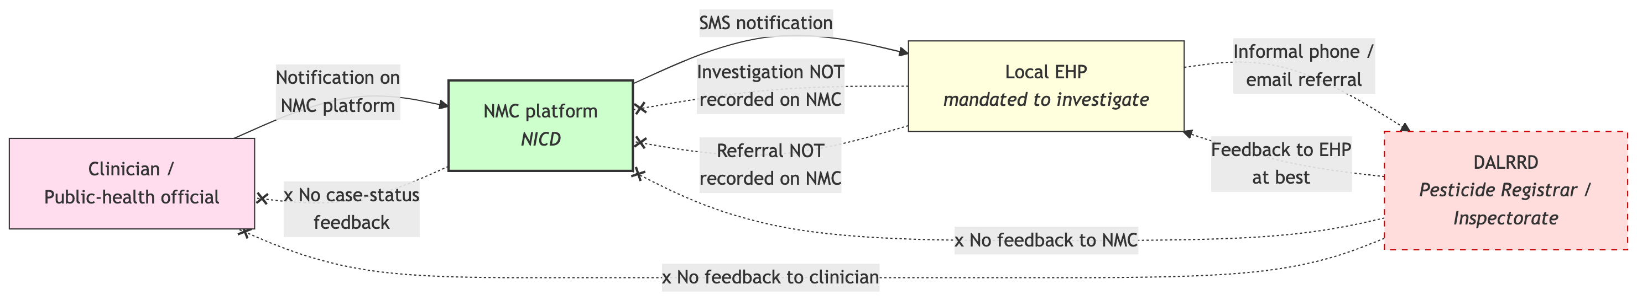
Figure 1: Current notification pathway. Clinicians and public-health officials notify on the NMC platform; NMC sends an SMS to the local EHP, who is mandated to investigate but does not record the investigation back on NMC. The EHP may informally refer to DALRRD, but this is not captured on NMC and DALRRD’s action (if any) is not fed back to NMC or the clinician.
Reading the diagram. Clinicians do file on NMC — that is the formal entry point. NMC does SMS the local EHP, who is mandated to investigate. The chain breaks at two specific places: (a) the EHP investigation outcome is never written back to NMC because no NMC field requires it; and (b) the EHP→DALRRD referral, when it happens, is informal and likewise unrecorded. DALRRD action — if any — flows back to the EHP at best, and never to NICD or the originating clinician.

4. Root cause analysis
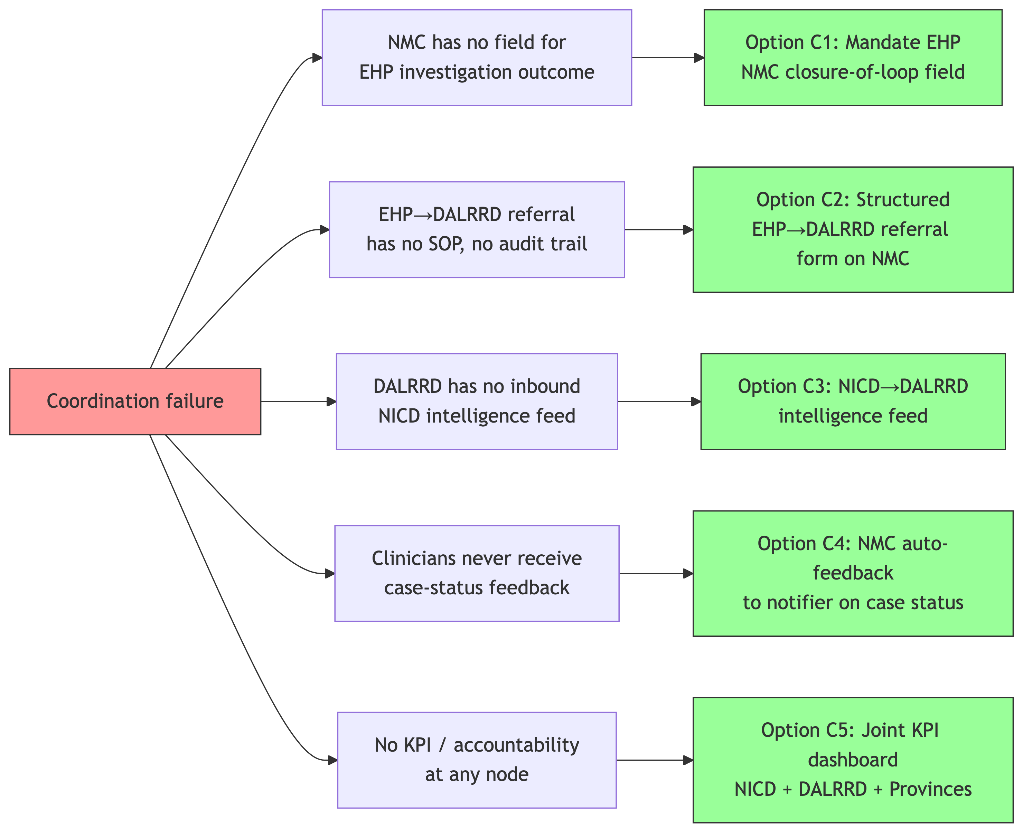
Figure 2: Root causes of coordination failure across the NMC–EHP–DALRRD chain.
The five drivers are: (1) NMC schema lacks a closure-of-loop field; (2) EHP→DALRRD referral has no SOP; (3) DALRRD has no inbound NICD intelligence feed despite a formal request for one; (4) clinicians get no case-status feedback so the notification has no perceived value; (5) no decision node in the chain has an accountable owner with a KPI, so nothing fails loudly when the loop breaks.

5. Policy options
ID | Option | What it does | Annual cost
C1 | NMC closure-of-loop field for EHPs | Structured “investigation outcome” field (visited, source identified, sampling, referral); 14-day completion KPI. No new legislation. | ~R30k
C2 | Structured EHP→DALRRD referral form on NMC | Auto-emails DALRRD Inspectorate with product, location, agent, severity; replaces informal phone/email referral. | ~R25k
C3 ★ | NICD→DALRRD poisoning intelligence feed | Quarterly NICD brief by product/geography/season + ad-hoc case-spike alerts. Gives DALRRD the evidence base for product-specific action (prerequisite for the Terbufos brief). | ~R40k
C4 | Notifier auto-feedback | Quarterly NMC case-status summary back to the notifying clinician. Removes the “notify into a black hole” disincentive. | ~R20k
C5 | Joint KPI dashboard | Public dashboard: notification-to-investigation time, % with recorded outcome, % with DALRRD action, % notifiers receiving feedback. Co-owned by NICD, DALRRD, provincial DoHs. | ~R30k

Coordination Full Package (C1 + C2 + C3 + C4 + C5)
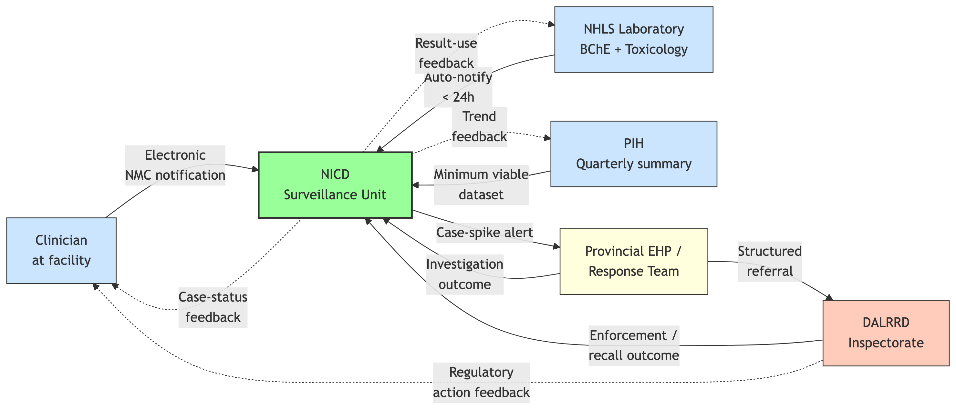
Figure 3: Proposed end-state: a closed feedback loop linking clinicians, laboratories, NICD, EHPs, DALRRD, and provincial response teams. Every actor both contributes data and receives back the action taken.
Total annual cost of the Coordination Full Package: ~R145,000. No new legislation required.

6. Decision tree — coordination outcomes per suspected case

6a. Where the chain breaks today

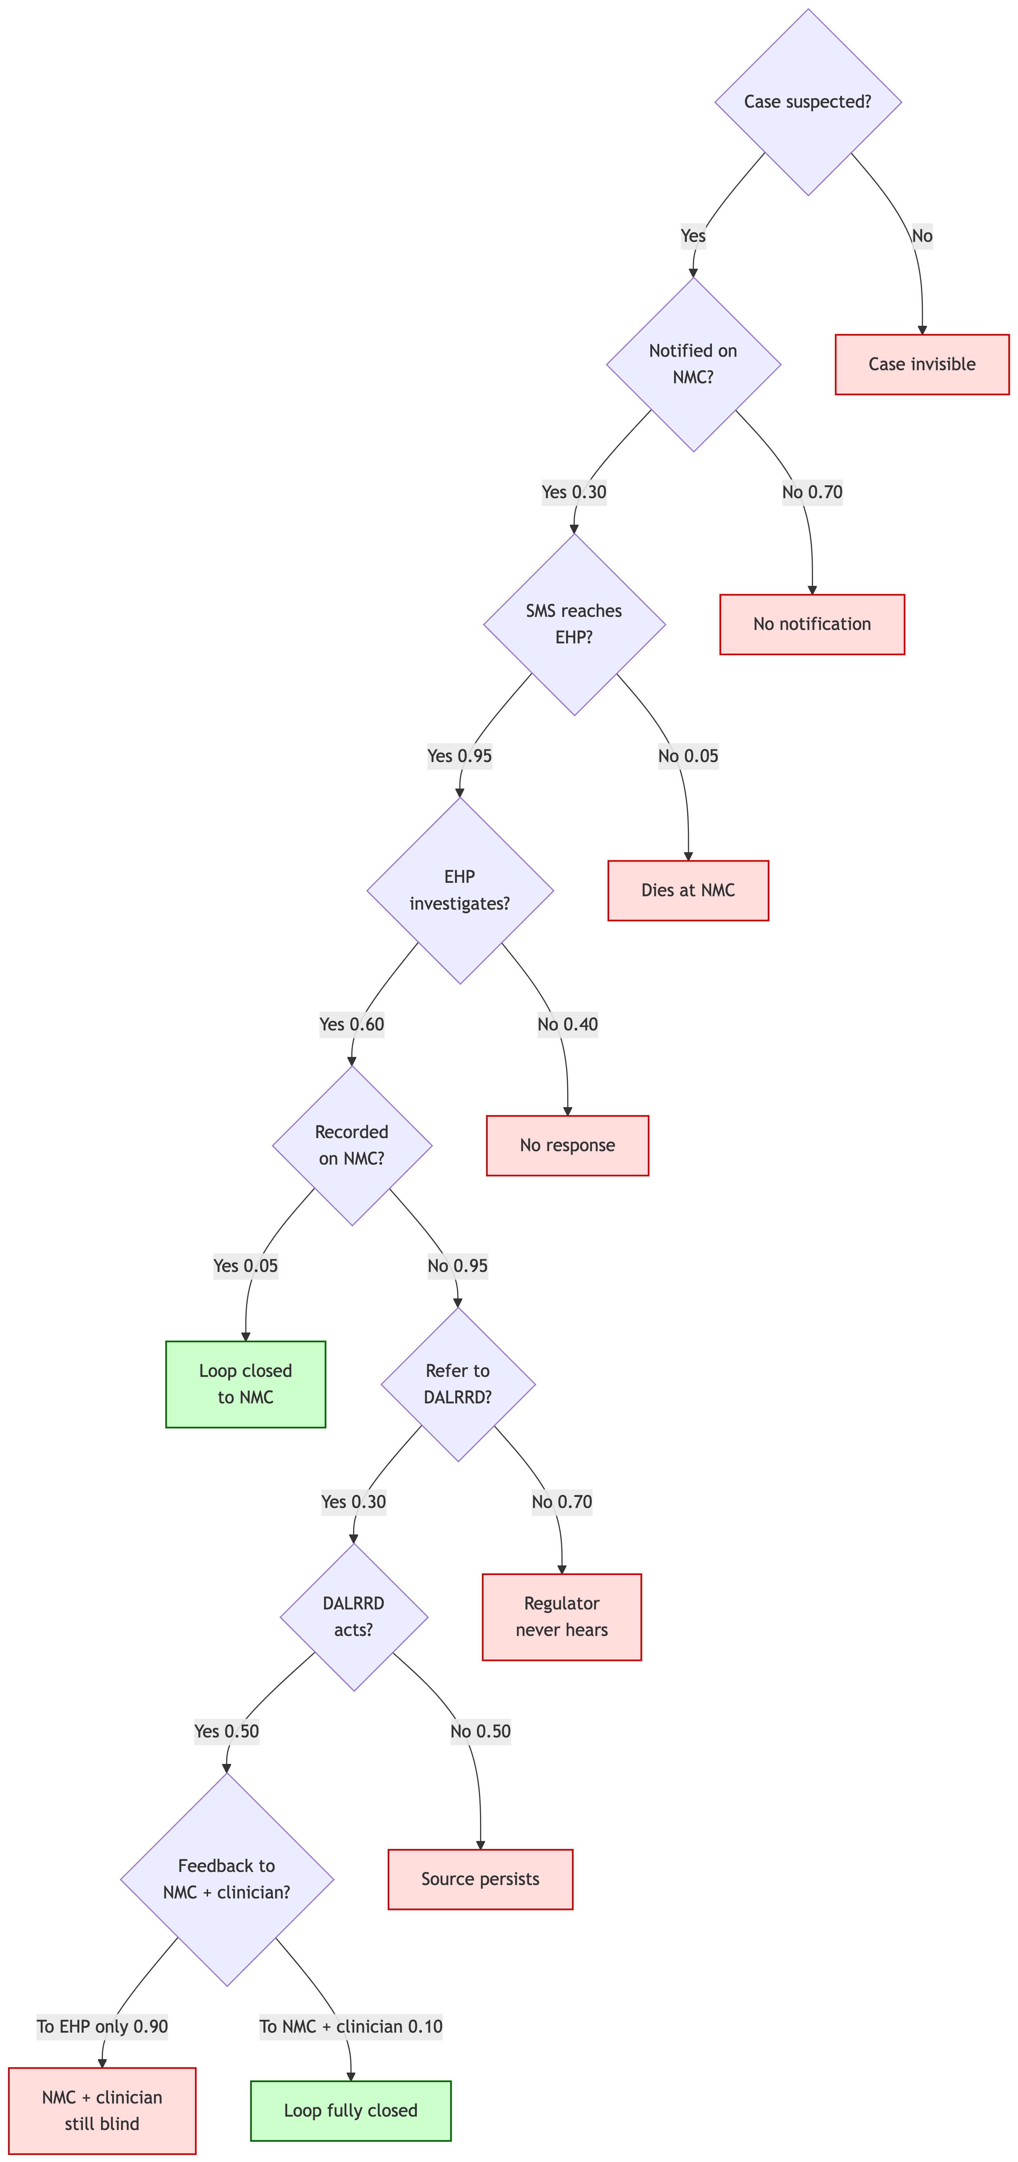
Coordination decision tree for a single suspected case under the status quo. Eight conditional steps; six terminate in a broken-loop outcome. All eight node probabilities pulled from amua_import_parameters_v3.csv at render time.
Joint P(loop fully closes) ≈ 1.1 % under the status quo (CSV: p_loop_closed_status_quo). Expected coordination cost per suspected case ≈ R196,400 — virtually the full per-case societal burden of R197,000, because the loop almost never closes.

6b. Per-loop yield — the parameter the integrated model consumes
A single fully-closed loop retires one uncontrolled source. The source would otherwise produce a cluster of $ρ_{\text{secondary}}$ further cases. Response efficacy $η$ is the fraction of that cluster that is actually averted once the loop closes. Per loop closed:
$$\text{cases prevented}=ρ_{\text{secondary}}×η \text{deaths prevented}=ρ_{\text{secondary}}×η×p_{\text{death}}$$
Table 1: Preventable cases, deaths, and societal burden per additional fully-closed loop, at low/mid/high response efficacy. All inputs from amua_import_parameters_v4.csv. These are the rates that overall_policy_model.qmd multiplies by Δ(loops closed) under each policy scenario.
Scenario | η | Cases / loop | Deaths / loop | Burden retired / loop (R)
Low engagement (η_lo) | 0.15 | 0.45 | 0.06 | R93,150
Base case (η_mid) | 0.30 | 0.90 | 0.12 | R186,300
Well-resourced (η_hi) | 0.50 | 1.50 | 0.20 | R310,500
Headline rule of thumb. At base case ($ρ=3$, $η=0.3$, $p_{\text{death}}=0.13$): every loop closed prevents ≈ 0.9 future cases and ≈ 0.12 deaths, retiring ≈ R186,300 of societal burden. Multiply by the change in number of loops closed under any scenario in the integrated model to get the policy yield.

6c. Clinical-outcome subtree
Each coordination terminal feeds into a clinical-outcome subtree for the index case and for the secondary cases that would otherwise follow from the same source:

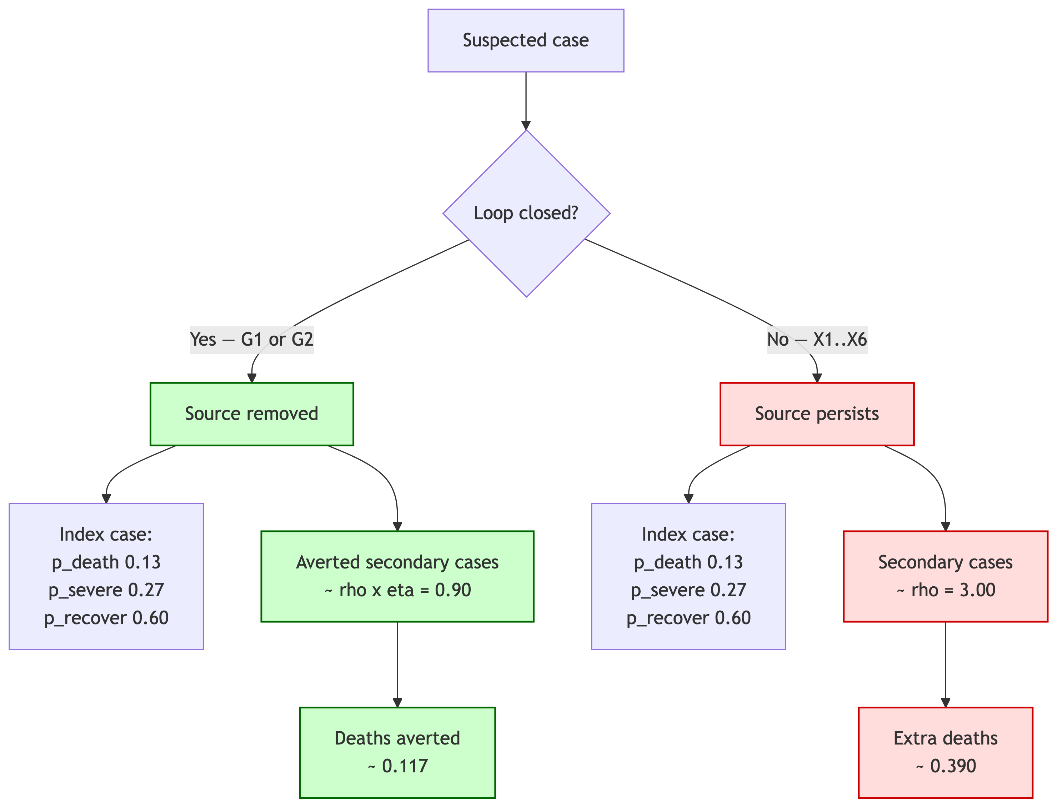
Clinical-outcome subtree attached to each coordination terminal. Index-case probabilities (p_death, p_severe, p_recover) and secondary-case multipliers (rho_secondary, eta_response_mid) all pulled from amua_import_parameters_v3.csv at render time.

6d. What changes under each coordination scenario
Burden avoided is split by who would otherwise have borne it, so each agency sees the share of the win that flows back to its own budget line or constituency. The avoided-burden split uses the same shares as the canonical stakeholder table above: ~3.4 % health sector (NDoH + NHLS), ~96.6 % households (mortality + OOP).
Modelled coordination outcomes at national scale (× 4,171 observed cases/year, 2023 streams). Stakeholder columns apply the canonical share table (NDoH+NHLS = R80M of R1.61B; households = R1.53B of R1.61B) to the total avoided burden in each scenario. Probabilities are placeholders aligned with the surveillance detection-rate ranges in the Surveillance brief.
Scenario | P(loop closed) | Deaths averted / yr | Avoided — health system (NDoH + NHLS) | Avoided — households (mortality + OOP) | Total avoided
Status quo | 1.1 % | 15 | — | — | —
+ C3 (NICD→DALRRD feed) | ~40 % | ~547 | ~R29M | ~R806M | ~R835M
Coordination Full Package (C1–C5) | ~70 % | ~957 | ~R50M | ~R1,400M | ~R1,450M
Reading by audience.
- NDoH / NHLS: the R50M avoided is ~330× the R145k Full-Package operating cost — a credible business case before counting household mortality.
- DALRRD: C3 is the lowest-cost route to the evidence base needed for product-specific action (see Terbufos brief).
- Treasury / Presidency: ~R1.4B/yr of household and societal cost retired; the cross-departmental return that justifies the joint DG circular.
Beyond terbufos. The Full Package retires ~957 deaths/yr today, dominated by organophosphate and carbamate clusters. As terbufos is withdrawn (see Terbufos brief) the residual cluster mix will shift first to other agricultural pesticides (aldicarb, paraquat, carbofuran), and over a 10–20 year development horizon increasingly toward opioids, methadone substitution, and recreational-drug overdoses — the toxicology profile that has dominated middle- and high-income countries since the 1990s. The closed loop is the asset that survives that transition; only the product list at C3 changes.

6e. Cost per loop closed — the unit cost the integrated model uses
The Full Package adds a fixed operating overhead (C1–C5 ≈ R145k/yr). It is spread across the additional loops it closes versus the status quo. That gives a single cost-per-loop-closed scalar that the integrated model can call directly when comparing scenarios.
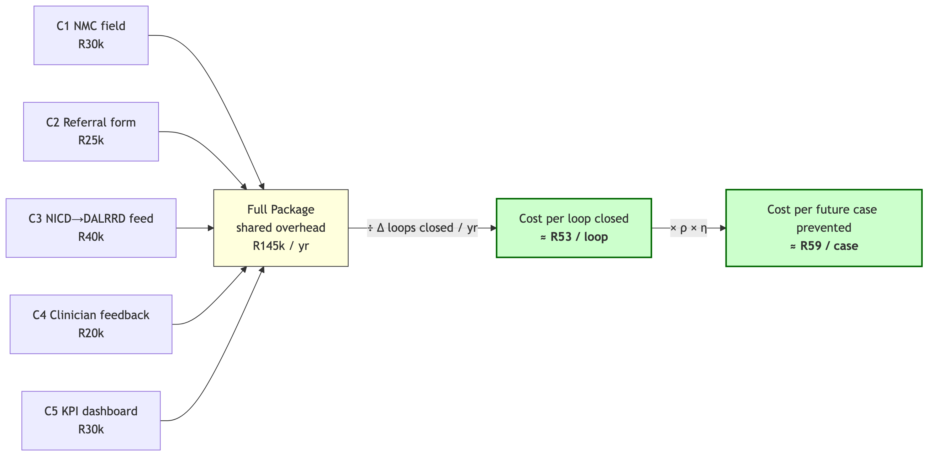
Figure 4: Cost decomposition for one fully-closed loop. Five fixed C-line items feed a shared overhead; that overhead is amortised across the incremental loops closed each year.
Table 2: Cost per loop closed and per future case prevented, derived from CSV inputs. These two scalars are the parameters overall_policy_model.qmd consumes when toggling the Coordination Full Package on/off.
Scenario | P(loop closed) | Δ loops closed / yr | Cost / yr (R) | Cost / loop (R) | Cases prevented / yr | Cost / case prevented (R)
C3 only | 40% | 1,537 | R40,000 | R26 | 1,383 | R29
Coordination Full Package | 70% | 2,722 | R145,000 | R53 | 2,449 | R59
At base case: ≈ R53 per additional loop closed, ≈ R59 per future poisoning prevented. Both scalars fall as ρ or η rise — the system gets cheaper per case averted in exactly the cluster-prone settings (illegal street-pesticide hotspots; future opioid overdose chains) where it matters most.

6f. Sensitivity — how strongly a working loop suppresses future poisonings
The headline policy claim is that a closed coordination loop prevents future poisonings. Two parameters drive the size of that effect: the loop-closure probability achieved by the policy ($P_{\text{loop}}$) and the response efficacy once a source is identified ($η$). Both have CSV-anchored ranges. The table below sweeps them jointly; cells are colour-shaded from low (red) to high (green).
Table 3: Future poisonings prevented per year as a function of achieved loop-closure rate (rows) and response efficacy η (columns), holding ρ = 3.0 and observed-case denominator = 3,950 cases/yr. Status-quo baseline (P_loop = 1.1 %) is shown for reference; all other rows are policy scenarios.
P_loop \ η | η_lo (15%) | η_mid (30%) | η_hi (50%)
Status quo (1 %) | 0 | 0 | 0
C3 only (40 %) | 691 | 1,383 | 2,305
Mid-implementation (55 %) | 958 | 1,916 | 3,194
Full Package (70 %) | 1,225 | 2,449 | 4,082
Best-in-class (85 %) | 1,491 | 2,983 | 4,971
Reading. Even at the low response-efficacy edge (η = 15 %), the Full Package prevents ~1225 future poisonings/yr; at the well-resourced edge (η = 50 %) it prevents ~4082/yr. The policy claim is therefore robust across the full CSV-anchored parameter range: every realistic combination of $(P_{\text{loop}},η)$ produces a four-figure annual reduction in future cases. The integrated model uses these two scalars (p_loop_closed_FP, eta_response_mid) as toggleable inputs alongside the surveillance and source-control levers.

6g. Per-action workload — what each loop-step actually costs
Closing a loop is not free at the operational tier. Each gross alert that enters the system (true case + false positive) costs an EHP environmental investigation (CSV: c_per_ehp_investigation_mid ≈ R4,000); a fraction $p_{\text{DALRRD}}$ ≈ 0.3 of those trigger a DALRRD inspectorate site visit (CSV: c_per_dalrrd_inspection_mid ≈ R12,000). Both unit costs have lo/hi ranges in the CSV.
Table 4: Per-action workload cost components (CSV-anchored). Each fully-closed loop consumes one EHP investigation; a fraction p_DALRRD trigger an inspectorate visit. These are the unit inputs overall_policy_model.qmd uses to translate alert volume into induced regulator workload.
Component | Low | Mid | High | CSV
EHP environmental investigation (per gross alert) | R2,500 | R4,000 | R7,000 | c_per_ehp_investigation_*
DALRRD inspectorate site visit (per referred case) | R6,000 | R12,000 | R25,000 | c_per_dalrrd_inspection_*
P(DALRRD action | confirmed referral) | — | 0.30 | — | p_dalrrd_action_given_referral

6h. False positives bite: induced workload under community surveillance
Administrative-tier feeds (NMC, NHLS BChE auto-notify, PIH) produce alerts that are essentially all true cases — false-positive rate ≈ 0. Community-tier surveillance (S1b in the Surveillance brief) produces alerts at a CSV-benchmarked false-positive rate of 20–50 %. Every alert — true or false — still consumes an EHP investigation before it can be discarded. Per true case detected:
$$\text{gross alerts}=\frac{1}{1−p_{\text{fp}}} \text{cost per true case}=\frac{c_{\text{EHP}}+p_{\text{DALRRD}}⋅c_{\text{DALRRD}}}{1−p_{\text{fp}}}$$
Table 5: Induced EHP + DALRRD workload cost per true case detected, as community-surveillance false-positive rate is varied (rows) against EHP unit cost (columns). Holds p_DALRRD = 0.30 and c_DALRRD at working value. All inputs from amua_import_parameters_v4.csv.
FP \ EHP unit cost | EHP lo (R2,500) | EHP mid (R4,000) | EHP hi (R7,000)
Administrative only (0 %) | R6,100 | R7,600 | R10,600
S1b lo (20 %) | R7,625 | R9,500 | R13,250
S1b mid (35 %) | R9,385 | R11,692 | R16,308
S1b hi (50 %) | R12,200 | R15,200 | R21,200
What the table says. At the working values (p_fp_S1b_mid = 35 %, EHP mid = R4,000, DALRRD mid = R12,000, p_DALRRD = 0.3), induced workload is ≈ R11,692 per true case detected — roughly 1.5× the administrative-tier figure. At the high-FP edge (50 %, early roll-out) it is ≈ R21,200 per true case.
Implication for the integrated model. When the overall model layers community-tier surveillance (S1b) on top of the coordination Full Package, induced EHP + DALRRD workload becomes the fastest-growing line in the regulator budget — faster than C1–C5 shared overhead, faster than NHLS test volume. The brief therefore proposes a two-step roll-out:
- Administrative tier first (NMC closure-of-loop + NHLS auto-notify + PIH MVD): near-zero FP, full coordination workload increment ≈ R145k + R7,600 × Δ alerts.
- Community tier (S1b) piloted with explicit measurement of p_fp_S1b before national rollout. The pilot must collect (a) confirmed-positive rate, (b) EHP time per investigation, and (c) DALRRD referral rate. These three numbers are the parameters that decide whether community surveillance is affordable at scale.
This is the explicit operational hand-off between the coordination loop (this brief) and the surveillance ladder (Surveillance brief): the loop only works as cheaply as the false-positive rate of its input feed.

7. Implementation considerations
Component | Lead agency | Year-1 cost | Critical path
C1: NMC closure-of-loop field | NICD NMC team + NDoH circular | R30k | NMC schema change; EHP training
C2: Structured DALRRD referral form on NMC | NICD + DALRRD Pesticide Registrar | R25k | DALRRD inbox + workflow
C3: NICD→DALRRD intelligence feed | NICD analyst + DALRRD liaison | R40k | Quarterly brief template; case-spike alert SOP
C4: Notifier auto-feedback | NICD NMC team | R20k | Email templating
C5: Joint KPI dashboard | NICD + DALRRD + Provinces | R30k | KPI definitions; public hosting
Total | NDoH-led | ~R145k | All within existing legal authority
Institutional mechanism. A quarterly Joint Coordination Forum (NICD chair; DALRRD, NHLS, PIH, and one rotating provincial DoH representative) reviews the KPI dashboard, signs off case-spike alert escalations, and resolves cross-departmental blockers. Mandated by joint NDoH–DALRRD Director-General circular. No new legislation required.
Risks and mitigations.
- EHP non-compliance with new NMC field. Mitigation: 14-day completion KPI tied to provincial performance reviews; circular from NDoH DG.
- DALRRD capacity to act on referrals. Mitigation: C3 quarterly brief lets DALRRD prioritise by burden rather than respond reactively.
- Privacy concerns on clinician auto-feedback. Mitigation: feedback is aggregate at clinician level, not patient-identifying.

8. Recommended next step
Adopt C1 + C3 as the Coordination MVP, and the Full Package within 12 months.
- Weeks 1–4: NDoH–DALRRD joint DG circular committing to the closed-loop model; standing up the Joint Coordination Forum.
- Weeks 4–12: C1 NMC schema change + EHP training; C3 NICD→DALRRD quarterly brief begins on the existing NMC data.
- Months 3–12: C2 referral form, C4 auto-feedback, C5 KPI dashboard go live.
- Month 12: Evaluate against (i) median notification-to-investigation time, (ii) % of notifications with recorded outcome, (iii) DALRRD-reported regulatory actions per quarter.
The surveillance signal that flows into this loop is covered in the Surveillance brief. The first product-specific regulatory action the loop should be designed to deliver is the subject of the Terbufos brief.

Companion briefs: Surveillance · Terbufos restriction · Decision Model · Costing Analysis
Technical appendix: B — Coordination joint-probability model

