Policy Brief Hub: Strengthening Pesticide Poisoning Surveillance and Response
  - Three companion policy documents on surveillance, coordination, and terbufos
D2P Project Team
2025-09-05
Table of contents

What this page is
Three decision-maker-facing briefs, each addressing a distinct policy question, all drawing on a single canonical parameter set. Read in order: Detect → Act → Restrict.

The three policy briefs

1 · Strengthening Pesticide Poisoning Surveillance
Policy question. Should NDoH invest in automated, multi-source surveillance to close the detection gap between NMC, the NHLS laboratory, and the Poisons Information Helpline?
Headline recommendation. Adopt the Surveillance MVP (NHLS→NMC IT feed + BChE auto-notification + PIH dashboard / MVD) — ~R137,000/year, lifting per-case detection from <5% to ~19% of true cases. (Surveillance changes only what is seen; deaths averted are delivered by the coordination and terbufos responses that act on the improved signal.)

2 · Closing the Coordination Loop
Policy question. Should NDoH and DALRRD mandate a closed-loop coordination workflow so that every NMC notification triggers an investigation that is recorded, every EHP→DALRRD referral is structured, and every DALRRD action is fed back?
Headline recommendation. Adopt the Coordination Full Package (mandatory NMC closure-of-loop field + structured DALRRD referral + NICD→DALRRD intelligence feed + clinician auto-feedback + joint KPI dashboard) — ~R145,000/year, ~957 deaths averted/year at scale.

3 · Restricting or Banning Terbufos
Policy question. Should South Africa restrict, or fully ban, terbufos as a registered agricultural pesticide?
Headline recommendation. Adopt Option T2 (tighter restriction) immediately, with a hard-coded 24-month evaluation gate that mechanically escalates to a full ban (Option T3) if attributable serious-poisoning cases do not fall by a pre-agreed margin.

How the three briefs fit together
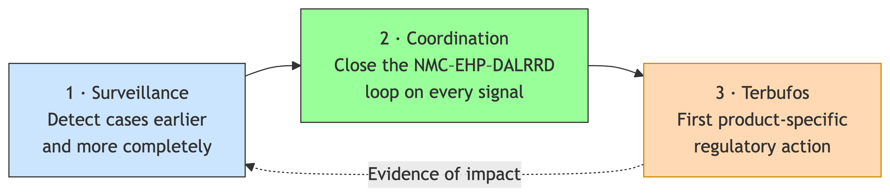
Figure 1: The three briefs operate as one system. Surveillance produces the signal; coordination ensures it leads to action; product-specific regulation (starting with terbufos) is the first concrete output the upgraded system should deliver.

Shared evidence base
All three briefs draw their numerical claims from a single shared parameter set (cases per year, CFR, per-case costs, decision-tree probabilities, prevention efficacy η, secondary-case multiplier ρ). The parameter file is intentionally separated so the model can be iterated centrally without re-editing each brief.
Source files:
- Decision Model — burden, parameters, sensitivity analyses
- Costing Analysis — full cost build-up
- Surveillance Concept Note — technical surveillance design

Read in order: Surveillance → Coordination → Terbufos.

