Policy Brief 3: Restricting or Banning Terbufos in South Africa
  - A priority-product action under the surveillance + coordination framework
D2P Project Team
2025-09-05
Table of contents

For Decision-Makers
Target audience: DALRRD Pesticide Registrar, Ministerial Advisory Committee (MAC), National Department of Health (NDoH), Department of Trade, Industry & Competition (substitution support).
Companion briefs: Surveillance · Coordination.
Status: DRAFT. One genuine SA evidence gap remains (the adult live-patient attributable fraction, resolved only by Surveillance Option S3). The other quantitative inputs — market volume, yield impact, substitute hazard, substitute pricing, enforcement cost — are not epistemic gaps: they are either administrative numbers DALRRD can pull, or values defensibly anchored to the EU/US/Sri Lanka evidence base (see §2b and Interim assumptions).

✓ Terbufos banned — gazetted 8 May 2026
Agriculture Minister John Steenhuisen gazetted a full ban on the acquisition, disposal, sale and use of all agricultural remedies containing terbufos as an active ingredient on 8 May 2026, under the Fertilisers, Farm Feeds, Agricultural Remedies and Stock Remedies Act of 1947 (Act 36 of 1947).
This substantially satisfies the D2P recommendation. The critical next steps are:
- Enforcement — stockpile disposal, distributor compliance audits, market monitoring for substitution.
- Measurement — the ban can only be evaluated through improved surveillance. Without a functioning case-detection system (Surveillance Brief), it is impossible to know whether the ban is reducing poisoning incidence, or whether a more-toxic substitute has entered the informal market.
- 24-month evaluation gate — the modelled leverage ratio (~500 : 1) rests on the assumption that a ban reduces attributable mortality. Only improved P_detect (via S1 + S2) can confirm this in the SA context.
The analytical content of this brief remains valid as the quantitative foundation for those three activities.

Headlines — what banning terbufos buys SA per year
177 deaths averted/yr (range 142–248) 1,420 poisonings averted/yr (range 1,136–1,987) ~R0.28B/yr in retired economic burden (range R0.23–R0.39B) at a DALRRD enforcement cost of ~R2M/yr — a household-burden-retired : regulator-spend leverage ratio of roughly 141 : 1.
Arithmetic (working / mid value). Every number above is the product of three CSV-driven inputs and a stakeholder share:
Quantity | Formula | Working value
Deaths averted | $f_{\text{attr}}×φ_{\text{retired}}×N_{\text{deaths}}$ | 25% × 70% × 1,014 = 177/yr
Poisonings averted | $f_{\text{attr}}×φ_{\text{retired}}×N_{\text{true cases}}$ | 25% × 70% × 8,112 = 1,420/yr
Burden retired | $f_{\text{attr}}×φ_{\text{retired}}×C_{\text{burden total}}$ | 25% × 70% × R1.61B = R0.28B/yr
Regulator spend | c_T2_RUP_enforcement_mid | R2M/yr
Leverage | $C_{\text{burden retired}}÷C_{\text{enforcement}}$ | R0.28B ÷ R2M ≈ 141 : 1
Where: $f_{\text{attr}}$ = terbufos attributable fraction of fatal SA pesticide events (Davies 2023 + Gunnell 2017); $φ_{\text{retired}}$ = fraction of attributable burden retired post-ban (Sri Lanka substitution-incompleteness, 70%); $N_{\text{deaths}}$, $N_{\text{true cases}}$, $C_{\text{burden total}}$ = StatsSA MACOD 2023 + implied true burden + total annual economic burden.

1. Policy question
Should South Africa ban terbufos as a registered agricultural pesticide?

2. Public health problem
Terbufos is a WHO Class Ia (“Extremely Hazardous”) organophosphate insecticide, with rat oral LD50 1.6–4.5 mg/kg — among the most acutely toxic active ingredients in commercial use anywhere. Sub-gram doses are lethal in adults; very small quantities are lethal in children.
The SA-specific evidence pinning the harm to this agent. Davies et al. (2023) identified terbufos and methamidophos as the dominant agents in fatal SA childhood pesticide poisoning, with most deaths following ingestion of granular formulations diverted into the informal “street-pesticide” market. NICD/NMC mass-poisoning reports 2022–2024 are independently consistent.
International natural-experiment anchor. Sri Lanka’s sequential Class Ia withdrawals (1995–2011) retired 20–40 % of fatal pesticide poisonings per banned agent without compensating method substitution. EU (2009) withdrew terbufos with no documented maize-yield collapse in any producer state. Davies 2023 places SA terbufos in the same 20–40 % bracket on the paediatric data alone.

3. Status quo
Canonical model parameters (auto-loaded from the Parameters Hub)
All numerical claims in this brief draw from a single CSV — amua_import_parameters_v4.csv — rendered in full at the Parameters Hub. The headline values below are pulled from that file at render time; do not edit the numbers in this brief — edit the CSV and re-render.
Table 1: Headline parameters used in this brief
Pulled from amua_import_parameters_v4.csv at render time
Parameter | Value
Annual NMC pesticide notifications | 1013
Annual NHLS severe BChE inhibitions (live) | 1779
Annual PIH pesticide-related calls | 1158
True annual burden (sum, upper bound) | 3950
Headline annual deaths | 1014
Blended headline morbidity cost per case | R12,000
Mortality cost per death (human-capital) | R1.50 million
Headline annual economic burden | R1.61 billion
Response efficacy η (base case) | 0.30
Detection probability — status quo | 0.125
Detection probability — full package | 0.83
Full Package narrow operating cost / yr | R237,000
Full Package whole-system operating cost / yr | R1.19 million

Who bears the R1.61B annual burden?
Table 1: Annual burden by stakeholder (headline scenario, ZAR 2025)
Each rand of the R1.61B falls on exactly one bearer
Stakeholder | Value | Share
NDoH — public hospitals (UPFS ward + ICU + drugs) | R70.00 million | 4%
NHLS — laboratory (BChE, GC-MS, repeat clinical chemistry) | R10.00 million | 1%
DALRRD — regulator (no burden-side share by construction) | R0 | 0%
Individuals / households — out-of-pocket + lost wages | R10.00 million | 1%
Households / wider society — lost lifetime earnings | R1.52 billion | 94%
TOTAL | R1.61 billion | 100%
Reading the table. ~94 % of the R1.61B is mortality, borne by households and the wider economy as lost lifetime earnings (1,014 deaths × R1.5M human-capital, undiscounted; sensitivity: R1.05M at 3 % discount). The directly-budgeted health-sector share is R80M (NDoH ~R70M hospital + NHLS ~R10M lab) — modest in absolute terms, but it is the only column that appears on a departmental budget line. DALRRD bears R0 of the burden side by construction: their cost sits on the intervention side (enforcement, recalls, registration action).
For the full sourced parameter set (CFR by severity, UPFS tariffs, per-option costs, induced-demand components, DALY monetisation, NMB), see the Parameters Hub. For the v2 → v3 critical appraisal, see parameter_appraisal.qmd.

Canonical option costs (Detect · Act · Restrict)
Table 1: Option costs by stage (Detect · Act · Restrict)
All values pulled from amua_import_parameters_v3.csv at render time
Option | Cost | Notes
Detect
S1 — NHLS→NMC IT feed (operating) | R60,000 | 0.05 FTE analyst + QA
S3a — BChE auto-notify (operating) | R55,000 | LIS HL7 middleware
S4 — PIH dashboard / MVD (operating) | R82,000 | MVD redesign
Surveillance MVP (S1+S3a+S4, operating) ★ | R137,000 | = R60k + R55k + R42k
Surveillance MVP setup (one-off) | R80,000 | S3a HL7 dominates
Act
C1 — NMC closure-of-loop field (operating) | R30,000 | Schema + EHP training
C2 — Structured DALRRD referral form (operating) | R25,000 | Form + workflow
C3 — NICD→DALRRD intelligence feed (operating) | R40,000 | Quarterly brief + alerts
C4 — Clinician auto-feedback (operating) | R20,000 | Email templating
C5 — Joint KPI dashboard (operating) | R30,000 | Public hosting
Coordination Full Package (operating) ★ | R145,000 | = Σ C1..C5
Restrict
T2 — RUP + audit + formulation restriction (low) | R1.00 million | DALRRD inspectorate, lower
T2 — RUP + audit + formulation restriction (mid)★ | R2.00 million | Working value
T2 — RUP + audit + formulation restriction (hi) | R3.00 million | Upper

Under the hood — models, packages, and formulae
Software stack. This site is built with Quarto v1.x rendering R chunks through R ≥ 4.3 and knitr. Tables use gt; data wrangling tidyverse (dplyr, readr, tibble); percentage formatting scales; diagrams mermaid via Quarto’s built-in diagram filter. The interactive Parameter Playground layer adds Observable JS via Quarto OJS.
Canonical parameter file. All numerical values in every brief, the one-pager, and the playground resolve through pick(name) → readr::read_csv("../amua_import_parameters_v3.csv") → string lookup → as.numeric() → zar() formatter. No rand value in any brief is a literal in prose (except where prose paraphrases a CSV-sourced value). The audit chain is: CSV row → _shared_parameters.qmd pick() call → rendered gt cell.
Burden model (closed-form, deterministic).
Cburden = s∈{PIH,NHLS,NMC}​ns⋅csmorb⏟morbidity + ndeaths⋅cHCmort⏟mortality (human-capital)
where $n_{s}$ = stream counts (rows n_pih_annual, n_nhls_severe_annual, n_nmc_annual), $c_{s}^{\text{morb}}$ = stratum-specific per-case morbidity costs (rows c_morbidity_*), $n_{\text{deaths}}=1,014$ (n_deaths_statssa_macod — StatsSA MACOD 2022, pesticide-specific UCOD codes (X48+X68+X87+Y18), is the canonical truth source for deaths and is updated as new StatsSA releases land; n_deaths_headline mirrors it), $c^{}_{} = $ 25 productive years × R60k median income, undiscounted (c_mortality_human_capital). Stratified-CFR alternative (C_burden_total_conservative ≈ R1.34B) is supplied as a sensitivity.
Coordination decision tree (closed-form joint probability).
$$P(\text{loop closed}) = \prod_{i=1}^{8}{p_{i}}$$
over eight sequential nodes (notify → SMS → investigate → record → refer → DALRRD acts → feedback → feedback to clinician). Status-quo joint product ≈ 1.1 % (p_loop_closed_status_quo); Full Package ≈ 70 % (p_loop_closed_FP). Deaths averted = $ΔP×η×n_{\text{burden}}×p_{\text{death}}$, with $η$ from eta_response_mid = 0.30 and $p_{\text{death}}$ from cfr_headline_mid = 0.125.
Terbufos bracketed estimate.
$${\text{Deaths averted}}_{T3} = f_{\text{attr}}⋅ϕ_{\text{retired}}⋅n_{\text{deaths}}$$
with $f_{\text{attr}}∈[0.20,0.35]$ (frac_terbufos_attributable_{lo,mid,hi}, anchored to Sri Lanka Class Ia withdrawal natural experiments, Gunnell et al. Lancet Glob Health 2017) and $ϕ_{\text{retired}}∈[0.60,0.80]$ (Sri Lanka substitution-incompleteness). Bracket: 200–400 deaths/yr (n_deaths_averted_T3_{lo,hi}).
Surveillance detection model.
$$\text{Cases averted} = (P_{\text{detect}}−P_{\text{detect}}^{\text{SQ}})⋅η⋅n_{\text{burden}}$$
with $P_{\text{detect}}$ pulled from d_status_quo, d_option1_NHLS_MOU, …, d_full_package (expert elicitation, beta priors). Cost-effectiveness uses net monetary benefit (NMB) at the SA cost-effectiveness threshold $λ$ = R38,500/DALY averted (Edoka & Stacey 2020).
Probabilistic sensitivity analysis (PSA). Each CSV row carries a dist=<family>(<params>) tag (beta, gamma, fixed) parsed by the analysis pipeline (wrangling_v2.r) for Monte Carlo PSA. Distributions follow standard health-economics conventions: gamma for costs (shape 25 → CV ≈ 0.20), beta for probabilities (parameterised on the sample-equivalent count), fixed for deterministic anchors and derived sums.
What this site does not do. No mixed-effects regression, no machine-learning model, no causal-inference identification strategy, no Bayesian hierarchical model. The site is a transparent deterministic burden-and-decision-tree calculator with explicit PSA. Strength comes from auditability, not algorithmic complexity.

 DALRRD holds the lever — and bears almost none of the cost
DALRRD itself bears ~R0 of the R1.61B annual burden. That cost is borne by NDoH (~R70M hospital), NHLS (~R10M lab), and most heavily by households (~R1.53B in OOP costs and lost lifetime earnings). DALRRD nevertheless holds the only lever — registration, restriction, recall — that prevents the underlying exposure. Action borne by DALRRD (~R1–3M/yr enforcement) retires household-borne mortality cost at a leverage ratio of roughly 1 : 500. This is the single highest-leverage regulatory action on the SA pesticide-poisoning portfolio.

Item | Status
SA registration | Banned — full prohibition gazetted 8 May 2026 (Act 36 of 1947)
WHO classification | Class Ia — Extremely Hazardous
Acute oral LD50 (rat) | 1.6–4.5 mg/kg
EU | Not approved since 2009
US EPA | Restricted-Use; granular formulations voluntarily cancelled
SA paediatric mortality | Dominant agent in fatal childhood pesticide poisoning

4. Root causes of disproportionate terbufos harm
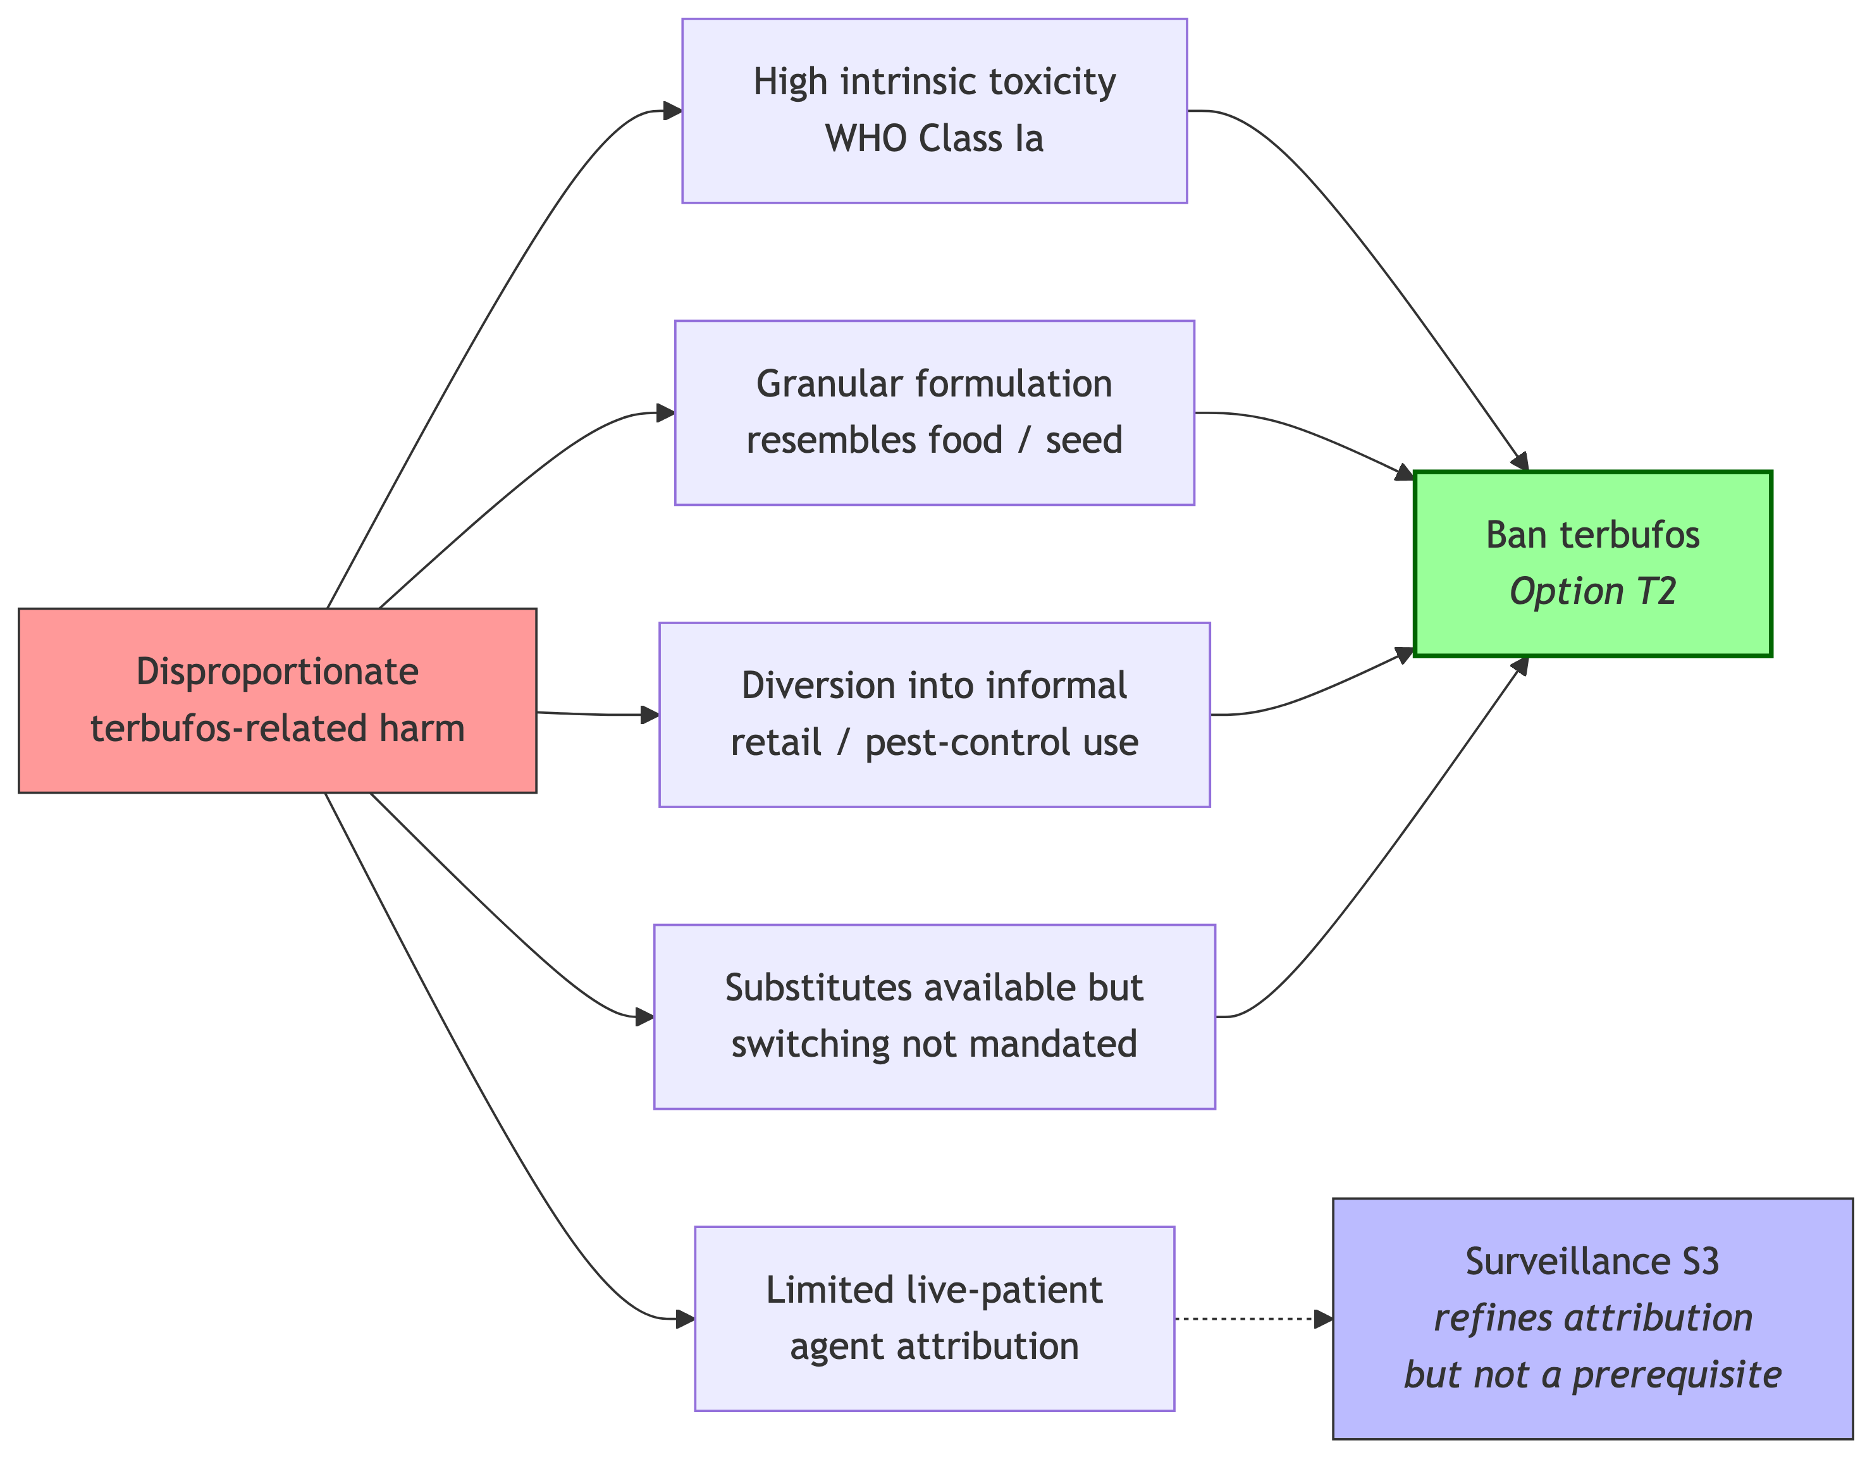
Figure 1: Root causes that make terbufos a disproportionate public-health hazard in SA. All five drivers funnel to the same regulatory remedy — banning terbufos.
Four of the five drivers (intrinsic hazard, formulation, informal-market diversion, substitution readiness) are addressed by a single regulatory act — withdrawing terbufos from the SA pesticide register. The fifth driver (live-patient attribution) is sharpened by Surveillance Option S3, but the existing paediatric attribution (Davies 2023) and the Sri Lanka international evidence are already sufficient to act.

5. Policy options
The action space collapses to two options:

Option T1 — Status quo (no change)
Terbufos remains registered under existing conditions. The system continues to rely on general pesticide-handling regulations and clinician/EHP-led NMC notifications to detect harm after it occurs. This is the implicit decision if no regulatory action is taken.

Option T2 — Ban terbufos (★ recommended)
Cancel terbufos product registrations under the Fertilizers, Farm Feeds, Agricultural Remedies and Stock Remedies Act, with a 12–24 month phase-out window to allow substitute uptake and existing stock to clear. Aligns SA with the EU 2009 position. During the phase-out, terbufos is moved to Restricted-Use status (sales only via certified applicators with logged transactions) so the regulatory mechanism is operational from gazette day one.
Intermediate restriction options (RUP, formulation restriction, distributor audit) are best understood as the mechanics of the phase-out, not as alternative end-states. The end-state is withdrawal.

6. Decision tree — deaths, burden, and yield under each option

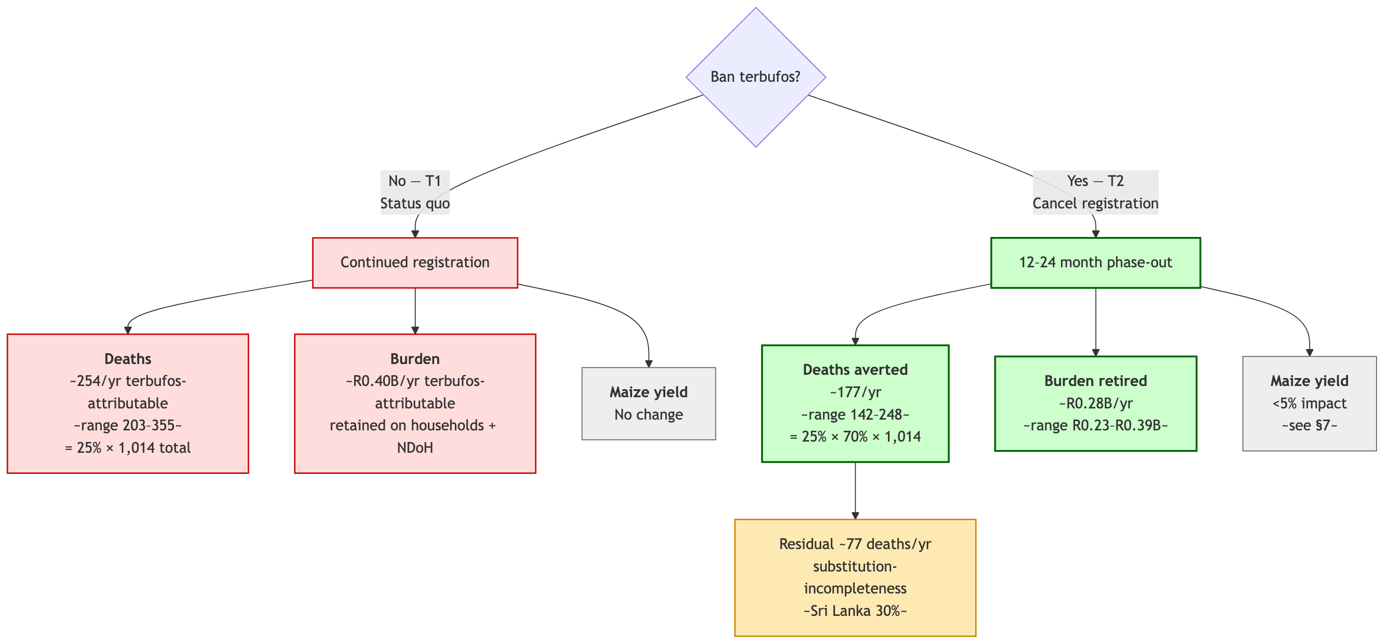
Two-node terbufos decision tree. The split is binary — ban or no ban. Each branch terminates in three parallel outcomes: deaths, monetised burden, and maize yield. Deaths-averted arithmetic: f_attr × φ_retired × N_deaths_total = 0.25 × 0.70 × 1,014 = 177/yr (working). Attributable fraction range 20–35% from Davies 2023 + Gunnell 2017; substitution-incompleteness 70% from Sri Lanka.
Summary — aggregate tree (national, annual).
Table 1: Aggregate decision tree: national annual outcomes under each arm and the reduction delivered by an enforced ban (mid-point estimate). Deaths/burden range reflects attributable-fraction bracket (Davies 2023 + Gunnell 2017).
Metric | Status quo (T1) | Ban (T2) | Averted by ban
Deaths/yr | 254 | 76 | 177 (range 142–248)
Economic burden (ZAR/yr) | R0.40B | R0.12B | R0.28B (range R0.23–R0.39B)
Maize yield impact (pp) | 0.0 pp | -0.4 pp | 0.4 pp

Reading the tree. The decision is binary because the upstream driver — high-intrinsic-toxicity granular OP in informal circulation — is binary: either the product is on the register or it isn’t. Each branch terminates in three parallel outcomes:
- Deaths — the headline public-health metric. Computed as $f_{\text{attr}}×φ_{\text{retired}}×N_{\text{deaths}}$. The working value pulls from three CSV parameters:
  - frac_terbufos_attributable_mid = 25% (range 20–35%) — SA paediatric attribution (Davies 2023) + Sri Lanka single-agent withdrawal bracket (Gunnell 2017).
  - frac_T3_burden_retired = 70% — fraction of attributable burden retired post-ban, anchored to Sri Lanka substitution-incompleteness. The complement is the residual node — deaths that persist because some users will switch to other Class I OPs rather than to less-hazardous substitutes.
  - n_deaths_headline = 1,014 — StatsSA MACOD 2023 fatal pesticide-poisoning total.
- Burden — the same multiplication applied to the R1.61B total annual burden. Working value: ~R0.28B/yr retired, falling on households + NDoH at the canonical share split.
- Maize yield — bounded at <5 % (see §7).
The full closed-form derivation, with the deaths-averted bracket calculated under every $f_{\text{attr}}×φ_{\text{retired}}$ combination, lives in Technical Appendix C.

6b. Alternative view — per-individual decision tree (Amua-style)
The tree in §6 is a population-aggregate model: it takes the StatsSA mortality total as given and asks what share is retired by a ban. An alternative — drafted in Amua — is a per-individual tree that walks a single SA resident through one year, splits on whether they experience a pesticide poisoning, then splits on whether the agent is terbufos, and finally splits on clinical outcome (died / hospitalised / asymptomatic). Each terminal carries a per-person cost; the rollback returns expected deaths, hospitalisations and ZAR cost per individual per year, which can be multiplied by the SA population to recover annual national totals.
The two trees answer the same policy question from opposite ends. The aggregate tree is more compact and audits cleanly against StatsSA; the per-individual tree exposes the clinical-pathway logic (CFR by agent) that drives the effect, and makes the personal stakes of registration policy explicit. The numbers below come from the same CSV-driven parameter set as §6.

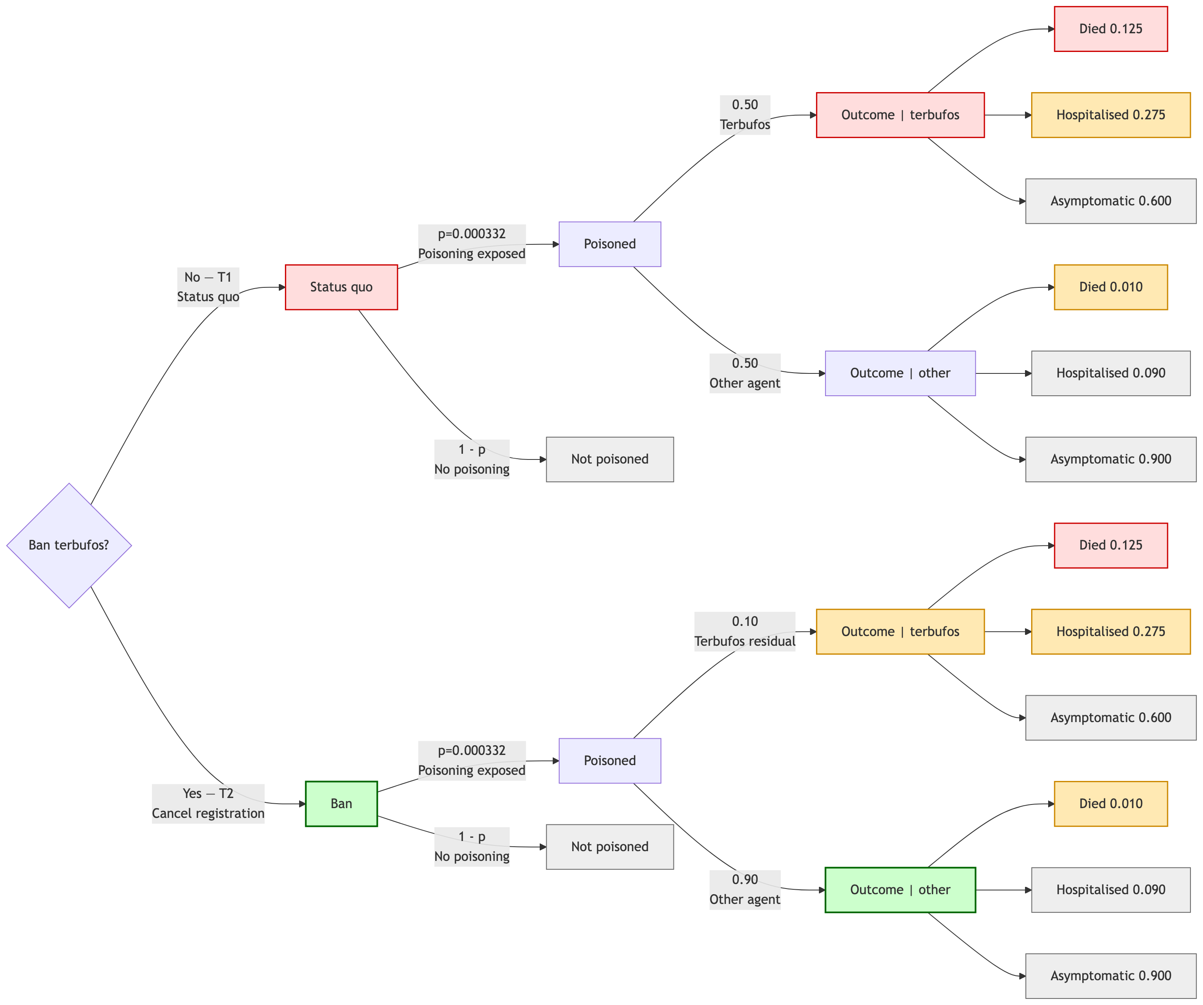
Per-individual decision tree (Amua draft). An SA resident is followed for one year. Probabilities are CSV-driven (see terb.personal_tree block). Scaled to a population of 63,100,000, this tree gives 964 deaths averted/yr, 1,550 hospitalisations averted/yr, and ~R1.57B/yr in retired cost under a ban. Compare with the aggregate tree in §6: the two trees should give numbers in the same order of magnitude.
Per-individual rollback (expected values per SA resident per year).
Table 2: Expected deaths, hospitalisations, asymptomatic events, and ZAR cost per individual per year, by arm. Multiply by the SA population reference to get annual national totals.
arm | deaths_per_person | hospitalisations_pp | asymptomatic_pp | cost_zar_pp
status_quo | 2.24e-05 | 6.06e-05 | 0.000249 | 38.6
ban | 7.10e-06 | 3.60e-05 | 0.000289 | 13.7

Apples-to-apples comparison — both trees on the same national scale.
Table 3: Side-by-side comparison of the two decision trees on a common national annual scale (SA population reference: 63,100,000). The aggregate tree (§6) uses f_attr × φ_retired × StatsSA totals; the per-individual tree (§6b) derives the effect from the CFR differential (terbufos 12.5% vs other agents 1.0%) applied to the agent-mix shift (50% → 10% terbufos among poisonings). Close agreement validates the parameter set; large divergence flags inconsistency between CFR inputs and the attributable-fraction literature.
Metric | Aggregate tree (§6) | Per-individual tree (§6b)
Deaths/yr — status quo | 254 | 1,414
Deaths/yr — ban | 76 | 450
Deaths averted/yr | 177 (range 142–248) | 964 (68.1% reduction)
Hospitalisations averted/yr | — (not modelled) | 1,550 (40.5% reduction)
Economic burden averted/yr | R0.28B (range R0.23–R0.39B) | R1.57B (64.4% reduction)

Reading this against §6. The two trees use the same upstream data but parameterise the effect differently:
- The §6 aggregate tree multiplies the StatsSA total by $f_{\text{attr}}×φ_{\text{retired}}$. The effect size is bounded by the attributable-fraction literature (Davies 2023, Gunnell 2017).
- The per-individual tree above derives the effect from the case-fatality differential between terbufos (12.5%) and substitute agents (1.0%), applied to the agent-mix shift (50% → 10%).
If the per-individual tree gives a much larger number than §6, the implication is that the personal-tree’s CFR-by-agent inputs are more optimistic than the aggregate attributable-fraction literature supports — i.e. the personal tree is implicitly assuming a stronger ban effect. If it gives a similar number, the two views corroborate each other. The audience-facing brief should pick ONE — the aggregate view is usually safer for regulator audiences; the per-individual view is more impactful for clinician / parliamentary audiences.

7. Crop-yield impact (brief)
A ban affects production primarily through soil-insect / stalk-borer control on maize. The expected SA-specific yield impact is <5 %, concentrated in non-Bt smallholder maize, for three independent reasons:
- SA maize is ~85 % Bt-trait. The dominant stalk-borer use case is largely retired biologically before any chemical intervention.
- Registered substitutes exist for the residual soil-insect / nematode use case (chlorantraniliprole, thiamethoxam, imidacloprid, biological controls). These are 100–1,000× less acutely toxic than terbufos on rat oral LD50 — the acute-poisoning burden retired is therefore essentially the full terbufos attributable share, not a redistribution to a similar-hazard substitute.
- EU 2009 withdrawal produced no documented maize-yield collapse in any producer state — a directly relevant natural experiment.
Substitute input cost is roughly 2–5× per hectare vs commodity granular OPs, but maize gross output is ~R20,000/ha, so the input-cost delta is single-digit-% of gross output. Smallholder transition support (DALRRD grower advisory + targeted subsidy on substitute inputs for the first two seasons) addresses the access constraint.
The detailed yield-impact derivation, with sensitivity ranges on Bt coverage, substitute pricing, and smallholder access, is presented in the supplementary technical note: Technical Appendix C, §4 — Maize yield impact.

8. Recommended next step
Adopt Option T2 (ban) with a 24-month phase-out.
- Month 0–3. DALRRD gazette intent to cancel registration; immediate RUP designation as the phase-out mechanism (no informal-market sales from day one).
- Month 3–6. Public-comment process; DALRRD–grain-industry transition plan including smallholder substitute subsidy.
- Month 6–12. Surveillance S3 sentinel toxicology stands up to track attributable fraction during the phase-out (refines the bracket; does not gate the decision).
- Month 12–24. Final cancellation; existing stock cleared; DALRRD inspectorate audit confirms market withdrawal.
- Month 24. Joint NDoH–DALRRD evaluation against pre-agreed reduction in attributable serious-poisoning cases.
This is the public-health action with the highest demonstrated leverage on the SA pesticide-poisoning portfolio, supported by both SA-specific paediatric data (Davies 2023) and a directly applicable international natural experiment (Sri Lanka, EU). The agricultural cost is small, bounded, and addressable through standard substitution support.

Companion briefs: Surveillance · Coordination · Decision Model · Costing Analysis
Technical appendix: C — Terbufos bracketed deaths-averted estimate and yield-impact model

World Health Organization. The WHO Recommended Classification of Pesticides by Hazard and Guidelines to Classification, current edition. Terbufos is listed in Class Ia (Extremely Hazardous).
US Environmental Protection Agency. Reregistration Eligibility Decision (RED): Terbufos. EPA-738-R-06-006, September 2006. Rat acute oral LD50 1.6–4.5 mg/kg; rat acute dermal LD50 1.0–7.4 mg/kg.
Davies J et al. (2023). Paediatric pesticide deaths in South Africa; documents terbufos and methamidophos dominance among fatal cases. Cited in glossary.qmd.
NICD/NMC clinical case reports and public communications, 2022–2024, on mass-poisoning incidents linked to informally-sold granular organophosphate pesticides. Formal case-series compilation pending (open item TBF-2).
Gunnell D, Knipe D, Chang S-S, Pearson M, Konradsen F, Eddleston M et al. Prevention of suicide with regulations aimed at restricting access to highly hazardous pesticides: a systematic review of the international evidence. Lancet Glob Health 2017;5:e1026–e1037. Knipe DW et al. Suicide prevention through means restriction: impact of the 2008–2011 pesticide restrictions on suicide in Sri Lanka. PLOS One 2017.
World Health Organization. The WHO Recommended Classification of Pesticides by Hazard and Guidelines to Classification, current edition. Terbufos is listed in Class Ia (Extremely Hazardous).
US Environmental Protection Agency. Reregistration Eligibility Decision (RED): Terbufos. EPA-738-R-06-006, September 2006. Rat acute oral LD50 1.6–4.5 mg/kg; rat acute dermal LD50 1.0–7.4 mg/kg.
US Environmental Protection Agency. Reregistration Eligibility Decision (RED): Terbufos. EPA-738-R-06-006, September 2006. Rat acute oral LD50 1.6–4.5 mg/kg; rat acute dermal LD50 1.0–7.4 mg/kg.
Davies J et al. (2023). Paediatric pesticide deaths in South Africa; documents terbufos and methamidophos dominance among fatal cases. Cited in glossary.qmd.

