Adjusting Respiratory (J-Coded) Mortality for Influenza Suppression to Estimate Hidden COVID-19 Deaths in South Africa, 2020–2022
Table of contents

Rationale
COVID-19 is a respiratory illness caused by the SARS-CoV-2 virus. It typically presents with respiratory signs and symptoms; in severe cases, progresses to pneumonia, hypoxia, or acute respiratory distress syndrome (ARDS) leading to death. Influenza A and B viruses, along with some other respiratory pathogens, have overlapping clinical signs and symptoms with COVID-19 illness. Respiratory pathogens circulate seasonally in South Africa during the Southern Hemisphere winter, with sentinel surveillance and influenza-like-illness indicators usually rising between May and August. Since many respiratory pathogens cause illness similar to COVID-19 ilness, medical certifiers likley defaulted to assign J-codes in the absence of a SARS-CoV-2 test to deaths where respiratory illness was potentialy evident. SARS-CoV-2 testing was limited in SA and almost half of deaths occur outside of a helath facility. During the COVID-19 pandemic, influenza circulation virtually disappeared - a pattern documented worldwide and confirmed by NICD sentinel surveillance (Olsen et al., n.d.; Tempia et al. 2021; Bents et al. 2022). This collapse was likely driven by widespread non-pharmaceutical interventions (NPIs) such as mask use, physical distancing, and restrictions on movement. NPI adherence tended to peak during periods of intense COVID-19 transmission. While SARS-CoV-2 still spread because of its higher transmissibility, the same interventions were highly effective at suppressing influenza, which has a lower basic reproduction number. As a result, influenza circulation was dramatically reduced even during major COVID-19 waves.
Surveillance limitations led to an undercount of true COVID-19 deaths, especially in low- and middle-income countries where testing capacity was constrained (Karlinsky and Kobak 2021). Many countries therefore implemented excess-death calculations to estimate pandemic mortality, acknowledging that some residual deaths could reflect collateral health-system effects. These calculations typically forecast expected deaths using the preceding five years of pre-pandemic data (Bradshaw et al. 2022). For J-coded deaths specifically, the standard approach assumes that influenza and other non-COVID respiratory deaths remained at pre-pandemic levels and were unaffected by NPIs or other pandemic disruptions; in practice, J codes likely became a default for many COVID-19 deaths who were not laboratory diagnosed. Adjustments for other causes (e.g., diabetes or cardiovascular disease) may be defensible, but the near-zero influenza circulation documented by sentinel surveillance is one of the strongest priors currently available and should be leveraged when estimating the number of COVID-19 deaths hidden within J-coded causes.

Methods
Vital registration data from 2015–2019 were used to model the expected number of J-coded deaths during the COVID-19 period (April 2020 onwards). A negative binomial regression estimated expected deaths while adjusting for seasonality and long-term trends aswell as demographic interactions. We evaluated province-level random effects and cluster-robust standard errors, but these did not materially improve model fit (AIC and pseudo-R^2) or meaningfully change estimates, so we retained the simpler specification.
We fit a negative binomial model with the following mean structure:
$$log(E(Y_{a,s,j,t}))=β_{0}+β_{1}⋅epiweek+β_{2}⋅ageGroup+β_{3}⋅sex+β_{4}⋅JCodeGroup+\text{interactions},$$
where $Y_{a,s,j,t}$ is the number of deaths in age group $a$, sex $s$, J-code group $j$ and epidemiological week $t$.
Three scenarios were modelled, with a fourth planned:
Scenario 1 (Baseline). Standard excess-death calculation where the difference between observed (actual) and expected (modelled) deaths yields the number of COVID-19 deaths binned into J codes. This scenario assumes influenza and other respiratory deaths stayed at pre-pandemic levels.
Scenario 2 (Upper bound). Assumes no influenza or other respiratory deaths occurred during the pandemic. Expected deaths are set to zero, so the observed total is interpreted as COVID-19 deaths.
Scenario 3 (NPI-adjusted). Assumes J-coded deaths were modulated by NPI use. Influenza had very low levels of circulation because of strict NPI adherence, which was typically highest during peak SARS-CoV-2 transmission. Given influenza’s lower R₀, NPIs suppressed influenza more effectively than COVID-19.
A COVID-19 trend is calculated by decomposing the COVID-19 deaths time series into trend, seasonal and random components using traditional decomposition.
Trend decomposition is performed using the following equation:
$$Y^{(i)}=trend^{(i)}+seasonal^{(i)}+random^{(i)}$$
where $Y$ is the observed COVID-19 deaths at time $i$ (epiweek $i$).
The trend component was converted to a proportion by dividing each weekly trend value by the maximum trend value observed during the pandemic period. This proportion represents the relative intensity of COVID-19 transmission over time. Since the relative intensity of COVID-19 transmission is inversely related to influenza circulation (i.e., when COVID-19 transmission is high, influenza circulation is low due to NPIs), we use this proportion to adjust expected J-coded deaths downward during periods of high COVID-19 transmission.
$$Adjusted Expected Deaths^{(i)}=Expected Deaths^{(i)}×\left(1−\frac{trend^{(i)}}{max(trend)}\right)$$
The difference between observed and adjusted expected deaths is then calculated.
Scenario 4 (planned). Fit a pre-pandemic negative binomial regression that includes influenza and influenza-like-illness (ILI) surveillance as predictors to characterise the relationship between influenza circulation and J-coded deaths. Use the fitted model to predict expected deaths during the pandemic based on observed influenza and ILI surveillance, then compute the excess. Ideally, surveillance data stratified by sex and age group would be available because death risk varies strongly by these dimensions.
$$log(E(Y))=β_{0}+β_{1}⋅epiweek+β_{2}⋅ageGroup+β_{3}⋅sex+β_{4}⋅JCodeGroup+β_{5}⋅influenzaSurveillance+β_{6}⋅ILIrate+\text{interactions}$$

Results
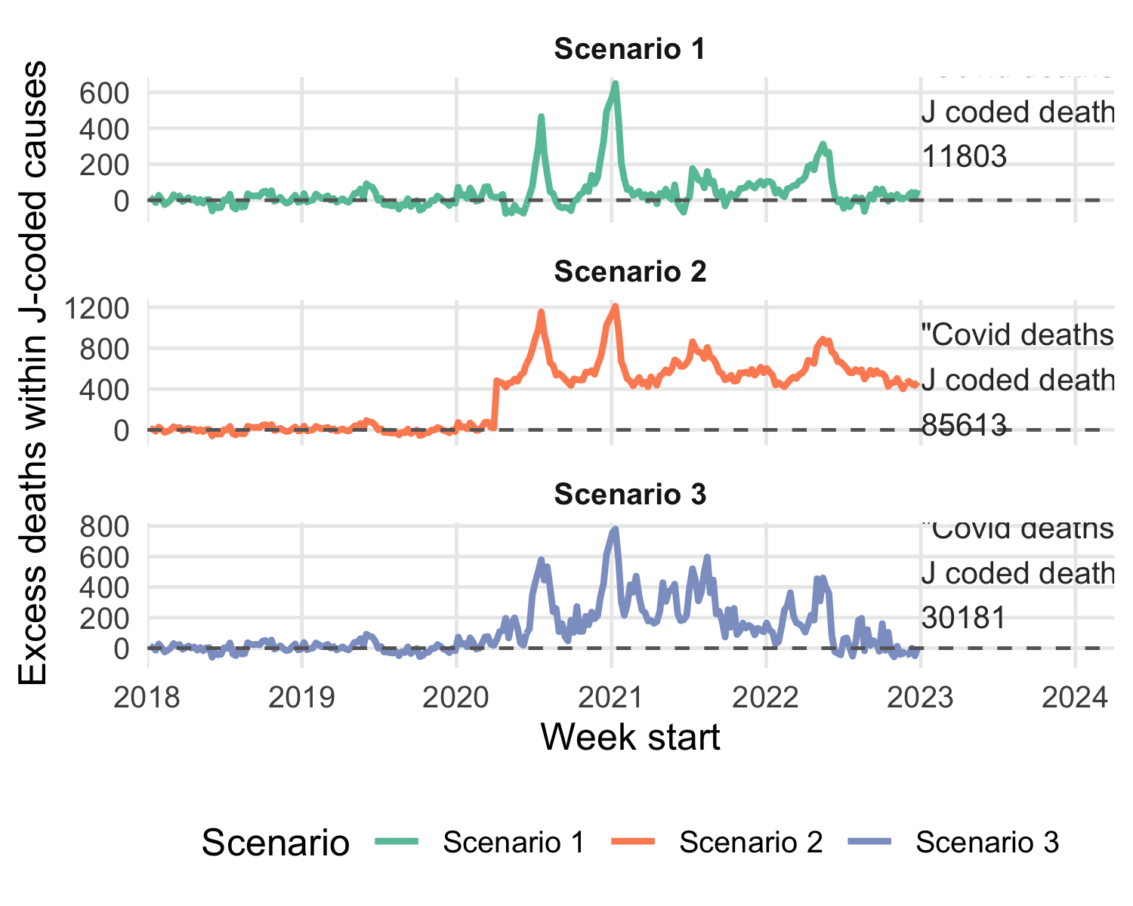
Figure 1: Excess death estimates for J-coded deaths under 3 (4th to be added) different scenarios, South Africa 2020-2022
Under the baseline scenario (Scenario 1), an estimated 11803 excess deaths among J-coded deaths were estimated. Scenario 2, which assumes no influenza or other respiratory deaths occurred during the pandemic, yields 85613 excess deaths. Scenario 3, which adjusts expected deaths based on NPI intensity and COVID-19 trends, estimates 30181 excess deaths.

Discussion
All J-codes of the underlying cause of death were used in this model however restriction to more specific respiratory codes (J09-J18) may yield more moderate results.
SARI and ILI surveillance data were influenced by health-seeking behaviour during the pandemic, so using those data to model expected deaths may introduce bias. Influenza sentinel surveillance may not perfectly represent national circulation, but it is currently the best data source for capturing the relationship between influenza and J-coded deaths - Age-sex–stratified surveillance data would be ideal to better model this relationship; can such data be accessed?
Estimating the number of mis-coded COVID-19 deaths may be biased if we assume influenza deaths stayed at pre-pandemic levels. The strong prior that influenza circulation was virtually absent should therefore inform J-code adjustments. Respecting the collapse of influenza circulation does not alter the overall excess-death totals but can substantially change cause-specific attribution within respiratory categories.
Many other causes (e.g., diabetes, cardiovascular disease, tuberculosis, garbage codes) may also have served as bins for unidentified COVID-19 deaths, yet the assumption that they remained at pre-pandemic levels is weaker because there is less clinical overlap and outcomes were likely affected by health-system disruptions and behavioural shifts. Adjusting those causes requires additional priors or data sources.

Public health impact and recommendations
Although the acute pandemic phase has ended, understanding the true burden of COVID-19–associated deaths remains essential for preparedness and resource allocation.
Applying strong priors—such as the documented collapse of influenza circulation—to excess-death calculations can markedly improve cause-specific attribution. Integrating additional surveillance data (e.g., malaria, HIV, TB, respiratory pathogens, climate indicators, pharmacy dispensing) would enable near–real-time adjustment of expected deaths and help identify potential “cause bins,” where increases in broad or ill-defined categories (such as R-coded deaths) correspond to specific syndromic or laboratory signals.
Improving medical certification of cause of death is crucial for accurate mortality surveillance. Investments in training clinicians, implementing electronic death registration with validation checks, and conducting regular audits will strengthen data quality. Reliable cause-of-death data remain vital for public health planning and crisis response.

References
Bents, Samantha, Cécile Viboud, Bryan Grenfell, et al. 2022. The Impact of COVID-19 Non-Pharmaceutical Interventions on Future Respiratory Syncytial Virus Transmission in South Africa. Public and Global Health. https://doi.org/10.1101/2022.03.12.22271872.
Bradshaw, Debbie, Rob Dorrington, Ria Laubscher, Pamela Groenewald, and Tom Moultrie. 2022. “COVID-19 and All-Cause Mortality in South Africa – the Hidden Deaths in the First Four Waves.” South African Journal of Science 118 (5/6). https://doi.org/10.17159/sajs.2022/13300.
Karlinsky, Ariel, and Dmitry Kobak. 2021. “Tracking Excess Mortality Across Countries During the COVID-19 Pandemic with the World Mortality Dataset.” eLife 10 (June): e69336. https://doi.org/10.7554/eLife.69336.
Olsen, Sonja J, Eduardo Azziz-Baumgartner, Alicia P Budd, et al. n.d. Decreased Influenza Activity During the COVID-19 Pandemic — United States, Australia, Chile, and South Africa, 2020.
Tempia, Stefano, Sibongile Walaza, Jinal N. Bhiman, et al. 2021. “Decline of Influenza and Respiratory Syncytial Virus Detection in Facility-Based Surveillance During the COVID-19 Pandemic, South Africa, January to October 2020.” Eurosurveillance 26 (29): 2001600. https://doi.org/10.2807/1560-7917.ES.2021.26.29.2001600.

