

Notifiable Medical Conditions
Surveillance System Report

May 2025

Table of Contents
Introduction……………………………………………………………………………………………………………………………………………………………………………………………………………………….1
NMC Reporting Application……………………………………………………………………………………………………………………………………………………………………………………………………1
NMC highlights …………………………………………………………………………………………………………………………………………………………………………………………………………1
Category 1 Conditions ………………………………………………………………………………………………………………………………………………………………………………………………………..1
Cumulative number of Category 1 notifications by province and epidemiological classification ………………………………………………………………………………………………………2
Admission Status of the notified NMC’s for Category 1 notification ………………………………………………………………………………………………………………………………….3
Timeliness and Data Quality in Reporting Category 1 Notifiable Medical Conditions …………………………………………………………………………………………………………………….4
Category 2 Notifications……………………………………………………………………………………………………………………………………………………………………………………………………. 5 Cumulative number of Category 2 notifications by province, Overall suspected , confirmed and death…………………………………………………………………………………………...5
Conclusion and Recommendations……………………………………………………………………………………………………………………………………………………………………………………….6
Appendix ………………………………………………………………………………………………………………………………………………………………………………………………………………………….7
Appendix No.1 NMC DATA FLOW CHART……………………………………………………………………………………………………………………………………………………………………………….7
Appendix No.2: NMC Categories, And Case Classification Definitions………………………………………………………………………………………………………………………………………7
Appendix No.3: Diphtheria outbreak situational report……………………………………………………………………………………………………………………………………………………………7
Appendix No.4: NMC Surveillance Officers List and contact……………………………………………………………………………………………………………………………………………………7

Introduction
This report summarises data from the National Notifiable Medical Conditions Surveillance System (NMCSS) on cases notified from 1st to 31st May 2025. The primary objective of the report is to provide an overview of the notifications by describing the notifications received. The report includes both Category I and Category 2 notifiable medical conditions (NMC), the epidemiological classification of cases by province, and the number of reported deaths.
NMC Reporting Application
NMC Reporting App is available on both web and mobile platforms. For information and registration contact the respective NMC surveillance Officer in your respective province, Appendix No.3: NMC Surveillance Officers List and contacts.

NMC highlights
- A total of 11 804 cases were reported to the NMCSS for category 1 and 2 in May 2025.
- Category 1 9% (1075/11 804) and Category 2 91% (10 729/ 11 804) of the cases notified
- Thirty three (33) deaths were reported under Category 1 notifications
Table 1: Cumulative number of NMC notifications for Categories 1 and 2: 01-31 May 2025
NMC Category | Clinical | Lab | Merged | Total
Category 1 | 698 (65%) | 340 (32%) | 37 (3%) | 1075 (100%)
Category 2 | 8206 (76.4%) | 2501 (23.3%) | 22(0.2%) | 10729 (100%)
Total | 8904 (74%) | 2841(24%) | 59 (0.4%) | 11804 (100%)

Category 1 Conditions
Category 1 conditions must be notified within 24 hours of diagnosis by healthcare providers and private or public health laboratories. These conditions must be notified based on clinical suspicion, before there is a laboratory confirmation. A total of n= 1 075 (9%) cases were reported for Category 1. The most frequently notified condition was Malaria 41% (439/1 075). Notably, Pertussis had a higher proportion of laboratory confirmed notifications (27/ 53). A total of n=33 (3%) deaths were reported under Category 1 notifications, with the most 57.5% (19/33) being for agricultural stock remedy poisoning notification. For diphtheria 3 of the 37 notifications were confirmed (See appendix 3 for the situational report).Table 2
Table 2: Cumulative number of Category 1 notifications by province and epidemiological classification: May 2025
Conditions | EC | FS | GP | KZN | LP | MP | NW | NC | WC | Total | Suspected | Confirmed | Death
Acute Flaccid Paralysis | 2 | 1 | 14 | 1 | 1 | 1 | 0 | 1 | 5 | 26 | 26 | 0 | 0
Acute Rheumatic Fever | 0 | 0 | 0 | 0 | 0 | 0 | 0 | 0 | 2 | 3 | 3 | 0 | 0
Agricultural or stock remedy poisoning | 3 | 16 | 73 | 2 | 16 | 4 | 6 | 2 | 18 | 140 | 140 | 0 | 19
Anthrax | 0 | 0 | 1 | 0 | 0 | 0 | 0 | 0 | 0 | 1 | 1 | 0 | 0
Botulism | 0 | 0 | 0 | 0 | 0 | 0 | 0 | 0 | 0 | 0 | 0 | 0 | 0
Cholera | 0 | 0 | 0 | 0 | 0 | 0 | 0 | 0 | 0 | 0 | 0 | 0 | 0
Congenital rubella syndrome | 3 | 1 | 4 | 8 | 1 | 3 | 1 | 0 | 2 | 23 | 23 | 0 | 0
Diphtheria | 1 | 0 | 3 | 7 | 10 | 3 | 0 | 0 | 16 | 40 | 37 | 3 | 0
Enteric fever (typhoid or paratyphoid fever) | 0 | 0 | 8 | 3 | 3 | 0 | 0 | 0 | 1 | 15 | 12 | 3 | 1
Food borne illness outbreak | 10 | 0 | 16 | 13 | 4 | 16 | 5 | 0 | 0 | 64 | 64 | 0 | 1
Haemolytic uraemic syndrome (HUS) | 0 | 0 | 0 | 0 | 0 | 0 | 0 | 0 | 0 | 0 | 0 | 0 | 0
Listeriosis | 1 | 0 | 5 | 3 | 0 | 0 | 0 | 0 | 2 | 11 | 9 | 2 | 2
Malaria | 7 | 11 | 97 | 55 | 97 | 132 | 16 | 7 | 17 | 439 | 426 | 13 | 3
Measles | 2 | 15 | 75 | 9 | 0 | 15 | 6 | 9 | 12 | 143 | 129 | 14 | 0
Meningococcal Disease | 3 | 0 | 5 | 0 | 5 | 1 | 1 |  | 6 | 21 | 12 | 9 | 3
Mpox | 0 | 0 | 4 | 1 | 0 | 0 | 0 | 0 | 0 | 5 | 5 | 0 | 0
Pertussis | 3 | 1 | 18 | 6 | 1 | 0 | 0 | 4 | 20 | 53 | 26 | 27 | 0
Plague | 0 | 0 | 0 | 0 | 0 | 0 | 0 | 0 | 0 | 0 | 0 | 0 | 0
Poliomyelitis | 0 | 0 | 0 | 0 | 0 | 0 | 0 | 0 | 0 | 0 | 0 | 0 | 0
Rabies | 2 | 0 | 0 | 2 | 2 | 0 | 0 | 0 |  | 6 | 5 | 1 | 4
Respiratory disease caused by a novel respiratory pathogen | 0 | 0 | 0 | 0 | 0 | 0 | 0 | 0 | 0 | 0 | 0 | 0 | 0
Rift Valley fever (human) | 0 | 0 | 0 | 0 | 0 | 0 | 0 | 0 | 0 | 0 | 0 | 0 | 0
Rubella | 4 | 23 | 7 | 6 | 5 | 11 | 21 | 5 | 3 | 85 | 84 | 1 | 0
Smallpox | 0 | 0 | 0 | 0 | 0 | 0 | 0 | 0 | 0 | 0 | 0 | 0 | 0
Viral haemorrhagic fever diseases | 0 | 0 | 0 | 0 | 0 | 0 | 0 | 0 | 0 | 0 | 0 | 0 | 0
Yellow fever | 0 | 0 | 0 | 0 | 0 | 0 | 0 | 0 | 0 | 0 | 0 | 0
Total | 41 | 68 | 330 | 116 | 145 | 186 | 56 | 28 | 104 | 1075 | 1002 | 73 | 33
* Suspected, confirmed and deaths are for the overall notification per condition for May i.e. not by province

Admission Status of the notified NMC’s for Category 1 notification

Among the notified Category I Notifiable Medical Conditions, 32% (343 /1 075) of the notifications were admitted to health facilities, while 3% (33/1 075) resulted in death.

Table 3: Age distribution by gender, admission status, and patient outcome for category 1 NMCs: May 2025

Age groups | Gender |  | Admission Status |  |  |  |  |  | Patient Vital Status
Age groups | Female | Male | Discharged | Inpatient | Outpatient | Transferred | Unknown | Missing | Alive | Deceased | Unknown | Missing
0-4 | 174 | 255 | 27 | 136 | 221 | 19 | 2 | 24 | 394 | 9 | 2 | 24
14-Oct | 44 | 30 | 12 | 12 | 17 | 1 | 0 | 32 | 41 | 1 | 0 | 32
15-19 | 18 | 19 | 2 | 17 | 11 | 0 | 1 | 6 | 28 | 3 | 0 | 6
20-24 | 20 | 29 | 5 | 13 | 12 | 2 | 2 | 15 | 31 | 1 | 2 | 15
25-29 | 17 | 33 | 1 | 19 | 9 | 1 | 2 | 18 | 28 | 3 | 1 | 18
30-34 | 16 | 33 | 2 | 26 | 6 | 2 | 0 | 13 | 33 | 3 | 0 | 13
35-39 | 20 | 26 | 3 | 22 | 13 | 0 | 1 | 7 | 38 | 1 | 0 | 7
40-44 | 16 | 21 | 3 | 16 | 5 | 2 | 1 | 10 | 25 | 2 | 0 | 10
45-49 | 6 | 24 | 5 | 9 | 4 | 1 | 0 | 11 | 18 | 1 | 0 | 11
50-54 | 3 | 11 | 1 | 6 | 2 | 1 | 0 | 4 | 10 | 0 | 0 | 4
55-59 | 7 | 15 | 1 | 14 | 2 | 1 | 2 | 2 | 18 | 1 | 1 | 2
09-May | 56 | 56 | 8 | 20 | 20 | 1 | 1 | 62 | 48 | 1 | 1 | 62
60-64 | 4 | 8 | 1 | 7 | 0 | 0 | 1 | 3 | 7 | 2 | 0 | 3
65+ | 9 | 7 | 0 | 9 | 0 | 0 | 1 | 6 | 7 | 3 | 0 | 6
Unknown | 34 | 64 | 0 | 17 | 3 | 0 | 1 | 77 | 19 | 2 | 0 | 77
Total | 444 | 631 | 71 | 343 | 325 | 31 | 15 | 290 | 745 | 33 | 7 | 290

Timeliness and Data Quality in Reporting Category 1 Notifiable Medical Conditions

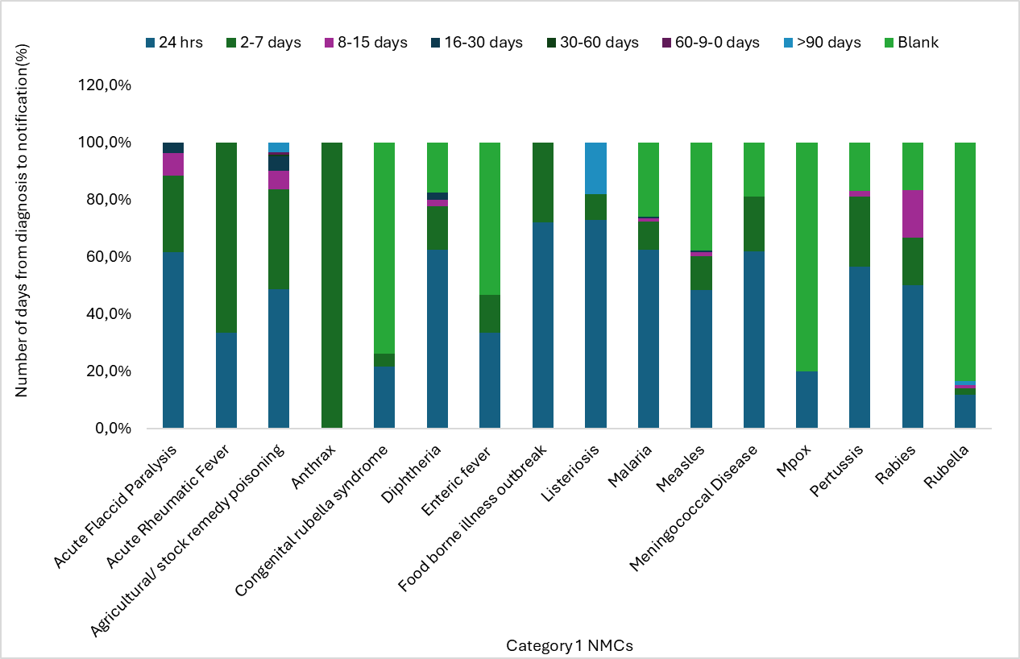
Figure 1: Summary Category 1 timelines of the reported cases on the NMC system
Timely reporting of Category 1 NMC within the stipulated 24-hour period is essential for the early detection of disease trends and potential outbreaks. Listeriosis 73% (8/11) and foodborne illness (FBI) 72% (46/64) are among the conditions most frequently reported within the stipulated timeframe. However, acute rheumatic fever (ARF) and agriculture or stock remedy poisoning are often reported late. Only 33% (1/3) of ARF cases are notified within 24 hours, with the remainder reported between 1 and 7 days. In the case of agriculture stock remedy poisoning, 50% (68/140) of notifications occur within 24 hours, 35% (49/140) between 2 and 7 days, and nearly 4% (5/140) are reported more than 90 days post-diagnosis. Additionally, conditions such as Rubella 84% (71/85), Mpox 80% (4/5), and Congenital Rubella Syndrome 74% (17/23) are often reported without a recorded diagnosis date, contributing to poor data quality in the NMC system.
Category 2 Notifications
Category 2 conditions must be notified within 7 days of diagnosis, they are important to monitor disease burden trends. Pulmonary tuberculosis (TB) was the most common 58.6% (6 295/10 729), followed by extra-pulmonary TB 12.5% (1 344/10 729) category 2 notification. 0.3% (81/10729) category 2 notifications resulted in death, most were of notified pulmonary tuberculosis 59.2% (48/81).
Table 4 : Cumulative number of Category 2 notifications by province, Overall suspected , confirmed and death : May 2025
Conditions | EC | FS | GP | KZN | LP | MP | NW | NC | WC | Total | Suspected | Confirmed | Death
Bilharzia (schistosomiasis) | 52 | 0 | 40 | 351 | 265 | 113 | 1 | 0 | 17 | 839 | 836 | 3 | 0
Brucellosis | 0 | 0 | 1 | 0 | 1 | 0 | 1 | 0 | 0 | 3 | 3 | 0 | 0
Congenital syphilis | 138 | 42 | 87 | 316 | 16 | 35 | 17 | 25 | 95 | 771 | 762 | 9 | 4
Haemophilus influenzae type B | 1 | 0 | 0 | 0 | 1 |  |  |  | 4 | 6 | 3 | 3 | 1
Hepatitis A | 21 | 17 | 68 | 63 | 13 | 29 | 13 | 17 | 45 | 286 | 280 | 6 | 0
Hepatitis B | 137 | 23 | 60 | 662 | 6 | 8 | 28 | 15 | 15 | 954 | 954 | 3 | 1
Hepatitis C | 0 | 1 | 6 | 0 | 3 | 0 | 0 | 0 | 0 | 10 | 10 | 0 | 1
Lead poisoning | 0 | 0 | 0 | 0 | 0 | 0 | 0 | 0 | 0 | 0 | 0 | 0 | 0
Legionellosis | 2 | 0 | 4 | 1 | 0 | 3 |  | 1 | 2 | 13 | 7 | 6 | 1
Leprosy | 0 | 0 | 1 | 0 | 0 | 0 | 0 | 0 | 0 | 1 | 1 | 0 | 0
Maternal death (pregnancy, childbirth and puerperium) | 1 | 0 | 4 | 2 | 2 | 0 | 0 | 0 | 1 | 10 | 10 | 0 | 7
Mercury poisoning | 0 | 0 | 0 | 2 | 0 | 0 | 0 | 0 | 0 | 2 | 2 | 0 | 0
Soil transmitted helminths | 1 | 0 | 0 | 1 | 0 | 0 | 0 | 0 | 0 | 2 | 2 | 0 | 0
Tetanus | 0 | 0 | 0 | 0 | 0 | 0 | 0 | 0 | 0 | 0 | 0 | 0 | 0
Tuberculosis: pulmonary | 762 | 341 | 1549 | 1126 | 310 | 249 | 253 | 352 | 1353 | 6295 | 6295 | 0 | 48
Tuberculosis: extra-pulmonary | 103 | 79 | 548 | 252 | 63 | 21 | 45 | 40 | 193 | 1344 | 1344 | 0 | 15
Tuberculosis: extensively drug -resistant (XDR -TB) | 1 | 1 | 3 | 0 | 0 | 0 | 0 | 0 | 2 | 7 | 7 | 0 | 0
Tuberculosis: multidrug- resistant (MDR -TB) | 20 | 17 | 40 | 52 | 2 | 5 | 4 | 2 | 44 | 186 | 186 | 0 | 3
Grand Total | 1239 | 521 | 2411 | 2828 | 682 | 463 | 362 | 452 | 1771 | 10729 | 10699 | 30 | 81

* Suspected, confirmed and deaths are for the overall notification per condition for May i.e. not by province

Recommendations

- We recommend that clinicians should complete all patient clinical and demographic details to improve NMC data quality.
- Completion of ID number capturing is highly recommended in the SDW system to improve data quality and merging purposes.
- We welcome stakeholders’ feedback and suggestions for the report
- Feel free to reach out to matimbam@nicd.ac.za , brianb@nicd.ac.za and Tlamelom@nicd.ac.za

Appendix No.1: NMC DATA FLOW CHART

Link to the website: https://www.nicd.ac.za/nmc-overview/nmc-resources/

Appendix No.2: NMC Categories, And Case Classification Definitions

Link to the website: https://www.nicd.ac.za/nmc-overview/nmc-resources/

Appendix No.3 Diphtheria situational report

https://www.nicd.ac.za/diphtheria-situational-report-week-23-of-2025/

Appendix No.4: NMC Surveillance Officers List and contacts
Province | Name & Surname | Email address | Cell Numbers
Eastern Cape | Nkosimpendulo Mngceke | nkosimpendulom@nicd.ac.za | 082 888 6194/083 519 5969
Free State | Moeketse Pheko | moeketsep@nicd.ac.za | 060 978 3042/076 889 7319
Gauteng & Northwest | Bokelani Nyaose | bukelanin@nicd.ac.za | 071 670 8741
Gauteng & Northwest | Lorato Mthombeni | loratom@nicd.ac.za | 0721341818
KwaZulu-Natal | Shakira Naido | shakiran@nicd.ac.za | 0713037392
Limpopo | Vuyolwethu Mashamaite | vuyolwethum@nicd.ac.za | 0609634834
Mpumalanga | Lesley Ingle | lesleyI@nicd.ac.za | 066 308 7539
Northern Cape | Matsheko Thekiso | matshekot@nicd.ac.za | 060 984 0980
Western Cape | Washiefa Isaacs | washiefaI@nicd.ac.za | 064 742 4005

The End!

