Recommendations:

Webster, Hardin, Hamilton, Butler, Wright, Grundy, Franklin & Humboldt Counties (PUMA: 1900600)

* This would be the first place I would recommend expanding to.
* It is not as far as the other counties, and there would not be additional resources from other states nearby
* Total Count of food insecure seniors (FSSTATUS): 7,979
  + This means that almost 8,000 seniors in the above counties identify as low or very low food secure.
    - Note: this included people in the middle section of the food insecurity measure FSSTATUS
* Proportion of food insecure seniors (FSSTATUS): 0.22 (22% of total senior population)
* Total count of food insecure seniors (FSWROUTY): 17,300
  + This means that over 17,000 seniors in the above counties are predicted to be worried about running out of food and unable to afford more
    - FSWROUTY is a 1 (yes) if they have felt sometimes or often true to the above statement
* Proportion of food insecure seniors (FSWROUTY): 0.47 (47% of total senior population)

PUMA 1900500 - Black Hawk County--Waterloo & Cedar Falls Cities

* Total Count of food insecure seniors (FSSTATUS): 6,164
* Proportion of food insecure seniors (FSSTATUS): 0.2018 (20.18%)
* Total Count of food insecure seniors (FSWROUTY): 13,910
* Proportion of food insecure seniors (FSWROUTY): 0.4557 (45.57%)

PUMA 1901200 - Marshall, Benton, Poweshiek, Tama & Iowa Counties

* Total Count of food insecure seniors (FSSTATUS): 6,615
* Proportion of food insecure seniors (FSSTATUS): 0.2131 (21.31%)
* Total Count of food insecure seniors (FSWROUTY): 14,579
* Proportion of food insecure seniors (FSWROUTY): 0.4697 (46.97%)

The following counties look to have a high count of food insecure seniors, many of these places may look to their neighboring states for resources. These areas with larger cities, likely already have some kind of resource.

* Southwest Iowa--Council Bluffs City
  + Probably finds resources in Omaha
* Dubuque, Buchanan, Jackson & Delaware Counties--Dubuque City
* Scott County--Davenport City

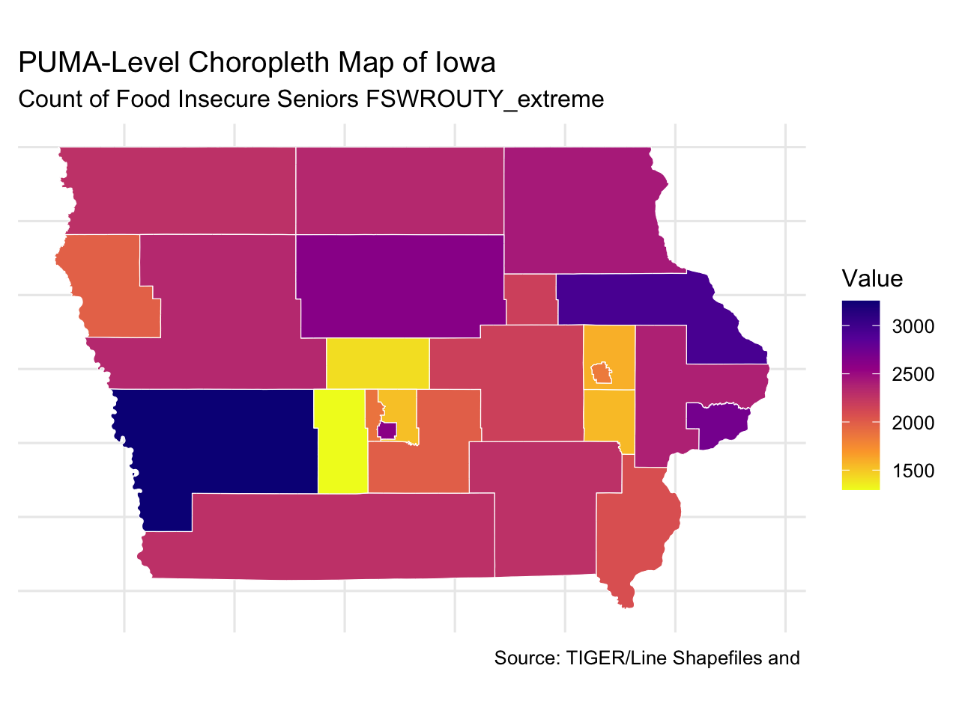

Webster, Hardin, Hamilton, Butler, Wright, Grundy, Franklin & Humboldt Counties (PUMA: 1900600)

* This would be the first place I would recommend expanding to.
* It is not as far as the other counties, and there would not be additional resources from other states nearby
* Total Count of food insecure seniors (FSSTATUS_extreme): 1,800
  + This means that almost 2,000 seniors in the above counties identify as very low food secure.
    - Answered very low food secure
* Proportion of food insecure seniors (FSSTATUS_extreme): 0.0499 (4.99% of total senior population in the above counties)
* Total count of food insecure seniors (FSWROUTY_extreme): 2,608
  + This means that over 2,500 seniors in the above counties are predicted to be worried about running out of food and unable to afford more
    - Answered “often true”
* Proportion of food insecure seniors (FSWROUTY_extreme): 0.071 (7.1% of total senior population)

Then, if they are already expanding to the above counties, I would also suggest expanding into Black Hawk County--Waterloo & Cedar Falls Cities (PUMA: 1900500). This PUMA is also very concentrated making for easier delivery of services.

* This is a smaller PUMA area just east of PUMA 1900600.
* Total count of food insecure seniors (FSSTATUS_extreme): 1,491
* Proportion of food insecure seniors (FSSTATUS_extreme): 0.0488 (4.88% of total senior population in the above PUMA)
* Total count food insecure seniors (FSWROUTY_extreme): 2,173
* Proportion of food insecure seniors (FSWROUTY_extreme): 0.0711 (7.11%)

Marshall, Benton, Poweshiek, Tama & Iowa Counties (PUMA: 1901200)

* Total count of food insecure seniors (FSSTATUS_extreme): 1,518
* Proportion of food insecure seniors (FSSTATUS_extreme): 0.0489 (4.89% of total senior population in the above PUMA)
* Total count food insecure seniors (FSWROUTY_extreme): 2,169
* Proportion of food insecure seniors (FSWROUTY_extreme): 0.0698 (6.98%)

Comparing Lasso and Ridge Models for FSWROUTY_extreme:

Comparing Lasso and Ridge Models for FSSTATUS_extreme:

