BIOS 30318

Whalen, Moroney, Quattromani

Prof. Jones

TA: Brittni

12/7/18

Final Project: Dynamic Modeling

**Lotka-Volterra Model**

The Lotka-Volterra consumer-resource model shows the dynamics between predator and prey populations. The model assumes that the only limit of prey population growth is the predator population and where the only limit on predator population growth is the prey population. This model does not take into account other factors that may be limiting population growth such as intra-species competition for resources. The model is based off of the following equations:

$$\frac{dH}{dt}=bH - aPH$$

$$\frac{dP}{dt}= eaPH - sP$$

Where *H* is the prey population, *P* is the predator population, *b* is the prey birth rate, *a* is the predator attack rate, *e* is the conversion efficiency of prey to predators, and *s* is the predator death rate.

*Conceptual Model:* A diagram conceptualizing the relationships between the state variables (*H* and *P*) and the parameter values (*b, a, e, s*).

Herbivore (H)=25

Predator (P)=5

Prey birth rate (b)=0.5

Predator death rate (s)=0.2

Predator attack rate(a)=0.02

Conversion efficiency (e)=0.1

*Initial Simulation:*

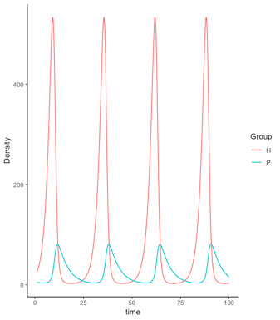

The initial simulation model where *H*=25, *P=*5*, b*=0.5, *a*=0.02, *e*=0.1, *s*=0.2, and the time period of 1 to 100 by a time step of 0.1.The relationship between predator *P* and prey *H* is cyclic with the population density of the prey beginning to fall as the population density of the predator starts to rise where a prey population peak occurs. As the population density of the prey drops to around 75, the population density of the predator peaks and also begins to drop, allowing the population density of the prey to rise again and begin the cycle anew. The predator-prey cycle takes about 25 time units to begin again.

*Role of Each Parameter*

Prey Birth Rate:

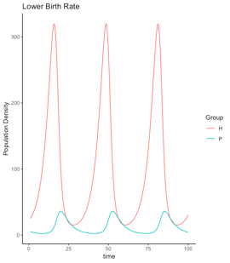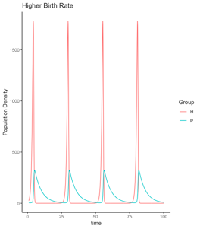

Lowering the birth rate of prey from 0.5 to 0.25 lowers the overall population densities of both predator and prey and increases the length of the cycle of the relationship. The lower birth rate of prey causes a slower rise in population density of the predator, leading to a longer period of population growth for the prey, but the length of the overall cycle has decreased with only three population peaks as compared to four population peaks in the initial model.

Increasing the birth rate of prey from 0.5 to 1.5 increases the overall population densities of both predator and prey and decreases the amount of time that the prey population is high. The peak for prey population happens very quickly. The higher birth rate of prey causes a faster rise in population density of the predator, leading to a shorter period of population growth for the prey before the population density of the predator gets high enough to start lowering the population density of the prey.

Predator Attack Rate:

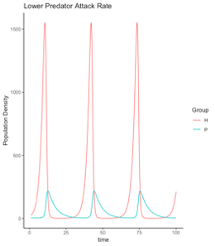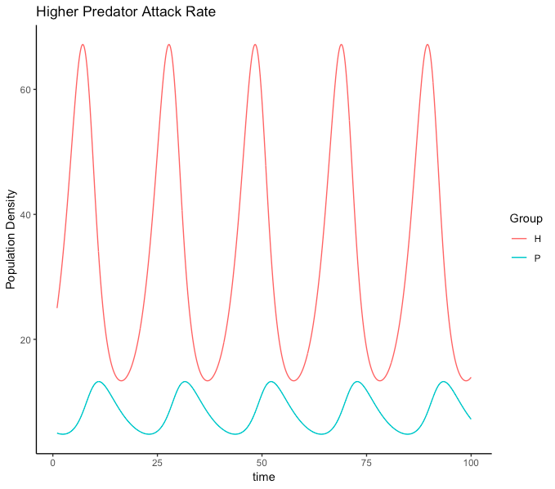

Lowering the predator attack rate from 0.02 to 0.01 increases the overall population densities of both predator and prey and increases the length of the cycle of the relationship. The lower predator attack rate causes a fast rise in population density of the prey and a slow rise in the population density of the predator, taking a longer amount of time for the predators to start attacking the prey.

Raising the predator attack rate from 0.02 to 0.06 decreases the overall population densities of both predator and prey. The higher predator attack rate causes the decline in population density of the prey to start earlier due to the high attack rate of the predator. The population densities of the predator and prey do not seem to overlap with the prey population not falling as low as the predator population.

Conversion Efficiency:

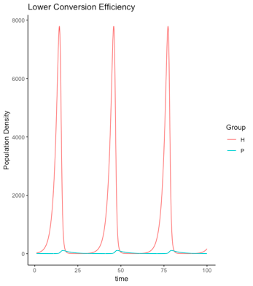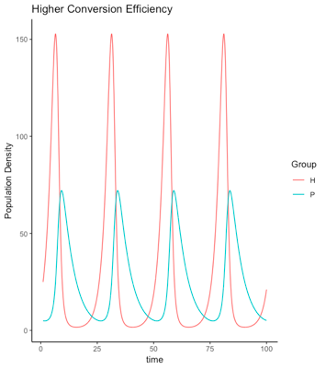

Lowering the conversion efficiency from 0.1 to 0.01 causes the population density of the predator to be very low, with the prey able to increase greatly up to very high numbers. The predators are not able to convert the biomass efficiently to get the energy they need so the population decreases. However, even though there are not many predators, they are still attacking and killing the prey, leading to a peak and then decline in prey population. The overall length has increased with only three population peaks as compared to four in the initial model.

Increasing the conversion efficiency from 0.1 to 0.3 lowers the population density of the prey, but the predator population density stays about the same as compared to the initial model predator population density. Increasing the parameter increases the ratio of the number of predators to prey (about 1:2 now). The length of the cycle appears around the same as well.

Predator Death Rate:

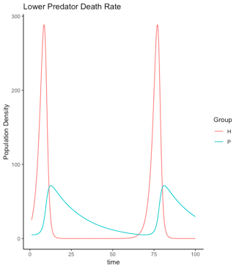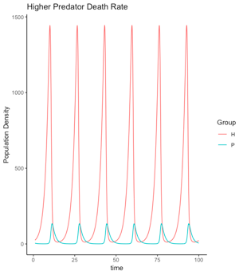

Decreasing the predator death rate from 0.2 to 0.05 lowers the population density of the prey and decreases the period of time that the prey population is growing. The low predator death rate causes a longer amount of time for the predator population to decline, leading to an overall increase in the length of the predator-prey cycle accompanied by a longer period of time that the prey population density is lower than the predator population density.

Increasing the predator death rate from 0.2 to 0.6 causes a drastic rise in the population density peak of the prey. The high death rate causes the predator population to decline faster, but the abundant prey population also allows the predators to recover quickly; leading to an overall decrease in the length of the predator-prey with six population peaks evident within the graph of the model.

*Role of the Predator:*

In the Lotka-Volterra Model, the predator acts as the only limiting factor on the population of the prey. The model assumes that no other limiting factors exist. The population of the predator controlling the population of the prey is evident in every simulation run and can be seen in the cyclic relationship between the predator and the prey. The prey population peaks as the predator population starts to rise, and only starts to grow again when the predator population has been lowered enough. Even when the predator attack rate is low or conversion efficiency is low, the predator is still controlling the population growth and the decline of the prey. The population of the predator is the only controlling factor on the prey and there is no competition within the prey species that would affect the prey population density.

*Parameter Values and Cycle Length:*

When decreasing any of the parameter values in general, the cycle length increases with less than four population peaks as compared to the initial parameter values where the cycle length had four population peaks. When increasing the parameters, the cycle length stayed about the same with about four population peaks. However, increasing the predator death rate also decreased the cycle length greatly where six population peaks were observed. Even if the cycle lengths seemed about the same when the parameters were increased, the different parameters affected the length of time of various periods within the cycle such as the period of population growth for the prey or the predator.

**Rosenzweig-MacArthur Model**

In addition to the Lotka-Volterra model, a more complex consumer-resource model was suggested by Michael Rosenzweig and Robert MacArthur (R-M model). This model was more complex in that it added two additional parameters. The first addition was a prey self-limiting factor, alpha, in which a carrying capacity for the prey species is introduced. The second addition was a saturating functional response of predators to prey density, essentially realizing that predators much reach a maximum rate of herbivores killed. The model equations are listed below:

$$(1) dH/dt = bH(1-αH)-w\frac{H}{d+H}P$$

$$(2) dP/dt=ew\frac{H}{d+H}P-sP$$

Looking at the state model equations above, a conceptual model, shown below can be used to visualize how each parameter affects, or does not affect, each state variable.

*Conceptual Model:*

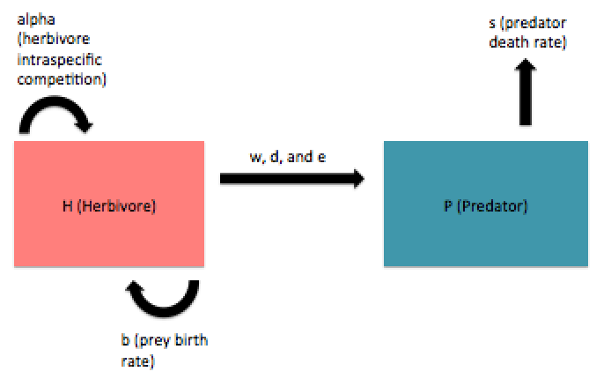

The conceptual model above shows the Rosenzweig-MacArthur Prey-Predator model with H and P as state variables and a,b,w,d,e, and s as the six parameters that affect either or both of the state variables.

The R-M model was simulated using an initial set of parameters (b=0.8, e=0.07, s=0.2, w=5, d=400, α=0.001, H0=500, P0=120) to obtain a herbivore-predator population density over time graph. This plot can be seen below. This standard parameter graph will allow for comparisons to be made once the parameters are increased or decreased.

*Standard Parameters:*

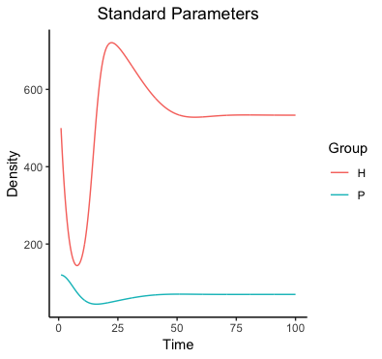

From running simulation dynamics on the R-M model with the standard parameters defined above, the plot shows one predator-prey cycle in which the herbivore population initially drops in response to the predator population. Quickly following this, though, the prey population spikes up to a maximum in a delayed response to a decrease in predator population. Between the self-limiting competition amongst the prey and the recovering predator population, the prey comes back down. Between their death rate and a saturating functional response to prey density, the predator populations slows its increase. Thus, after one cycle, both populations hit an equilibrium population density.

*Prey Birth Rate:*

Increasing and decreasing each parameter and making a similar plot to the standard plot will make it more clear what role in each parameter plays in the equation. First, the b parameter will be increased and decreased by a multiple of 3. The plots below shows the simulation plots for this change.

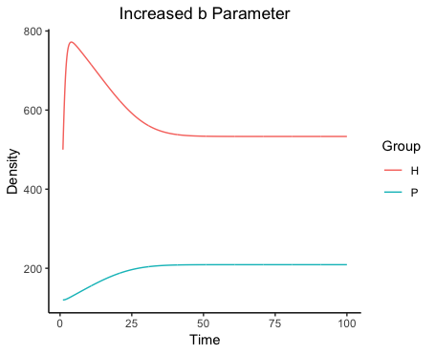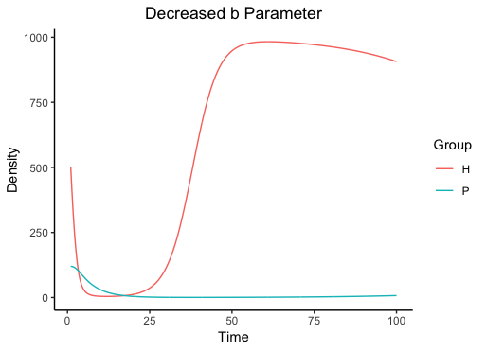

In this model, b is prey birth rate. In the case of a spike in prey birth rate, the herbivore population increases in population density, but the predator population has a lagged increase in population which causes a subsequent decrease in herbivore population. In the case of a drop in prey birth rate, the herbivore population responds by dropping in population density. This decrease, though, triggers a following decrease in predator population and the herbivores recover their population density. Additionally, an increased b parameter raises the equilibrium of the predator population density with no real effect on prey equilibrium. A decreased b parameter shifts equilibrium down for predator and up for prey. Knowing all this, is can be said that the b parameter has a direct influence on herbivore population which causes a delayed response in the predator population.

*Conversion Efficiency of Prey to Predators:*

Next, the e parameter was altered by a multiple of 2. This specific parameter is the conversion efficiency of prey to predators. It measures the predators ability to turn the biomass of killed prey into new offspring for the predator population. The resulting plots of increasing and decreased parameter e by a multiple of 2 are shown below.

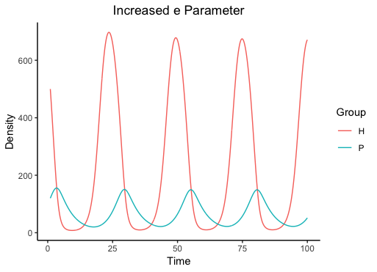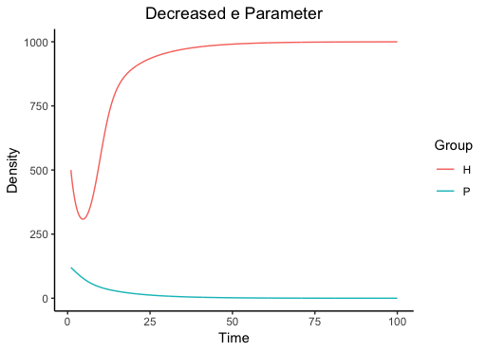

The plot of increased e parameter shows multiple predator-prey cycles, looking very similar to a Lotka-Volterra model. There are multiple cycles, as opposed to one, because the prey to predator conversion efficiency is very high. This encourages rapid predator-prey cycle repetitions. On the other hand, a decrease in the e parameter shows an initial decrease in herbivore population as some of the population density is killed, but the failure to convert prey biomass into new predator population allows the herbivore population to spike and sends the predator population to a low equilibrium. It appears, then, that the role of this parameter is to simulate the response of predators to prey deaths.

*Predator Death Rate:*

After the e parameter was studied, the s parameter was altered as well. The s parameter is for predator death rate and was changed by a multiple of 2. Plots for the s parameter are below.

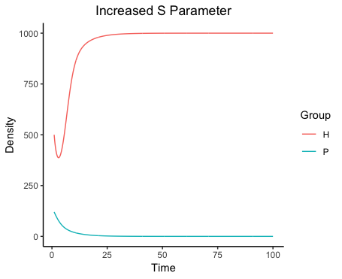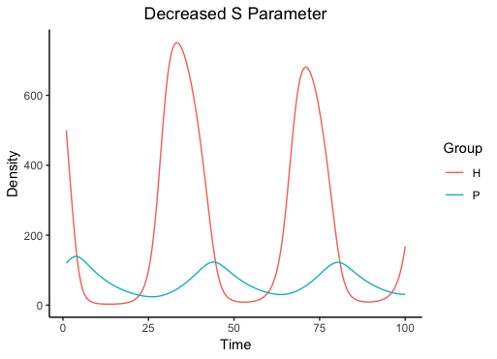

The s parameter is relatively straightforward for the increased plot. It follows the expectation that an increase in predator deaths should result in an increase in herbivore population. In the example of the decreased predator death, the lines do not simply flip because there are many more herbivores than predators in general. Instead, the predator prey cycle occurs more quickly and the prey seems to hit a smaller maximum in the second cycle. This would indicate that the s parameter has a direct impact on the predator population with a secondary effect on the prey population.

*Predator Attack Rate:*

Next, the w parameter was varied by a multiple of 3 and plots made. W is the predator attack rate, which was the a parameter in the Lotka-Volterra model.

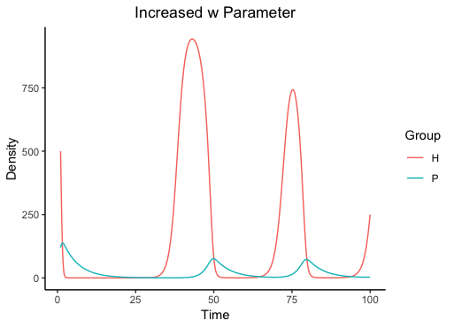 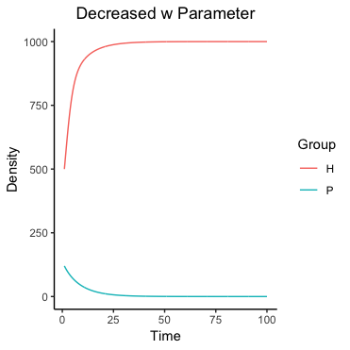

The increase in predator attack rate causes a sharp initial decrease in prey population, but as the number of prey is limited, the predators have a limited food source and decrease as well. This causes a sharp recovery of the prey and the cycle repeats, but with smaller prey maximums as their numbers decline from being killed. When the parameter is decreased, prey population increases and predators decreases. These plots show that the w parameter has an influence on both predator and prey dynamics, as both populations are influenced by the predator attack rate. The increased w parameter models closer to the increased equivalent parameter in the L-V model, where the decreased w parameter models like the standard parameters set.

*Saturation Term:*

The d parameter was then changed by a multiple of 2 in order to see how the the first of the additional parameters added by the R-M model would affect the state variables. The addition of the d parameter introduces a type of saturation term in which predators reach a maximum receptivity to an increase in prey population. Plots for this parameter are shown below.

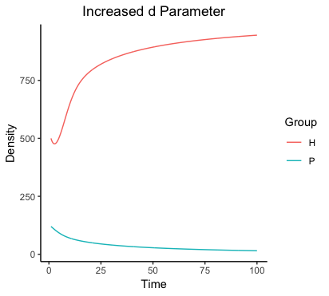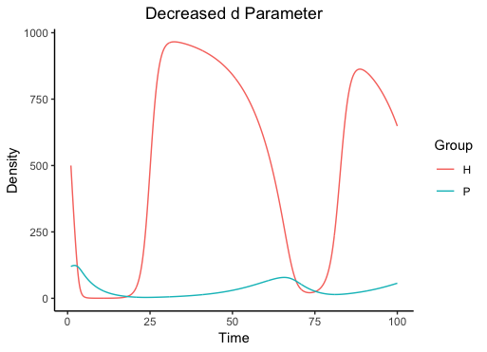

The d parameter is defined as the density of prey at which the predators’ kill rate reaches half its maximum (“Rosenzweig-MacArthur models”). It can be seen that as d increases, the saturation term goes to a fraction and it appears that as prey density is increasing that the predators do, in fact, reach their maximum number of prey killed per unit time. When this term goes a fraction it detracts from the predator population P state variable and allows the herbivores to thrive. In the case of a decreased d parameter, the predators do not reach this maximum in the time cycle and can move through natural prey-predator cycles. This parameter, then, has a direct impact on predator response to prey population density.

*Competition Coefficient:*

The final parameter that was varied was the alpha parameter and it was changed by a multiple of 3. This is also an additional parameter to the R-M model and introduces a self-regulating term for the prey species. Alpha is called the competition coefficient and effectively gives the herbivore population a carrying capacity (k) in which alpha is equal to 1/k. The plots can be seen below.

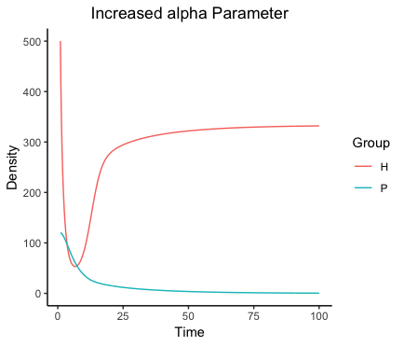 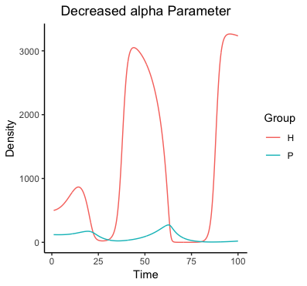

Changing this parameter leads to some very interesting results in which the left hand plot resembles that of the R-M standard model and the right hand plot resembles the L-V model. This makes sense as a decrease in alpha decreases the effect of the alpha parameter and the effective carrying capacity is high enough that it is not a limiting factor in the population dynamics. On the other hand, with an increased alpha the carrying capacity of the herbivore population matters and the two populations follow R-M model dynamics. This parameter, then, has a direct effect on how the prey population simulates.

*Comparison to Lotka-Volterra:*

It is important to think about how the R-M model differs fundamentally from the L-V model. The R-M dynamics have the additional saturation factor and prey self limiting factor. This means that the predator is no longer the only thing affecting prey population, but there is the possibility of the prey species limiting themselves. This model seems to be much more realistic and accurate to real life population dynamics, as intra-species competition and regulation are both similar to how predator-prey populations actually function. In thinking about the population dynamics of the well studied lynx and hare, the R-M model would be more successful in modeling the coupling between the two species.

*Parameter Values and Predator Abundance:*

It seems that the most obvious impact of parameter values on predator abundance is in regulating and shifting the shifts from equilibrium for the predator species. The parameters also determine whether the predator species is allowed to rapidly cycle through prey-predator cycles multiple times or whether the two species undergo one cycle and hit an equilibrium species density. The parameters do not seem to shift the predator population density equilibrium too much, as the equilibrium never shifts past 250. Instead, the parameters affect how predators respond to shifts in prey equilibrium.

**Paradox of Enrichment**

Finally, the R-M model was used to simulate dynamics of varying carrying capacities. The plots below show the difference in population density as the carrying capacity is varied from 800 to 2,000 in 200 value intervals.

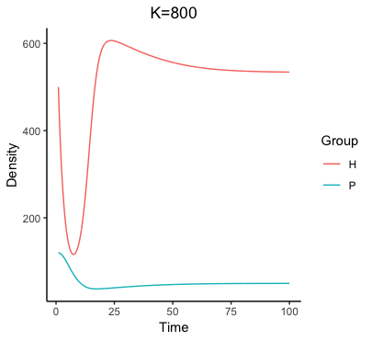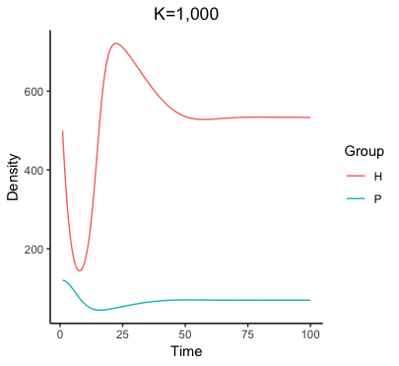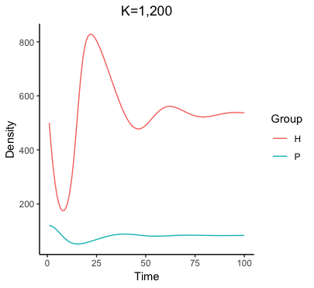

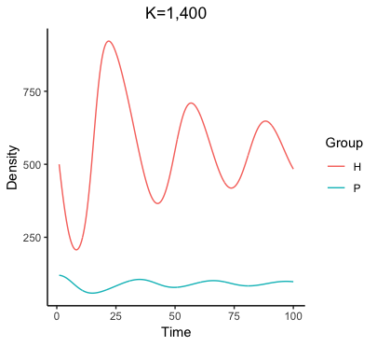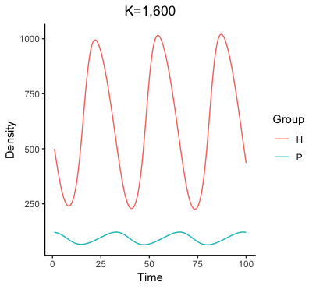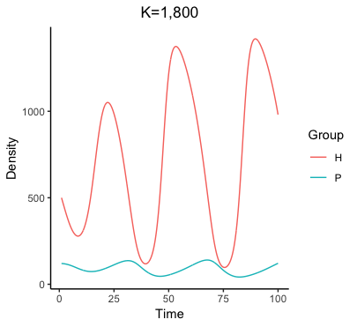

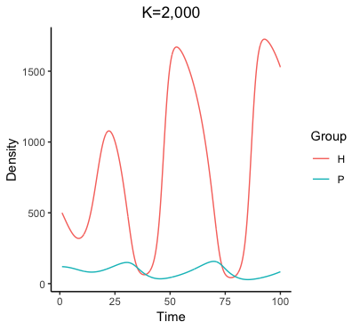

In the figure, it can be seen that as the carrying capacity increases, the population dynamics begin to look more and more like the Lotka-Volterra model dynamics and less like the Rosenzweig-MacArthur dynamics. This is due to the fact that as carrying capacity increases, the prey have no way to hit that capacity limit and they can undergo regular cycles without self limiting. Also visible in these graphs is the *Paradox of Enrichment*, which counter intuitively shows a negative relationship between prey carrying and predator population. The *Paradox of Enrichment* is caused by an imbalance, and subsequent downward spiral effect, of a predator population when the prey is growing abundantly. This could be caused by the disruption of an otherwise in-balance ecosystem and a smaller population (such as the predator population) could be more susceptible to changes in this ecosystem. The *Paradox of Enrichment* will not persist for the entirety of the time cycles, but will even out as the ecosystem gets back to normalcy. It is quite possible that Rosenzweig and MacArthur observed the *Paradox of Enrichment* at a particular time of instability in the ecosystem they were testing.

**References:**

1. “Rosenzweig-MacArthur Models”. *Math Awareness Month 1999.* April 19, 1999. https://math.arizona.edu/~maw1999/population/phspln.htm.