NUMERICAL METHODS ASSIGNMENT
Root-Finding and ODE Solution using the Secant Method,
Newton-Raphson Method, and 4th-Order Runge-Kutta Method
Includes: worked numerical examples, flowcharts, and MATLAB code organised by function type for each method
Group 3

Introduction
This document presents three widely used numerical methods for solving engineering and scientific problems: the Newton-Raphson method and the Secant method, both used for finding roots of nonlinear equations f(x) = 0, and the 4th-Order Runge-Kutta (RK4) method, used for solving ordinary differential equations (ODEs). For every method this report provides: the governing formula, a flowchart of the algorithm, MATLAB code organised by function type, and two fully worked numerical examples with iteration tables.
The algorithms are implemented in MATLAB using main, local, nested, anonymous, private, recursive and class-method functions, and a callback function. No for or while loops are used; repetition is done by recursion.

1. Newton-Raphson Method
The Newton-Raphson method is an open method for finding a root of the equation f(x) = 0. Starting from an initial guess x0, successive approximations are generated using the iterative formula:
x(i+1) = x(i) - f(x(i)) / f '(x(i))
Iteration continues until the difference between successive approximations is smaller than a specified tolerance e (tol in the code), or a maximum number of iterations N is reached. In the MATLAB code the repetition is done by a recursive function, so no for or while loop is used.

1.1 Flowchart
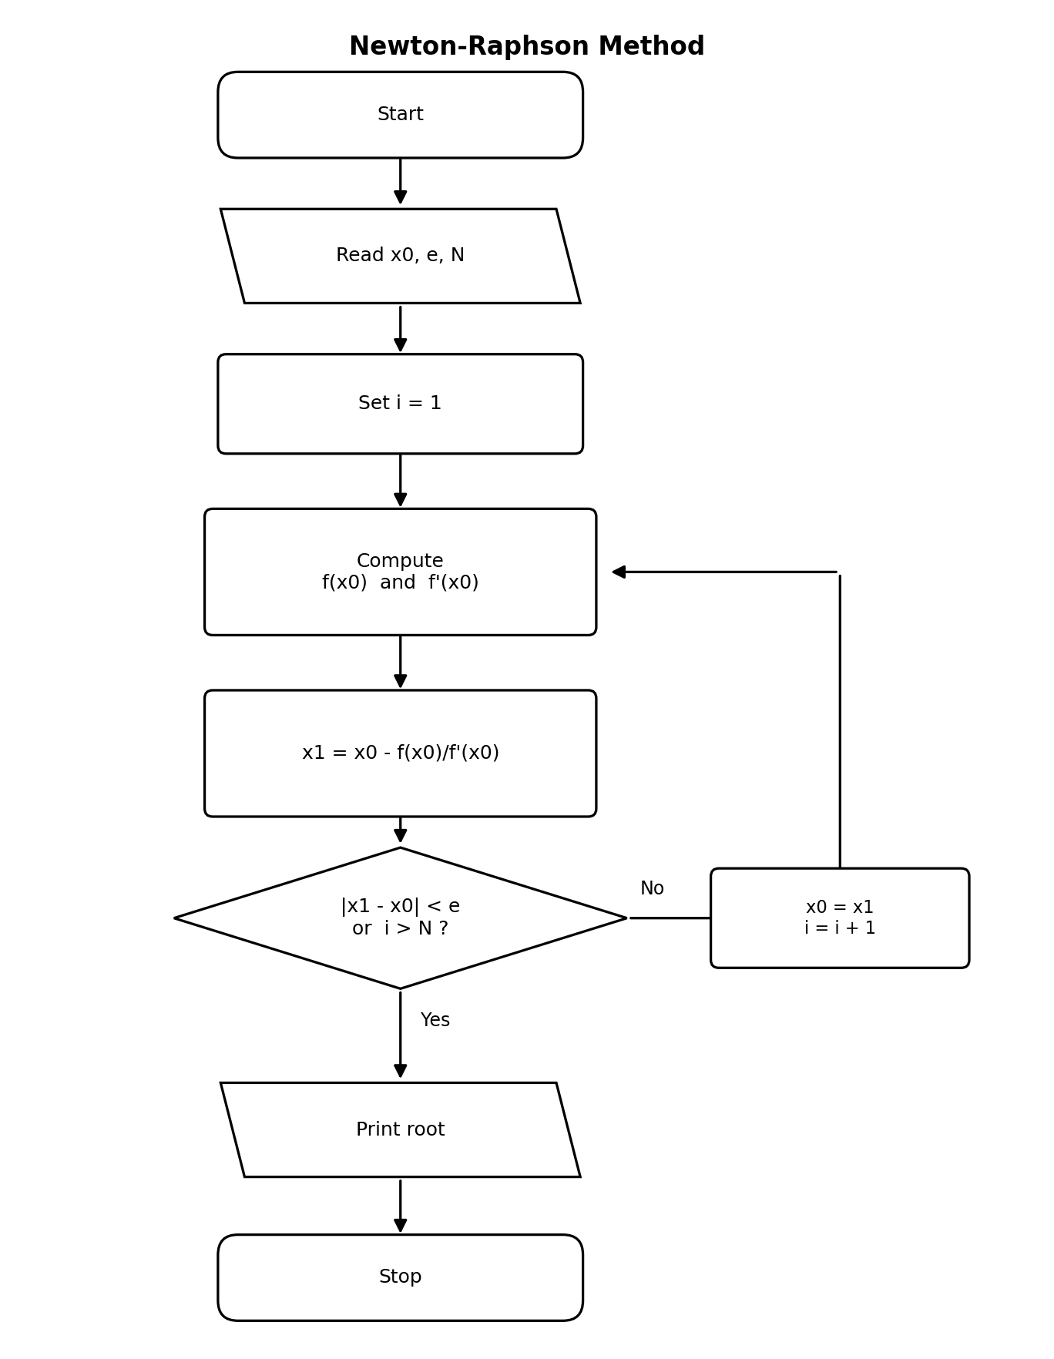
Figure 1 - Flowchart of the Newton-Raphson Method

1.2 Anonymous function - defines f(x) and f'(x)
The equation and its derivative are short formulas stored as function handles. They are passed to the solver as arguments, so the same solver works for any equation.
f = @(x) x.^3 - x - 2; % ANONYMOUS function: f(x)
df = @(x) 3*x.^2 - 1; % ANONYMOUS function: f'(x)

1.3 Local function - one Newton step
newtonStep takes the current estimate x and returns the next estimate x - f(x)/f'(x). It is a helper for this file only, so it is hidden from all other code.
function xNew = newtonStep(f, df, x) % LOCAL function
xNew = x - f(x) / df(x);
end

1.4 Recursive function - repeats the step until convergence
newtonRec performs one Newton step and compares the new estimate with the old one. If the difference is below tol, or the iteration count i has reached N, it returns the root. Otherwise it calls itself with the new estimate and i + 1. This replaces the for and while loop.
function [root, iter] = newtonRec(f, df, x0, tol, N, i) % RECURSIVE function
x1 = newtonStep(f, df, x0); % one step (local function)
if abs(x1 - x0) < tol || i >= N % stopping condition
root = x1;
iter = i;
else
[root, iter] = newtonRec(f, df, x1, tol, N, i + 1); % calls itself
end
end

1.5 Main function - the function other files call
newton_main receives the anonymous functions, the starting guess, the tolerance and the maximum iterations. It starts the recursion at i = 1 and prints the root. It is the only function in the file that can be called from outside.
function [root, iter] = newton_main(f, df, x0, tol, N) % MAIN function
[root, iter] = newtonRec(f, df, x0, tol, N, 1);
fprintf('Root = %.6f after %d iterations\n', root, iter);
end

1.6 Nested function - shares variables with its parent
iterate sits inside newton_nested, so it reads and changes the parent's variables x0, x1 and iter directly. No arguments or return values are needed. It repeats by calling itself until the tolerance is met.
function [root, iter] = newton_nested(f, df, x0, tol, N) % MAIN function
x1 = x0;
iter = 0;
iterate(); % start the repetition
root = x1;
fprintf('Root = %.6f after %d iterations\n', root, iter);

function iterate() % NESTED function
x0 = x1; % shared with the parent
x1 = x0 - f(x0) / df(x0);
iter = iter + 1;
if abs(x1 - x0) >= tol && iter < N
iterate(); % repeat
end
end
end

1.7 Worked Example 1
Solve f(x) = x^3 - x - 2 = 0, starting from x0 = 1.5, with tolerance e = 1e-5.
f = @(x) x.^3 - x - 2; % anonymous functions
df = @(x) 3*x.^2 - 1;
[r, n] = newton_main(f, df, 1.5, 1e-5, 50) % main + local + recursive
% Root = 1.521380 after 3 iterations

i | x(i) | f(x(i)) | f '(x(i)) | x(i+1)
1 | 1.500000 | -0.125000 | 5.750000 | 1.521739
2 | 1.521739 | 0.002137 | 5.947070 | 1.521380
3 | 1.521380 | 0.000001 | 5.943790 | 1.521380

Result: the sequence converges after 3 iterations to a root of x ≈ 1.521380. newton_nested gives the same root.

1.8 Worked Example 2
Solve f(x) = x^2 - 2 = 0 (i.e. compute √2), starting from x0 = 1, with tolerance e = 1e-5.
f = @(x) x.^2 - 2;
df = @(x) 2*x;
[r, n] = newton_nested(f, df, 1, 1e-5, 50) % nested function version
% Root = 1.414214 after 4 iterations

i | x(i) | f(x(i)) | f '(x(i)) | x(i+1)
1 | 1.000000 | -1.000000 | 2.000000 | 1.500000
2 | 1.500000 | 0.250000 | 3.000000 | 1.416667
3 | 1.416667 | 0.006944 | 2.833333 | 1.414216
4 | 1.414216 | 0.000006 | 2.828431 | 1.414214

Result: at i = 4 the change between estimates (about 2e-6) is below the tolerance, so the sequence converges after 4 iterations to a root of x ≈ 1.414214 (≈ √2).

2. Secant Method
The Secant method is similar to Newton-Raphson, but it avoids the need to compute the derivative f'(x). Instead, it approximates the derivative using two previous points, x(i-1) and x(i):
x(i+1) = x(i) - f(x(i)) · (x(i) - x(i-1)) / ( f(x(i)) - f(x(i-1)) )
Two initial guesses x0 and x1 are required. Iteration continues until convergence, using a recursive function instead of a loop.

2.1 Flowchart
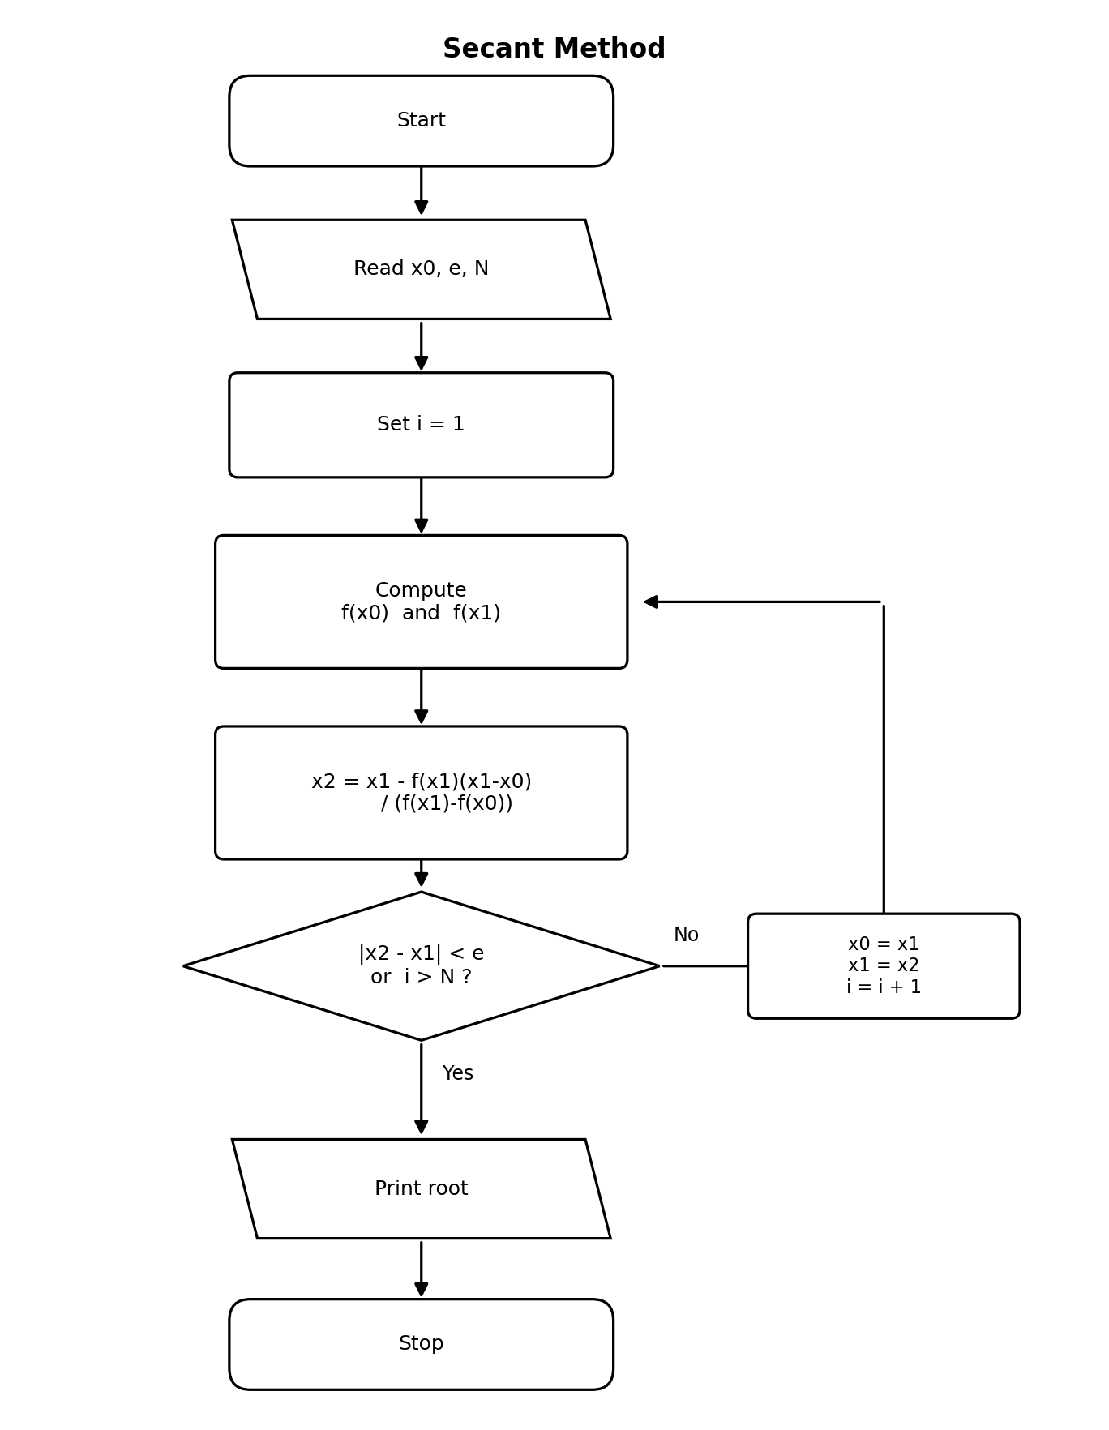
Figure 2 - Flowchart of the Secant Method

2.2 Anonymous function - defines f(x)
The equation is stored as a function handle and passed to the solver. No derivative is needed for the Secant method, so only one handle is required.
f = @(x) x.^3 - x - 2; % ANONYMOUS function

2.3 Local function - one secant step
secantStep uses the two latest estimates x0 and x1 to compute the next estimate x2 from the secant formula. Only secant_main.m can use it.
function x2 = secantStep(f, x0, x1) % LOCAL function
x2 = x1 - f(x1) * (x1 - x0) / (f(x1) - f(x0));
end

2.4 Recursive function - repeats the step until convergence
secantRec computes x2 with secantStep and stops if |x2 - x1| is below tol or i has reached N. Otherwise it calls itself with the estimates moved forward by one place (x1 becomes x0, x2 becomes x1) and i + 1.
function [root, iter] = secantRec(f, x0, x1, tol, N, i) % RECURSIVE function
x2 = secantStep(f, x0, x1);
if abs(x2 - x1) < tol || i >= N % stopping condition
root = x2;
iter = i;
else
[root, iter] = secantRec(f, x1, x2, tol, N, i + 1); % calls itself
end
end

2.5 Private function - checks the starting guesses
checkGuesses stops the program with an error if the two starting guesses are equal or give the same value of f, because the secant formula would then divide by zero. Code outside the parent folder cannot see or call it.
secant_project/
secant_main.m
private/
checkGuesses.m

function checkGuesses(f, x0, x1) % PRIVATE function
if x0 == x1 || f(x0) == f(x1)
error('Secant:badGuess', ...
'The two starting guesses must give different values of f.');
end
end

2.6 Main function - the function other files call
secant_main first calls the private function to check the guesses, then starts the recursion at i = 1 and prints the root.
function [root, iter] = secant_main(f, x0, x1, tol, N) % MAIN function
checkGuesses(f, x0, x1); % PRIVATE function
[root, iter] = secantRec(f, x0, x1, tol, N, 1);
fprintf('Root = %.6f after %d iterations\n', root, iter);
end

2.7 Worked Example 1
Solve f(x) = x^3 - x - 2 = 0, starting from x0 = 1, x1 = 2, with tolerance e = 1e-5.
f = @(x) x.^3 - x - 2; % anonymous function
[r, n] = secant_main(f, 1, 2, 1e-5, 50)
% Root = 1.521380 after 6 iterations

i | x(i-1) | x(i) | f(x(i-1)) | f(x(i)) | x(i+1)
1 | 1.000000 | 2.000000 | -2.000000 | 4.000000 | 1.333333
2 | 2.000000 | 1.333333 | 4.000000 | -0.962963 | 1.462687
3 | 1.333333 | 1.462687 | -0.962963 | -0.333339 | 1.531169
4 | 1.462687 | 1.531169 | -0.333339 | 0.058626 | 1.520926
5 | 1.531169 | 1.520926 | 0.058626 | -0.002693 | 1.521376
6 | 1.520926 | 1.521376 | -0.002693 | -0.000020 | 1.521380

Result: the sequence converges after 6 iterations to a root of x ≈ 1.521380 (matches Newton-Raphson Example 1).

2.8 Worked Example 2
Solve f(x) = cos(x) - x = 0, starting from x0 = 0, x1 = 1, with tolerance e = 1e-5.
f = @(x) cos(x) - x;
[r, n] = secant_main(f, 0, 1, 1e-5, 50)
% Root = 0.739085 after 5 iterations

i | x(i-1) | x(i) | f(x(i-1)) | f(x(i)) | x(i+1)
1 | 0.000000 | 1.000000 | 1.000000 | -0.459698 | 0.685073
2 | 1.000000 | 0.685073 | -0.459698 | 0.089299 | 0.736299
3 | 0.685073 | 0.736299 | 0.089299 | 0.004660 | 0.739119
4 | 0.736299 | 0.739119 | 0.004660 | -0.000057 | 0.739085
5 | 0.739119 | 0.739085 | -0.000057 | 0.000000 | 0.739085

Result: the sequence converges after 5 iterations to a root of x ≈ 0.739085 (the well-known Dottie number).

3. Fourth-Order Runge-Kutta (RK4) Method
The 4th-Order Runge-Kutta method solves an initial value problem dy/dx = f(x, y), y(x0) = y0, by advancing the solution one step h at a time using four slope estimates k1, k2, k3, k4:
k1 = h · f(x, y)
k2 = h · f(x + h/2, y + k1/2)
k3 = h · f(x + h/2, y + k2/2)
k4 = h · f(x + h, y + k3)
y(new) = y + (k1 + 2k2 + 2k3 + k4) / 6
x(new) = x + h

3.1 Flowchart
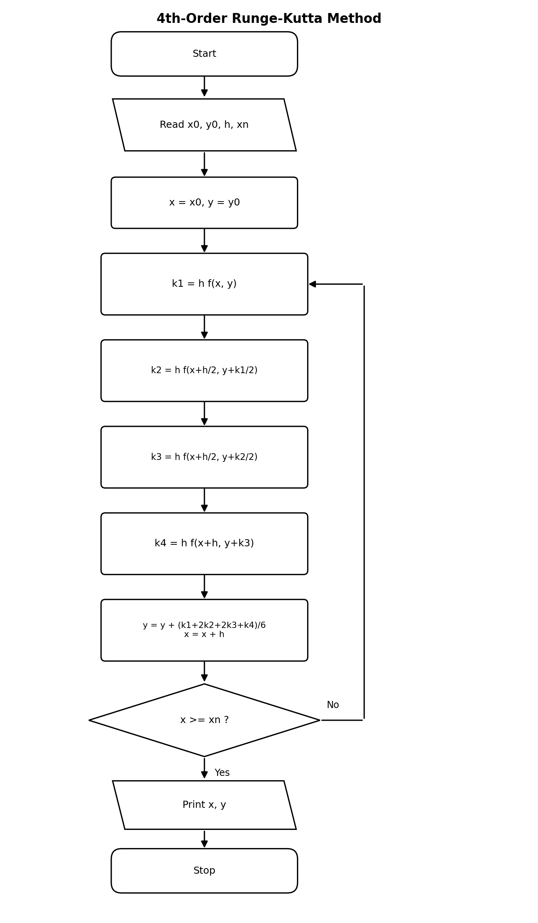
Figure 3 - Flowchart of the 4th-Order Runge-Kutta Method

3.2 Anonymous function - defines dy/dx = f(x, y)
The differential equation is a function handle of two variables, x and y. It is passed to the solver, so the same RK4 code solves any first-order equation.
f = @(x, y) x + y; % ANONYMOUS function: dy/dx = x + y

3.3 Local function - one RK4 step
rk4Step computes the four slopes k1 to k4 and returns the new value of y after one step of size h. Only rk4_main.m can use it.
function yNew = rk4Step(f, x, y, h) % LOCAL function
k1 = h * f(x, y);
k2 = h * f(x + h/2, y + k1/2);
k3 = h * f(x + h/2, y + k2/2);
k4 = h * f(x + h, y + k3);
yNew = y + (k1 + 2*k2 + 2*k3 + k4) / 6;
end

3.4 Recursive function - advances the solution to x = xn
rk4Rec returns when x has reached xn. Otherwise it takes one step with rk4Step, increases x by h, prints y, and calls itself with the new x and y. A tiny tolerance (1e-12) avoids rounding error from adding h repeatedly.
function [x, y] = rk4Rec(f, x, y, h, xn) % RECURSIVE function
if x >= xn - 1e-12 % stopping condition
return
end
y = rk4Step(f, x, y, h); % one step (local function)
x = x + h;
fprintf('y(%.2f) = %.6f\n', x, y);
[x, y] = rk4Rec(f, x, y, h, xn); % calls itself
end

3.5 Main function - the function other files call
rk4_main receives the anonymous function f, the starting point (x0, y0), the step size h and the end point xn, and starts the recursion.
function [x, y] = rk4_main(f, x0, y0, h, xn) % MAIN function
[x, y] = rk4Rec(f, x0, y0, h, xn);
end

3.6 Class method - RK4 as the behaviour of an object
The equation f and the step size h are stored as properties of the object. The method step performs one RK4 step, and the method solve advances the solution by calling itself on the object until x reaches xn.
classdef RK4Solver
properties
f % function handle f(x, y)
h % step size
end
methods
function obj = RK4Solver(f, h) % constructor
obj.f = f;
obj.h = h;
end

function yNew = step(obj, x, y) % CLASS METHOD: one RK4 step
h = obj.h;
k1 = h * obj.f(x, y);
k2 = h * obj.f(x + h/2, y + k1/2);
k3 = h * obj.f(x + h/2, y + k2/2);
k4 = h * obj.f(x + h, y + k3);
yNew = y + (k1 + 2*k2 + 2*k3 + k4) / 6;
end

function [x, y] = solve(obj, x0, y0, xn) % CLASS METHOD (recursive)
if x0 >= xn - 1e-12
x = x0;
y = y0;
else
y1 = obj.step(x0, y0);
x1 = x0 + obj.h;
fprintf('y(%.2f) = %.6f\n', x1, y1);
[x, y] = obj.solve(x1, y1, xn);
end
end
end
end

3.7 Worked Example 1
Solve dy/dx = x + y, with y(0) = 1, using step size h = 0.1. Find y at x = 0.2.
f = @(x, y) x + y; % anonymous function
[x, y] = rk4_main(f, 0, 1, 0.1, 0.2); % main + local + recursive
% y(0.10) = 1.110342
% y(0.20) = 1.242805

Step | x | y | k1 | k2 | k3 | k4 | y(new)
1 | 0.00 | 1.000000 | 0.100000 | 0.110000 | 0.110500 | 0.121050 | 1.110342
2 | 0.10 | 1.110342 | 0.121034 | 0.132086 | 0.132638 | 0.144298 | 1.242805

Result: y(0.2) ≈ 1.242805.

3.8 Worked Example 2
Solve dy/dx = -2xy, with y(0) = 1, using step size h = 0.1. Find y at x = 0.2.
f = @(x, y) -2*x.*y;
solver = RK4Solver(f, 0.1); % create the object
[x, y] = solver.solve(0, 1, 0.2); % call the class method
% y(0.10) = 0.990050
% y(0.20) = 0.960789

Step | x | y | k1 | k2 | k3 | k4 | y(new)
1 | 0.00 | 1.000000 | 0.000000 | -0.010000 | -0.009950 | -0.019801 | 0.990050
2 | 0.10 | 0.990050 | -0.019801 | -0.029404 | -0.029260 | -0.038432 | 0.960789

Result: y(0.2) ≈ 0.960789. (This equation has the exact solution y = e^(-x^2), which gives y(0.2) = 0.960789 - confirming the accuracy of RK4.)

4. Callback Function - Interactive RK4 Solver
The callback solveCallback runs whenever the user presses the button. It reads the step size from the edit box, creates an RK4Solver object, solves dy/dx = x + y with y(0) = 1 up to x = 0.2, and shows the answer on screen. Because it is also a nested function, it can read the interface components (hEdit, hOut) created by its parent.
function rk4_app() % MAIN function
fig = figure('Name', 'RK4 Solver', 'NumberTitle', 'off', ...
'MenuBar', 'none', 'Position', [300 300 340 140]);
hEdit = uicontrol(fig, 'Style', 'edit', 'String', '0.1', ...
'Position', [20 85 100 28]);
hOut = uicontrol(fig, 'Style', 'text', 'String', 'y(0.2) = ', ...
'Position', [20 25 300 30]);
uicontrol(fig, 'Style', 'pushbutton', 'String', 'Solve dy/dx = x + y', ...
'Position', [140 85 180 28], ...
'Callback', @solveCallback); % link the callback to the button

function solveCallback(~, ~) % CALLBACK (and nested) function
h = str2double(hEdit.String);
solver = RK4Solver(@(x, y) x + y, h); % anonymous function + class
[~, y] = solver.solve(0, 1, 0.2);
hOut.String = sprintf('y(0.2) = %.6f', y);
end
end

5. Conclusion
All three methods were implemented using only MATLAB function types, with no for or while loops. The iteration tables agree: Newton-Raphson and the Secant method find the same root of x^3 - x - 2 = 0, and RK4 reproduces the exact solution of dy/dx = -2xy.

