NUMERICAL METHODS ASSIGNMENT
Root-Finding and ODE Solution using the Secant Method,
Newton-Raphson Method, and 4th-Order Runge-Kutta Method
Includes: worked numerical examples, flowcharts, and pseudocode (for-loop and while-loop) for each method

Introduction
This document presents three widely used numerical methods for solving engineering and scientific problems: the Newton-Raphson method and the Secant method, both used for finding roots of nonlinear equations f(x) = 0, and the 4th-Order Runge-Kutta (RK4) method, used for solving ordinary differential equations (ODEs). For every method this report provides: the governing formula, a flowchart of the algorithm, pseudocode written in both 'for-loop' and 'while-loop' form, and two fully worked numerical examples with complete iteration tables.

1. Newton-Raphson Method
The Newton-Raphson method is an open method for finding a root of the equation f(x) = 0. Starting from an initial guess x0, successive approximations are generated using the iterative formula:
x(i+1) = x(i) - f(x(i)) / f '(x(i))
Iteration continues until the difference between successive approximations is smaller than a specified tolerance e, or a maximum number of iterations N is reached.

1.1 Flowchart
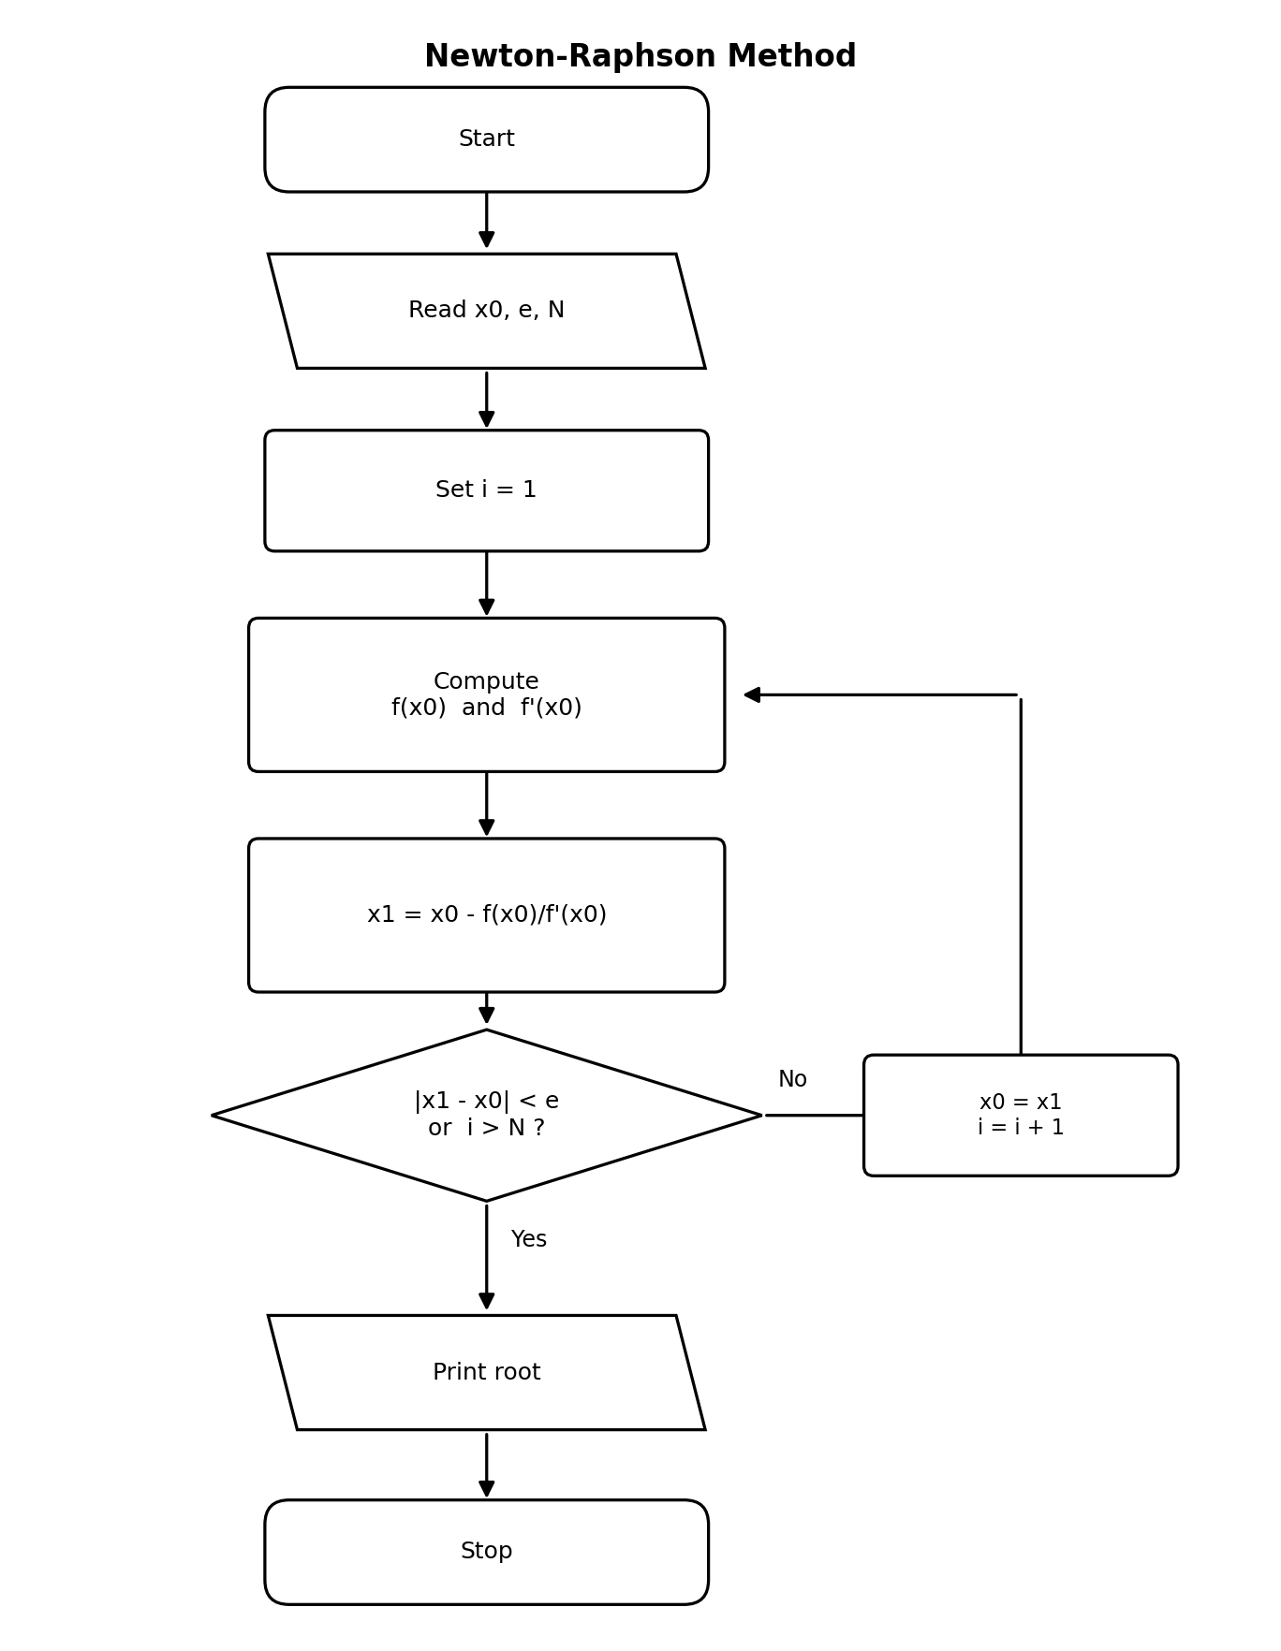
Figure 1 - Flowchart of the Newton-Raphson Method

1.2 Pseudocode - 'for' loop version
Read x0, e, N
for i = 1 to N:
fx = f(x0)
dfx = f'(x0)
x1 = x0 - fx / dfx
if abs(x1 - x0) < e:
break
x0 = x1
Print "Root = ", x1

1.3 Pseudocode - 'while' loop version
Read x0, e, N
i = 1
x1 = x0 - f(x0) / f'(x0)
while abs(x1 - x0) >= e and i <= N:
x0 = x1
x1 = x0 - f(x0) / f'(x0)
i = i + 1
Print "Root = ", x1

1.4 Worked Example 1
Solve f(x) = x^3 - x - 2 = 0, starting from x0 = 1.5, with tolerance e = 1e-5.
i | x(i) | f(x(i)) | f '(x(i)) | x(i+1)
1 | 1.500000 | -0.125000 | 5.750000 | 1.521739
2 | 1.521739 | 0.002137 | 5.947070 | 1.521380
3 | 1.521380 | 0.000001 | 5.943790 | 1.521380

Result: the sequence converges after 3 iterations to a root of x ≈ 1.521380.

1.5 Worked Example 2
Solve f(x) = x^2 - 2 = 0 (i.e. compute √2), starting from x0 = 1, with tolerance e = 1e-5.
i | x(i) | f(x(i)) | f '(x(i)) | x(i+1)
1 | 1.000000 | -1.000000 | 2.000000 | 1.500000
2 | 1.500000 | 0.250000 | 3.000000 | 1.416667
3 | 1.416667 | 0.006944 | 2.833333 | 1.414216
4 | 1.414216 | 0.000006 | 2.828431 | 1.414214
5 | 1.414214 | 0.000000 | 2.828427 | 1.414214

Result: the sequence converges after 5 iterations to a root of x ≈ 1.414214 (≈ √2).

2. Secant Method
The Secant method is similar to Newton-Raphson, but it avoids the need to compute the derivative f'(x). Instead, it approximates the derivative using two previous points, x(i-1) and x(i):
x(i+1) = x(i) - f(x(i)) · (x(i) - x(i-1)) / ( f(x(i)) - f(x(i-1)) )
Two initial guesses x0 and x1 are required. Iteration continues until convergence.

2.1 Flowchart
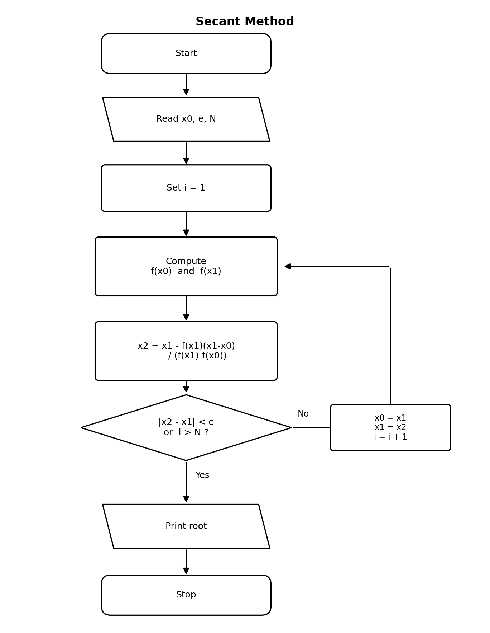
Figure 2 - Flowchart of the Secant Method

2.2 Pseudocode - 'for' loop version
Read x0, x1, e, N
for i = 1 to N:
x2 = x1 - f(x1)*(x1 - x0) / (f(x1) - f(x0))
if abs(x2 - x1) < e:
break
x0 = x1
x1 = x2
Print "Root = ", x2

2.3 Pseudocode - 'while' loop version
Read x0, x1, e, N
i = 1
x2 = x1 - f(x1)*(x1 - x0) / (f(x1) - f(x0))
while abs(x2 - x1) >= e and i <= N:
x0 = x1
x1 = x2
x2 = x1 - f(x1)*(x1 - x0) / (f(x1) - f(x0))
i = i + 1
Print "Root = ", x2

2.4 Worked Example 1
Solve f(x) = x^3 - x - 2 = 0, starting from x0 = 1, x1 = 2, with tolerance e = 1e-5.
i | x(i-1) | x(i) | f(x(i-1)) | f(x(i)) | x(i+1)
1 | 1.000000 | 2.000000 | -2.000000 | 4.000000 | 1.333333
2 | 2.000000 | 1.333333 | 4.000000 | -0.962963 | 1.462687
3 | 1.333333 | 1.462687 | -0.962963 | -0.333339 | 1.531169
4 | 1.462687 | 1.531169 | -0.333339 | 0.058626 | 1.520926
5 | 1.531169 | 1.520926 | 0.058626 | -0.002693 | 1.521376
6 | 1.520926 | 1.521376 | -0.002693 | -0.000020 | 1.521380

Result: the sequence converges after 6 iterations to a root of x ≈ 1.521380 (matches Newton-Raphson Example 1).

2.5 Worked Example 2
Solve f(x) = cos(x) - x = 0, starting from x0 = 0, x1 = 1, with tolerance e = 1e-5.
i | x(i-1) | x(i) | f(x(i-1)) | f(x(i)) | x(i+1)
1 | 0.000000 | 1.000000 | 1.000000 | -0.459698 | 0.685073
2 | 1.000000 | 0.685073 | -0.459698 | 0.089299 | 0.736299
3 | 0.685073 | 0.736299 | 0.089299 | 0.004660 | 0.739119
4 | 0.736299 | 0.739119 | 0.004660 | -0.000057 | 0.739085
5 | 0.739119 | 0.739085 | -0.000057 | 0.000000 | 0.739085

Result: the sequence converges after 5 iterations to a root of x ≈ 0.739085 (the well-known Dottie number).

3. Fourth-Order Runge-Kutta (RK4) Method
The 4th-Order Runge-Kutta method solves an initial value problem dy/dx = f(x, y), y(x0) = y0, by advancing the solution one step h at a time using four slope estimates k1, k2, k3, k4:
k1 = h · f(x, y)
k2 = h · f(x + h/2, y + k1/2)
k3 = h · f(x + h/2, y + k2/2)
k4 = h · f(x + h, y + k3)

y(new) = y + (k1 + 2k2 + 2k3 + k4) / 6
x(new) = x + h

3.1 Flowchart
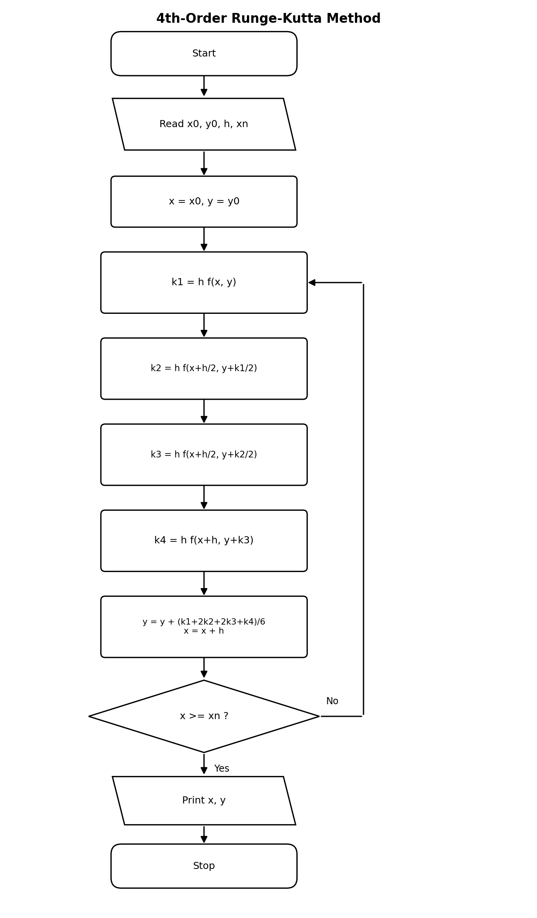
Figure 3 - Flowchart of the 4th-Order Runge-Kutta Method

3.2 Pseudocode - 'for' loop version
Read x0, y0, h, xn
n = (xn - x0) / h // number of steps
x = x0
y = y0
for i = 1 to n:
k1 = h * f(x, y)
k2 = h * f(x + h/2, y + k1/2)
k3 = h * f(x + h/2, y + k2/2)
k4 = h * f(x + h, y + k3)
y = y + (k1 + 2*k2 + 2*k3 + k4) / 6
x = x + h
Print "y(", x, ") = ", y

3.3 Pseudocode - 'while' loop version
Read x0, y0, h, xn
x = x0
y = y0
while x < xn:
k1 = h * f(x, y)
k2 = h * f(x + h/2, y + k1/2)
k3 = h * f(x + h/2, y + k2/2)
k4 = h * f(x + h, y + k3)
y = y + (k1 + 2*k2 + 2*k3 + k4) / 6
x = x + h
Print "y(", x, ") = ", y

3.4 Worked Example 1
Solve dy/dx = x + y, with y(0) = 1, using step size h = 0.1. Find y at x = 0.2.
Step | x | y | k1 | k2 | k3 | k4 | y(new)
1 | 0.00 | 1.000000 | 0.100000 | 0.110000 | 0.110500 | 0.121050 | 1.110342
2 | 0.10 | 1.110342 | 0.121034 | 0.132086 | 0.132638 | 0.144298 | 1.242805

Result: y(0.2) ≈ 1.242805.

3.5 Worked Example 2
Solve dy/dx = -2xy, with y(0) = 1, using step size h = 0.1. Find y at x = 0.2.
Step | x | y | k1 | k2 | k3 | k4 | y(new)
1 | 0.00 | 1.000000 | 0.000000 | -0.010000 | -0.009950 | -0.019801 | 0.990050
2 | 0.10 | 0.990050 | -0.019801 | -0.029404 | -0.029260 | -0.038432 | 0.960789

Result: y(0.2) ≈ 0.960789. (This equation has the exact solution y = e^(-x^2), which gives y(0.2) = 0.960789 - confirming the accuracy of RK4.)

