Over Lapping Check Box and Car Name in My Garage Page

Browser: Chrome

Steps to replicate

1. Open <https://www.carmudi.com.ph/>
2. Add 2 or more cars to the My Garage page by clicking the heart icon in any of the available cars under featured Vehicles
3. Go to My Garage by clicking the car icon at the right most part of the page. Beside SELL YOUR CAR

Screenshot

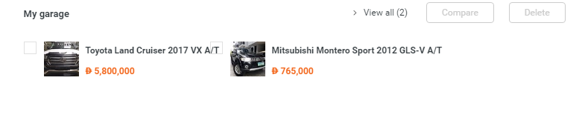

Favorite Icon in the Vehicles Details does not reflect the correct status after deleting car in My Garage Page

Browser: Chrome

Steps to replicate

1. Open <https://www.carmudi.com.ph/>
2. Add 2 or more cars to the My Garage page by clicking the heart icon in any of the available cars under featured Vehicles
3. Go to My Garage by clicking the car icon at the right most part of the page. Beside SELL YOUR CAR
4. Delete one car from the list by ticking in the check box of the car then click delete. See screenshot for result

Expected: Heart Icon of the deleted car from the My Garage should not be RED

Screenshot:

