<Project Name>: Team ?

Place picture of project with team members here.

Complete the caption, below.

Delete this text box before pasting in your photo!

Team members, left to right are: Luke Neumann, Brian Rieder, and Subhav Ramachandran

Name | Class No. | Honors
Luke Neumann | 3147-N | No
Brian Rieder |  | No
Subhav Ramachandran |  | No

MINI-PROJECT GRADING CRITERIA | Regular Students | Honors Contract Students
Originality, creativity, level of project difficulty | 20 | 10
Technical content, succinctness of report | 10 | 5
Writing style, professionalism, references/citations | 10 | 5
Project functionality demonstration | 20 | 10
Overall quality/integration of finished product | 10 | 5
Effective utilization of microcontroller resources | 10 | 5
Significance of individual contributions* | 20 | 10
PCB hardware schematic | N/A | 10
PCB top and bottom copper illustrations | N/A | 10
PCB functionality demonstration | N/A | 20
PCB written report | N/A | 10

*scores assigned to individual team members may vary

Scoring Multiplier:
1.0 | Excellent – among the very best projects/reports completed this semester
0.8 - 0.9 | Good – all requirements were amply satisfied
0.6 - 0.7 | Average – some areas for improvement, but all basic requirements were satisfied
0.4 - 0.5 | Below average – some basic requirements were not satisfied
0.1 - 0.3 | Poor – very few of the project requirements were satisfied

TABLE OF CONTENTS
1.0 Introduction | 1
2.0 Interface Design | 2
3.0 Peripheral Utilization | 3
4.0 Software Narrative | 4
5.0 Packaging Design | 5
6.0 Summary and Conclusions | 6
7.0 References | 7
Appendix A: Individual Contributions and Activity Logs | 8
Appendix B: Interface Schematic | 17
Appendix C: Software Flowcharts | 19
Appendix D: Packaging Design | 21
Appendix E: Honors Contract Deliverables (if applicable) | ?

- Introduction

This project is a digital implementation of the classic word game “Boggle”. The game is played by randomly generating a 4x4 grid of characters. These characters are visible to the player for the duration of the game. The player then attempts to find words in the grid within a two minute time limit. A word is “in the grid” if it can be spelled out with adjacent characters (up, down, left, right, or diagonal) without reusing any grid location. Additionally the word entered must be no less than three and no more than 7 characters long, and words cannot be used more than once. If the word is determined to be valid, it is added to the list of used words and the player’s score is increased based on the length of the word (1 point for length 3-4; 2 points for length 5; 3 points for length 6; 5 points for length 7).

In our implementation, the word grid and remaining time are displayed on a larger 20x4 LCD, player entered words a displayed on a primary 16x2 LCD, and score is displayed on a secondary 16x2 LCD. The player enters words by typing into a PS/2 keyboard which can be plugged in/ unplugged from the rest of the project. As the time counts down, the backlight of the two smaller LCD’s increases in intensity, until ten seconds remain, at which point they flash on and off at 2 Hz. The grid of characters is generated with a seed which could either be entered by the player, or randomly generated by checking the Timer peripheral. Entering a seed allows several players to play the same grid and compete for higher scores.

Although every member of the team worked on all aspects of the project, each member coordinated the completion of different tasks. The role of team documentation/ packaging leader was played by Brian Rieder, who planned the use of team time, ordered many of the hardware components, and completed the final packaging. Subhav Ramachandran played the role of software leader by planning the structure of the project’s code base, and managing the project’s git repository. The role of peripheral leader was played by Luke Neumann, who wrote several drivers utilizing the microcontroller’s peripherals. The interface leader role was shared, with all members contributing to and adjusting schematics as the project developed.

- Interface Design

Describe any external interfaces utilized (e.g., switches, LEDs, sensors). Include your OrCAD schematic as Appendix B.

Length should be about one page.

Microcontroller Resource Utilization

Describe how the microcontroller’s peripherals (ATD, SCI, SPI, TIM, PWM) as well as its other on-chip resources (RTI, SRAM, flash memory, etc.) were utilized, including the mode(s) in which they were programmed to operate. Provide rationale for the choices made.

Length should be about one page.

- Software Narrative

Describe what the software does and how it is organized/structured (i.e., event-driven, state machine, etc.). Submit your complete software listing on-line separately. Include a flowchart to document program structure in Appendix C.

Length should be about one page.

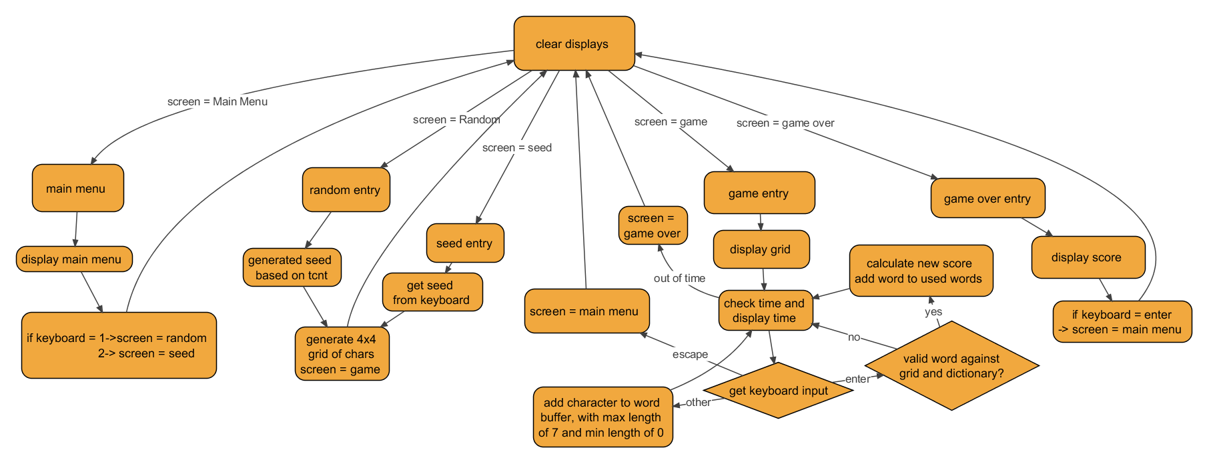
5.0 Packaging Design

Describe the packaging design for your project; include drawings/photos in Appendix D.

Length should be about one page.

- Summary and Conclusions

Describe what you learned from completing the project and what you might do to improve your design if you had more time.

Length should be about one page.

- References

List any references (e.g., data sheets, application notes, web sites) used in formulating your solutions. Be sure to cite these references in your report.

NOTE: Use IEEE format.

Appendix A:

Individual Contributions
and
Activity Logs

Activity Log for: <name-1> Role: <role on team>

Activity | Date | Start Time | End Time | Time Spent

Written Summary of Technical Contributions: <name-1>

Provide a concise but sufficiently detailed description of your technical contributions to the project.

Length should be about one page.
Activity Log for: <name-2> Role: <role on team>

Activity | Date | Start Time | End Time | Time Spent

Written Summary of Technical Contributions: <name-2>

Provide a concise but sufficiently detailed description of your technical contributions to the project.

Length should be about one page.
Activity Log for: <name-3> Role: <role on team>

Activity | Date | Start Time | End Time | Time Spent

Written Summary of Technical Contributions: <name-3>

Provide a concise but sufficiently detailed description of your technical contributions to the project.

Length should be about one page.
Activity Log for: <name-4> Role: <role on team>

Activity | Date | Start Time | End Time | Time Spent

Written Summary of Technical Contributions: <name-4>

Provide a concise but sufficiently detailed description of your technical contributions to the project.

Length should be about one page.

Appendix B:

Interface Schematic

Paste a copy of your Eagle or OrCAD interface schematic here.

Be sure to clearly identify the team member(s) responsible for producing this documentation.

Appendix C:

Software Flowcharts

Include software flow diagrams and/or pseudo code here.

Be sure to clearly identify the team member(s) responsible for producing this documentation.

NOTE: Software source listing file must be submitted on-line and should NOT be included here.

Appendix D:

Packaging Design

Paste illustrations/pictures of your project packaging here.

Be sure to clearly identify the team member(s) responsible for producing this documentation.

Appendix E:

Honors Contract Deliverables

To receive honors credit, the following deliverables must be submitted when the Mini-Project report is submitted:
- Printed schematic of interface hardware designed
- Printout of top and bottom copper layers of PCB with silkscreen layer shown
- Demonstration of populated PCB functionality
- Two-page written report detailing the PCB design considerations, including photos of the completed board and project – to be included as “Appendix E” of the Team’s Mini-Project Report

NOTE: Delete this appendix if there are no honors contract students on your Mini-Project team.

NOTE: Use the on-line form on the Mini-Project website page to submit this report (.doc file) along with your source code file (.c or .zip)

Delete this text box before submitting your report! Also, delete all highlighted instructions provided in this skeleton file as you edit each section of your report.

