class05.R

brie

2019-04-17

# Class 5 R graphics and plots  
  
  
# get the data in  
weight <- read.table("bimm143_05_rstats/weight_chart.txt", header = TRUE)  
  
# 2A. plot a scatterplot of age vs weight  
plot(weight$Age, weight$Weight)

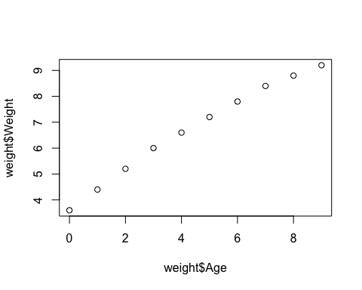

# use plot() function to draw as a point line graph with special details  
plot(weight$Age, weight$Weight, type="o", xlab="Age (months)", ylab="Weight (kg)",  
 pch = 15, cex=1.5, lwd=2, ylim=c(2,10), main="Infant Growth")

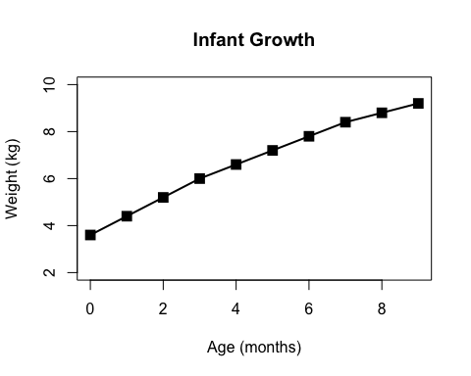

# 2B. Barplot  
feat <- read.table("bimm143_05_rstats/feature_counts.txt", header=TRUE, sep="\t")  
  
# OR you can also use   
feat <- read.delim("bimm143_05_rstats/feature_counts.txt")  
  
# create bar plot  
barplot(feat$Count, horiz=TRUE, names.arg = feat$Feature,  
 main="Number of features in the mouse GRCm38 genome", las=1)

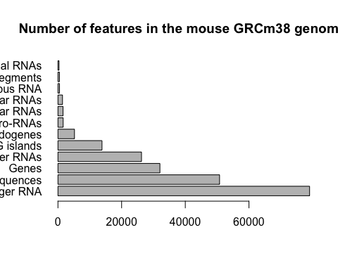

old.par <- par()$mar  
  
# labels are clipped off - time to fix them  
par(mar=c(5,12,4,4))  
barplot(feat$Count, horiz=TRUE, names.arg=feat$Feature,  
 main="Number of features in the mouse GRCm38 genome", las=1, col.main= "blue")

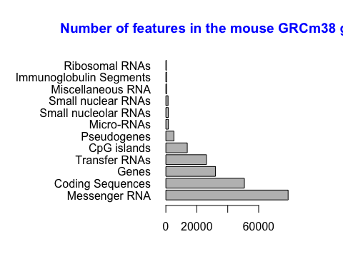

# still want to edit the title for this graph  
  
# section 3A   
mf <- read.delim("bimm143_05_rstats/male_female_counts.txt", header=TRUE)  
  
par(mar=c(5,7,4,4))  
barplot(mf$Count, col=c("blue", "salmon1"), names.arg=mf$Sample, las=2)

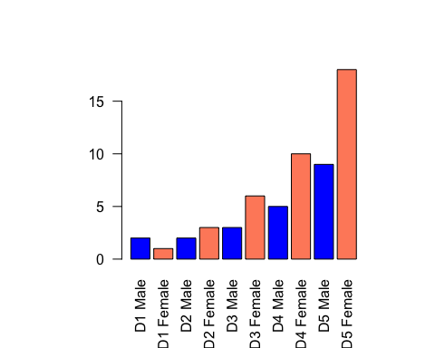

# Section 3B  
genes <- read.delim("bimm143_05_rstats/up_down_expression.txt")  
nrow(genes)

## [1] 5196

table(genes$State)

##   
## down unchanging up   
## 72 4997 127

plot(genes$Condition1, genes$Condition2, col=genes$State)

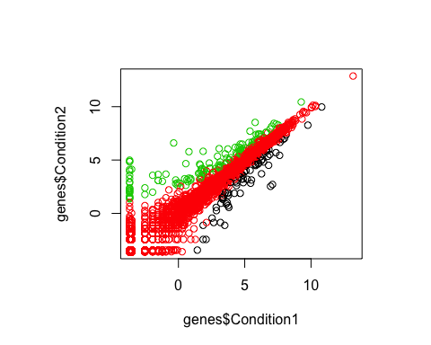

palette(c("red", "green", "blue"))  
plot(genes$Condition1, genes$Condition2, col=genes$State)

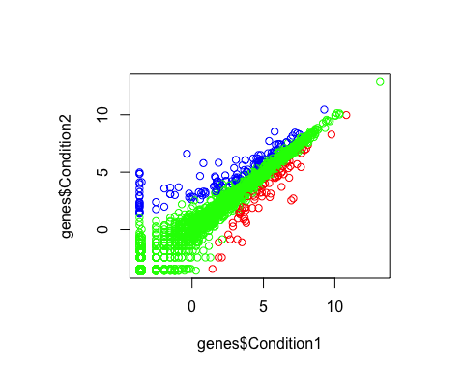

# 3C. Dynamic use of color   
meth <- read.delim("bimm143_05_rstats/expression_methylation.txt", header=TRUE)  
  
#scatterplot  
plot(meth$gene.meth, meth$expression)

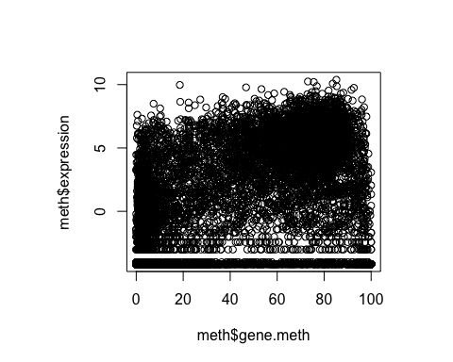

dcols <- densCols(meth$gene.meth, meth$expression)  
  
# Plot changing the plot character ('pch') to a solid circle  
plot(meth$gene.meth, meth$expression, col = dcols, pch =20)

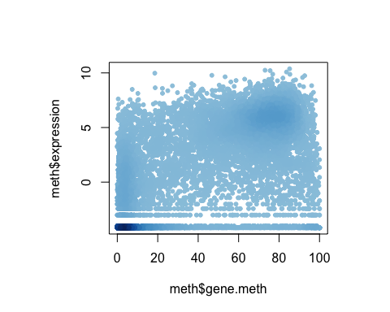

# only plot genes taht have more than zero expression values  
# Find the indices of genes with above 0 expression  
inds <- meth$expression > 0   
  
# Plot just these genes  
plot(meth$gene.meth[inds], meth$expression[inds], col = dcols, pch =20)

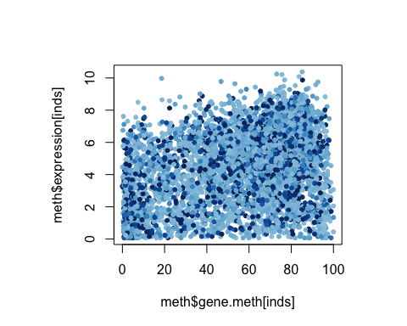

dcols.custom <- densCols(meth$gene.meth[inds], meth$expression[inds],  
 colramp = colorRampPalette(c("blue2",  
 "green2",  
 "red2",  
 "yellow")))  
plot(meth$gene.meth[inds], meth$expression[inds],   
 col = dcols.custom, pch = 20)

