Skill Check Week 7: Decisions under uncertainty part 2 & Risk
Course: NAT_R 8001 Decision Analysis for Research and Management of Natural Resources
Instructor: Brielle Thompson

Instructions: Imagine you are a state fishery manager for Missouri and you are in charge of choosing between three invasive carp removal strategies (Strategy A, Strategy B, Strategy C, and No removal). You aim to have a high number of invasive carp removed. However, each strategy comes with risk and there is a chance that the amount of removal identified will not occur.
Below is the problem’s decision tree:
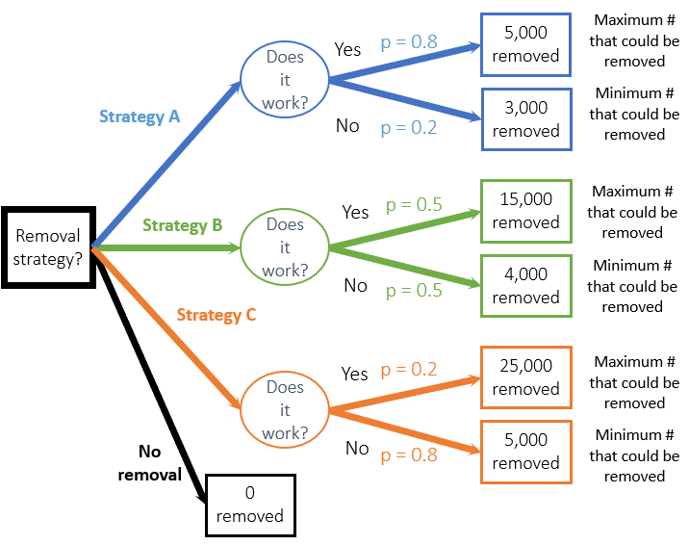
Task:
A. Across removal strategies identify:
- The strategy for a risk-neutral decision maker (aka which strategy has the highest EV) and what is its expected value?
- The strategy for a risk-averse decision maker (aka which strategy best minimizes losses or is the mini-max choice)
- Identify the strategy for a risk-seeker
B. Answer the following questions:
-Which strategy would you choose?
- What if the decision was instead about reintroducing an endangered species and the strategies varied in the number of individuals introduced. Would your strategy change? Would you address risk differently for a native species vs invasive species?

